NURSERY 2 — FIRST TERM
TEACHER COPY — not for pupils. This file carries the term-paper keys, the answer texts and the marking points. Keep it out of the pupil's book and out of the classroom pile.
Teacher's edition · the pupil pages plus the keys and marking guidance.
11 subjects · 105 lessons · 13 sections. Weeks 7, 10, 11 and 12 are Mid-Term Break, Revision, Examination and Closing: no lesson is written for a week the school keeps for those, except where the school's own table prints a teaching row there.
Each lesson ends with a worksheet and a piece of my own work; each subject ends with the term practice paper — 30 objective, 10 sub-objective and 5 theory questions. The contents page lists every part and every lesson of this book.

CONTENTS
11 subjects · 105 lessons · 13 term practice papers. Each part begins on a fresh page.
Basic Science 3
WEEK 1 — OUR BODY 3
WEEK 2 — CARE FOR OUR BODY 4
WEEK 3 — FIRSTAID: FIRSTAID BOX CONTENTS 5
WEEK 4 — FIRSTAID: USES 6
WEEK 5 — BODY CARE FOR WOUNDS: MEANING, CAUSES AND TYPES 7
WEEK 6 — BODY CARE FOR WOUNDS: CARE FOR WOUNDS 8
WEEK 8 — SICKNESS: DEFINITION, TYPES AND SYMPTOMS, CAUSES AND CARE 9
WEEK 9 — ROCKS AND SOIL 11
Cultural and Creative Arts (CCA) 13
WEEK 1 — COLOURING A CAR 13
WEEK 2 — THUMB PRINT AND HAND PRINT ART 14
WEEK 3 — COLOURING BARNEY 15
WEEK 4 — COLOURING A PIG 16
WEEK 5 — STRAW JEWELRY MAKING 17
WEEK 6 — COLOURING AN UMBRELLA 18
WEEK 8 — VEGETABLE PRINT ART 19
WEEK 9 — PLASTICINE (ADVANCED) 20
Christian Religious Studies (CRS) 22
WEEK 1 — GOD THE CREATOR (PART 1) 22
WEEK 2 — GOD THE CREATOR (PART 2) 22
WEEK 3 — GOD THE CREATOR (PART 3) 23
WEEK 4 — GOD, THE GIVER OF GOOD THINGS (PART 1) 24
WEEK 5 — GOD, THE GIVER OF GOOD THINGS (PART 2) 25
WEEK 6 — GOD, THE GIVER OF GOOD THINGS (PART 3) 25
WEEK 8 — GOD'S GIFT OF HIS SON (PART 1) 26
WEEK 9 — GOD'S GIFT OF HIS SON (PART 2) 27
Basic Digital Literacy 29
WEEK 1 — TECHNOLOGY AND DIGITAL DEVICES 29
WEEK 2 — TYPES OF COMPUTER: DESKTOP, LAPTOP, TABLET 30
WEEK 3 — BASIC PARTS: MONITOR, KEYBOARD, MOUSE, CPU 31
WEEK 4 — USES OF THE COMPUTER IN DAILY LIFE 32
WEEK 5 — CARE AND HANDLING OF DEVICES 33
WEEK 6 — COMPUTER LAB SAFETY RULES 34
WEEK 8 — FROM THE ABACUS TO TODAY'S COMPUTER 35
WEEK 9 — KEY INVENTORS: CHARLES BABBAGE AND ADA LOVELACE 37
Nigerian History 39
WEEK 1 — MEANING AND IMPORTANCE OF HISTORY (PART 1) 39
WEEK 2 — MEANING AND IMPORTANCE OF HISTORY (PART 2) 39
WEEK 3 — PEOPLES AND PLACES IN THE COMMUNITY (PART 1) 40
WEEK 4 — PEOPLES AND PLACES IN THE COMMUNITY (PART 2) 41
WEEK 5 — PLACES IN THE COMMUNITY (PART 1) 42
WEEK 6 — PLACES IN THE COMMUNITY (PART 2) 43
WEEK 8 — LIVING TOGETHER IN PEACE 44
WEEK 9 — NATIONAL UNITY AND DIVERSITY 45
Physical and Health Education (PHE) 46
WEEK 1 — EXERCISES AND GAMES: IMPORTANCE 46
WEEK 2 — GAMES: BASIC GAMES 47
WEEK 3 — BODY EXERCISE: STRETCHING, BENDING, RAISING ARMS AND LEGS, SKIPPING, LEAPING AND HOPPING 48
WEEK 4 — BODY CONDITIONING AND BALANCING 49
WEEK 5 — SIMPLE MOVEMENTS OF PARTS OF THE BODY 50
WEEK 6 — MANIPULATIVE MOVEMENTS: THROWING AND CATCHING 51
WEEK 8 — NEURO-MUSCULAR SKILLS: DANCING AND SOMERSAULTING 53
WEEK 9 — DEVELOPMENT THROUGH SPORT ACTIVITIES: PHYSICAL DEVELOPMENT 54
Prevocational Studies (PVS) 56
WEEK 1 — MEANING OF AGRICULTURE; IMPORTANCE OF AGRICULTURE TO HUMANS 56

WEEK 2 — AGRICULTURE IN OUR DAILY LIVES 57
WEEK 3 — BASIC FARMING ACTIVITIES 58
WEEK 4 — SCOPE OF AGRICULTURE: CROPS 59
WEEK 5 — SCOPE OF AGRICULTURE: ANIMALS 60
WEEK 6 — SCOPE OF AGRICULTURE: FORESTRY 62
WEEK 8 — SCOPE OF AGRICULTURE: FISHERY 63
WEEK 9 — AGRICULTURE IN NIGERIA 64
Social and Citizenship Studies (SCS) 66
WEEK 1 — LEADERSHIP 66
WEEK 2 — LEADERSHIP AT HOME 66
WEEK 3 — COMMUNITY MOBILIZATION (PART 1) 67
WEEK 4 — COMMUNITY MOBILIZATION (PART 2) 68
WEEK 5 — CIVIC RESPONSIBILITIES (PARTS 1 AND 2) 69
WEEK 6 — NATIONAL IDENTITY AND SYMBOLS (PART 1) 70
WEEK 8 — NATIONAL IDENTITY AND SYMBOLS (PART 2) 71
WEEK 9 — PEOPLE, PLACES AND OBJECTS TO RESPECT (PARTS 1 AND 2) 72
Yoruba 73
WEEK 1 — Ede: Didaruko nnkan inu yara ikawe / Asa: Ikini ni ile Yoruba / Litireso: Orin keekeekee (imototo, ibawi) 73
WEEK 2 — Ede: Onka ede Yoruba 1-10 / Asa: Iwa rere / Litireso: Orin ikilo fun omode 74
WEEK 3 — Ede: Kika alifabeeti ede Yoruba / Asa: Awon ojo ninu ose / Litireso: Orin idaraya 75
WEEK 4 — Ede: Isorongbesi laarin akekoo / Asa: Imototo ara eni / Litireso: Orin iwa rere 76
WEEK 5 — Ede: Sise nnkan (oro ase) / Asa: Ojuse ebi ninu idile / Litireso: Orin keekeekee ati ijo 77
WEEK 6 — Ede: Kika alifabeeti A-GB / Asa: Ikini fun orisirisi igba ati asiko / Litireso: Orin ibawi fun omode 78
WEEK 8 — Ede: Kiko alifabeeti / Asa: Imototo ayika / Litireso: Ere osupa sise ni ale 79
WEEK 9 — Ede: Itesiwaju kika alifabeeti H-Q / Asa: Ikini fun ise (ise abinibi) / Litireso: Ewi keekeekee 80
WEEK 11 — Exam Preparation 81
Mathematics & English 83
WEEK 1 — VOWELS AND CONSONANTS 83
WEEK 2 — SINGLE SOUNDS: d, a, i, m 84
WEEK 3 — SIGHT WORDS: You, Me, Her, We 85
WEEK 4 — SIGHT WORDS: I, Go, Car 86
WEEK 5 — DIGRAPH: th, ck, wh 87
WEEK 6 — SIGHT WORDS: The, This, They 89
WEEK 8 — DIGRAPH: ph, sh, ch 90
WEEK 9 — SIGHT WORDS: Photo, She, Chart · CONSONANT BLENDS: Play, Fly, Greet 91
WEEK 1 — REVIEW OF ALPHABET: Aa – Ff 92
WEEK 2 — REVIEW OF ALPHABET: Gg – Ll 93
WEEK 3 — REVIEW OF ALPHABET: Mm – Rr 94
WEEK 4 — REVIEW OF ALPHABET: Ss – Zz 95
WEEK 5 — THREE-LETTER WORDS: CVC PATTERN (Part 1) 97
WEEK 6 — THREE-LETTER WORDS: CVC PATTERN (Part 2) 98
WEEK 8 — THREE-LETTER WORDS: CVC PATTERN (Part 3) 99
WEEK 9 — STORY TELLING AND LETTER WORK INTEGRATION 100
WEEK 1 — WHOLE NUMBERS 1–200 101
WEEK 2 — PLACE VALUE 102
WEEK 3 — WRITING NUMBERS IN WORDS 103
WEEK 4 — WRITING WORDS IN FIGURES 104
WEEK 5 — ADDITION (INTRODUCTION) 106
WEEK 6 — ADDITION 107
WEEK 8 — SUBTRACTION (INTRODUCTION) 108
WEEK 9 — SUBTRACTION 109
General Knowledge 111
WEEK 1 — MYSELF: MY NAME, MY AGE AND MY BODY 111
WEEK 2 — MY FAMILY: MEMBERS AND THEIR ROLES 111
WEEK 3 — MY SCHOOL: PLACES, PEOPLE AND THINGS 112
WEEK 4 — MY CLASSROOM: RULES AND MATERIALS 113
WEEK 5 — MY HOME AND MY NEIGHBOURHOOD 114
WEEK 6 — COLOURS, SHAPES AND SIZES AROUND ME 114
WEEK 8 — ANIMALS AND BIRDS AROUND ME 115
WEEK 9 — GOOD HABITS: GREETINGS, POLITENESS AND CLEANLINESS 116
EXAMINATION PRACTICE — BASIC SCIENCE (Nursery 2 · First Term) 118
EXAMINATION PRACTICE — CULTURAL AND CREATIVE ARTS (Nursery 2 · 1st Term) 121
EXAMINATION PRACTICE — CHRISTIAN RELIGIOUS STUDIES (Nursery 2 · 1st Term) 124
EXAMINATION PRACTICE — BASIC DIGITAL LITERACY (Nursery 2 · 1st Term) 127
EXAMINATION PRACTICE — NIGERIAN HISTORY ( · ) 130
EXAMINATION PRACTICE — PHYSICAL AND HEALTH EDUCATION (Nursery 2 · 1st Term) 133
EXAMINATION PRACTICE — PREVOCATIONAL STUDIES (Nursery 2 · 1st Term) 137
EXAMINATION PRACTICE — SOCIAL AND CITIZENSHIP STUDIES (Nursery 2 · 1st Term) 140
EXAMINATION PRACTICE — YORUBA (Nursery 2 · 1st Term) 144
EXAMINATION PRACTICE — MATHEMATICS & ENGLISH · LITERACY (LANGUAGE DOMAIN) (Nursery 2 · 1st Term) 147
EXAMINATION PRACTICE — MATHEMATICS & ENGLISH · LITERACY (LETTER WORK) (Nursery 2 · 1st Term) 150
EXAMINATION PRACTICE — MATHEMATICS & ENGLISH · NUMERACY (Nursery 2 · 1st Term) 153
EXAMINATION PRACTICE — GENERAL KNOWLEDGE ( · ) 156

BASIC SCIENCE
Weeks 1 to 6, 8 and 9. Week 7 is Mid-Term Break, Week 10 Revision, Week 11 Examination, Week 12 Closing — those weeks carry no note. Depth: NERDC 2025 · Nursery 3 · Basic Science and Technology · First Term, pp 491–497.

WEEK 1 — OUR BODY
Depth: NERDC Nursery 3 · Basic Science and Technology · First Term W1 (pp 491–494).
You will learn to
• name the five big parts of my body
• point to the parts of my head, my trunk and my limbs
• say what my body parts do
• know that my body is special and belongs only to me
Things to know
• My body is everything about me — from the top of my head to the tips of my toes.
• The five big parts of the body are the head, neck, trunk, arms and legs.
• The head is on top and it is round. Inside the head is the brain.
• The neck joins the head to the body. The trunk is the middle part.
• Parts of the head: eyes, nose, ears, mouth, hair.
• Parts of the trunk: chest, stomach, back, waist.
• Parts of the limbs: shoulders, elbows, wrists, hands, fingers, hips, knees, ankles, feet, toes.
• I have ten fingers and ten toes.
• Eyes see, ears hear, nose smells, mouth eats and talks, legs walk, hands hold.
• Nobody else has a face exactly like mine. My body is special.
• I use my body to see, hear, run, jump, eat, hold and play.
Words for my notebook
I have a body. My body has a head, neck, trunk, arms and legs. My body is special.
Let us talk
1. Point to your neck.
2. Name the parts on your head.
3. What do we use to hear?
4. Touch your elbow, then your ankle.
5. Say one thing only you do with your hands.
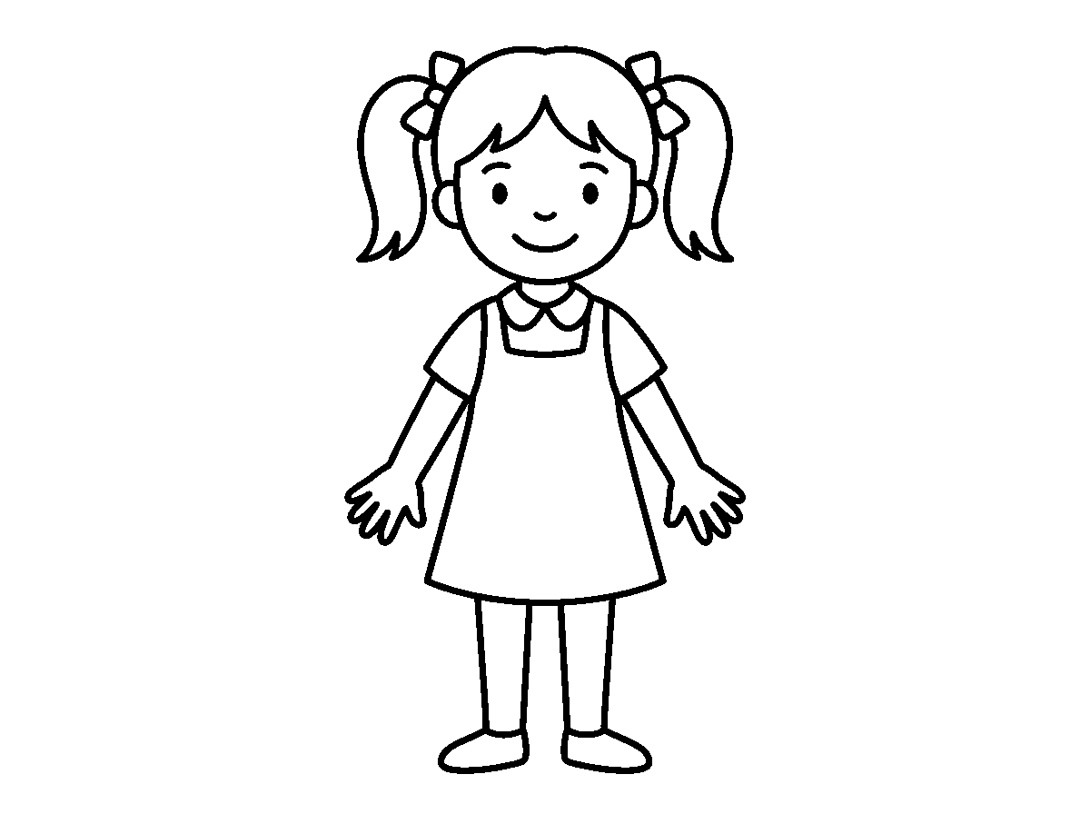
Worksheet
1. Which of these is NOT a part of the head? A) hair B) elbow C) nose D) ear
2. The part of the body between the head and the trunk is the A) leg B) waist C) neck D) finger

3. Which one is on the trunk? A) wrist B) knee C) ankle D) chest
4. We use our ____ to smell. A) nose B) ears C) hands D) feet
5. Fill in: I have ____ fingers on both hands.
6. Name two things your body helps you to do every day.
7. Write two sentences about the parts of your body that you can count.
My own work
Draw your own body in your notebook and label five parts you know.

WEEK 2 — CARE FOR OUR BODY
Depth: NERDC Nursery 3 · Basic Science and Technology · First Term W2 (pp 491–494).
You will learn to
• say why I must care for my body
• tell the daily body-care practices in order
• wash my hands and brush my teeth the right way
• say how much sleep and rest my body needs
Things to know
• A body that is looked after stays strong, does not itch, does not smell and does not fall sick often.
• I bathe every day with soap and water.
• I brush my teeth twice a day — in the morning and at night.
• I wash my hands before eating and after using the toilet.
• Hair: I wash it, I comb it and I keep it neat.
• Nails: I keep them short and clean, because long nails hide dirt and scratch the skin.
• I wear clean clothes every day; the dirty ones go to the basin, not back on my body.
• I eat good food — rice, beans, yam, vegetables and fruit — and I drink clean water.
• I sleep early and rest well, so that my body can grow.
• Running and playing make my body strong.
• Once in a while a health worker checks my teeth, my eyes and how tall I have grown.
Words for my notebook
I bathe daily. I brush twice a day. I wash my hands. I keep my nails short and my clothes clean.
Let us talk
1. How many times a day do we brush our teeth?
2. Show me how you wash your hands.
3. Name two things we do to the hair.
4. Why must nails be kept short?
5. What do we do when we are very tired?
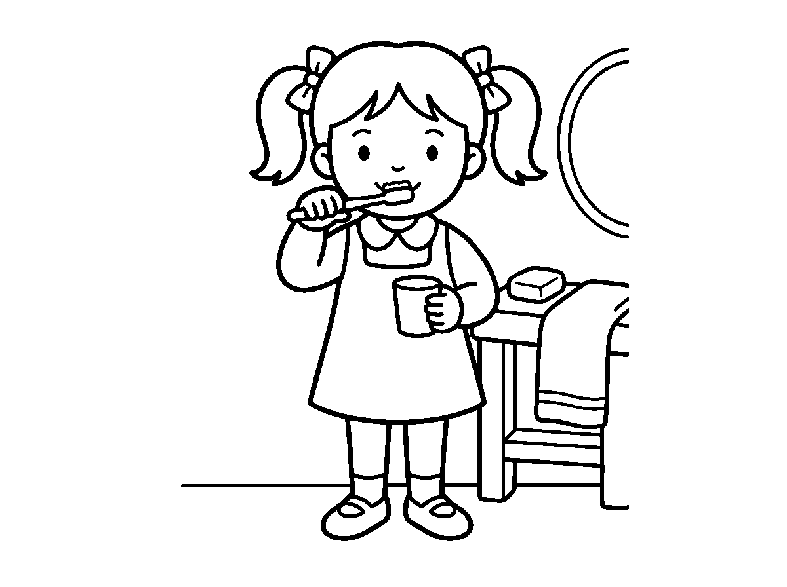

Worksheet
1. We brush our teeth ____ a day. A) four times B) twice C) once D) three times
2. Which one keeps our nails clean and safe? A) a cap B) a comb C) a cup D) a nail cutter
3. Before eating we must A) wash our hands B) sing C) run D) sleep
4. Dirty clothes should be A) put in the basin B) worn again C) given away D) kept under the bed
5. Fill in: We drink ____ water so that we do not fall sick.
6. Mention two things you do every morning to keep your body clean.
7. Write two sentences on how you keep your body strong.
My own work
Colour the picture of the clean child and cross out the one who is dirty.

WEEK 3 — FIRSTAID: FIRSTAID BOX CONTENTS
Depth: NERDC Nursery 3 · Basic Science and Technology · First Term W3 (pp 491–494).
You will learn to
• say what first aid is in one line
• name six things inside a first aid box
• point to where the box is kept
• say who may use the things in the box
Things to know
• First aid is the first help we give to a person who is hurt or suddenly sick, before the nurse or the doctor comes.
• The things in the box are kept in a box so that help is ready when it is needed.
• Contents of the first aid box: plasters (band-aids), bandages, cotton wool, antiseptic liquid or cream, scissors, thermometer, safety pins, gloves.
• Other things that may be inside: pain relief medicine, gauze, tape and tweezers.
• A plaster covers a small cut. A bandage wraps a wound. Cotton wool cleans a wound.
• The box is kept clean, in one fixed place, and it is always filled up.
• Only grown-ups use the things in the box. We do not take the scissors, we do not open the medicine and we never drink the antiseptic.
Words for my notebook
First aid is the first help for a hurt person. The box has plasters, bandages, cotton wool and a thermometer.
Let us talk
1. What is first aid?
2. Mention four things in the box.
3. Where is the box kept in our school?
4. Who is allowed to use it?

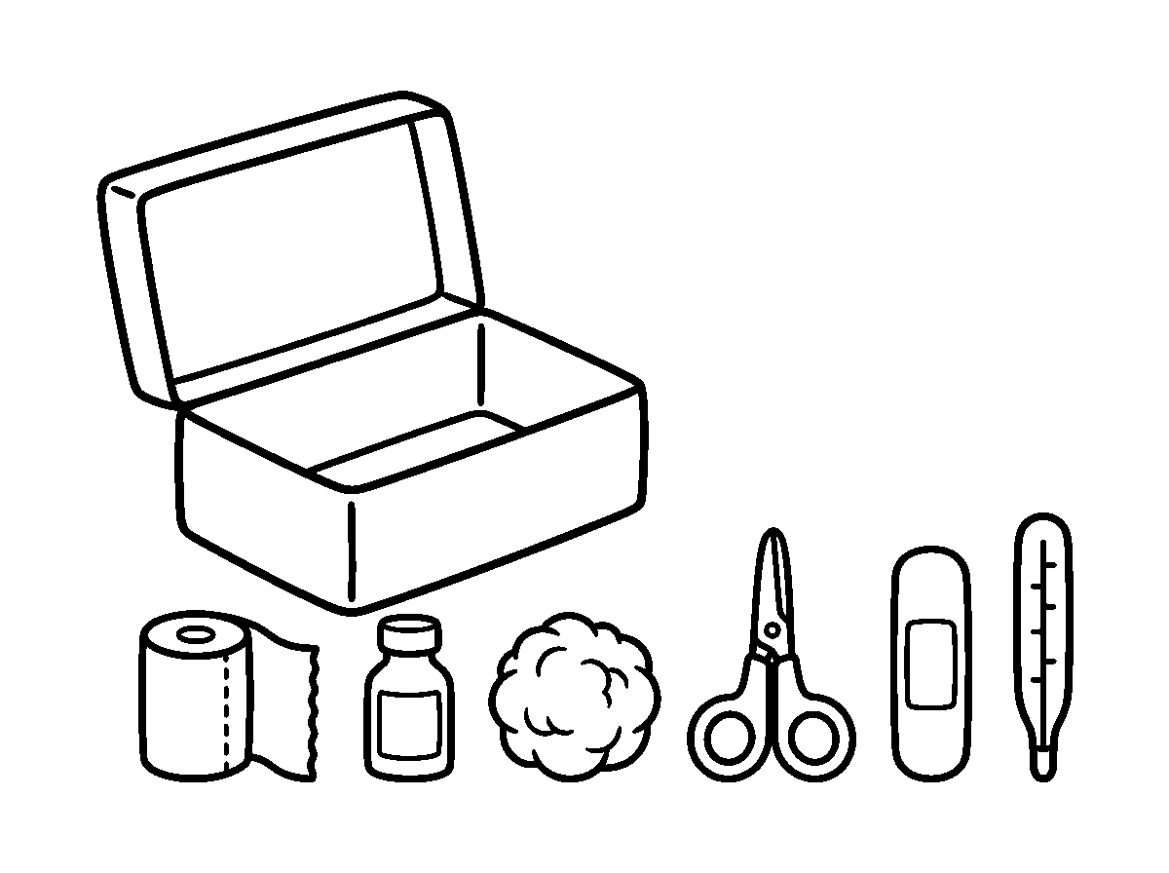
Worksheet
1. First aid means the ____ help given to a hurt person. A) slow B) secret C) last D) first
2. Which of these covers a small cut? A) a comb B) a shoe C) a plaster D) a spoon
3. Which one is NOT kept in the first aid box? A) chewing stick B) cotton wool C) bandage D) plaster
4. Who should use the things in the first aid box? A) a baby B) grown-ups C) a friend D) any pupil
5. Fill in: We keep the first aid box clean and always ____.
6. Name three things you can find inside a first aid box.
7. Write two sentences on what first aid means.
My own work
Draw the two things in the box that you have seen at home.

WEEK 4 — FIRSTAID: USES
Depth: NERDC Nursery 3 · Basic Science and Technology · First Term W4 (pp 491–494).
You will learn to
• match each first aid thing to what it is used for
• say when a grown-up must be called at once
• say what a thermometer is for
• stay calm when somebody is hurt
Things to know
• Plasters and band-aids cover small cuts and scrapes.
• A bandage wraps a wound and supports a sprained wrist or leg.
• Cotton wool cleans a wound and carries the medicine to it.
• Antiseptic washes the wound so that germs do not enter; it may sting once.
• A thermometer checks whether the body is hot with fever.
• Call a grown-up at once for a deep cut, blood that will not stop, a big burn, an animal bite, or a nail or thorn gone deep into the skin.
• We never try to be the doctor for a big wound; we go and call for help.
• When somebody is hurt and we shout, everybody becomes frightened. We breathe, we speak well, and we say: Are you okay? I am calling a teacher.
Words for my notebook
Plaster for a small cut. Bandage to wrap. Cotton to clean. Thermometer for fever. Call a grown-up.
Let us talk
1. What do we use for a small cut?
2. What is the thermometer for?

3. Mention two injuries that need a grown-up at once.
4. Show me the calm voice you use when a friend is hurt.
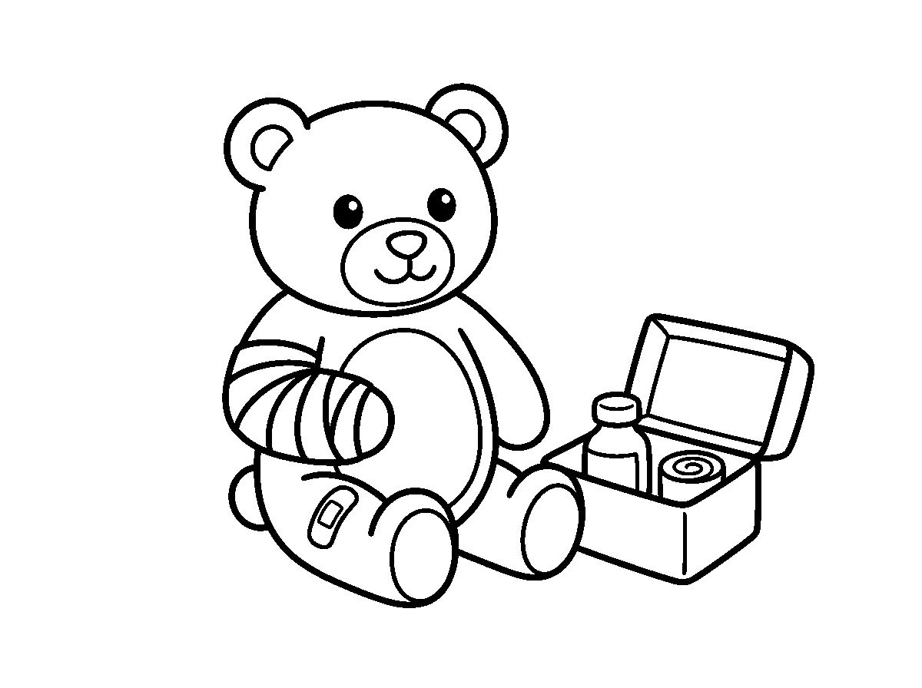
Worksheet
1. A bandage is used to A) brush the teeth B) write on the book C) wrap a wound and support a sprain D) cook food
2. A thermometer tells us whether the body has A) dirt B) fever C) a cut D) a bruise
3. Antiseptic is put on a wound to A) make it bleed B) keep germs out C) colour it D) stop it feeling
4. Which one must make us call a grown-up at once? A) a torn book B) a small scrape C) a deep cut that will not stop bleeding D) a dirty shoe
5. Fill in: When somebody is hurt we must keep ____ and call a grown-up.
6. Name the thing used for (a) a small cut (b) checking fever.
7. Write two sentences on how you will help a friend who has fallen.
My own work
Match with a line: plaster–cut, bandage–wrap, cotton–clean, thermometer–fever.

WEEK 5 — BODY CARE FOR WOUNDS: MEANING, CAUSES AND TYPES
Depth: NERDC Nursery 3 · Basic Science and Technology · First Term W7 (pp 491–494).
You will learn to
• say what a wound is
• name the causes of wounds at home and at school
• tell the five types of wounds apart
• say two ways of preventing wounds
Things to know
• A wound is an injury that breaks the skin — where the skin is open, or cut, or has blood on it.
• If the skin is not broken, it is not a wound.
• Cuts come from sharp things: a knife, broken glass, a razor blade, a tin lid.
• Falls and scrapes come from running in the compound or falling from a chair.
• Burns come from a hot pot, a kettle, a lantern or a candle.
• Insect bites (mosquito, bee, ant) and animal scratches (cat, dog) also make wounds.
• A cut is a straight opening made by something sharp.
• A scrape (graze) is the top skin rubbed off after a fall.
• A bruise is a blue-black mark from bumping; the skin is not open.

• A burn is made by heat or fire. A puncture is a small deep hole from a nail or a thorn.
• We do not play with knives, blades or broken glass, and we keep away from the pot on the fire.
• Some wounds are small and we clean them; some are big and only a doctor or nurse can treat them.
Words for my notebook
A wound breaks the skin. Types: cut, scrape, bruise, burn, puncture. Small wounds are cleaned; big wounds need a doctor.
Let us talk
1. What is a wound?
2. Name two things in the house that can cut.
3. Show me the picture of a burn.
4. What kind of wound comes from a thorn?
5. Mention one way of preventing wounds.
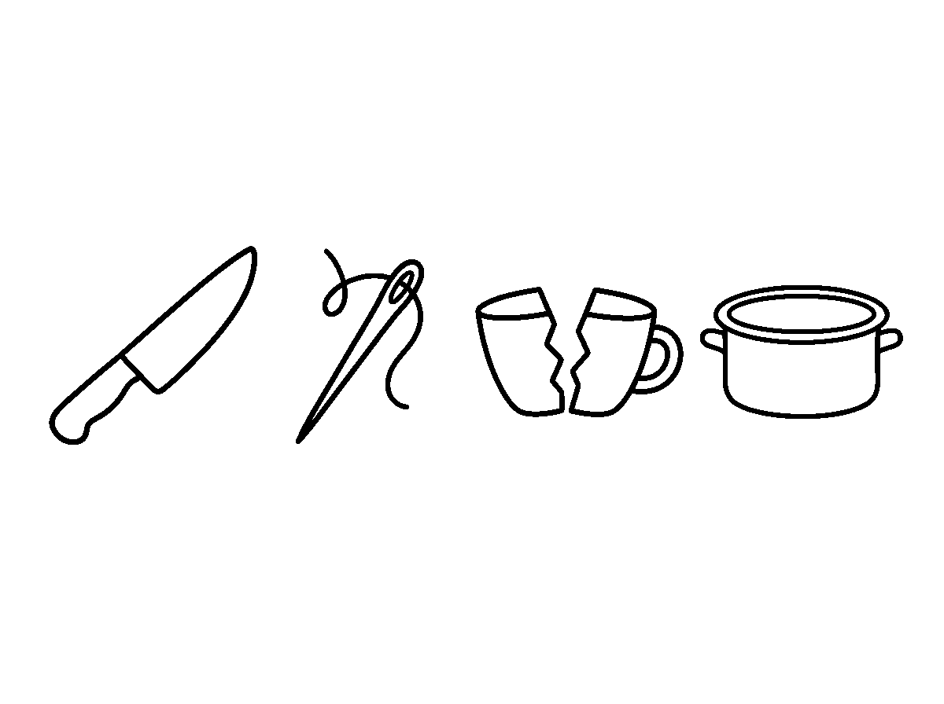
Worksheet
1. A wound is an injury that A) paints the skin B) breaks the skin C) cleans the skin D) warms the skin
2. A blue-black mark from bumping, with the skin not open, is a A) cut B) bruise C) plaster D) burn
3. A puncture wound can come from A) soap B) a bandage C) a thorn or a nail D) a plaster
4. Which one can cause a burn? A) a hot pot from the fire B) a toy C) a book D) cold water
5. Fill in: We do not play with knives, glass or ____ blades.
6. Mention three things that cause wounds at home.
7. Write two sentences on the difference between a bruise and a cut.
My own work
Draw one thing that can cause a cut and one thing that can cause a burn.

WEEK 6 — BODY CARE FOR WOUNDS: CARE FOR WOUNDS
Depth: NERDC Nursery 3 · Basic Science and Technology · First Term W8 (pp 491–494).
You will learn to
• put the four steps for a small wound in order
• say when a grown-up must be called
• keep the rules about the scab and the bandage
• know the signs that a wound is going bad
Things to know
• Step one: wash the hands first.
• Step two: clean the wound with clean water.
• Step three: put on the antiseptic with cotton wool — we dab it, we do not rub it.

• Step four: cover the wound with a plaster or a bandage.
• Never touch a wound with dirty hands.
• Do not pick at the scab. The scab is the body's own plaster; when it is picked, the wound opens again and can leave a mark.
• A wet or dirty bandage is not a bandage — it is changed.
• If the wound becomes red, or swells, or pus comes out, or it pains more after two days, that is infection: tell a grown-up.
• A wound heals in some days if we keep it clean and let the scab finish its work.
• Prevention is better than treatment: it is better not to be cut at all.
Words for my notebook
Wash hands, clean with water, put on antiseptic, cover. Do not pick the scab. Red or swollen = tell a grown-up.
Let us talk
1. What is the first thing we do for a small wound?
2. Show me step two and step three.
3. Why must we not pick a scab?
4. Mention one sign that a wound is going bad.
5. What does "prevention is better than treatment" mean?
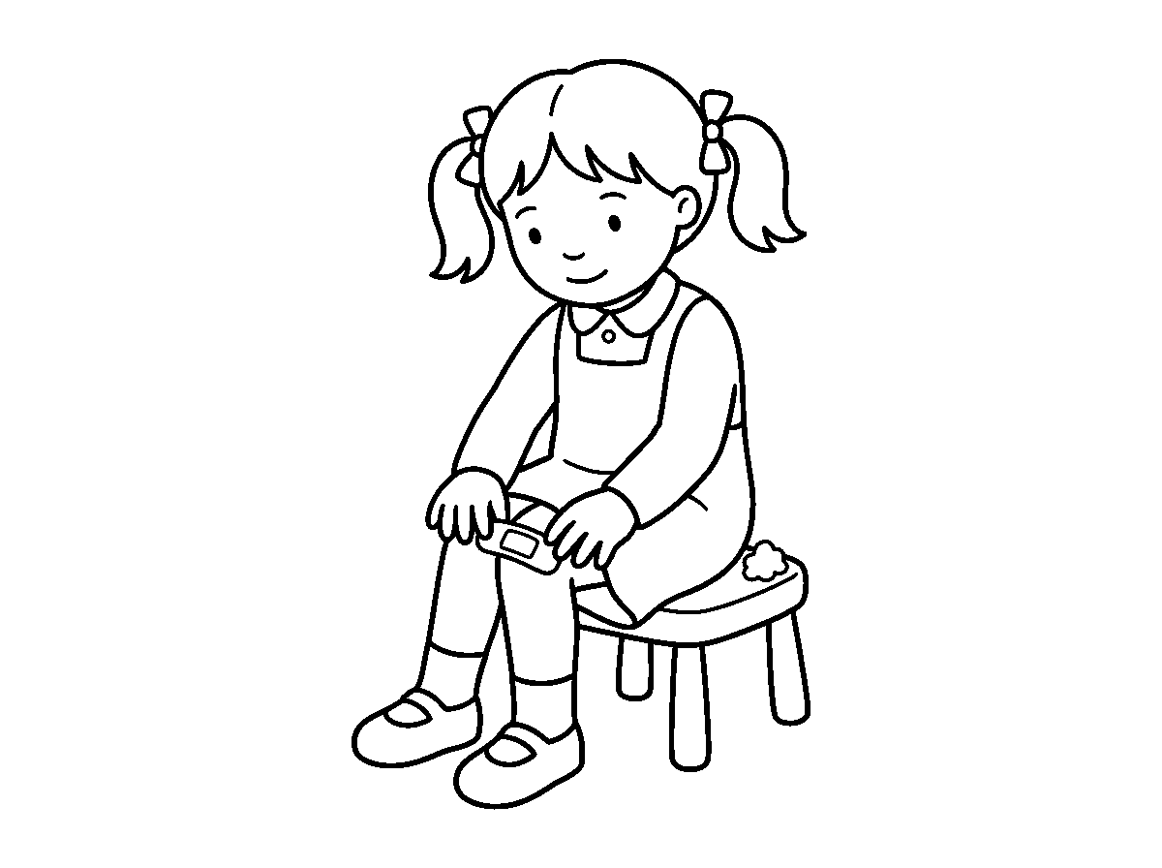
Worksheet
1. What is the FIRST thing to do before caring for a wound? A) wash our hands B) put on a plaster C) blow on it D) run to the doctor
2. We clean a small wound with A) dirty water B) pepper C) mud D) clean water
3. On a healing wound there is a scab; we must A) leave it to fall off itself B) pick it daily C) rub sand on it D) cut it
4. Which one says the wound is going bad? A) it is dry B) it itches a little C) it is red and swollen D) its colour is the same
5. Fill in: When a bandage gets wet or dirty, we ____ it.
6. Write the four steps for caring for a small wound in order.
7. Write two sentences on why we must not pick a scab.
My own work
Number 1 to 4 the pictures of the four steps in your notebook.

WEEK 8 — SICKNESS: DEFINITION, TYPES AND SYMPTOMS, CAUSES AND CARE
Depth: NERDC Nursery 3 · Basic Science and Technology · First Term W9 and W10 (pp 491–494) — this week takes both NERDC weeks together.
You will learn to
• define sickness in one line
• name common sicknesses of children and the signs they show
• say what brings sickness and how to prevent it
• describe how a sick person is cared for

Things to know
• Sickness (illness) is when the body is not working properly and we feel unwell.
• A well body eats and plays; a sick body is weak and needs rest.
• Common sicknesses of children: cold and cough, fever, stomach ache, headache, malaria, diarrhoea, measles, chicken pox.
• The signs of sickness are fever or high temperature, pain, coughing, sneezing, vomiting, weakness, loss of appetite and rashes.
• Signs are how the body tells us that something is wrong.
• A thermometer is used to check whether the body has fever.
• Sickness is brought by germs (bacteria and viruses), dirty water and dirty food, the bite of an infected mosquito, not eating well, not sleeping enough and very cold weather.
• We prevent sickness by washing the hands, eating healthy food, drinking clean water, covering the mouth when we cough, and sleeping under a mosquito net.
• A sick person needs rest and sleep, the medicine the doctor gave at the time given, plenty of water, good food and warmth.
• When somebody is sick we go to the doctor or the clinic; we do not take medicine alone.
• We are kind to a sick person — we do not laugh at them, we speak softly, we take them a cup of water.
• Sickness is not for ever: with care we get better.
Words for my notebook
Sickness is the body not working well. Rest, water, good food and the doctor's medicine make us well again.
Let us talk
1. What is sickness?
2. Name three signs of sickness.
3. What does a thermometer check?
4. Mention two things that bring sickness.
5. What do you do for a brother or sister who is sick?
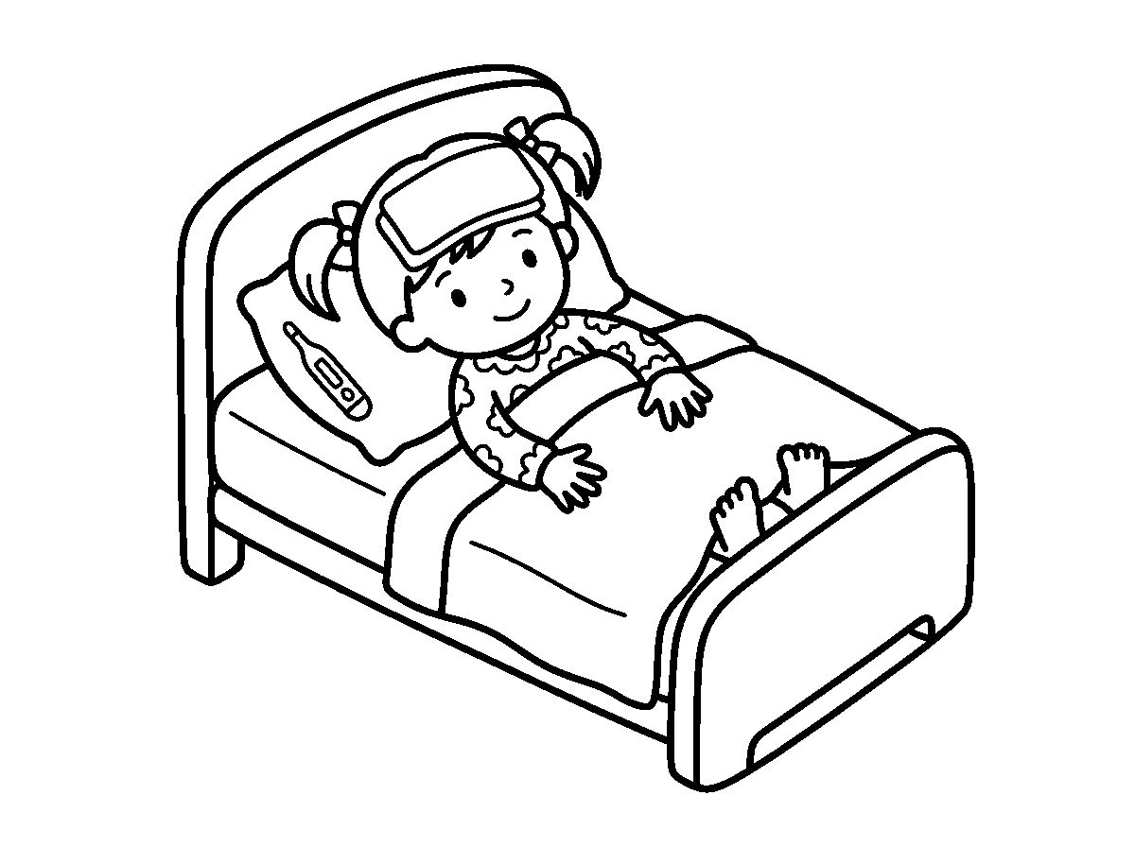
Worksheet
1. Sickness means the body A) is sleeping well B) is growing C) is working properly D) is not working properly
2. Which one is a sign of sickness? A) a clean cloth B) a sharp pencil C) running fast D) high temperature
3. Malaria is brought to us by A) rain B) a book C) a mosquito D) a goat
4. A sick person should drink plenty of A) kerosene B) cold soda C) water D) palm oil
5. Fill in: We cover our mouth when we ____.
6. Mention three ways of preventing sickness.
7. Write two sentences on how a sick person is cared for at home.

My own work
Write four words that tell us a person is sick (for example: fever, ____).
Draw the four things a sick child needs to get well again and colour them.

WEEK 9 — ROCKS AND SOIL
Depth: NERDC Nursery 3 · Basic Science and Technology · Second Term W1 (pp 494–497).
You will learn to
• define a rock and soil in one line each
• sort stones by size
• name three uses of rocks
• tell sandy, clayey and loamy soil apart by touch
Things to know
• A rock is a hard, solid thing found in nature on the earth; nobody made it.
• Some rocks were made when hot liquid from inside the earth (lava) cooled and became hard.
• Some were made when little bits of stone were pressed together for a very long time; others were changed by great heat and pressure.
• Sizes we can see: big rocks, small stones, pebbles and sand.
• Rocks are used for building houses, making roads, decoration and making some tools.
• Soil is the top layer of the earth where plants grow.
• Soil comes from rocks that broke into tiny bits over many years, mixed with dead plants and dead animals.
• Sandy soil is grainy and the water runs through it quickly.
• Clay soil is sticky when wet and smooth when dry; it can be moulded into a ball.
• Loamy soil is a mixture of both and is the best soil for plants.
• Plants grow in soil, animals live in soil, and the food we eat comes from soil.
• Take the soil away and there is no yam, no rice and no tree.
Words for my notebook
A rock is hard and comes from nature. Soil is the top layer of the earth. Loamy soil is best for plants.
Let us talk
1. What is a rock?
2. Show me the pebbles.
3. Name two uses of rocks.
4. Which soil is sticky when it is wet?
5. Which soil is best for plants, and why?
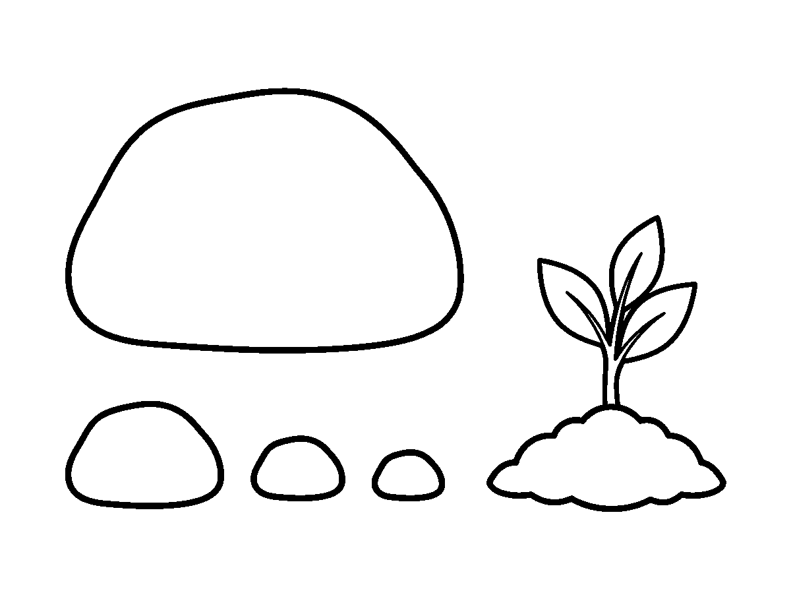

Worksheet
1. A rock is A) a kind of animal B) a kind of food C) soft and made by people D) hard and found in nature
2. Which of these is the smallest size of rock? A) pebble B) stone C) big rock D) boulder
3. Sandy soil lets water A) run through quickly B) stay on top C) freeze D) rise up
4. Which soil is the best for growing plants? A) clay B) sand C) gravel D) loam
5. Fill in: Soil is the ____ layer of the earth where plants grow.
6. Mention three uses of rocks.
7. Write two sentences on the three types of soil.
My own work
Put two small stones and one leaf in a paper bag and bring them to class tomorrow.

CULTURAL AND CREATIVE ARTS (CCA)
Weeks 1 to 6, 8 and 9. No note for Week 7 (Mid-Term), 10 (Revision), 11 (Examination). Depth: NERDC 2025 · Nursery 3 and Nursery 2 · Creativity · pp 412–414 and 564–571.

WEEK 1 — COLOURING A CAR
Depth: NERDC Nursery 3 · Creativity · First Term W1 (pp 564–566).
You will learn to
• know the parts of a car that I can see on paper
• colour inside the lines without going out
• choose the colours I want for my car
• say what a car does for people
Things to know
• A car is a means of transportation: it carries people and things from place to place.
• The parts of the car on my colouring paper: body, wheels, windows, doors and headlights.
• Any colour is a good colour for a car — the colour I choose is my own idea.
• Windows are often blue or black; wheels are black or grey; headlights are yellow.
• Cars come in different types: sedan, SUV and sports car.
• A picture looks complete when I add a background: the road under it, the sky above it, and trees beside it.
• Colouring inside the lines makes my work neat; finishing the whole page makes it complete.
Words for my notebook
A car has a body, wheels, windows, doors and headlights. A car carries people and things.
Let us talk
1. Point to the wheels on your car.
2. What colour did you give the windows, and why?
3. Name one other thing that carries people.
4. What did you draw under the car?
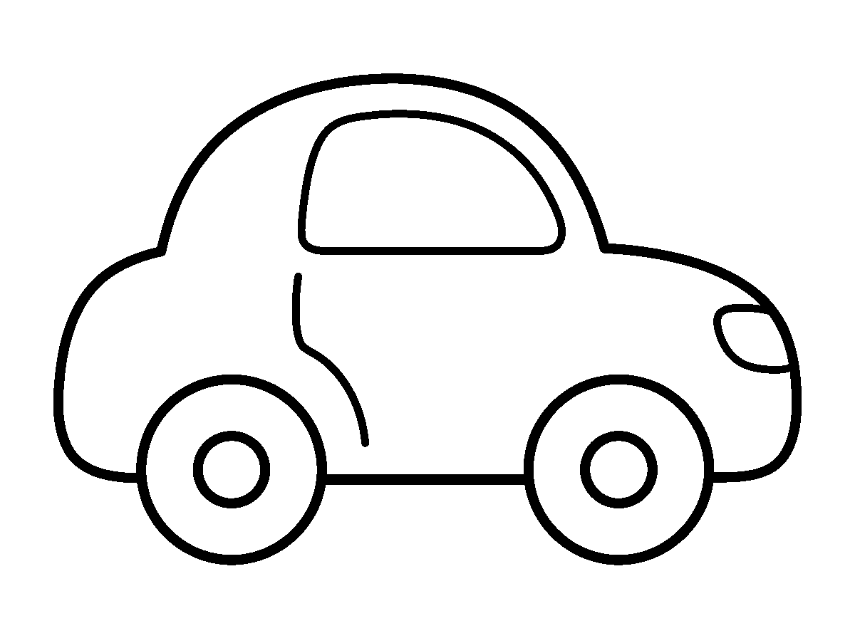
Worksheet
1. Which part of the car makes it move? A) horn B) door C) wheel D) window
2. Colouring inside the lines makes my work A) dark B) wet C) messy D) neat
3. Which of these is a type of car? A) single B) sandal C) sedan D) centre
4. A car is a means of A) eating B) sleeping C) transportation D) writing

5. Fill in: The part you look through in a car is the ____.
6. Name three parts of a car you coloured.
7. Write two sentences on the picture you made and the colours you chose.
My own work
Finish your car: colour the whole outline and add a road, a sky and one tree.

WEEK 2 — THUMB PRINT AND HAND PRINT ART
Depth: NERDC Nursery 3 · Creativity · First Term W4 (pp 564–566).
You will learn to
• press my thumb and my hand on paper to make pictures
• make a caterpillar, a butterfly, a fish or a flower from prints
• add details after the paint has dried
• wash my hands well after the activity
Things to know
• A thumb print is made by dipping the thumb in washable paint or an ink pad and pressing it on paper.
• Many thumb prints in a line make a caterpillar; two joined make a butterfly; small ones scattered make a ladybug on a leaf; three in a row can make a fish.
• A hand print is made by painting the whole palm and fingers and pressing the hand flat on the paper.
• A hand print can become a bird, a fish, a tree or a person with fingers as legs and hair.
• Every thumb print is different — mine is not like my friend's; that is what makes my picture mine.
• After the paint is dry, I add eyes, legs and lines with a marker or a pen.
• More than one print can make a whole scene: a garden, a pond, a family.
• When I finish, I wash my hands with soap and water.
Words for my notebook
I dip, I press, I lift. My thumb print is unique — nobody has another one like it.
Let us talk
1. What do we dip the thumb in?
2. Show me your butterfly or caterpillar.
3. Name one thing you made with your hand print.
4. What must be dry before I use a marker?
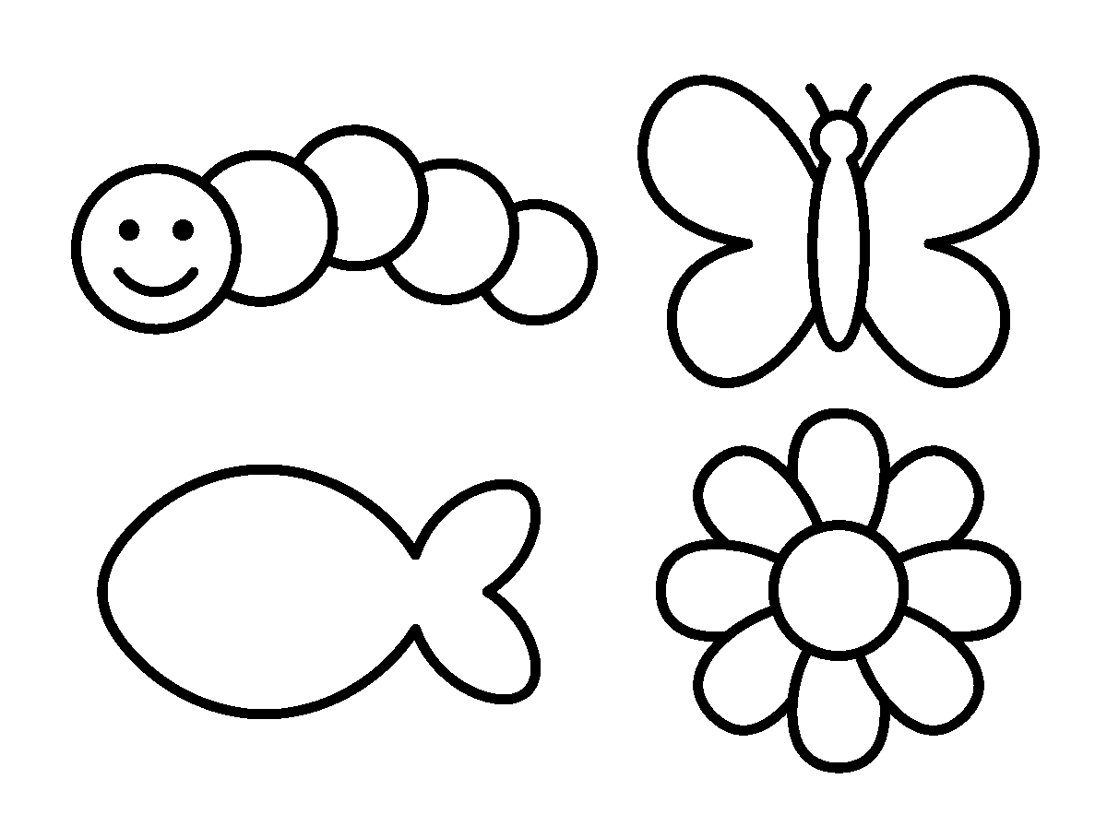
Worksheet
1. A thumb print is made with A) a ruler B) chalk C) water only D) paint

2. Many thumb prints in a line can look like a A) car B) house C) ball D) caterpillar
3. Before I add details with a marker, the paint must be A) cold B) dry C) wet D) hot
4. Every thumb print is A) square B) unique C) the same D) blue
5. Fill in: After the activity I wash my ____ with soap.
6. Name three pictures you can make with thumb prints.
7. Write two sentences on the picture you made in class today.
My own work
Make six more thumb prints on a spare page and turn three of them into animals.

WEEK 3 — COLOURING BARNEY
Depth: NERDC Nursery 3 · Creativity · First Term W8 (pp 564–566).
You will learn to
• colour a character inside its outline
• keep the body colours the character is known for
• add a background to my picture
• colour carefully and neatly to the end
Things to know
• Barney is a purple dinosaur in a children's programme; his belly and his back details are green.
• A character picture has an outline — the lines that show where the body, the arms and the legs end.
• Colouring inside the outline keeps the character looking like itself.
• I start with the biggest part (the body), then the smaller parts (the belly, the hands, the feet).
• A background makes the picture complete: a playground, a park, or the sky with clouds.
• Characters also live in books, on cards and on screens; a colouring page takes one of them onto my paper.
• Neat work is finished work: no white patches left inside, no colour outside the lines.
Words for my notebook
Barney is a purple dinosaur with a green belly. I colour inside the lines and finish my whole page.
Let us talk
1. What colour is Barney's body?
2. What did you draw behind him?
3. Show me one place where you stayed inside the line.
4. Why should we not leave white patches?
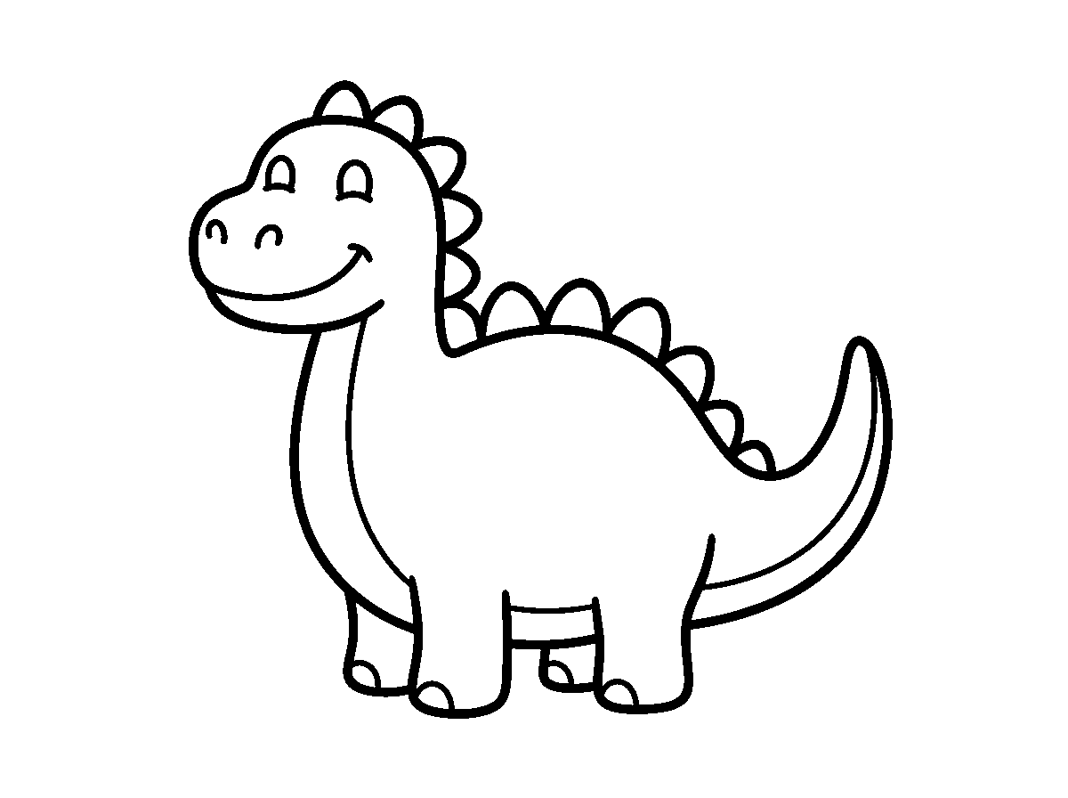

Worksheet
1. Barney is a A) red bird B) yellow goat C) purple dinosaur D) blue fish
2. The lines that show where the body ends are the A) paper B) pencil C) colours D) outline
3. A background in my picture can be A) my bag B) the sky C) a shoe D) a spoon
4. Which colour is Barney's belly? A) brown B) black C) white D) green
5. Fill in: I colour inside the ____ so my work is neat.
6. Name two things you can draw behind a character.
7. Write two sentences on how you finished your colouring.
My own work
Draw one friend standing beside Barney and colour both of them.

WEEK 4 — COLOURING A PIG
Depth: NERDC Nursery 2 · Creativity · First Term W9 and Nursery 3 · Creativity · First Term W9 (pp 412–414, 564–566).
You will learn to
• name the parts of a pig I am colouring
• choose the colours a pig can be
• colour a curved shape neatly
• say two things we get from farm animals
Things to know
• Parts of a pig: snout (the long nose), curly tail, round body, small ears and hooves.
• A pig is a farm animal; it lives in a pen on the farm with goats, sheep and hens.
• Pig colours: pink is the most common; some are brown, black or white.
• Details that make the picture real: two eyes, two nostrils on the snout, and hooves on the legs.
• A muddy background, a barn or a fence tells where the pig lives.
• We learn about farm animals through art: the shape of the body, the size of the ears, the kind of legs.
• Farm animals give us food, and they are looked after every day.
• Curved lines are harder to colour inside than straight ones; I go slowly on the round back and the snout.
Words for my notebook
A pig has a snout, a curly tail, a round body and hooves. I colour inside the curved lines.
Let us talk
1. Point to the snout on your picture.
2. What colour did you make the pig?
3. Where does a pig live?
4. Name one other farm animal.

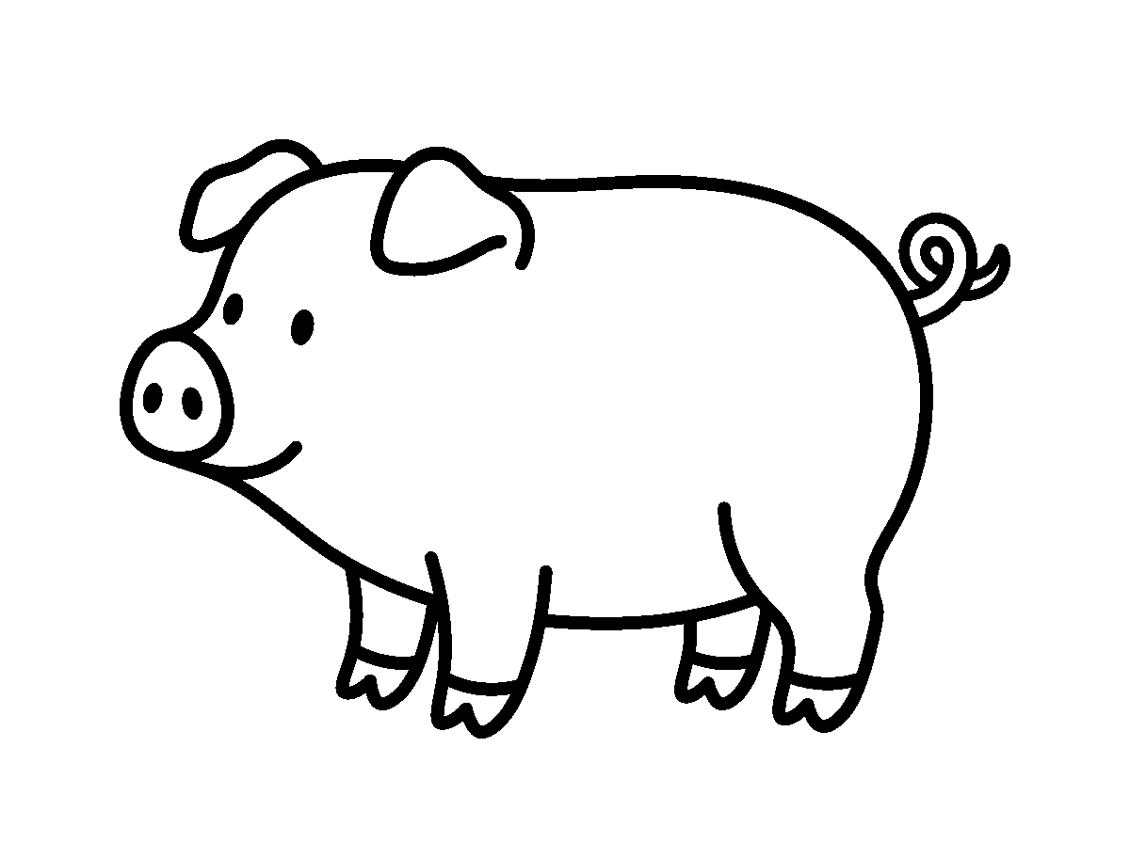
Worksheet
1. The long nose of a pig is called its A) hoof B) horn C) snout D) wing
2. Which colour is the most common for a pig? A) grey B) purple C) orange D) pink
3. A pig lives A) in the river B) in a tree C) on a farm D) in the sky
4. The foot of a pig is a A) web B) hoof C) claw D) paw
5. Fill in: A pig's tail is ____.
6. Name three parts of the pig you coloured.
7. Write two sentences on a farm animal you know and what it gives us.
My own work
Add a fence and a barn behind your pig, then colour the whole page.

WEEK 5 — STRAW JEWELRY MAKING
Depth: NERDC Nursery 3 · Creativity · First Term W10 (pp 564–566).
You will learn to
• cut straws into small bead-sized pieces with help
• thread the pieces onto a string
• make a pattern that repeats
• tie a knot so that my necklace does not open
Things to know
• The things I need: drinking straws cut into small pieces, string or yarn, and scissors.
• The straw pieces are as small as beads, so the necklace can lie flat around my neck.
• Straws are cut into bead-sized pieces with a grown-up guiding the scissors.
• Threading: I push the string through one piece, then the next, keeping them in a line.
• A pattern is a repeat: red, blue, red, blue — or red, red, yellow, red, red, yellow.
• The same pieces can make a necklace (longer) or a bracelet (shorter).
• A knot at both ends, tied with help, keeps the work from falling apart.
• Patterns are everywhere: on cloth, on beads, on the floor tiles; my necklace is a pattern I made.
• Rolling, pushing and threading between my fingers make my hands clever for writing.
• The jewelry I made can be worn, and it can be a gift for somebody I love.
Words for my notebook
I cut, I thread, I repeat a pattern, I tie a knot. My necklace is wearable art.

Let us talk
1. Show me the pattern you repeated.
2. How many colours did you use?
3. What keeps the beads from falling off?
4. Who helped with the scissors, and why?
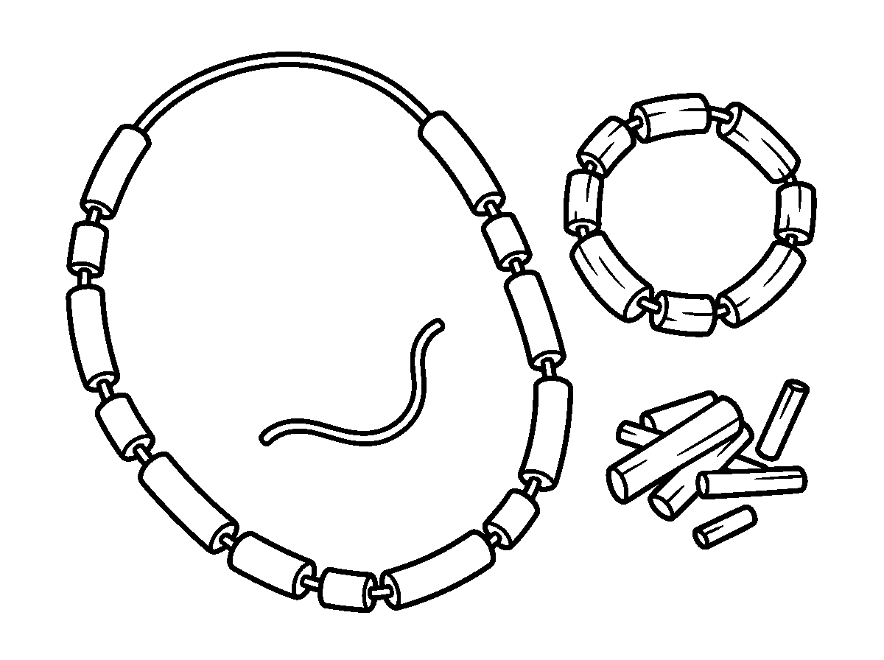
Worksheet
1. The small pieces for my necklace are cut from A) wood B) paper C) leaves D) straws
2. Red, blue, red, blue is a A) pattern B) knot C) colour D) line
3. What do I use to hold the pieces together? A) water B) glue C) chalk D) a string
4. A shorter necklace worn on the wrist is a A) hat B) bag C) bracelet D) shoe
5. Fill in: I tie a ____ at the end so my work does not open.
6. Name the three things needed for straw jewelry.
7. Write two sentences on the pattern you chose and how you made it.
My own work
Wear your necklace or bracelet to school tomorrow and say its pattern out loud in class.

WEEK 6 — COLOURING AN UMBRELLA
Depth: NERDC Nursery 2 · Creativity · First Term W10 and Nursery 3 · Creativity · Second Term W1 (pp 412–414, 568–571).
You will learn to
• name the parts of an umbrella
• mix bright colours together without fear
• make stripes, dots or sections on my umbrella
• colour a curved outline neatly
Things to know
• Parts of an umbrella: the canopy (the round top), the handle, and the spokes inside the canopy.
• An umbrella keeps rain off us, and it keeps the strong sun off us too.
• Bright colours look good on an umbrella — red, blue, yellow, green and orange can sit together.
• Patterns I can make: stripes from the top to the edge, polka dots, or sections where each part gets its own colour.
• Colour combinations: yellow goes with blue, red goes with green; two colours in one section make it look designed.
• The background can carry rain, raindrops, clouds — or a shining sun if the day is hot.
• The curved edge of the canopy is where neatness shows; I colour slowly near the curve.

• Finishing the whole page — canopy, handle and background — makes the work complete.
Words for my notebook
An umbrella has a canopy, spokes and a handle. It keeps rain and sun off us.
Let us talk
1. Point to the canopy on your picture.
2. What pattern did you put on it?
3. What did you draw in the sky?
4. Name two colours that sit well together in your work.
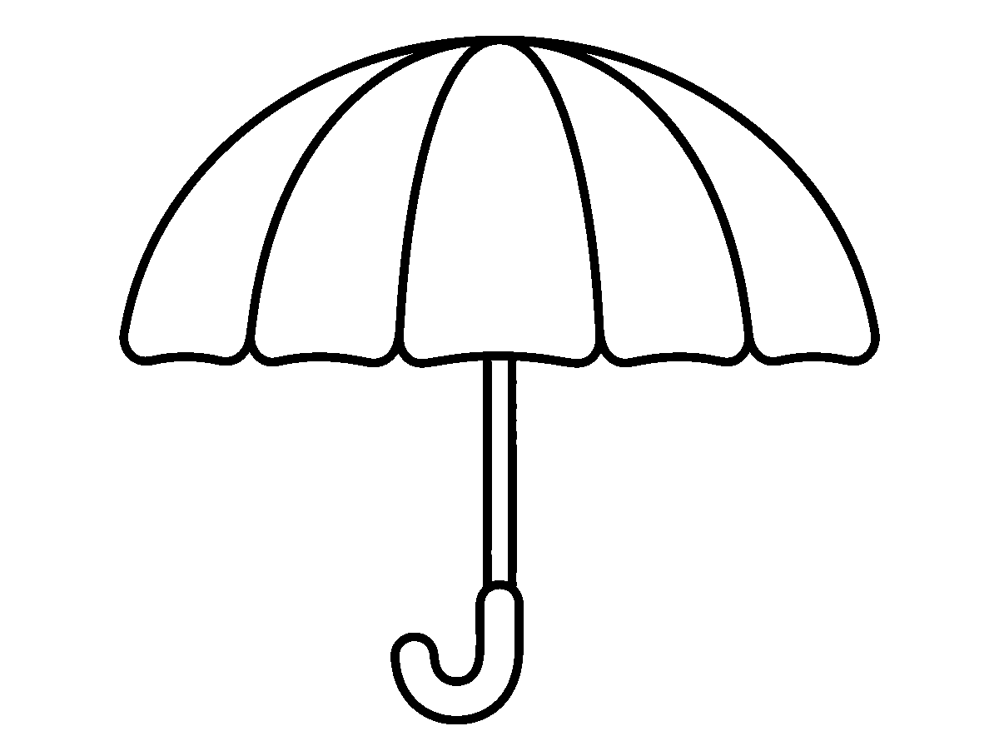
Worksheet
1. The round top of the umbrella is the A) spoke B) canopy C) roof D) handle
2. An umbrella keeps off rain and A) sun B) dust C) dogs D) wind
3. Dots all over the canopy are called A) stripes B) lines C) boxes D) polka dots
4. Which of these is inside an umbrella? A) wheels B) leaves C) spokes D) strings
5. Fill in: I colour slowly near the curved ____ of the canopy.
6. Name the parts of an umbrella.
7. Write two sentences on the colours you used for your umbrella.
My own work
Draw an umbrella over two people walking in the rain, and colour it.

WEEK 8 — VEGETABLE PRINT ART
Depth: NERDC Nursery 3 · Creativity · Second Term W2 (pp 568–571).
You will learn to
• use vegetables as stamps
• know the shape each vegetable makes
• dip, press and lift without smearing
• clean up after the activity
Things to know
• Vegetables can be stamps: an okra cut across prints a star, a carrot prints a circle, a potato can be carved into shapes, and bell pepper, cabbage and celery print their own patterns.
• The vegetable is cut for us by a grown-up — we do not use the cutting blade ourselves.
• I dip the cut face of the vegetable into paint, then press it on the paper and lift it straight up.
• Pressing hard and moving the stamp smears the print; a firm, still press gives a clean mark.
• Different vegetables can be combined: okra stars on cabbage circles, carrot rings in a line like a road.

• Prints can be made into a greeting card, a wrapper design, or a picture of a garden.
• The shape a vegetable already carries is what makes its print different from another's.
• When I finish, I wash the stamps or put them where they belong, wipe the table and wash my hands.
• Art can come from food and from nature; the same plant that feeds us can also print.
Words for my notebook
Okra makes a star, carrot makes a circle. I dip, press and lift — then I clean up.
Let us talk
1. Which vegetable made a star in your work?
2. Show me a print that came out clean.
3. What do we do after printing?
4. Name one thing you can make with vegetable prints.
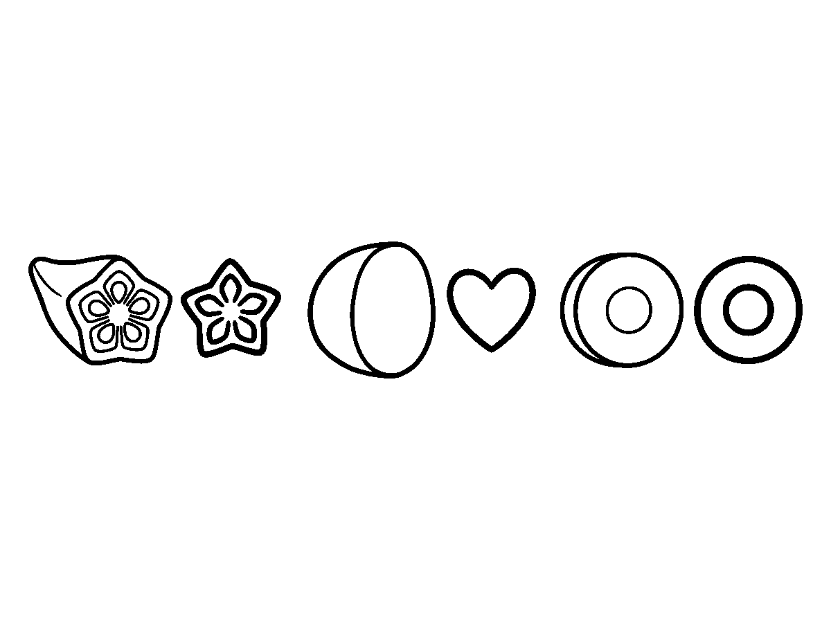
Worksheet
1. Which vegetable prints a star shape? A) onion skin B) rice C) okra D) yam
2. A carrot cut across prints a A) circle B) line C) square D) star
3. Who cuts the vegetables for printing? A) a grown-up B) any pupil C) the class goat D) nobody
4. To get a clean print I must A) blow on it B) press and hold still C) move it about D) rub hard
5. Fill in: After printing, I wash the ____ and the table.
6. Name three vegetables that can be used as stamps.
7. Write two sentences on the picture you made with prints.
My own work
Make one more print on a spare page and write under it the name of the vegetable that made it.

WEEK 9 — PLASTICINE (ADVANCED)
Depth: NERDC Nursery 3 · Creativity · Second Term W3 (pp 568–571).
You will learn to
• roll, flatten, pinch and coil plasticine
• build a figure that has several parts
• mix two colours to make a new one
• make a scene with more than one object
Things to know
• Four movements with plasticine: rolling (a ball or a snake), flattening (a pancake), pinching (ears, a nose) and coiling (a snail's shell, a rope).
• A figure with parts: a person with a head, a body, two arms and two legs; the limbs can be joined loosely so they move.

• A detailed animal has ears, a tail, legs and eyes; a vehicle has a body, wheels and windows.
• Small pieces go on big pieces: make the body first, then add the smaller parts.
• Two colours pressed together make a new shade: red and yellow make orange; blue and yellow make green; black and white make grey.
• A scene holds more than one object: a house with a car and a tree; a farm with animals and a farmer.
• Building makes me think in three ways: what sits under, what sits on top, what will fall.
• Too much pressing spoils the shape; I hold my work from the bottom, not the top.
• My plasticine work is put on the table to dry a little before it is moved into my bag.
Words for my notebook
I roll, flatten, pinch and coil. Big part first, then small parts. Red and yellow make orange.
Let us talk
1. Show me how you make a coil.
2. What two colours did you mix, and what did you get?
3. Name the parts of the figure you built.
4. What did you put in your scene?
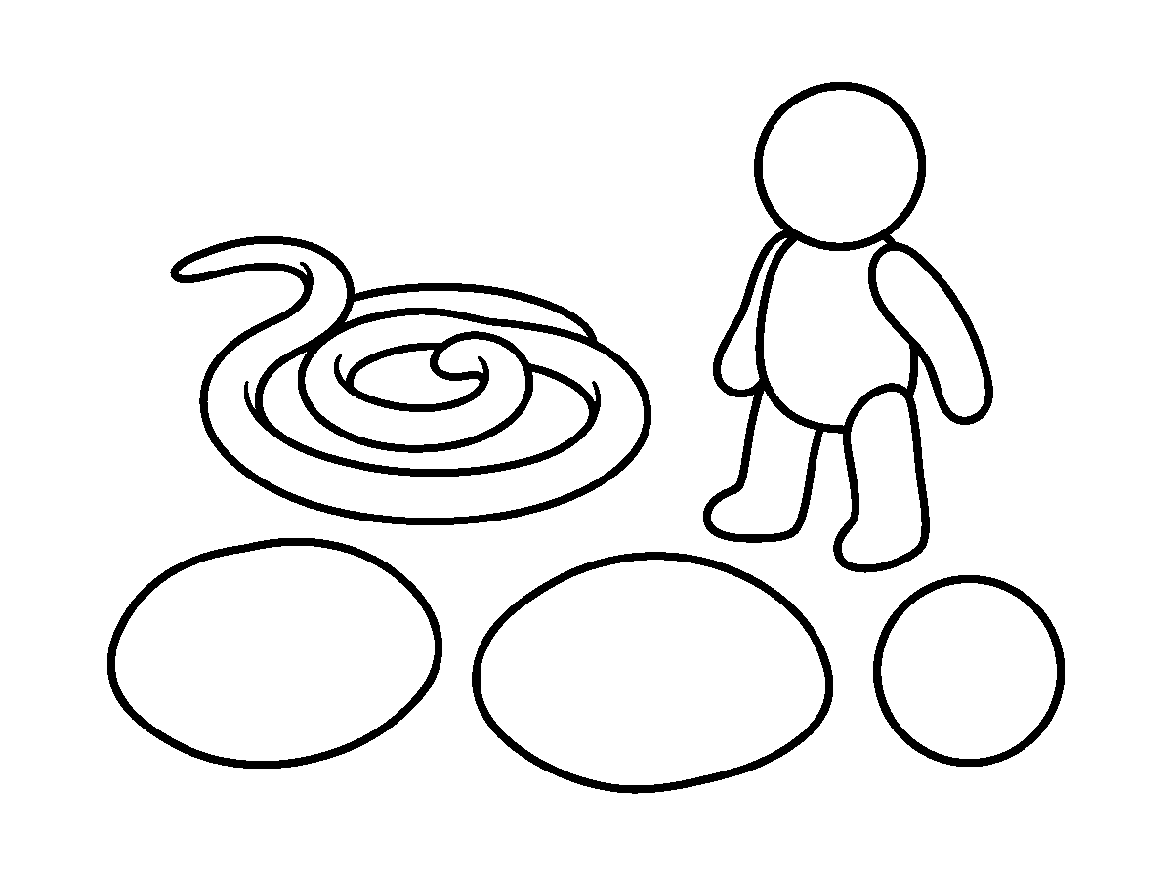
Worksheet
1. Making a long snake of plasticine is A) folding B) cutting C) rolling D) painting
2. Red and yellow plasticine together make A) brown B) purple C) black D) orange
3. Blue and yellow make A) green B) gold C) pink D) grey
4. A snail's shell is made by A) flattening B) tearing C) pinching D) coiling
5. Fill in: I make the ____ part first, then the small parts.
6. Name the four movements we use with plasticine.
7. Write two sentences on the figure you built today.
My own work
Build one small animal with four legs, a tail and two ears, and name it.
Draw the animal you are going to build in plasticine first, colour your drawing, then build it.

CHRISTIAN RELIGIOUS STUDIES (CRS)
Weeks 1 to 6, 8 and 9. No note for Week 7 (Mid-Term), 10 (Revision), 11 (Examination). Depth: NERDC 2025 · Primary 1 · Christian Religious Studies · First Term, pp 638–639 — the school teaches this band two classes earlier, so the Primary 1 list is kept and told as story.

WEEK 1 — GOD THE CREATOR (PART 1)
Depth: NERDC Primary 1 · CRS · First Term W1 (pp 638–639).
You will learn to
• say who God is in one line
• tell what God made on the first and the second day
• name things in God's creation around me
• thank God for what I see
Things to know
• God is the Supreme Being, the Almighty — the greatest, and there is nobody greater than Him.
• God made the world and everything in it.
• Day 1: God said, "Let there be light." There was light. God divided the light from the darkness, and called them day and night.
• Day 2: God made the sky and the clouds above the earth.
• The sun, the moon, the trees, the rivers, my eyes and my dog are all part of God's creation.
• Things that people make (a chair, a cup, a book) are not creation the way the sky is — people make them from things God already made.
• When I look at something beautiful, I can say: "Thank you, God, for Your creation."
Words for my notebook
God is the Almighty. God made the world. On Day 1 He made light; on Day 2 He made the sky.
Let us talk
1. Who made the world?
2. What did God make on the first day?
3. Name three things around you that God made.
4. What do we say when we see something beautiful?
Worksheet
1. God is the A) small B) guest C) neighbour D) Supreme Being
2. On Day 1 God made A) fish B) light C) stars D) birds
3. The division of light from darkness gave us A) church and mosque B) yam and rice C) day and night D) rain and wind
4. Which of these is part of God's creation? A) a plastic cup B) a school bag C) the sky D) a chair
5. Fill in: On Day 2 God made the sky and the ____.
6. Mention two things God made.
7. Write two sentences thanking God for something you saw today.
My own work
Write the names of five things you can see from your window that God made.
Draw three things God made on the first day and colour the light.

WEEK 2 — GOD THE CREATOR (PART 2)
Depth: NERDC Primary 1 · CRS · First Term W2 (pp 638–639).
You will learn to
• tell what God made on Days 3, 4 and 5
• name the living things God made
• sing a creation song
• care for what God made
Things to know
• Day 3: God made the dry land and the seas, and He made grass, plants, trees and flowers.
• Day 4: God made the sun to rule the day, the moon to rule the night, and the stars.

• Day 5: God made the fish in the sea and the birds in the sky, the great whales and every small creeping thing of the water.
• God told the fish and the birds to be many all over the earth.
• Each living thing has its own home: fish in water, birds in the air and on trees, animals on the land.
• Naming the creatures is part of knowing them: goat, hen, eagle, tilapia, catfish, sparrow.
• Creation songs we can sing: "All good gifts around us are from God above"; "He made the stars also."
• Because God made these things, I do not waste food, I do not break branches for fun, and I do not throw dirt into the water where fish live.
Words for my notebook
Day 3 — land, sea and plants. Day 4 — sun, moon and stars. Day 5 — fish and birds.
Let us talk
1. What did God make on the third day?
2. Which two lights did God make on the fourth day?
3. Name three living things from Day 5.
4. Mention one way we care for God's creation.
Worksheet
1. On Day 3 God made A) the birds B) man C) land, seas and plants D) the sun
2. The light that rules the night is the A) fire B) lamp C) moon D) torch
3. Fish and birds were made on Day A) 7 B) 5 C) 1 D) 3
4. Which of these did God NOT make on Day 4? A) goat B) sun C) stars D) moon
5. Fill in: God told the fish and the birds to be ____ on the earth.
6. Mention two things we do to care for God's creation.
7. Write two sentences on the day of creation you like best and why.
My own work
Draw one thing God made on Day 3, one on Day 4 and one on Day 5, and write the day under each.

WEEK 3 — GOD THE CREATOR (PART 3)
Depth: NERDC Primary 1 · CRS · First Term W3 (pp 638–639).
You will learn to
• tell what God made on Days 6 and 7
• say in one line what it means that we are made in God's image
• say why rest and worship matter
• thank God for making me
Things to know
• Day 6: God made the animals of the land — cattle, creeping things and wild beasts — and then He made man and woman.
• God made people in His own image: like God in the way we think, love, speak and choose what is right.
• God told the first people to be kind, to have children, and to take care of the earth.
• Day 7: God rested from all His work, and He made that day holy.
• Rest is not laziness: God Himself rested, so rest is good for the body that works.
• On the seventh day people go to church or mosque to worship God and thank Him.
• I am special because God made me — not by chance, but on purpose, as part of the last day of creation.
• A prayer of thanks: "Thank You, God, for making me and for making everything."
Words for my notebook
On Day 6 God made animals and people. On Day 7 He rested. We are made in God's image.

Let us talk
1. Whom did God make on Day 6?
2. What did God do on Day 7?
3. Say one thing that shows you are made in God's image.
4. Why do we go to church or mosque on the seventh day?
Worksheet
1. On Day 6 God made A) light B) animals and people C) the sea D) the stars
2. People are made in the image of A) the king B) their friends C) the sun D) God
3. God rested on Day A) 6 B) 5 C) 1 D) 7
4. The first people God made were A) a king and a queen B) twins C) two brothers D) a man and a woman
5. Fill in: We are special because ____ made us.
6. Mention two things God made on Day 6.
7. Write two sentences on why rest and worship are good for us.
My own work
Write a short prayer of three sentences thanking God for making you.
Draw two animals from the story and colour the bigger one.

WEEK 4 — GOD, THE GIVER OF GOOD THINGS (PART 1)
Depth: NERDC Primary 1 · CRS · First Term W4 (pp 638–639).
You will learn to
• name the good things God gives us
• say that life and breath come from God
• thank God for my family and my home
• share good things with others
Things to know
• God is the One who gives us good things, and we thank Him for them.
• God gives us life and breath — the fact that I am awake this morning is a gift.
• God gives us families: father, mother, brothers, sisters and relatives.
• God gives us homes to live in — a room to sleep in, a place to eat, a door to shut at night.
• Nobody can add one hour to their life by worrying; the days we live are God's gift.
• When a good thing comes to me, I do two things: I say "Thank you, God", and I share it.
• A home is kept clean and peaceful by everybody in it — that too is part of valuing the gift.
Words for my notebook
God gives me life, my family and my home. I thank Him and I share.
Let us talk
1. Who gives us life and breath?
2. Name the people in your family that you thank God for.
3. What is one good thing about your home?
4. What two things do we do when something good comes to us?
Worksheet
1. God gives us life and A) trouble B) sleep only C) breath D) toys only
2. The people God puts around us first are our A) dogs B) strangers C) enemies D) family
3. Our home is a gift from A) the market B) God C) the shop D) the neighbour
4. When somebody gives me something good, I A) thank God and share B) fight C) hide it D) boast
5. Fill in: God gives us ____ to live in.
6. Mention three good things God has given you.
7. Write two sentences of thanks to God for your family.

My own work
Write the names of four people in your family and one good thing each of them does.
Draw four good things God gives us and colour the one you like best.

WEEK 5 — GOD, THE GIVER OF GOOD THINGS (PART 2)
Depth: NERDC Primary 1 · CRS · First Term W7 (pp 638–639).
You will learn to
• name the food, water and clothing God provides
• say who gives us schools and teachers
• give thanks before a meal
• not waste what God has provided
Things to know
• God gives us food to eat: fruits (mango, banana, watermelon, orange), vegetables (ewédú, ugu, spinach), rice, yam, beans, cassava and fish.
• The rain that waters the farm comes from God; the farmer who plants is also God's help.
• God gives us water to drink — clean water keeps the body well.
• God gives us clothes to wear — cotton grown from the earth, cloth woven and dyed.
• God gives us schools and teachers so that we can learn to read, to count and to know right from wrong.
• Before a meal we say: "Thank You, God, for this food." We do not throw food on the floor and we finish what we take.
• Daily provision means: today's food for today, and thanks today — not keeping greed for tomorrow.
Words for my notebook
God gives food, water, clothes, schools and teachers. We thank God before we eat.
Let us talk
1. Name three foods God has provided.
2. Where does the water we drink come from?
3. Who does God give us so that we can learn?
4. What do we say before a meal?
Worksheet
1. Which of these is a fruit? A) watermelon B) plate C) chalk D) chair
2. God gives us ____ to drink. A) sand B) kerosene C) ink D) water
3. The rain that waters the farm comes from A) the market B) the shop C) God D) the river only
4. We thank God for schools and A) teachers B) tins C) ticks D) tears
5. Fill in: Before eating we say "Thank You, God, for this ____."
6. Mention four things God gives us every day.
7. Write two sentences on how we show that we do not waste God's gifts.
My own work
Write the prayer you say before eating, in your own three sentences.
Draw one good thing you have at home and colour it.

WEEK 6 — GOD, THE GIVER OF GOOD THINGS (PART 3)
Depth: NERDC Primary 1 · CRS · First Term W8 (pp 638–639).
You will learn to
• name the good things God gives that we cannot buy
• say how God protects us
• thank God in prayer for health, friends and weather
• ask God for help before doing something risky
Things to know
• God gives us friends to play with — a friend is a gift, not something we buy.
• God gives us health and strength: a body that runs, eyes that see, a mouth that speaks.

• God gives us the sun for light and warmth, the rain for the farm, and good weather for our journeys.
• God protects us from danger — from the road, from water, from a bad fall, from people who mean harm.
• Thanking God is called praise; asking God for help is called petition; both belong in our prayers.
• A short prayer of thanks: "Thank You, God, for my friends, for my body, for the sun and the rain. Keep me from danger."
• Before crossing a busy road or going near water, we still ask God's help — and we also use what we were taught to do.
Words for my notebook
Friends, health, sun, rain and safety are God's gifts. We thank God and we ask for protection.
Let us talk
1. Name one gift from God that you cannot buy with money.
2. What does God give that makes crops grow?
3. How does God protect us?
4. What is the difference between praise and petition?
Worksheet
1. God gives us friends to A) play with B) sell C) fight with D) fear
2. Health and strength come from A) money B) the market C) the doctor only D) God
3. The rain that makes crops grow is given by A) the driver B) God C) the trader D) the farmer
4. God ____ us from danger. A) forgets B) punishes C) hides D) protects
5. Fill in: Saying "thank You God" is called ____.
6. Mention three gifts from God that money cannot buy.
7. Write two sentences of a prayer of thanks.
My own work
Write a prayer of four sentences: thank God for two gifts and ask for protection in two ways.
Draw two hands: one for giving and one for working. Colour the giving hand.

WEEK 8 — GOD'S GIFT OF HIS SON (PART 1)
Depth: NERDC Primary 1 · CRS · First Term W9 (pp 638–639).
You will learn to
• say why God sent Jesus
• tell the beginning of the birth story
• name the people in the story
• say what the angels told the shepherds
Things to know
• John 3:16 — God loved the world so much that He gave His only Son, so that whoever believes in Him should not perish but have everlasting life.
• God sent His Son Jesus into the world. This is God's greatest gift.
• Mary was a young woman who lived in Nazareth; an angel told her that she would have a son. Joseph was a carpenter, and he took care of Mary.
• Jesus was born in Bethlehem, and He was laid in a manger — a feeding trough for animals — because there was no room in the inn.
• Angels appeared to shepherds who were watching their flocks at night, and said: "Fear not: unto you is born this day a Saviour, which is Christ the Lord."
• The shepherds went and saw the baby, and they told everybody what the angels had said.
• Wise men later came from the east following a star — that part of the story belongs to next week.

Words for my notebook
God loved the world and sent Jesus, His Son. Jesus was born in Bethlehem in a manger.
Let us talk
1. Why did God send Jesus?
2. In which town was Jesus born?
3. Where was the baby laid?
4. Who heard the angels first?
Worksheet
1. God sent His Son because He A) was busy B) was angry C) loved the world D) was far away
2. Jesus was born in A) Lagos B) Nazareth C) Jericho D) Bethlehem
3. The baby Jesus was laid in a A) car B) bed C) manger D) basket
4. The angels first spoke to A) soldiers B) shepherds C) kings D) fishermen
5. Fill in: Mary's husband-to-be, who took care of her, was ____.
6. Name four people or beings in the birth story.
7. Write two sentences on why Jesus is called God's greatest gift.
My own work
Draw the manger with the baby Jesus, and write "God loved the world" under it.

WEEK 9 — GOD'S GIFT OF HIS SON (PART 2)
Depth: NERDC Primary 1 · CRS · First Term W10 (pp 638–639).
You will learn to
• name the three gifts of the wise men
• say why God sent Jesus
• tell what Jesus came to teach
• say how Christmas is celebrated
Things to know
• Jesus is God's greatest gift to us, and a gift is received with thanks.
• Wise men from the east came following the star, and they brought gifts: gold, frankincense and myrrh.
• Gold is for a king; frankincense is a sweet perfume burned in worship; myrrh is an ointment used to prepare a body for burial — it told us ahead of time that Jesus came to die for us.
• Why God sent Jesus: to save us from sin and to show us God's love.
• Jesus came to teach us how to live: to love God, to love our neighbour, to forgive, to care for the poor and the small.
• We remember Jesus' birth at Christmas, on the 25th of December: churches have services, families share food, and children receive gifts.
• The best Christmas gift we can give is a kind act — the same love we received.
Words for my notebook
The wise men brought gold, frankincense and myrrh. God sent Jesus to save us and to show us love.
Let us talk
1. What three gifts did the wise men bring?
2. Why did God send Jesus?
3. Name two things Jesus taught us.
4. What do people do at Christmas?
Worksheet
1. The gifts of the wise men were gold, frankincense and A) money B) mango C) myrrh D) milk
2. God sent Jesus to A) save us and show God's love B) build houses C) become a king of Rome D) punish the world
3. Jesus taught us to love God and A) our neighbour B) our enemies' gifts C) money D) only ourselves

4. Christmas keeps the memory of Jesus' A) teaching B) death C) journey D) birth
5. Fill in: Frankincense is a sweet ____ burned in worship.
6. Mention two reasons why God sent Jesus.
7. Write two sentences on a kind act you can give as a Christmas gift.
My own work
Write one sentence for each of the three wise men's gifts, saying what each gift tells us about Jesus.
Draw the three gifts the wise men brought and colour the gold one.

BASIC DIGITAL LITERACY
Weeks 1 to 6, 8 and 9. No note for Week 7 (Mid-Term), 10 (Revision), 11 (Examination). Depth: NERDC 2025 · Primary 4 · Basic Digital Literacy · First Term W1–W2, pp 827–828 — the school redistributes this content into the lower classes, so the Primary 4 week is the depth floor and every line is pitched as naming, pointing and handling, not reading and writing code.

WEEK 1 — TECHNOLOGY AND DIGITAL DEVICES
Depth: NERDC Primary 4 · Basic Digital Literacy · First Term W1 (pp 827–828).
You will learn to
• say what technology means in one line
• name the digital devices I know
• point to a computer, a tablet, a phone, a watch and a camera
• tell which things at home are digital
Things to know
• Technology means the smart things people make and use to do work more easily.
• A digital device is a machine that thinks with electricity and shows us things on a screen.
• Devices I know: computer, tablet, smartphone, smart watch, camera.
• A computer is big and has a screen, keys and a mouse; a tablet is flat and I touch the screen with my finger.
• A smartphone fits in the hand; it calls, photographs, and plays music.
• A smart watch is worn on the wrist; it tells the time and counts my steps.
• A camera takes pictures; some cameras are inside a phone.
• Digital things at home: the television remote, the decoder, the radio with a screen, the microwave, the fan regulator, the ATM.
• Not everything electrical is a computer — the torch and the fridge use electricity but do not think.
Words for my notebook
Technology is what people make to work easily. Computer, tablet, phone, watch and camera are digital devices.
Let us talk
1. What is a digital device?
2. Point to the device your father or mother uses for calling.
3. What can a camera do?
4. Name one thing at home that is not a digital device.
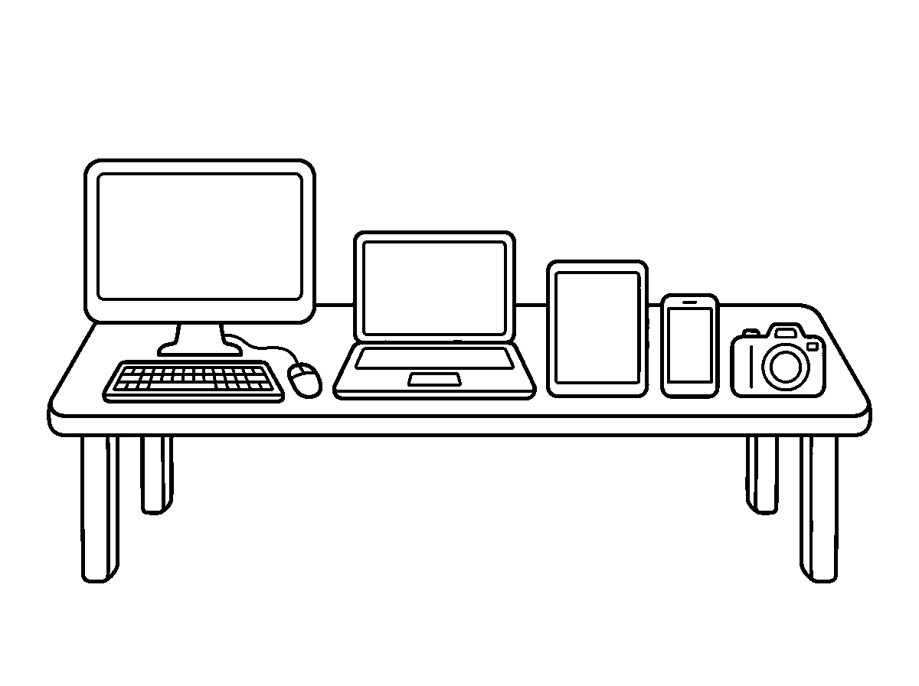

Worksheet
1. A digital device works with A) electricity B) wind C) water D) fire only
2. Which device is worn on the wrist? A) monitor B) smart watch C) tablet D) camera
3. Which one is used for taking pictures? A) keyboard B) camera C) CPU D) mouse
4. A tablet is mostly A) pushed with a rope B) blown C) touched with the finger D) watered
5. Fill in: A ____ lets us talk to people far away.
6. Name five digital devices.
7. Write two sentences on one device you have seen and what it does.
My own work
Count the digital devices you see in your house today and write the number in your notebook.
Draw three machines in your house and colour the one that makes the most noise.

WEEK 2 — TYPES OF COMPUTER: DESKTOP, LAPTOP, TABLET
Depth: NERDC Primary 4 · Basic Digital Literacy · First Term W1 (pp 827–828).
You will learn to
• tell a desktop from a laptop and a tablet
• say what each type is good for
• say which parts come with a desktop
• choose the right computer for the right work
Things to know
• A desktop sits on a table and does not move about; it has a separate monitor, keyboard, mouse and a CPU box.
• A laptop opens and shuts like a book; the screen, the keys and the touchpad are all in it, and it has a battery.
• A tablet is one flat board with a screen you touch with your finger; it is the smallest and the lightest to carry.
• A desktop is used at the office or at home where it can stay; a laptop is carried to school, to work, to a journey.
• A tablet is good for watching, reading and drawing; a desktop or laptop is better for typing a long letter.
• All three can do the same kind of work; they differ in size, in how they are held, and in how they are moved.
• The CPU is the part that does the thinking, so it is called the brain of the computer.
• A laptop is closed when it is not in use, so that its screen is safe.
Words for my notebook
Desktop stays on the table, laptop folds and goes, tablet is held in the hand. The CPU is the brain.
Let us talk
1. Which computer do you carry in a bag?
2. What is the brain of the computer called?
3. Point to a device in this room that has a touchpad.
4. Why do we close a laptop?

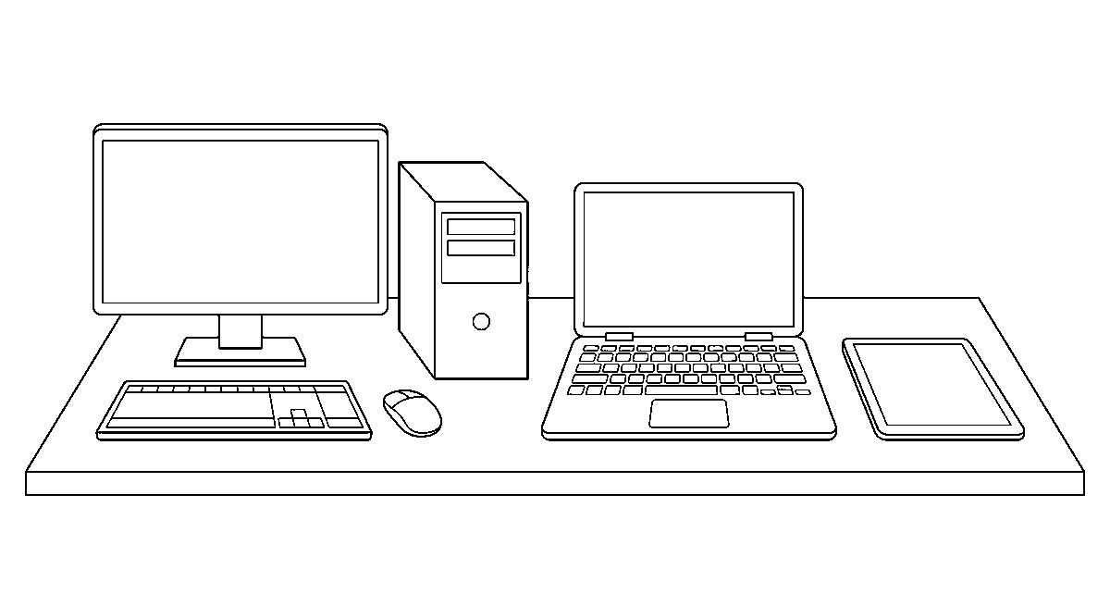
Worksheet
1. Which computer stays on a table? A) phone B) desktop C) tablet D) laptop
2. The part of the computer that does the thinking is the A) pad B) CPU C) case D) mouse
3. Which one is touched with the finger on the screen? A) printer B) CPU C) desktop D) tablet
4. A laptop is shut mainly to protect its A) bag B) cable C) screen D) keys
5. Fill in: A desktop has a separate monitor, keyboard, mouse and ____.
6. Mention the three types of computer you know.
7. Write two sentences on which computer your family uses and why.
My own work
Draw one desktop, one laptop and one tablet, and write one use under each.

WEEK 3 — BASIC PARTS: MONITOR, KEYBOARD, MOUSE, CPU
Depth: NERDC Primary 4 · Basic Digital Literacy · First Term W1 (pp 827–828).
You will learn to
• name the four basic parts of a computer
• say what each part does
• point to each part on a real computer
• put the parts in the right order of work
Things to know
• The four basic parts: monitor, keyboard, mouse and CPU.
• The monitor is the screen; it shows what the computer is doing — pictures, letters and numbers.
• The keyboard has the letters and numbers; we press the keys to put information into the computer.
• The mouse is held in the hand; it moves the arrow on the screen and clicks to choose things.
• The CPU is the box that does the work and remembers things — the brain of the computer.
• Order of work: I give with the keyboard or the mouse → the CPU thinks → the monitor shows the answer.
• Other parts I may see: speakers (they give out sound), a printer (it puts the picture on paper), and a USB drive (it carries files about).
• The mouse is not an animal — it is a part of the computer, and it is held gently, not thrown.
Words for my notebook
Keyboard and mouse put work in; CPU does the work; monitor shows the work.
Let us talk
1. Which part shows you the pictures?
2. What do we press to type a letter?
3. Show me how you hold the mouse.
4. Which part is called the brain?

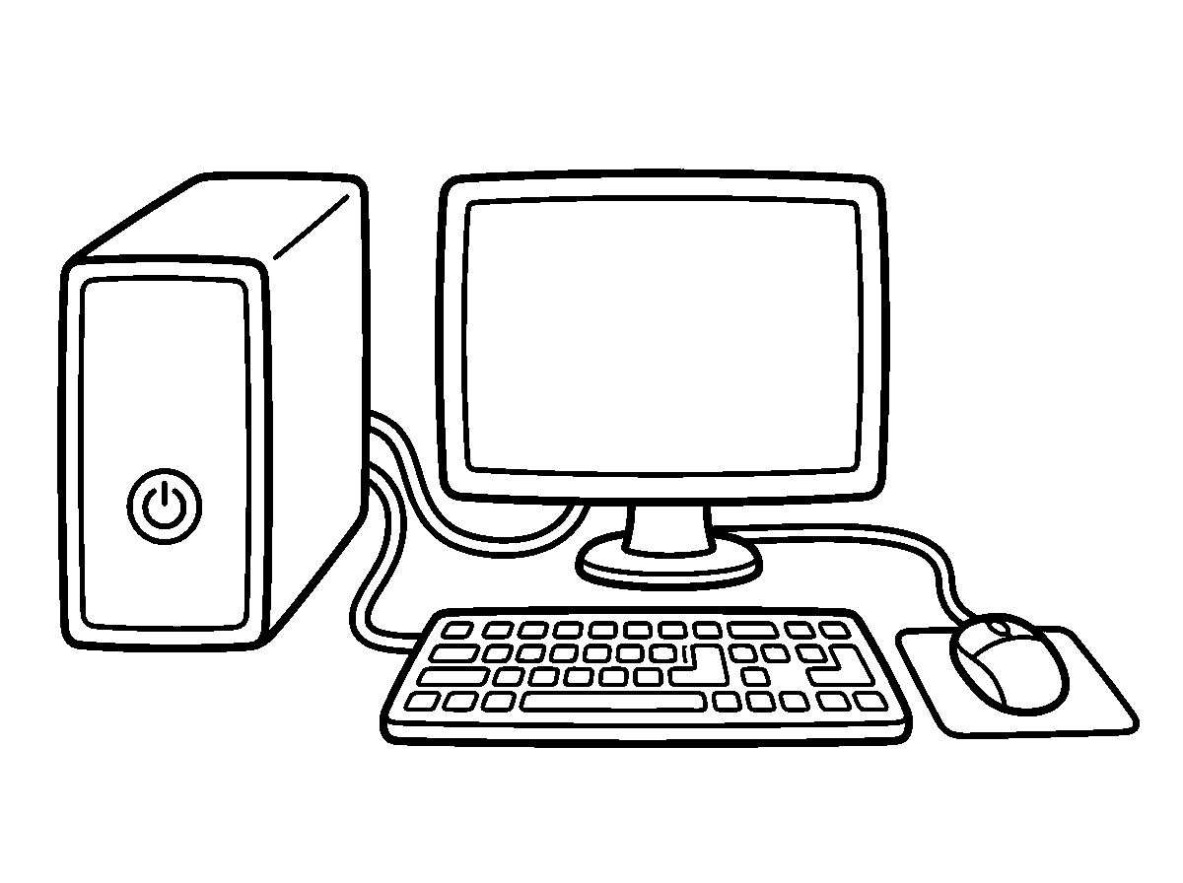
Worksheet
1. The screen of the computer is the A) monitor B) bag C) mouse D) keyboard
2. We type with the A) keyboard B) cable C) monitor D) speaker
3. The part that moves the arrow on the screen is the A) key B) CPU C) mouse D) fan
4. The brain of the computer is the A) mouse pad B) wire C) monitor D) CPU
5. Fill in: A printer puts the picture on ____.
6. Name the four basic parts of a computer.
7. Write two sentences on what happens when you click the mouse.
My own work
Label a printed picture of a computer with the four parts: monitor, keyboard, mouse, CPU.
Draw the four parts of a computer as four shapes on a desk and colour the CPU box.

WEEK 4 — USES OF THE COMPUTER IN DAILY LIFE
Depth: NERDC Primary 4 · Basic Digital Literacy · First Term W1 (pp 827–828), with the Primary 5 Third Term "AI in daily life" line kept only as examples of uses.
You will learn to
• say what people use a computer for at work
• say what I use a tablet for at home
• name machines in the shop, the bank and the hospital
• tell the difference between work play and learning on a device
Things to know
• People write letters, draw pictures and keep records on a computer.
• In the bank, a computer counts money and prints the receipt; in the shop, the machine that reads the price is a computer.
• In the hospital, the computer keeps the name of the patient and shows the result of the test.
• In the school, we use it to learn counting, letters and reading; a tablet can show me a story with pictures.
• Computers send messages and calls to people far away, and they print photographs.
• Voice assistants answer a question when we speak to them, and the device that shows me cartoons also learns which cartoons I like — that is the computer learning from what I do.
• Time on a device is of two kinds: learning (letters, numbers, a story) and play (games, cartoons). Play is only for a little while, and my eyes rest when I look away and go out to run.
• Nobody should watch a screen for the whole day; a device is a servant, not a master.

Words for my notebook
The computer counts money, prints, teaches and carries messages. We use it for learning, not only for play.
Let us talk
1. Mention two places where a computer is used.
2. What does the machine at the shop do?
3. Say one thing you can learn on a tablet.
4. Why should we not look at a screen all day?
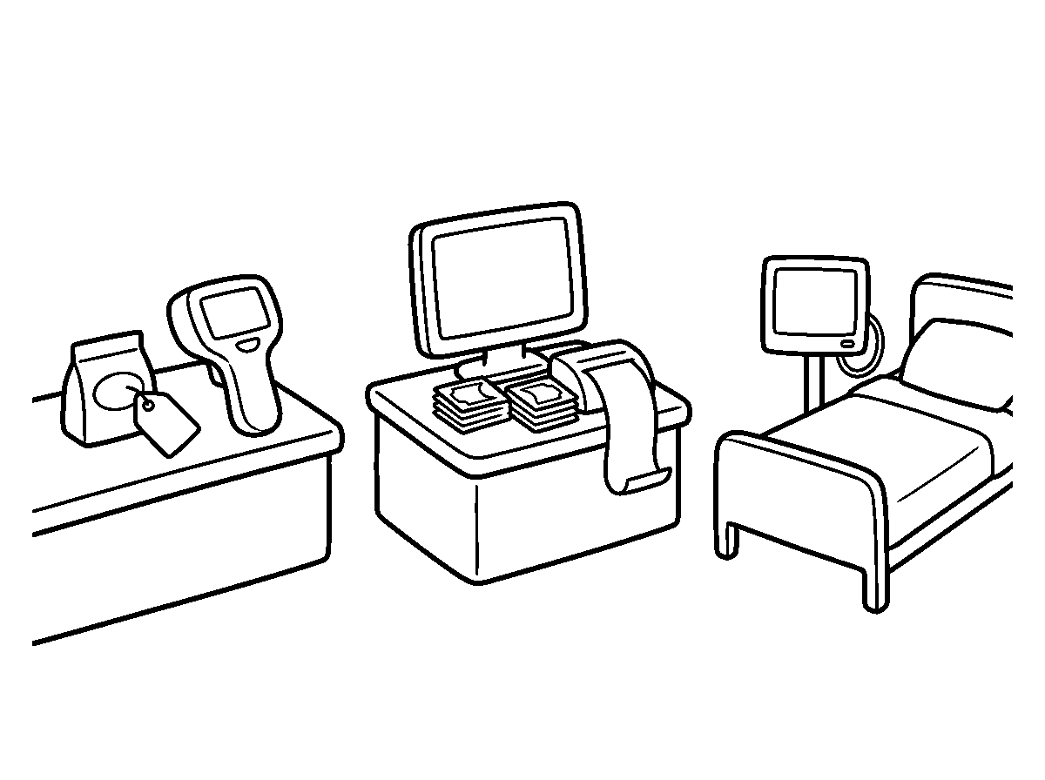
Worksheet
1. In the bank, a computer is used to A) cook B) plant C) sweep D) count money
2. A device that answers when we speak to it is a A) voice assistant B) clock tower C) broom D) chair
3. Which one is a good use of a tablet for a child? A) learning letters B) watching in the dark C) all-night games D) throwing it
4. The machine at the shop reads the A) newspaper B) book C) price D) shoe
5. Fill in: A computer can ____ photographs and messages.
6. Mention three places where computers are used every day.
7. Write two sentences on one thing you learnt on a device this week.
My own work
Write down two ways your family uses a phone or computer for work, and two ways for rest.

WEEK 5 — CARE AND HANDLING OF DEVICES
Depth: NERDC Primary 4 · Basic Digital Literacy · First Term W1 (pp 827–828).
You will learn to
• keep a device clean and dry
• hold and carry a device with two hands
• charge a device safely with a grown-up near
• shut a device the right way
Things to know
• Devices are expensive and easily spoiled, so we handle them gently.
• Keep food and drink away from the keyboard; water inside a device spoils it for good.
• Wipe a screen with a soft, dry cloth — not with a rough rag, not with wet water.
• Carry a laptop or tablet with two hands, closed, and put it in a padded bag before it travels.
• Do not pull the cable out of the socket by the wire — hold the plug itself.

• Charging: the charger is put in and taken out by a grown-up; a charging device is not played with in the bath.
• Switch off properly: save my work, shut the programme, then turn the power off; do not just remove the light.
• Do not drop, throw, hit or sit on a device; keep it out of the sun and away from a fan blowing dust.
• A phone with a cracked screen can cut a finger — tell a grown-up at once if a device breaks.
Words for my notebook
Clean hands, dry cloth, two hands to carry, grown-up for the plug. Care for the device and it serves long.
Let us talk
1. What two things spoil a keyboard quickly?
2. Show me how you carry a tablet.
3. Who puts the charger into the socket?
4. What do you do before switching a computer off?
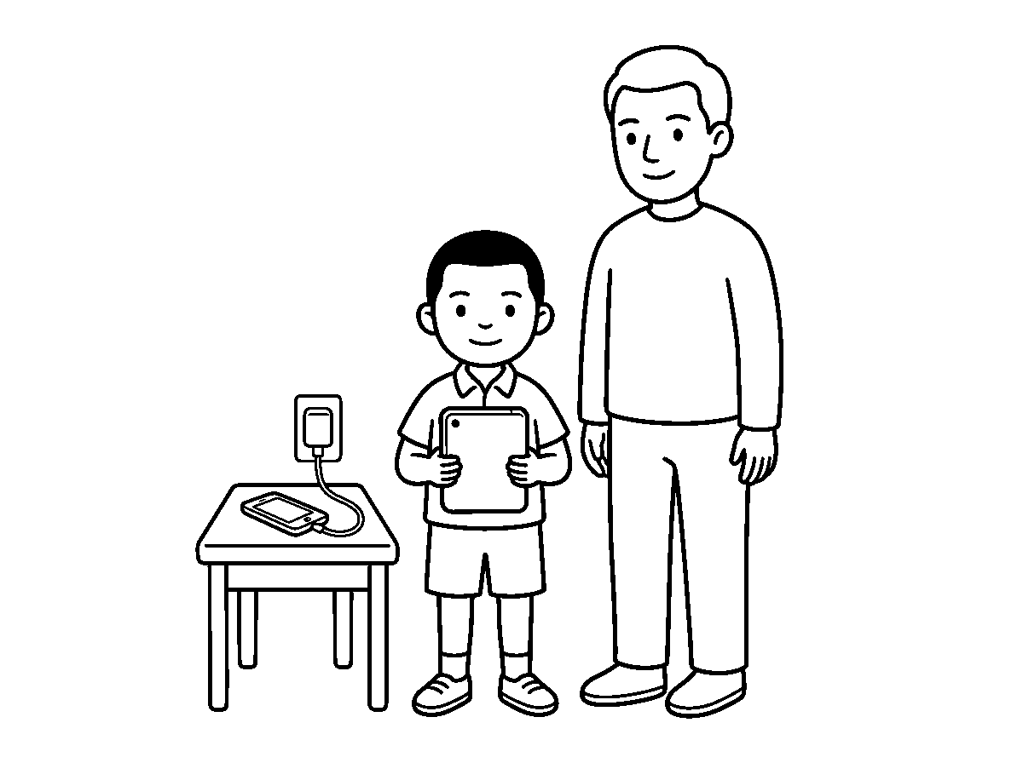
Worksheet
1. A screen is wiped with A) a soft dry cloth B) a duster with water C) a rough stone D) a wet mop
2. Liquid near a keyboard is A) cheap B) dangerous to the device C) needed D) good
3. A laptop is carried with A) one finger B) a rope C) the teeth D) two hands
4. The charger is put into the socket by A) a grown-up B) the class dog C) any pupil D) a baby
5. Fill in: Do not pull the cable by the ____; hold the plug.
6. Mention three rules for taking care of devices.
7. Write two sentences on what you do before switching a computer off.
My own work
Wipe the dust off one device in your house with a soft dry cloth, and tell your class what you cleaned.

WEEK 6 — COMPUTER LAB SAFETY RULES
Depth: NERDC Primary 4 · Basic Digital Literacy · First Term W1 (pp 827–828).
You will learn to
• say what a computer lab is
• state the rules we keep in the lab
• sit and move correctly in the lab
• tell the teacher at once when something is wrong
Things to know
• A computer lab is the room in the school where many computers are kept for lessons.

• We walk in the lab; we do not run, because a cable or a chair can throw us down.
• We go in quietly, when we are called, and we sit at the machine we are given.
• No food, no drink and no water bottle on the desk with a computer.
• We do not touch the cables, the sockets or the back of the machine; electric wire can bite.
• Only the teacher switches on the computers and the lights.
• We do not change the settings, delete somebody's work, or move the mouse and keyboard violently.
• If a machine gives smoke, a bad smell, a shock or a strange sound: leave it and tell the teacher at once.
• We push our chair in and leave the lab as we found it.
Words for my notebook
In the computer lab we walk, we sit quietly, we keep food out, and we tell the teacher at once if something is wrong.
Let us talk
1. What is a computer lab?
2. Why must we not run in the lab?
3. Who switches on the computers?
4. What do you do if a machine begins to smoke?
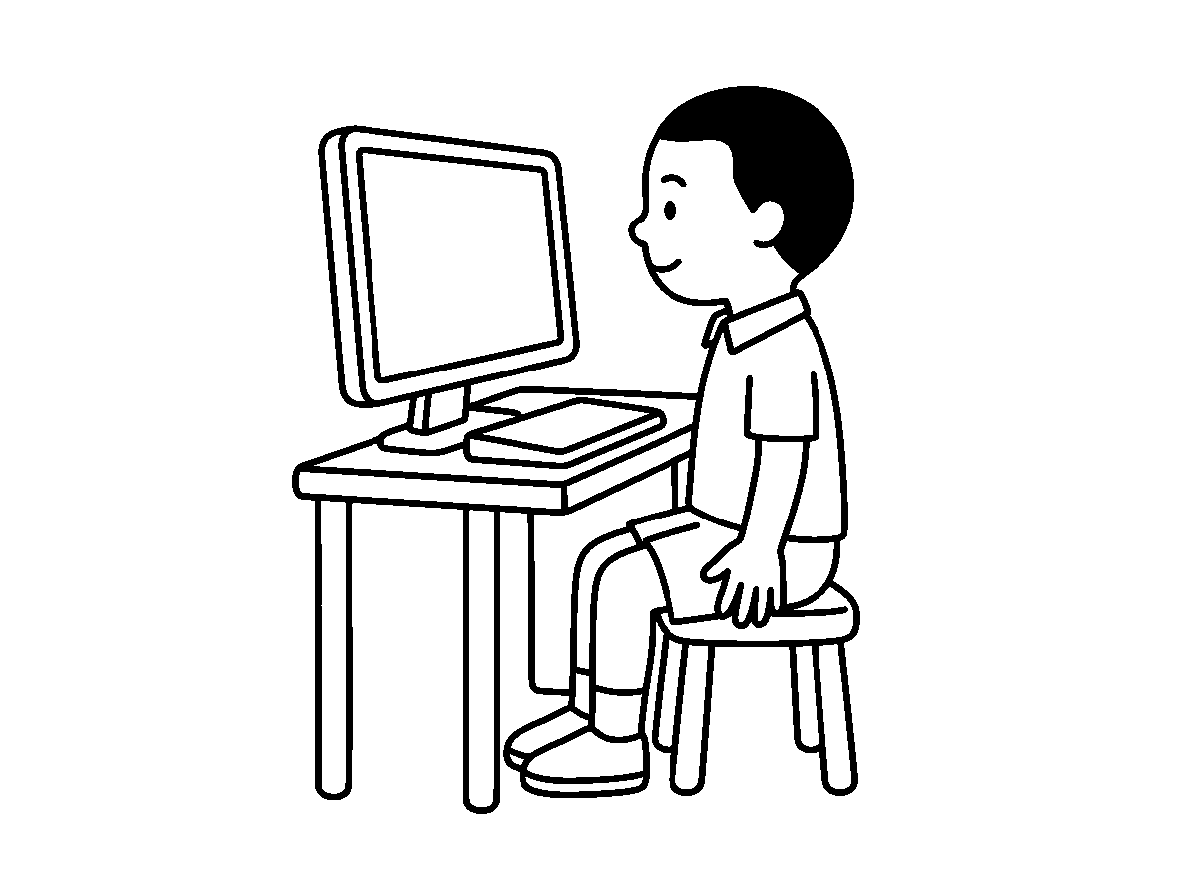
Worksheet
1. In the computer lab we must A) run B) walk C) shout D) jump
2. Food and drink in the lab are A) not allowed B) allowed on the desk C) needed D) given to machines
3. The first thing to do when a cable is loose is to A) pull it B) tell the teacher C) hide it D) cut it
4. The computers are switched on by A) the monitor B) the teacher C) the pupils D) any visitor
5. Fill in: We leave the lab as we ____ it.
6. Mention four safety rules of the computer lab.
7. Write two sentences on what you saw in the lab today and the rule that kept it safe.
My own work
Write five rules of the computer lab on a sheet and put it on the wall of your notebook.

WEEK 8 — FROM THE ABACUS TO TODAY'S COMPUTER
Depth: NERDC Primary 4 · Basic Digital Literacy · First Term W2 (pp 827–828).
You will learn to
• name the first tool people used to count
• tell how computers changed over time

• name the five generations in order
• say what became smaller, faster and cheaper
Things to know
• Long ago people counted with stones and fingers, then with the abacus — a frame with beads that slide on wires.
• The abacus is still used in some markets and some schools: beads up means add, beads down means take away.
• The first real computing machines were very big — one filled a whole room, needed a bed of vacuum tubes, and could be spoiled by a fly inside.
• Five generations of computers, in order: vacuum tubes → transistors → integrated circuits → microprocessors → AI.
• Vacuum tubes glowed and grew hot; the transistor replaced them and was tiny; an integrated circuit put many parts on one little chip; a microprocessor put the whole brain on one chip.
• The fifth generation is the generation of AI — machines that learn and decide.
• With every generation the computer became smaller, faster and cheaper: what once filled a room now sits on a wrist.
• Old machines are found in museums; some grandparents still keep an abacus in a drawer.
Words for my notebook
Before computers: fingers, stones, the abacus. Then five generations — each smaller, faster and cheaper.
Let us talk
1. What did people use to count before machines?
2. What does an abacus look like?
3. Name the two biggest changes from the first computer to your father's phone.
4. Which generation are we living in now?
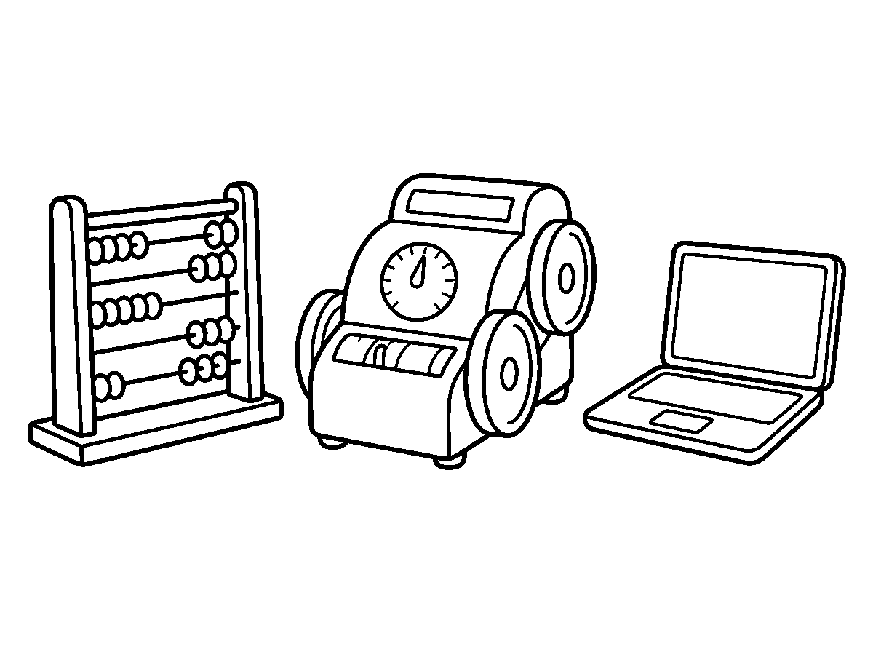
Worksheet
1. The frame with sliding beads used for counting is a A) abacus B) laptop C) scale D) ruler
2. The first generation of computers used A) phones B) vacuum tubes C) chips D) pens
3. The tiny part that replaced vacuum tubes is the A) fan B) transistor C) abacus D) candle
4. Computers over the years have become A) heavier B) smaller and faster C) dearer D) bigger and slower
5. Fill in: The fifth generation of computers is the generation of ____.
6. Name the five generations in order.
7. Write two sentences on how the computer of today is different from the first computers.

My own work
Draw an abacus with ten beads on one wire and write what you use your fingers for when you count.

WEEK 9 — KEY INVENTORS: CHARLES BABBAGE AND ADA LOVELACE
Depth: NERDC Primary 4 · Basic Digital Literacy · First Term W2 (pp 827–828).
You will learn to
• name the father of the computer
• say what Ada Lovelace did
• put the two inventors in their time order
• say why an idea can be as valuable as a machine
Things to know
• Charles Babbage was an Englishman who, about two hundred years ago, designed a machine called the Analytical Engine; because of that plan he is called the father of the computer.
• His first machine was called the Difference Engine; it was built to work out tables of numbers without mistakes.
• Babbage drew the plan and made parts, but the workshop of his day could not build the whole thing from his drawing.
• Ada Lovelace wrote the first set of instructions for his machine — the first computer programme; she is called the first programmer in the world.
• Ada saw further than her machine: she wrote that one day such a machine could compose music and do more than merely count.
• The Ada language of programming was named after her.
• One built the body, the other taught the body to think: an idea can be as valuable as a machine.
• Their names are remembered today in museums, in books and in the names of computer languages.
Words for my notebook
Babbage planned the first computer machine; Ada Lovelace wrote the first programme for it.
Let us talk
1. Who is called the father of the computer?
2. What did Ada Lovelace write?
3. Which of them came first with the plan — the machine or the programme?
4. Why do we still say their names today?
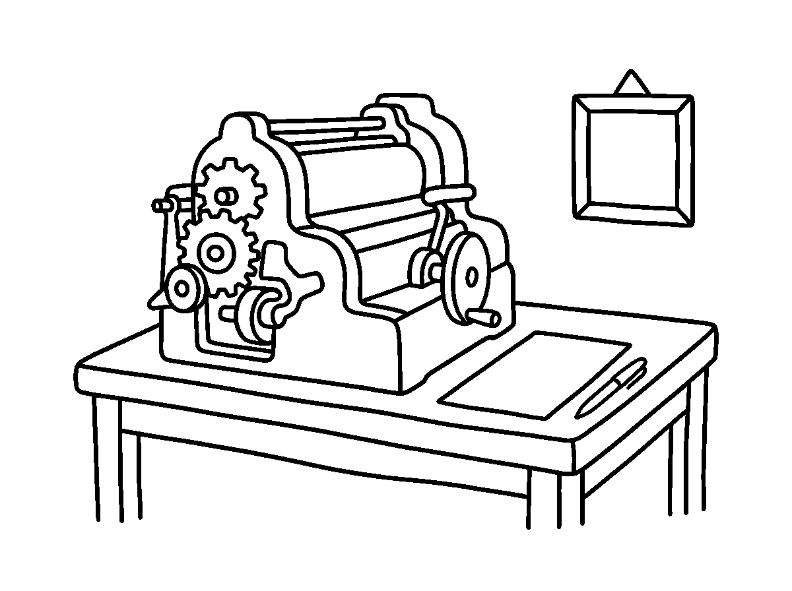
Worksheet
1. The father of the computer is A) Ada Babbage B) Thomas Edison C) Charles Babbage D) Isaac Newton
2. Babbage's machine plan was called the A) Steam Boat B) Printing Press C) Loom D) Analytical Engine

3. The first computer programmer was A) Mary Kingsley B) Ada Lovelace C) Flora Shaw D) Queen Amina
4. Ada Lovelace wrote A) the first programme B) a law C) a story book D) a song
5. Fill in: A ____ language was named after Ada Lovelace.
6. Name the two inventors and say one thing each of them did.
7. Write two sentences on why an idea can be as valuable as a machine.
My own work
Write one sentence about Babbage and one about Ada Lovelace, and say which of the two you would like to meet.
Draw one big old machine with many wheels on it, the kind Babbage made, and colour the wheels.

NIGERIAN HISTORY
Weeks 1 to 6, 8 and 9. No note for Week 7 (Mid-Term), 10 (Revision), 11 (Examination). Depth: NERDC 2025 · Primary 1 · Nigerian History · First Term, pp 649–650 — the school teaches this band two classes earlier, so the Primary 1 list stands as the floor and is told as story and picture.

WEEK 1 — MEANING AND IMPORTANCE OF HISTORY (PART 1)
Depth: NERDC Primary 1 · Nigerian History · First Term W1 (pp 649–650).
You will learn to
• say what history is in one line
• give an example of the past from my own life
• name the people and things that tell us about the past
• say one reason we learn history
Things to know
• History is the story of the past — of what happened before now.
• Yesterday is past. Last week is past. Last year is past. This very minute, when it has gone, is past too.
• What I did yesterday is a little history: "I went to my uncle's house." "We ate rice."
• Last week: a birthday, a naming ceremony, a funeral, the day the rain broke the footpath.
• Last year: "I was in Nursery 1, and I was smaller."
• Who tells us the past? Grandparents, fathers and mothers, the pastor and the imam, the old men of the street.
• What shows us the past? A photograph, an old object (the kerosene lamp, the iron that was heated in the fire), a book, a ruin, a monument.
• Why we learn history: it tells us about our families — who our grandparents were, and where our people come from.
• History is not a fairy tale: a story that is true and happened is history.
Words for my notebook
History is the story of the past. Yesterday, last week and last year are all past. Grandparents and photographs tell us the past.
Let us talk
1. What is history?
2. Say one thing you did yesterday.
3. Mention two people who can tell you about the past.
4. What can an old photograph tell us?
5. Say one reason we learn history.
Worksheet
1. History is the story of A) today's lunch B) the past C) the future D) the sky
2. Which one belongs to the past? A) right now B) yesterday C) this minute D) today at noon
3. Who can tell us about the past? A) a grandparent B) a plate C) a stone D) a chair
4. A photograph of when you were small tells us about A) next term B) the weather C) the past D) the price of yam
5. Fill in: Last year I was in Nursery ____.
6. Mention two things that help us know about the past.
7. Write two sentences on something you did last week.
My own work
Ask at home for one true story about when you were a baby, and come to tell the class.
Draw three things that were here before you were born and colour the oldest one.

WEEK 2 — MEANING AND IMPORTANCE OF HISTORY (PART 2)
Depth: NERDC Primary 1 · Nigerian History · First Term W2 (pp 649–650).

You will learn to
• say which family I belong to
• say where my people come from
• name a lesson the past teaches
• draw my family tree
Things to know
• History is about identity: to which family do I belong? Every family has a name, and my name is part of it.
• "I am a child of the ______ family." That family name came from my grandfather, and his father before him.
• History tells us where we come from: my father's people come from ______; my mother's people come from ______. It may be a village, a town, or a street in this city.
• Learning from the past is how we grow wise: grandma says, "The farmer who worked his land ate well; the one who slept was hungry."
• History helps us make good decisions: before I do a thing, I can ask "What happened last time somebody did this?"
• A family tree is a drawing that shows the order of the family: grandparents at the top, then father and mother, then the children.
• Drawing activity of the week: our trees went on the wall, and we looked at one another's.
• The past also tells us what has changed: lamp then, bulb now; mortar and pestle then, milling machine now.
Words for my notebook
I belong to the ______ family. My people come from ______. The past teaches us what is right.
Let us talk
1. What is your family name?
2. Where do your grandparents come from?
3. Say one lesson the past teaches us.
4. Whom do we put at the top of a family tree?
5. Mention one thing that has changed since your grandfather was small.
Worksheet
1. At the top of the family tree we write A) the babies B) the friends C) the grandparents D) the children
2. Your father's mother is your A) aunt B) sister C) cousin D) grandma
3. Knowing your family's name gives you A) a pen B) a shoe C) food D) identity
4. The past can teach us to A) work hard B) quarrel C) steal D) lie
5. Fill in: My father's people come from ____.
6. Draw or name the three levels of a family tree.
7. Write two sentences on something your family is known for.
My own work
Finish your family tree and write one thing your family is known for under it.

WEEK 3 — PEOPLES AND PLACES IN THE COMMUNITY (PART 1)
Depth: NERDC Primary 1 · Nigerian History · First Term W3 (pp 649–650).
You will learn to
• say what a community is
• name the people who live around me
• name the people who help us in the community
• greet a neighbour well
Things to know
• A community is the people and the places around us — the street, the houses, the shops, the church and the mosque, the field where children play.
• In our community there are different people: children, youths, mothers, fathers, grandmothers, teachers, drivers, traders, the watchman.

• Neighbours are the people who live beside us; friends are the people we play with. A neighbour is not always a relation, but we still greet him.
• People who help us: the nurse (she treats the sick), the policeman (he keeps us from harm), the driver (he carries us), the trader (she sells food), the teacher (she teaches us), the cleaner (he sweeps the street).
• Some people help with their hands, some with a machine, some with words — all of them are needed.
• Nobody can do everything alone: the man who plants the rice is not the man who drives it to town.
• Living near people means: greet in the morning, do not throw dirt into another man's gutter, share what you have, and keep noise down when a baby is sleeping.
• Role-play of the week: carry a basket to the neighbour's door, ask for a cup, say thank you.
Words for my notebook
A community is the people and places around us. Neighbours, friends and helpers all belong to it.
Let us talk
1. What is a community?
2. Name two people who live near you.
3. Who treats people when they are sick?
4. Who keeps the street safe?
5. Say two things we do to live well with neighbours.
Worksheet
1. A community is made up of A) only motor cars B) only children C) only houses D) people and places around us
2. The person who sells us food is a A) nurse B) trader C) teacher D) pilot
3. Who keeps the community safe? A) the goat B) the baker C) the policeman D) the baby
4. Our neighbours are the people who A) live beside us B) sleep C) teach in school D) live far away
5. Fill in: The person who sweeps our street is the ____.
6. Mention three people who help us in the community.
7. Write two sentences on what you do when you meet your neighbour in the morning.
My own work
Draw three people who help people in your community and write one thing each of them does.

WEEK 4 — PEOPLES AND PLACES IN THE COMMUNITY (PART 2)
Depth: NERDC Primary 1 · Nigerian History · First Term W4 (pp 649–650).
You will learn to
• name the three major ethnic groups of Nigeria
• say one thing each group is known for
• name other groups living in our community
• say how we treat people of other groups
Things to know
• Nigeria has many peoples. The three major ethnic groups are the Hausa, the Igbo and the Yoruba.
• The Hausa are mainly in the north; they greet with "Sannu"; they eat tuwo with soup; the big embroidered robe is the babban riga.
• The Igbo are in the south-east; they greet with "Ndewo"; they eat fufu with soup; some men wear a red cap.
• The Yoruba are in the south-west; they greet with "Ẹ̀ káàárọ̀"; they eat amala with ewédú soup; their cloth is àdìrè, and a chief wears agbádá.
• Other groups in Nigeria: Nupe, Tiv, Kanuri, Ijaw, Efik, Fulani, Igala, Ibibio, Edo, Urhobo — some of them live in our own community.

• What we learn from this: different is not wrong. Another people's food is not a laughing matter; another people's greeting is not a foolish thing.
• We respect people of every group: we greet in their own language when we can, and we do not call anybody's tribe names.
• The line of the week, said three times: "We are all Nigerians."
Words for my notebook
Hausa, Igbo and Yoruba are the three big groups. There are many others. Different tongues, one country — we are all Nigerians.
Let us talk
1. Name the three major ethnic groups of Nigeria.
2. Which greeting belongs to the Hausa people?
3. Mention one food and one cloth of the Yoruba.
4. Name one other ethnic group you know.
5. What should we never do to another group's language?
Worksheet
1. Which of these is a major ethnic group of Nigeria? A) Toyota B) Naira C) Lagos D) Hausa
2. "Sannu" is the greeting of the A) Tiv B) Hausa C) Igbo D) Yoruba
3. Amala and ewédú are food of the A) Kanuri B) Hausa C) Ijaw D) Yoruba
4. The three big groups live in A) different parts of Nigeria B) another country C) the bush only D) one town only
5. Fill in: "Ẹ̀ káàárọ̀" is a greeting in the ____ language.
6. Name three other ethnic groups in Nigeria.
7. Write two sentences on how we treat people of another group.
My own work
Write the names of the three groups and draw one food that any of them eats.

WEEK 5 — PLACES IN THE COMMUNITY (PART 1)
Depth: NERDC Primary 1 · Nigerian History · First Term W7 (pp 649–650).
You will learn to
• name the important places in our community
• say what each place is used for
• say how we behave in each place
• tell where help is found in an emergency
Things to know
• Important places: school, hospital, market, church, mosque, police station, fire station, park and playground, the motor park, the bank, the post office.
• The school is where we learn; we come on time and we carry our books.
• The market is where food and things are bought; we hold our money well and we say "thank you" to the seller.
• The hospital is where the sick are treated; we speak softly and we sit down to wait for our turn.
• Church and mosque are places of prayer: we go in quietly, we do not run about, and we respect the people worshipping whatever our own family's place is.
• The police station is for a thief, for a lost child, for any danger; the fire station is for fire. Both work at night as well as in the day.
• The park and playground are for games and rest: we take turns and we do not push the smaller children.
• If a grown-up is not around and something is wrong, a child can go to the police station — help is kept there for everybody.
Words for my notebook
School for learning, market for buying, hospital for sickness, church and mosque for prayer, police and fire station for help.
Let us talk
1. Where do we buy tomatoes and fish?

2. Where do we go when somebody is sick?
3. Whom do we call when a house is on fire?
4. How should we behave in a place of prayer?
5. What do we do on the playground when two children want one swing?
Worksheet
1. We buy food and things at the A) police station B) mosque C) market D) hospital
2. A house on fire needs the A) tailor B) park C) library D) fire station
3. A lost child should be taken to the A) police station B) barber C) market D) playground
4. In the hospital we must A) climb the chairs B) run about C) shout D) speak softly and wait our turn
5. Fill in: We learn our books in the ____.
6. Name four places in your community and what each is used for.
7. Write two sentences on how you behave in a church or a mosque.
My own work
Draw two places in your community and write what each one is used for.

WEEK 6 — PLACES IN THE COMMUNITY (PART 2)
Depth: NERDC Primary 1 · Nigerian History · First Term W8 (pp 649–650).
You will learn to
• name the traditional places in our community
• say who rules in the palace and what he does
• say what the community hall is used for
• describe one old thing in our area
Things to know
• Besides the hospital and the market, every town has old, traditional places: the palace, the community hall, and sometimes a monument.
• The palace is the home of the traditional ruler. In Yorubaland he is the Oba (in some towns the Aláàfin, the Deji, the Olú); in the north he is the Emir; in Igboland he may be the Igwe or the eldest man of the kindred.
• The ruler wears beads and a crown, sits on a stool, gives titles, and settles quarrels in his palace. He is honoured, and he listens to the chiefs with him.
• The community hall is where the whole town meets: to plan the water, to fix the broken road, to arrange the festival, to congratulate a child who got a scholarship.
• A monument is something old that people keep because it tells the story of the place: an old bridge, a wall, a tree where the first settlers met, the site of the first school.
• Picture study of the week: the class looked at the pictures and said — What is this? Where is it? Is it old or new? Who uses it?
• If our town has an old place near us, a short walk to see it is a field trip — the safety rules of Basic Science apply.
• These places belong to everybody; that is why we do not write on their walls or break anything there.
Words for my notebook
The palace of the ruler, the community hall of the town, and the monuments of the past are our traditional places.
Let us talk
1. Where does a traditional ruler live?
2. Name the ruler's title in the north of Nigeria and in Yorubaland.
3. What happens in the community hall?
4. What is a monument?
5. Who do the old places of a town belong to?
Worksheet
1. The home of a traditional ruler is the A) garage B) market C) clinic D) palace

2. In the north the traditional ruler is the A) Emir B) Igwe C) Deji D) Oba
3. Town matters are discussed at the A) shed B) community hall C) bus park D) kitchen
4. An old building kept to tell the story of a town is a A) monument B) gutter C) market D) fence
5. Fill in: The ruler settles quarrels in his ____.
6. Name the ruler's title among the Yoruba, the Hausa and the Igbo.
7. Write two sentences on an old thing in your town and why it is kept.
My own work
Draw the palace or the community hall and write one line about what happens there.

WEEK 8 — LIVING TOGETHER IN PEACE
Depth: NERDC Primary 1 · Nigerian History · First Term W9 (pp 649–650).
You will learn to
• say what tolerance means
• name ways of respecting people of other groups
• say why we play and learn together
• give examples of sharing and caring
Things to know
• Tolerance means: other people are different from me, and that is all right.
• Different things about people: their name, their language, their food, their cloth, their place of worship, the way they greet.
• A child with tolerance does four things: he does not mock another child's name, he does not say another person's god is wrong, he is ready to sit with anybody, and he learns to greet in another language.
• Playing together teaches more than any lesson: on the ball field the big boy must pass to the small one, or there is no game.
• Learning together: when one child knows the answer and another does not, the one who knows helps, and both are better for it.
• Sharing and caring: share the biscuit, share the crayons; help the child that fell; speak to the child who is sitting alone.
• We are stronger together: one stick breaks in the hand, a bundle of sticks does not; one thread is not a rope, many threads are.
• If a quarrel starts, the peaceful child walks away and tells a grown-up; he does not add to the noise.
• The sentence of the week: "What I want for myself, I also want for you."
Words for my notebook
Tolerance is respecting people who are different. We play together, learn together, share and care. We are stronger together.
Let us talk
1. What is tolerance?
2. Mention two things a tolerant child does not do.
3. What happened when the class drew on one sheet of paper?
4. Name two things you can share at school.
5. What do you do when two friends begin to quarrel?
Worksheet
1. Tolerance means A) mocking names B) staying alone always C) respecting people who are different D) fighting
2. When a friend falls we should A) laugh B) run away C) help him D) hit him
3. With one ball in class we should A) take it home B) fight for it C) take turns D) hide it
4. A bundle of sticks is hard to break because we are A) alone B) weaker together C) stronger together D) sleepy
5. Fill in: What I want for myself, I also want for ____.
6. Mention four ways of showing respect to people of other groups.

7. Write two sentences on a time you shared something and how it felt.
My own work
Write three ways you will show tolerance in this class next week.

WEEK 9 — NATIONAL UNITY AND DIVERSITY
Depth: NERDC Primary 1 · Nigerian History · First Term W10 (pp 649–650).
You will learn to
• say that Nigeria is one country with many peoples
• name the differences among Nigerians
• describe how our diversity is celebrated
• identify the Nigerian flag and say what it represents
Things to know
• Nigeria is one country with many peoples — more than two hundred and fifty groups live inside it.
• Our differences: languages (Hausa, Igbo, Yoruba, Tiv, Nupe, Ijaw and the rest), foods (garri, tuwo, fufu, eba, rice), cloths (agbádá, babban riga, George wrapper, àdìrè), and festivals.
• Festivals we know: the Durbar in the north (horses and colour), Eyo in Lagos (white cloth and beads), the New Yam festival in the south-east (the first yam of the season), the Argo/masquerade days in many towns.
• At a festival, everybody is invited; food is given to the stranger as well as to the family. That is how diversity is celebrated, not hidden.
• The language we all use to speak to one another in school is English, while each child keeps his own language at home — a Nigerian can hold two or three languages.
• The Nigerian flag is two green strips with one white strip in the middle: green for the land and its green things, white for peace and unity.
• We stand and sing the national anthem; the flag is saluted in the morning assembly.
• The sentence of the week, said by the whole class: "Different people, one Nigeria."
Words for my notebook
Nigeria has more than 250 peoples. Different tongues, foods and festivals; one flag, one country. Different people, one Nigeria.
Let us talk
1. About how many groups of people live in Nigeria?
2. Name three languages you have heard this term.
3. What do the colours of our flag stand for?
4. Mention one festival and where it is held.
5. Say the sentence of the week.
Worksheet
1. Nigeria has about how many groups of people? A) three B) ten C) one D) more than 250
2. The strip in the middle of our flag is A) green B) white C) blue D) red
3. The green colour on the flag stands for A) milk B) the land C) the sky D) the river
4. The language used in our school to join all groups is A) English B) Arabic C) Hausa D) Yoruba
5. Fill in: The Durbar festival is held mainly in the ____ of Nigeria.
6. Mention three ways Nigerians are different and two things that make us one.
7. Write two sentences on a festival you have seen or heard of.
My own work
Colour the Nigerian flag correctly — two green strips, one white in the middle — and write "one Nigeria" under it.

PHYSICAL AND HEALTH EDUCATION (PHE)
Weeks 1 to 6, 8 and 9. No note for Week 7 (Mid-Term), 10 (Revision), 11 (Examination). Depth: NERDC 2025 · Nursery 3 · Physical and Health Education · pp 547–557.

WEEK 1 — EXERCISES AND GAMES: IMPORTANCE
Depth: NERDC Nursery 3 · PHE · First Term W1 (pp 547–551).
You will learn to
• say what exercise means and what a game is
• name the things exercise does for my body
• tell why games have rules
• show that exercise is fun, not a punishment
Things to know
• Exercise means the physical activities that make the body move and work.
• A game is an organized activity with rules, usually played for fun and sometimes to win.
• Exercise and games keep the body strong and healthy and help me grow properly.
• They develop my muscles and bones, and they make my body bend and balance better.
• They give me energy, and they help my heart and my lungs work well.
• Playing keeps me from becoming too heavy (obesity).
• A child who plays sleeps better at night and wakes up fresh.
• Games teach discipline and focus: I wait for my turn, I listen for the whistle, I remember the rule.
• Team games teach me to play with others, and my eyes and hands learn to work together.
• Every game has rules, and the rules make the game fair for everybody.
Words for my notebook
Exercise makes the body move. Games have rules. Both keep me strong, quick and happy.
Let us talk
1. What is exercise?
2. Mention three things exercise does for the body.
3. Why does a game need rules?
4. Say one game you love to play.
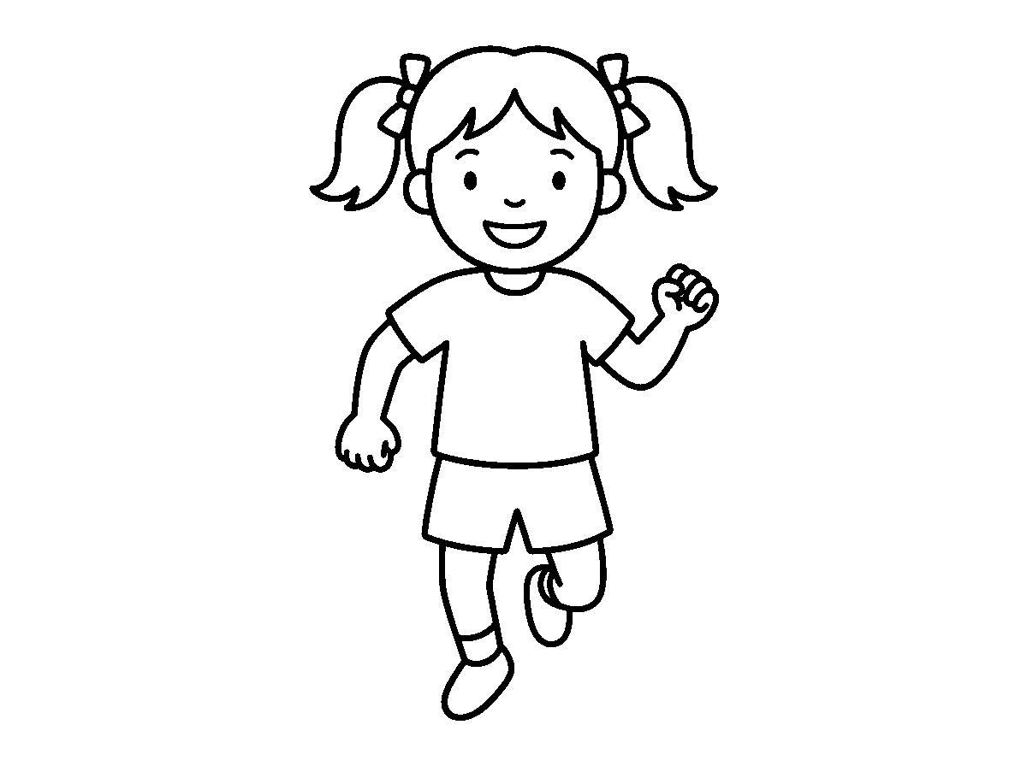
Worksheet
1. Exercise means activities that make the body A) move and work B) sleep C) grow cold D) rest
2. A game is played with A) rules B) money C) no rule D) books only

3. Which one does exercise NOT do for us? A) spoil our teeth B) give energy C) strengthen muscles D) improve balance
4. Playing games at the right time helps us to A) fight B) skip food C) stay awake all night D) sleep well
5. Fill in: Exercise should be ____, not a punishment.
6. Mention four benefits of exercise and games.
7. Write two sentences on the game you play best and its rule.
My own work
Do ten jumping jacks, ten arm circles and ten toe touches, then tick the box your classmate draws for you.
Draw yourself playing your favourite game and colour the ball.

WEEK 2 — GAMES: BASIC GAMES
Depth: NERDC Nursery 3 · PHE · First Term W2 (pp 547–551).
You will learn to
• play the basic games of the field
• keep the balance in the egg-and-spoon race
• follow the rules of each game
• play fairly and encourage the others
Things to know
• Egg and spoon race: a small ball or bean bag is balanced on a spoon and carried to the line; if it falls, you pick it up and go on from where it fell.
• The egg-and-spoon game teaches balance and control of the hand.
• Sack race: you stand inside a sack and jump to the finish line; it trains the legs and the sense of balance.
• Blindfold and fill a basket: a player is blindfolded and, guided by the voices of teammates, picks objects up and puts them in a basket.
• The blindfold game teaches trust, listening and knowing where things are around you.
• Three-legged race: the inside legs of two players are tied together, and the pair must walk as one.
• Other basic games: musical chairs, freeze dance and the obstacle course (run, crawl under, step over, jump across).
• Fair play means: no pushing, no cheating, no taking another's place.
• We take turns, and when a friend loses we say "well played" instead of laughing.
Words for my notebook
Balance on the spoon, jump in the sack, listen with the eyes shut. Play fairly and clap for the others.
Let us talk
1. Which game uses a spoon and a ball?
2. What does the sack race train?
3. Who guides the blindfolded player?
4. Say two things fair players do.

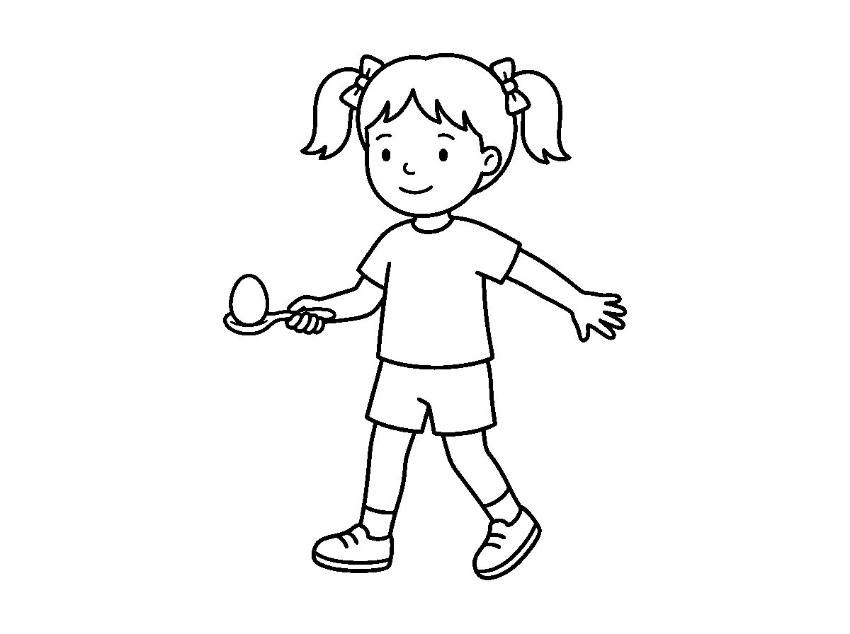
Worksheet
1. In the egg and spoon race, if the ball falls you A) cry B) hit your friend C) pick it up and carry on D) go home
2. The sack race is played by A) running with a bucket B) jumping in a sack C) throwing a ball D) sitting down
3. Musical chairs is a game of A) moving when the music plays B) reading C) swimming D) writing
4. Fair play means A) hiding the ball B) pushing the small ones C) not cheating D) taking another's turn
5. Fill in: In the three-legged race, two players must walk as ____.
6. Mention three games you played today.
7. Write two sentences on one rule that makes a game fair.
My own work
Draw one of the games and write the rule that you must not forget.

WEEK 3 — BODY EXERCISE: STRETCHING, BENDING, RAISING ARMS AND LEGS, SKIPPING, LEAPING AND HOPPING
Depth: NERDC Nursery 3 · PHE · First Term W3 and W4 (pp 547–551) — the school takes both weeks together.
You will learn to
• stretch the neck, arms, back and legs
• bend and raise the arms and legs in the right form
• skip with and without a rope
• leap and hop without falling
Things to know
• Stretching: reach for the sky, touch your toes, bend sideways, roll the neck slowly, turn the arms in circles, turn the ankles.
• Stretching warms the muscles up, keeps us from being hurt, and makes the body bend easily.
• Bending: bend forward, bend backward carefully, bend sideways, and bend the knees (squat) like a frog.
• Raising arms and legs: arm raise to the front, to the side, up over the head; leg raise marching, to the side, and behind.
• Skipping: jump with a rope forwards, jump backwards, or skip without a rope and count the skips — 1, 2, 3… to 20.
• Skipping makes the legs strong, the heart quick, and the whole body well-coordinated.
• Leaping is a big jump from one foot to the other foot; arms swing to help; we leap over a line or a cone.
• Hopping is on one foot only — five hops on the right leg, five on the left.
• Form and safety come first: land with soft knees, keep space between you and your neighbour, and never push.

Words for my notebook
Stretch, bend, raise, skip, leap and hop. Warm up first, land with bent knees, and keep your space.
Let us talk
1. Why do we stretch before exercise?
2. Show me a squat and a side bend.
3. What is the difference between leaping and hopping?
4. Count twenty skips out loud.
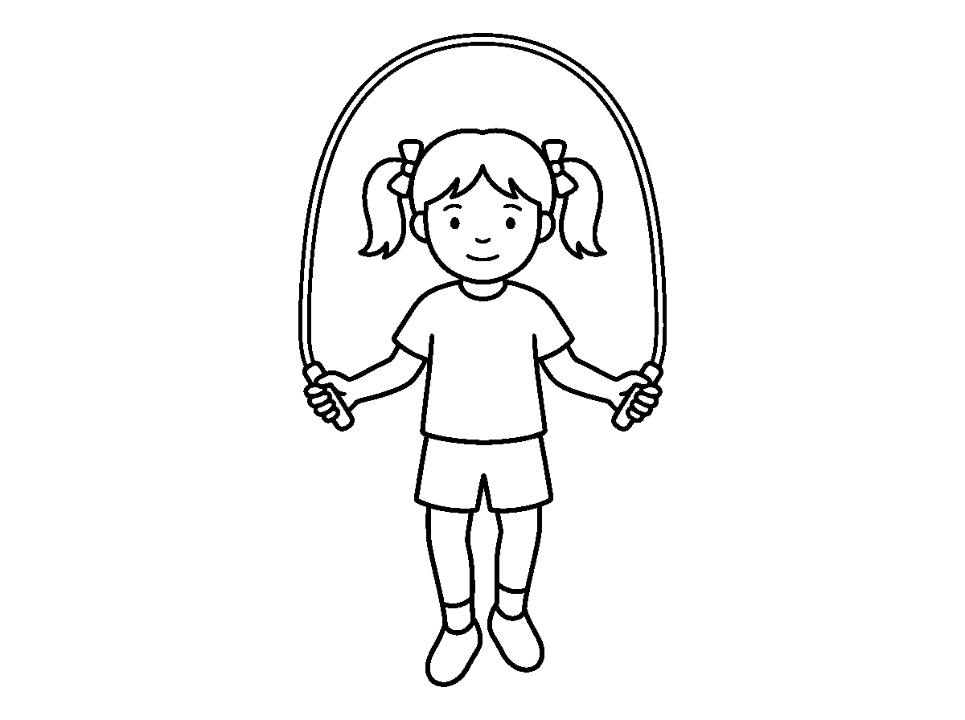
Worksheet
1. Stretching before exercise mainly A) hurts the legs B) cools the body C) warms the muscles up D) makes us tired
2. A leap is a jump A) from one foot to the other B) in bed C) with eyes shut D) on one foot
3. Hopping is done on A) one foot B) the knees C) both hands D) the back
4. Which one is NOT a stretching action? A) ankle rotation B) touching the toes C) sleeping D) arm circles
5. Fill in: We land from a jump with soft, bent ____.
6. Name the four body exercises in this lesson.
7. Write two sentences on the exercise you found hardest.
My own work
Do ten stretches and twenty skips at home; write down how many skips you managed without stopping.
Draw one child stretching up tall and one bending down; colour the shoes of both.

WEEK 4 — BODY CONDITIONING AND BALANCING
Depth: NERDC Nursery 3 · PHE · First Term W7 (pp 547–551).
You will learn to
• say what body conditioning means
• say what balance is
• stand on one leg for ten counts
• play the dance-and-freeze game well
Things to know
• Body conditioning means exercises that make the whole body fit and in good control.
• Balance means staying steady without falling.
• Stand on the right leg and count to ten; then the left leg; then, when you are strong, try with your eyes shut.
• Arms are stretched out sideways while balancing — they act like the beam of a scale.
• Balancing strengthens the small muscles that keep us upright, and it teaches the mind to focus.

• Dancing and freezing game: dance while the music (or a drum) plays; when it stops, freeze like a statue and hold that position.
• Holding the freeze tests balance, teaches rhythm and trains the ears to listen.
• Other balancing activities: walk heel to toe on a line drawn on the floor, stand on tiptoe, walk along a low, safe beam.
• Balance falls when the eyes are shut, when the head moves about, or when somebody pushes — so we try again quietly.
Words for my notebook
Conditioning keeps the body fit; balance keeps us steady. Arms out, eyes fixed, count to ten.
Let us talk
1. What is balance?
2. What do the arms do when we stand on one leg?
3. When do we freeze in the dancing game?
4. Name one other balancing activity.
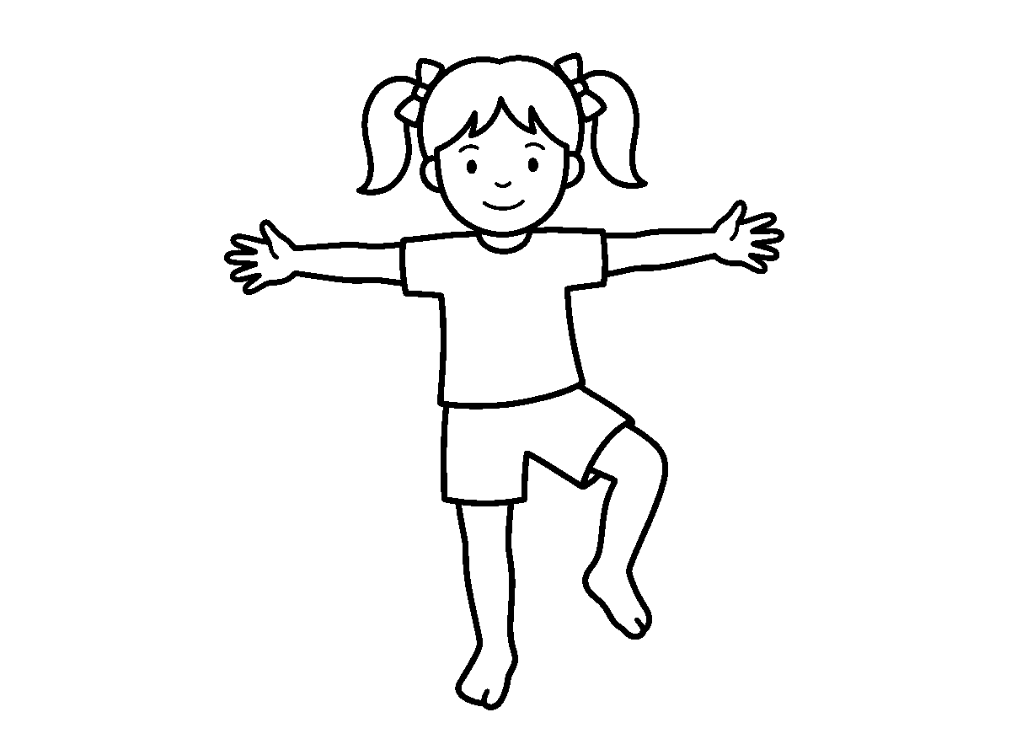
Worksheet
1. Balance means staying A) fast B) loud C) asleep D) steady without falling
2. In the freezing game we hold our position when the music A) is too loud B) is soft C) stops D) starts
3. Which of these helps us balance? A) running about B) eyes shut tight C) arms out sideways D) jumping high
4. Walking heel to toe is a game of A) writing B) balance C) singing D) swimming
5. Fill in: Body conditioning keeps the whole body ____ and in good control.
6. Mention three balancing activities.
7. Write two sentences on how long you can stand on one leg with your eyes shut.
My own work
Draw the mark of ten on the floor and walk heel to toe along it five times without stepping off.

WEEK 5 — SIMPLE MOVEMENTS OF PARTS OF THE BODY
Depth: NERDC Nursery 3 · PHE · First Term W8 (pp 547–551).
You will learn to
• move to the beat of a tambourine
• walk, jog, run and crawl correctly
• bend, turn, jump and swing the body parts
• move safely in a space shared with others
Things to know
• Tambourine movement: move when it plays; move fast for fast beats, slow for slow beats; freeze when it stops.

• Different body parts answer the beat: the hands clap, the feet stamp, the head nods, the trunk twists.
• Walking has many forms: normal walk, fast walk, slow walk, on tiptoe, on the heels, and walking backwards.
• Jogging is light running — in one place or moving along.
• Running is faster: knees lift, arms pump at the elbow, eyes ahead.
• Bending is at the waist or at the knees, forwards, backwards and sideways.
• Turning, spinning, jumping and crawling are also basic movements; crawling is done on hands and knees under a line.
• Fundamental movement patterns are the foundation of every sport: without them a child cannot kick, throw or catch well.
• Moving safely in a shared space: keep your own spot, do not run into a neighbour, stop when the whistle blows.
Words for my notebook
Fast, slow, freeze — that is the tambourine. Walk, jog, run, bend, turn, jump, crawl. Keep your space.
Let us talk
1. What do you do when the tambourine stops?
2. Show me walking on the heels and on tiptoe.
3. What makes running faster than walking?
4. Name three movements you do with the trunk.
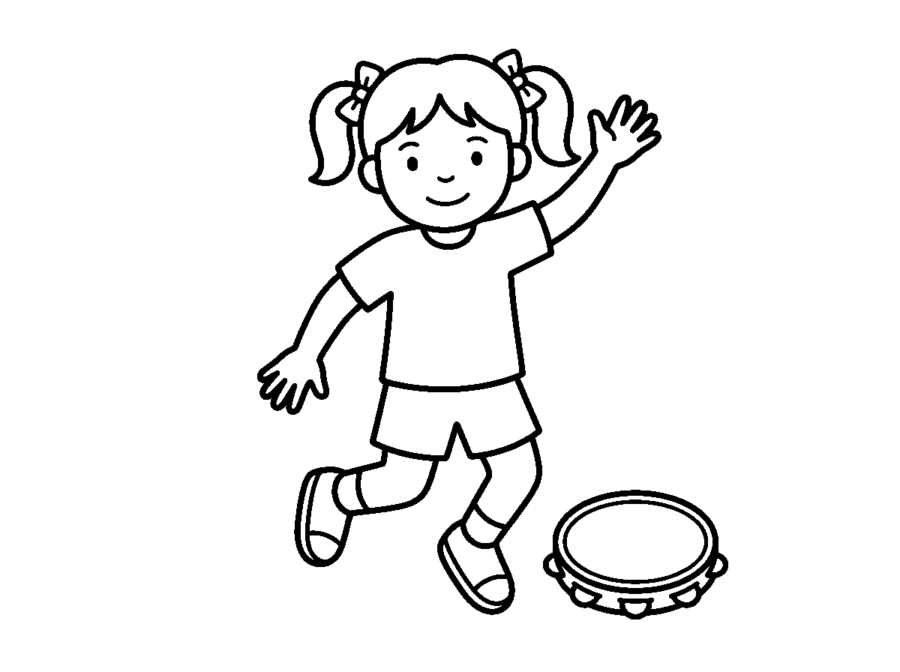
Worksheet
1. When the tambourine plays quickly we move A) backwards only B) slowly C) not at all D) quickly
2. Light running is called A) skipping B) sleeping C) crawling D) jogging
3. Walking on the heels is a way of practising A) eating B) reading C) writing D) balance
4. Which one is NOT a basic movement? A) bending B) brushing C) crawling D) spinning
5. Fill in: In a shared space we keep our own ____ and stop at the whistle.
6. Name four ways of walking.
7. Write two sentences on the movement you can do best.
My own work
Set out six bottles in a line and crawl or step through them twice, then write how many you touched.
Draw the five parts of your body you move with and colour each one a different colour.

WEEK 6 — MANIPULATIVE MOVEMENTS: THROWING AND CATCHING
Depth: NERDC Nursery 3 · PHE · First Term W9 (pp 547–551).

You will learn to
• say what manipulative movement means
• throw underhand and overhand
• catch with two hands at different heights
• keep the safety rules when throwing
Things to know
• Manipulative movements are movements that control and move an object using a body part.
• They are the skills every sport is built on: throwing, catching, kicking, hitting, bouncing, rolling.
• Underhand throw: the arm swings from behind and low, the object leaves the hand in front of the body.
• Overhand throw: the arm goes up behind the head, the body turns sideways, and we step and throw.
• We can throw at a target (a hoop on the wall), for distance (as far as we can), or into a partner's hands.
• Catching is done with two hands, arms out in the ready position, eyes on the object all the way to the hands.
• Catch a bean bag first, then a soft ball; catch high throws and low throws separately.
• With a partner we throw and catch, and slowly move a step further apart after each ten good catches.
• Safety: only soft objects are used for throwing in class; we never throw at a person's face, and we look before we throw.
Words for my notebook
Throw underhand or overhand; step and throw. Catch with two hands, eyes on the ball. Soft things only.
Let us talk
1. What is a manipulative movement?
2. Show me the ready position for catching.
3. What do we do with our feet when we throw far?
4. Name one throwing safety rule.
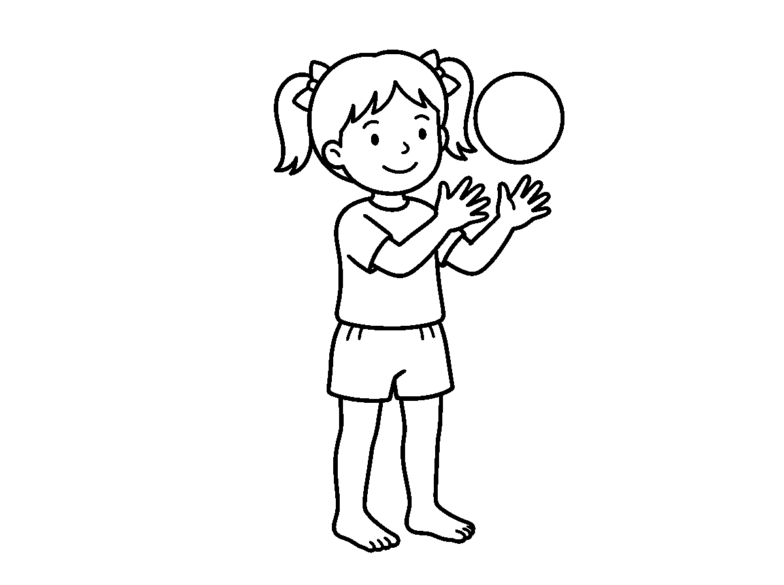
Worksheet
1. Controlling and moving an object with the body is a A) manipulative movement B) song C) stretch D) balancing skill
2. An overhand throw is made with the arm A) in water B) up behind the head C) low D) behind the back
3. We catch mainly with A) one hand B) two hands C) the knee D) the head
4. Which object is safe to throw in class? A) a bottle B) a shoe with a rock C) a stone D) a bean bag
5. Fill in: We never throw at a person's ____.
6. Name three manipulative skills.
7. Write two sentences on catching: what do the eyes and the hands do?

My own work
Throw and catch a soft ball twenty times with a brother, sister or friend, and count the catches you made.
Draw a ball in the air above your two hands and colour the ball.

WEEK 8 — NEURO-MUSCULAR SKILLS: DANCING AND SOMERSAULTING
Depth: NERDC Nursery 3 · PHE · First Term W10 (dancing) and Nursery 2 · PHE · Second Term W10 (somersaulting), pp 547–551.
You will learn to
• say what a neuro-muscular skill is
• do simple dance steps with the arms and legs together
• roll forward on a mat with the chin tucked
• say why the roll is done only with supervision
Things to know
• Neuro-muscular means the working together of the nerves (the brain and its wires) and the muscles to produce movement.
• A skill of this kind needs timing: the brain says go, the muscles obey, and the body obeys at the right moment.
• Dancing is moving the body to music or rhythm: step left, step right, clap, jump, turn.
• Simple dance steps are done in a routine — the same order again and again so the body remembers it.
• Cultural dances (simple ones) teach us where our people come from, and the whole class joins in.
• Dancing trains rhythm, timing and the coordination of the arms and the legs, and it is fun exercise.
• Somersaulting (forward roll): from a squat, hands on the mat, tuck the chin to the chest, push with the legs and roll on the rounded back.
• The roll is done only on a mat or soft ground, with a grown-up watching — never on a hard floor, never on a bed, never on a friend.
• A child who is not ready does not roll: that is alright. Confidence is built one small step at a time.
Words for my notebook
Neuro-muscular = brain and muscles working together. Dance to the beat. Roll only on a mat, chin tucked, with a grown-up.
Let us talk
1. What does neuro-muscular mean?
2. Show me two dance steps in order.
3. Where should the chin be during a forward roll?
4. Why must an adult watch the roll?
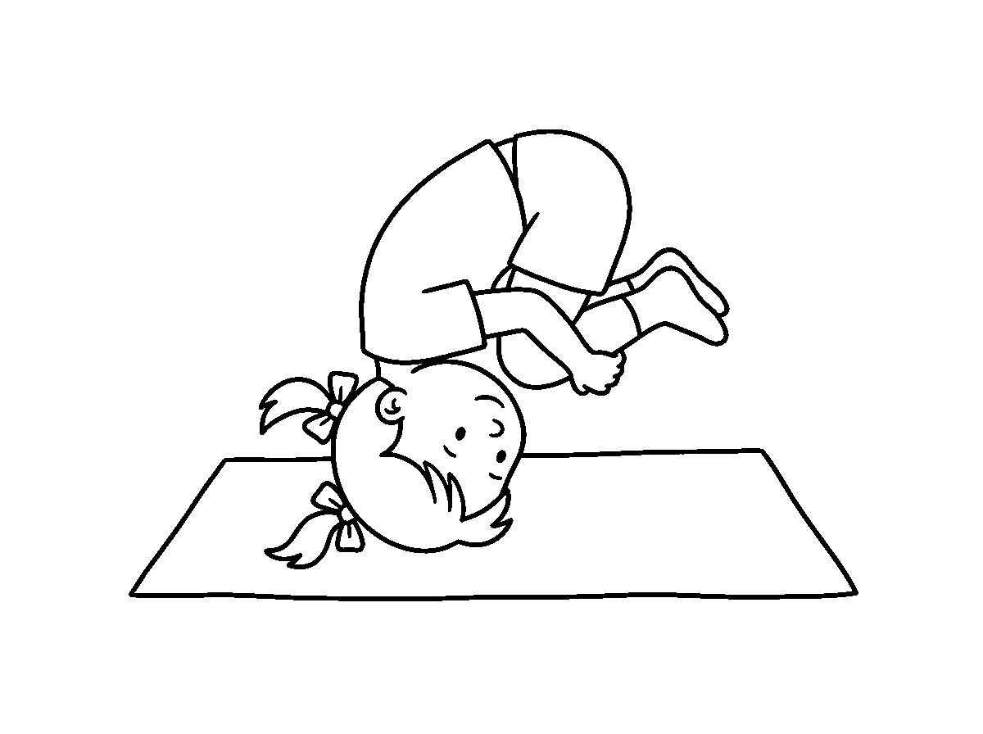
Worksheet
1. A neuro-muscular skill joins the A) brain and the muscles B) shoe and the leg C) nose and the ear D) two hands

2. A dance routine is A) one long jump B) the same steps in order C) a food D) a song about books
3. In a forward roll the chin must be A) up B) in the air C) tucked to the chest D) sideways
4. The roll must be done on A) a mat or soft ground B) a hard floor C) a bed D) the staircase
5. Fill in: If a child is not ready to roll, that is ____.
6. Name two things dancing does for the body.
7. Write two sentences on how a forward roll is done safely.
My own work
Set out four dance steps in order, name them, and show them to your class tomorrow.
Draw the pose you dance in and colour the cloth you dance in.

WEEK 9 — DEVELOPMENT THROUGH SPORT ACTIVITIES: PHYSICAL DEVELOPMENT
Depth: NERDC Nursery 3 · PHE · Second Term W1 (pp 552–557).
You will learn to
• name the parts of the body that sport develops
• say what flexibility, balance and speed mean
• tell which activity builds which quality
• say what a child of my age can do
Things to know
• Sports and physical activity help the whole body develop, not only the legs.
• Flexibility is the ability to bend and stretch easily; it is improved by stretching exercises.
• Agility is the ability to move quickly and change direction easily; games and drills build it.
• Balance is staying steady without falling; balancing exercises (one leg, the line, the beam) improve it.
• Coordination is using different parts of the body together smoothly — eyes and hands, arms and legs.
• Reaction is answering a signal quickly: ear hears the clap, leg starts to run.
• Speed is how fast we move; running activities develop it.
• Strength is how strong the muscles are; exercise and play build it.
• Regular sport develops all of these together; one game can train three or four of them.
• At my age I am learning these things, not competing as a grown-up athlete; my bones and muscles are still growing, so rest is part of the plan.
Words for my notebook
Sport builds flexibility, agility, balance, coordination, reaction, speed and strength — at my own age, with rest.
Let us talk
1. What is flexibility?
2. Which quality tells you how fast you move?
3. Name one activity that builds balance.
4. Why do children also need rest?

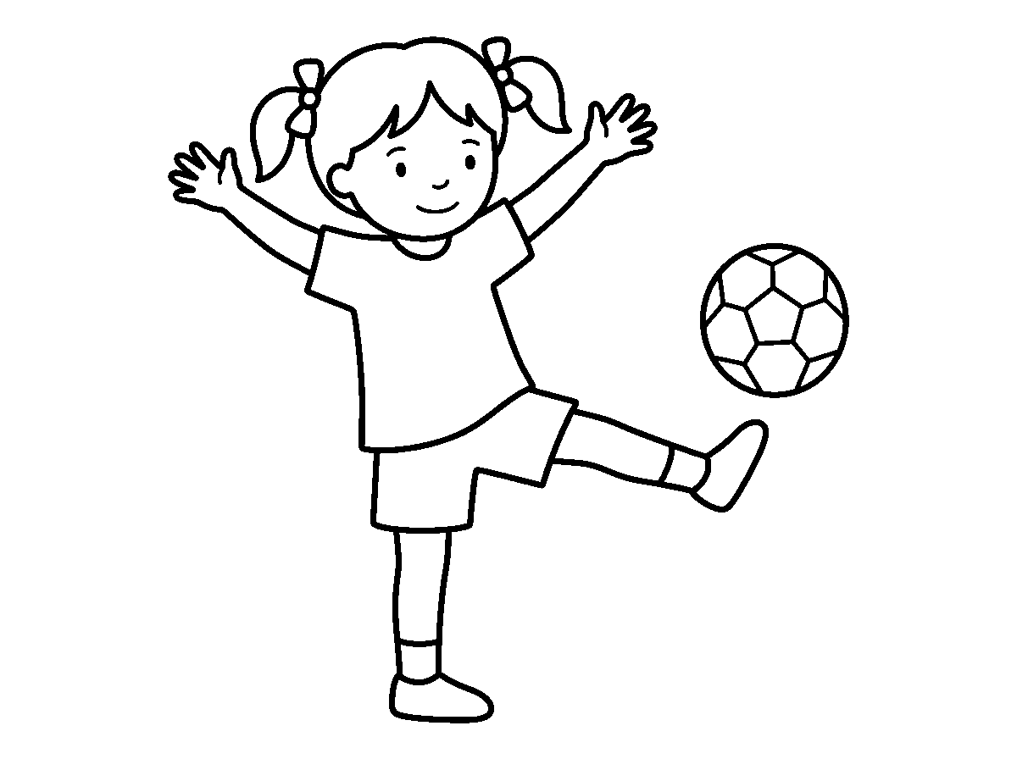
Worksheet
1. Being able to bend and stretch easily is A) flexibility B) reaction C) speed D) strength
2. Changing direction quickly in a game is A) reading B) balance C) sleep D) agility
3. Which one is NOT developed by sport? A) speed B) coordination C) strength D) taller books
4. The ability to stay steady is A) speed B) balance C) reaction D) flexibility
5. Fill in: ____ is answering a signal quickly.
6. Mention five qualities sport builds in the body.
7. Write two sentences on the sport that trains your balance best.
My own work
Write the five qualities you are strongest in, and pick one you want to improve by next term.
Draw the ground you play on and colour the line you run along.

PREVOCATIONAL STUDIES (PVS)
Weeks 1 to 6, 8 and 9. No note for Week 7 (Mid-Term), 10 (Revision), 11 (Examination). Depth: NERDC 2025 · Primary 4 · Prevocational Studies · First Term W1–W2, p 833 — this subject is redistributed into the lower classes, so the Primary 4 week on the concept of agriculture is the floor, told here with things a 4–5 year-old can see, touch and name.

WEEK 1 — MEANING OF AGRICULTURE; IMPORTANCE OF AGRICULTURE TO HUMANS
Depth: NERDC Primary 4 · Prevocational Studies · First Term W1–W2 (p 833).
You will learn to
• say what agriculture means in one line
• name the things agriculture gives us
• tell who a farmer is
• say why every person needs agriculture
Things to know
• Agriculture is the work of growing crops and rearing animals for man to use.
• A person who does this work is a farmer.
• Agriculture gives us the food we eat: yam, rice, beans, maize, plantain, vegetables and fruit.
• It gives us animals for food: eggs and meat from the hen, milk from the cow, meat from the goat and the sheep.
• It gives us cotton for cloth, wood for furniture, and leaves and roots some people use as medicine.
• Without agriculture there would be no food on the table and no raw material for the factory.
• Farmers sell their surplus at the market and use the money for school fees, clothes and houses.
• Many people in Nigeria earn their living from agriculture.
• Agriculture is important to every one of us, whether we live in the town or in the village.
Words for my notebook
Agriculture is growing crops and rearing animals. It gives us food, clothes, work and money.
Let us talk
1. What is agriculture?
2. Who is a farmer?
3. Mention three things agriculture gives us.
4. Why does a town child also need agriculture?
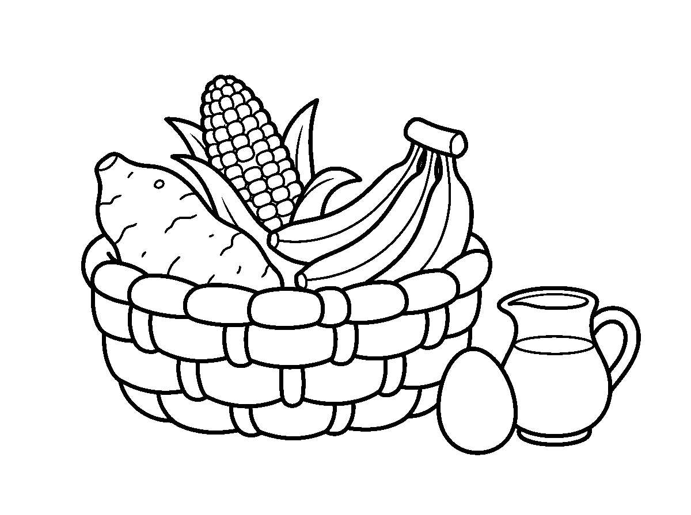
Worksheet
1. Agriculture is the work of A) driving taxis B) selling cloth only C) growing crops and rearing animals D) building houses

2. A person who grows food for us is a A) banker B) driver C) farmer D) pilot
3. Which of these comes from agriculture? A) plastic chair B) radio C) yam D) bicycle
4. Cotton for our clothes comes from A) the mine B) a machine C) a crop D) the river
5. Fill in: The cow gives us beef and ____.
6. Mention four things we get from agriculture.
7. Write two sentences on why agriculture is important to your family.
My own work
Write the names of five foods in your house and say which of them came from a farm.
Draw a hoe, a cutlass and a basket, then colour the basket.

WEEK 2 — AGRICULTURE IN OUR DAILY LIVES
Depth: NERDC Primary 4 · Prevocational Studies · First Term W1–W2 (p 833).
You will learn to
• trace a meal from the farm to the table
• name farm foods taken at breakfast, lunch and dinner
• say which farm things are used at home besides food
• tell why we must not waste farm produce
Things to know
• The swallow we eat — rice, yam flour, beans, garri — all came from a farm.
• The oil in our soup came from the palm fruit; the groundnut in our snack came from the ground.
• Fresh fish and catfish come from the river and the fish pond; milk and eggs come from animals kept at home.
• Fruit that I eat between meals — mango, orange, watermelon, banana — grew on a tree or a creeper.
• Farm things are not only for eating: broom from the midrib, mats from raffia, wood for the chair, and the cow's skin for shoes.
• A market day is where farm produce comes together: the seller's basket holds what the farmer's hoe made.
• Food that is wasted was grown with rain, sweat and time; we finish what we take and we keep the rest for later.
• If there is no farm work, the shop has nothing to sell and the table has nothing to carry.
Words for my notebook
From the farm to my plate: rice, oil, fish, milk, fruit. What the farm gives, we do not throw away.
Let us talk
1. Name three foods you ate today that came from a farm.
2. Where does palm oil come from?
3. Mention one farm thing used at home that is not food.
4. Why must we not waste food?

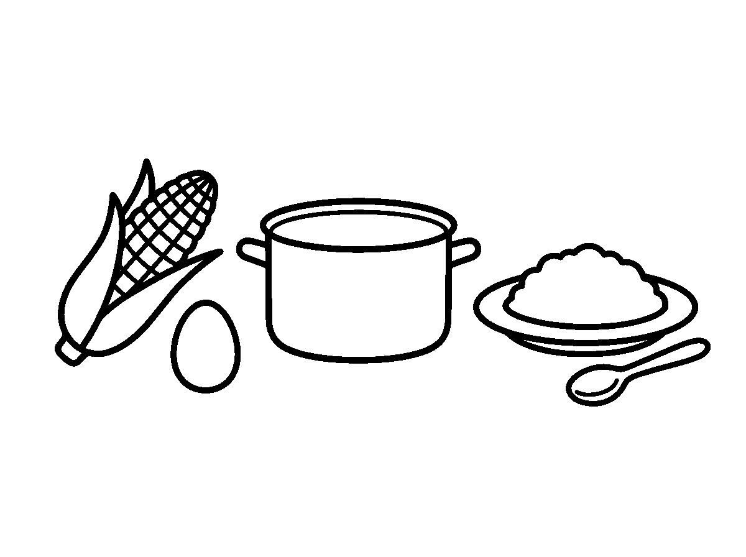
Worksheet
1. Garri is made from A) stone B) milk C) fish D) cassava
2. Palm oil used for our soup comes from A) the palm fruit B) the river C) the shop D) the mine
3. Which of these is NOT from a farm? A) table salt from the sea B) yam C) egg D) rice
4. Raffia mats are made from A) sand B) plastic C) iron D) a farm plant
5. Fill in: The market seller sells what the ____ has grown.
6. Mention four farm foods you eat at home.
7. Write two sentences on one kind of waste we should stop in our food.
My own work
Draw your last meal and write under each item where on the farm it came from.

WEEK 3 — BASIC FARMING ACTIVITIES
Depth: NERDC Primary 4 · Prevocational Studies · First Term W1–W2 (p 833).
You will learn to
• put the farming activities in order
• name the tools used at each stage
• say how crops are cared for
• tell what happens at harvest time
Things to know
• Farming has an order, and every stage waits for the one before it.
• Clearing: the bush and old sticks are removed from the land with a cutlass.
• Tilling: the soil is turned and broken with a hoe so that it becomes soft for planting.
• Planting: seeds, yam setts, cassava sticks or cocoyam are put into the ground at the right time of the year.
• Weeding and watering: grass that competes with the crop is removed; where there is no rain, the crop is watered.
• Applying manure: rotten leaves and animal droppings are added to make the soil rich.
• Protecting the crop: birds, grasshoppers, goats and cattle are kept away from the growing farm.
• Harvesting: yam, maize, cassava and rice are gathered when they are ripe.
• Storage and selling: the harvest is dried, kept safe from weevils, eaten, or taken to the market.
• Simple tools of the small farm: cutlass, hoe, rake, watering can, knapsack sprayer, basket.

Words for my notebook
Clear, till, plant, weed, water, harvest, store, sell — the farmer's work goes in that order.
Let us talk
1. What is done before planting?
2. Which tool turns the soil?
3. Why do we weed the farm?
4. Name two things done after harvest.
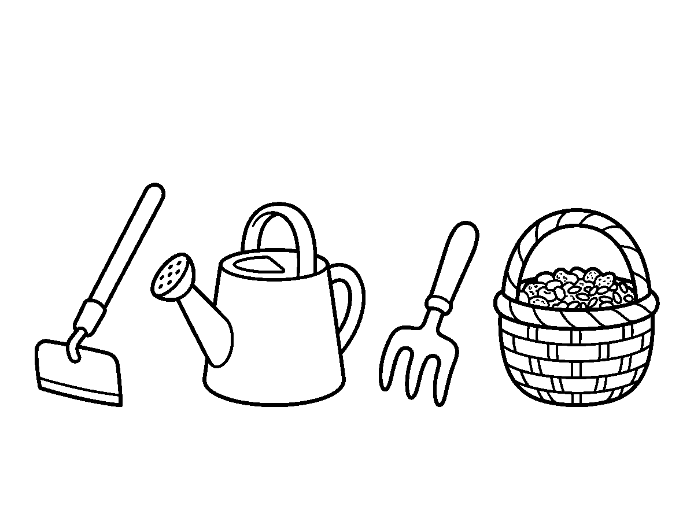
Worksheet
1. The first farming activity is A) cooking B) clearing C) selling D) harvesting
2. Breaking and turning the soil is called A) shelling B) tilling C) milling D) weeding
3. Rotten leaves and animal droppings used to enrich the soil are A) cement B) manure C) chalk D) garri
4. Which tool is used for cutting bushes? A) cutlass B) rake C) spade D) hoe
5. Fill in: Young plants are watered when there is no ____.
6. Write the first four farming activities in order.
7. Write two sentences on what happens during harvest in your place.
My own work
Number these in your notebook: harvesting, planting, clearing, weeding, tilling.
Draw the four farm jobs in order — clear, plant, water, harvest — and colour the harvest.

WEEK 4 — SCOPE OF AGRICULTURE: CROPS
Depth: NERDC Primary 4 · Prevocational Studies · First Term W1–W2 (p 833).
You will learn to
• say what crop production means
• group crops as food, cash and fruit crops
• name crops grown in our state
• say which part of a crop we eat
Things to know
• Crop production (crop farming) is the branch of agriculture that deals with growing plants for man and animals.
• Food crops are grown to feed the family: rice, yam, maize, cassava, beans, plantain, cocoyam.
• Cash crops are grown to be sold and to bring money: cocoa, groundnut, cotton, palm produce, rubber, ginger.
• Fruit and vegetable crops: mango, orange, watermelon, banana; tomatoes, pepper, spinach, ewédú, ugu.

• Cereals are grain crops — rice, maize, guinea corn, wheat; they are the staff of life.
• Some crops give us oil (palm, groundnut, sunflower) and some give us drink (cocoa, coffee, sugarcane).
• We eat different parts: the root or tuber (yam, cassava), the grain (maize, rice), the leaf (spinach), the fruit (mango).
• Leguminous crops such as beans and groundnut make the soil rich as they grow.
• Trees like iroko and mahogany are forestry; crops in the field are crop production — they are not the same branch.
Words for my notebook
Crops divide into food crops, cash crops, fruit and vegetable crops. Cereals are grains; beans make soil rich.
Let us talk
1. What is crop production?
2. Name three food crops and two cash crops.
3. Which part of the cassava plant do we eat?
4. Give one example of a cereal crop.
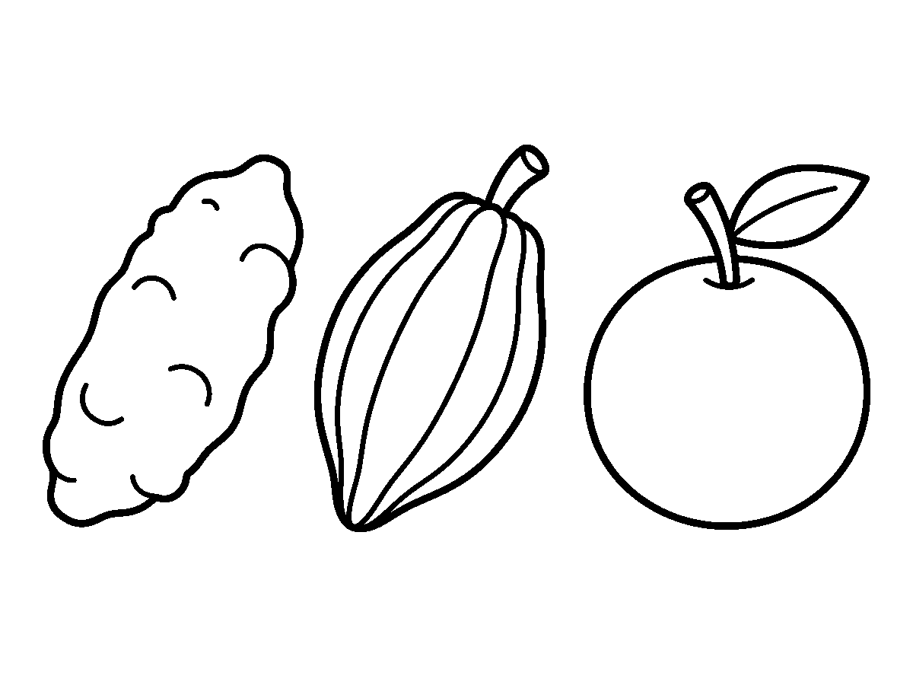
Worksheet
1. Crops grown mainly to bring money are called A) food crops B) weeds C) cash crops D) grasses
2. Which of these is a cereal crop? A) cassava B) palm C) banana D) maize
3. Cocoa and cotton are examples of A) cash crops B) tools C) fish D) food crops
4. The crop that makes the soil rich as it grows is A) plantain B) yam C) bean D) rice
5. Fill in: We eat the ____ of the yam plant (yam, cassava).
6. Mention three crops grown in our state.
7. Write two sentences on a fruit crop and the part of it we eat.
My own work
Bring one grain, one tuber and one leaf to school and write their names on a paper.
Draw four crops you know and colour the yam.

WEEK 5 — SCOPE OF AGRICULTURE: ANIMALS
Depth: NERDC Primary 4 · Prevocational Studies · First Term W1–W2 (p 833).
You will learn to
• say what animal rearing means
• name farm animals and their young ones
• state what each animal gives us
• say how farm animals are cared for

Things to know
• Animal rearing (animal husbandry) is the branch of agriculture that deals with keeping farm animals.
• Farm animals: cow, goat, sheep, pig, rabbit, dog, cat, and the birds we keep — hen, duck, turkey, guinea fowl.
• The young of the cow is the calf; of the goat, the kid; of the sheep, the lamb; of the hen, the chick.
• The cow gives milk, meat and hide; the goat gives meat and skin; the hen gives eggs and meat.
• Animals also give manure for the farm and strength for ploughing and carrying loads.
• An animal needs four things every day: food, clean water, shade, and a clean, safe place to sleep.
• The animal is dosed and vaccinated when the vet or the health worker says so; sick animals are kept apart.
• Animals are not beaten; they are driven gently, and water is given to them in the hot season.
• Fish are kept in ponds and in the river — that part of agriculture is called fishery.
Words for my notebook
Animal rearing gives milk, eggs, meat and manure. Every animal needs food, water, shade and a safe place.
Let us talk
1. What is animal rearing?
2. What do we call the young one of a hen?
3. Mention two things the cow gives us.
4. Say three things an animal needs daily.
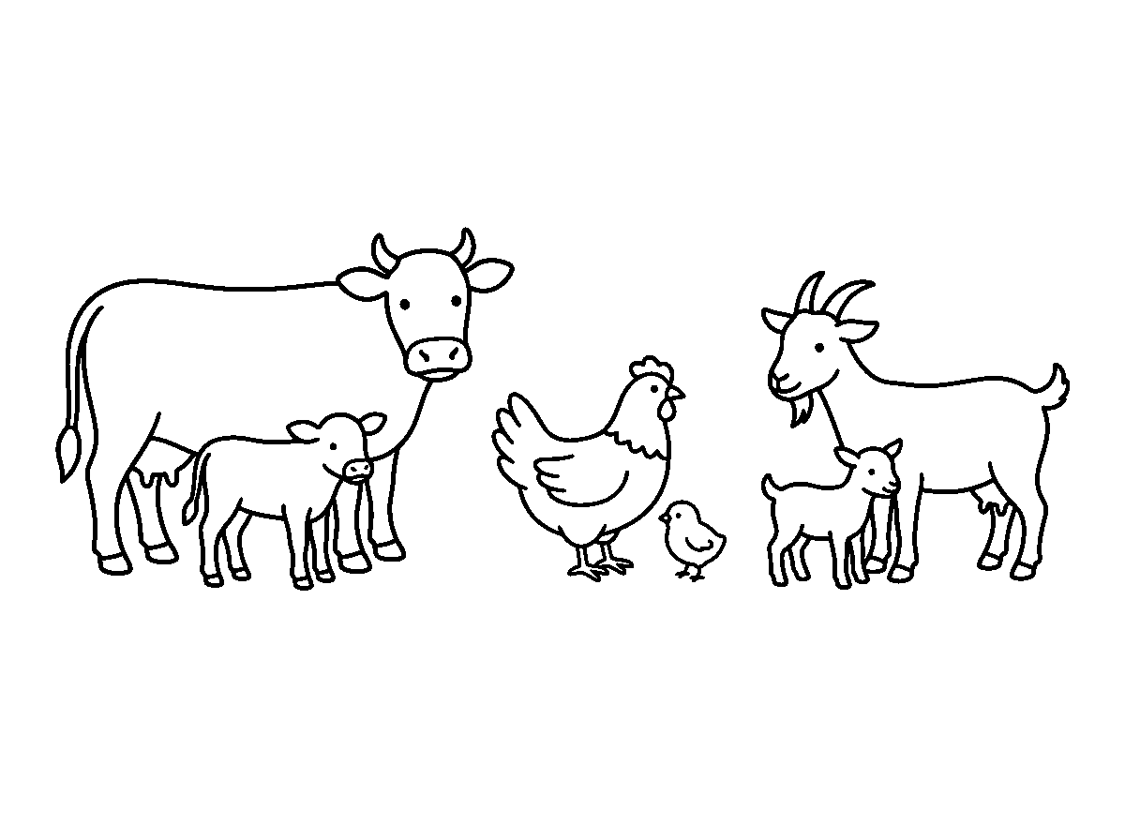
Worksheet
1. The young one of a goat is a A) chick B) kid C) calf D) lamb
2. The branch of agriculture that keeps animals is A) crop production B) animal rearing C) fishing D) forestry
3. Which animal is reared mainly for eggs? A) goat B) pig C) hen D) sheep
4. Manure from animals is used to A) enrich the soil B) boil water C) build a house D) thatch a roof
5. Fill in: A sick animal should be kept ____ from the others.
6. Name four farm animals and one product from each.
7. Write two sentences on how an animal is cared for in your home or in your village.
My own work
Draw a farm animal, its young one, and write two things it gives people.

WEEK 6 — SCOPE OF AGRICULTURE: FORESTRY
Depth: NERDC Primary 4 · Prevocational Studies · First Term W1–W2 (p 833).
You will learn to
• say what forestry means
• name trees that give timber and trees that give fruit
• state the uses of trees
• say why we plant trees and do not cut them all
Things to know
• Forestry is the branch of agriculture that deals with the growing, management and protection of trees and the forest.
• Timber trees give us wood for planks, furniture and building: iroko, mahogany, teak, pine, obeche.
• Fruit trees give us food: mango, orange, guava, coconut, oil palm, cashew.
• Trees also give us medicine (neem leaves, bitter leaf roots), firewood, charcoal, and shelter from the sun.
• The forest is home to wild animals and birds: monkey, antelope, parrot, snail.
• Trees hold the soil with their roots, so the ground does not wash away when rain falls.
• Trees clean the air we breathe and bring the rain; where the trees are all cut, the land becomes dry.
• We cut only the trees that are marked, we cut a tree and plant two, and we do not burn bushes in harmattan.
• In Nigeria there are forest reserves, and there is a ministry that looks after them.
Words for my notebook
Forestry deals with trees: timber, fruit, medicine, shade. Cut one, plant two.
Let us talk
1. What is forestry?
2. Name two timber trees and two fruit trees.
3. What do the roots of trees do for the soil?
4. Why should we not burn bushes in the dry season?
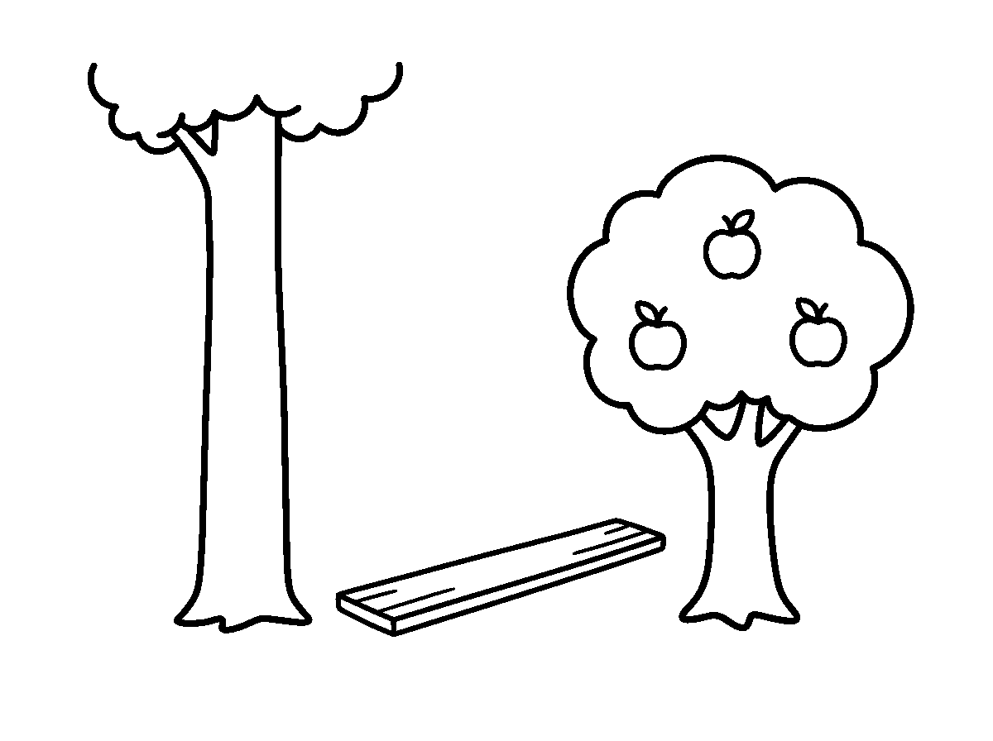
Worksheet
1. Forestry is the branch of agriculture that deals with A) roads B) fish C) trees D) poultry
2. Iroko and mahogany are trees grown for A) timber B) fruit C) eggs D) milk
3. The part of the tree that keeps the soil in place is the A) leaf B) bark C) root D) flower

4. Which of these is a product of the forest? A) rubber B) garri C) milk D) egg
5. Fill in: When we cut a tree, we ____ two.
6. Mention four uses of trees.
7. Write two sentences on why the land becomes dry where trees have all been cut.
My own work
Water one tree or one plant near your house for five days and write what you noticed.

WEEK 8 — SCOPE OF AGRICULTURE: FISHERY
Depth: NERDC Primary 4 · Prevocational Studies · First Term W1–W2 (p 833).
You will learn to
• say what fishery means
• name fish we eat and where they come from
• state the tools used in fishing
• say how fish are kept and prepared for market
Things to know
• Fishery is the branch of agriculture that deals with catching or rearing fish and other water animals.
• Catch fishing takes place in the river, the lake and the sea; fish farming (aquaculture) keeps fish in a pond or a cage.
• Fish we eat in Nigeria: catfish, tilapia, titus/mackerel, croaker, bonga, sardine; also prawn, crayfish and periwinkle.
• The tools of the fisherman: net, hook and line, fishing rod, basket, trap, canoe and boat.
• Fish are kept fresh with salt and smoke or ice; dried fish and smoked fish travel far to the market.
• Fish give us body-building food (protein); a child who eats fish grows strong.
• Fishing is done with rules: small fish are thrown back, so that there will be fish next year.
• Fish must not be taken from dirty water, and water for the pond must be kept clean.
• The river, the lake and the sea give work to fishermen, fish sellers and the women who smoke the fish.
Words for my notebook
Fishery is catching or rearing fish: net, hook, canoe, pond. Small fish thrown back keeps the water full.
Let us talk
1. What is fishery?
2. Name three fish we eat.
3. What tool does a fisherman use?
4. Why is a small fish thrown back into the water?

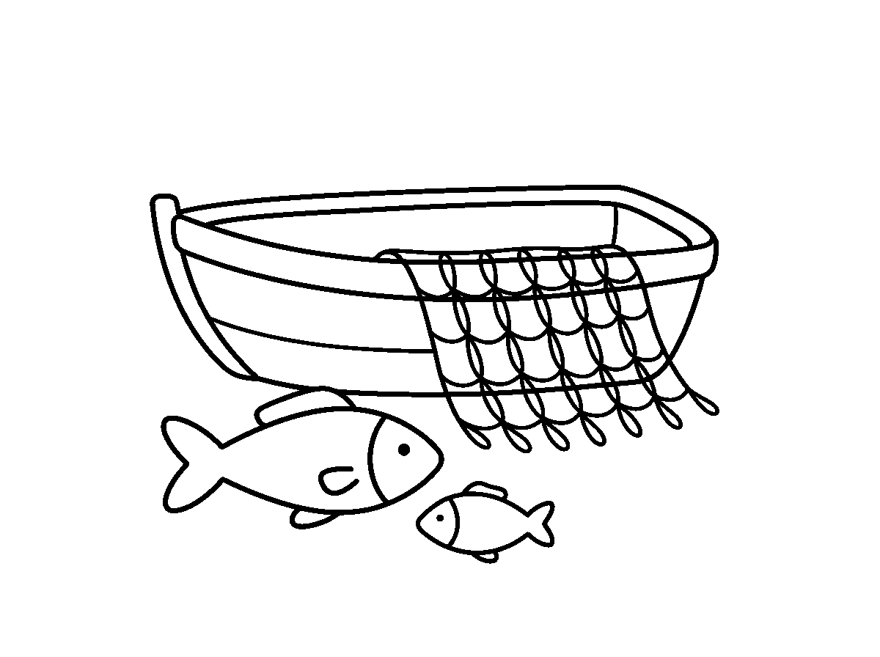
Worksheet
1. Fish farming in a pond is also called A) forestry B) tillage C) milling D) aquaculture
2. Which of these is a fishing tool? A) hoe B) net C) cutlass D) rake
3. Catfish and tilapia are A) animals of the bush B) crops C) birds D) fish
4. Fish are preserved by smoking, drying or using A) leaves B) sand C) ice D) salt water only
5. Fill in: The ____ is the fisherman's boat on the water.
6. Mention three water animals we eat besides fish.
7. Write two sentences on why we should not take fish from dirty water.
My own work
Write the name of the fish your family buys, and the place it came from.
Draw a fish, a net and a canoe, and colour the net.

WEEK 9 — AGRICULTURE IN NIGERIA
Depth: NERDC Primary 4 · Prevocational Studies · First Term W1–W2 (p 833) and Primary 6 · Prevocational Studies · Third Term W9 (p 952) for the sustainable-use lines.
You will learn to
• name the crops Nigeria is known for
• say where farming is done in the country
• explain sustainable and organic farming in a child's words
• say what a pupil can do to protect the environment
Things to know
• Nigeria farms in every part of the country: groundnut and cotton in the north, rice and maize on the middle belt, palm produce, cocoa and cassava in the south, fish in the rivers of the south-south.
• Crops that bring money into Nigeria include cocoa, groundnut, palm oil, rubber and cashew.
• Most food in Nigeria comes from small family farms, worked with the hoe and the cutlass.
• Sustainable agriculture means farming in a way that the land will still be good for our children — not taking everything and leaving nothing.
• Organic farming uses compost (rotten leaves and dung) instead of only chemical fertiliser.
• Reducing waste at home: finish the food on the plate; use the peels for the compost; do not pour oil down the gutter.
• Conserving resources: water is used once well; trees are left standing; the bush is not burnt.

• Protecting the environment keeps the soil, the river and the air clean for farming and for us.
• A pupil's part: grow one plant, water a tree, keep the compound clean, and finish the food on the plate.
Words for my notebook
Nigeria farms groundnut, cocoa, palm produce, rice and fish. Sustainable farming leaves good land for the next child.
Let us talk
1. Name two crops of the northern part of Nigeria.
2. What does sustainable agriculture mean in your own words?
3. Mention two ways of reducing waste at home.
4. Say one thing you can do to protect the environment.
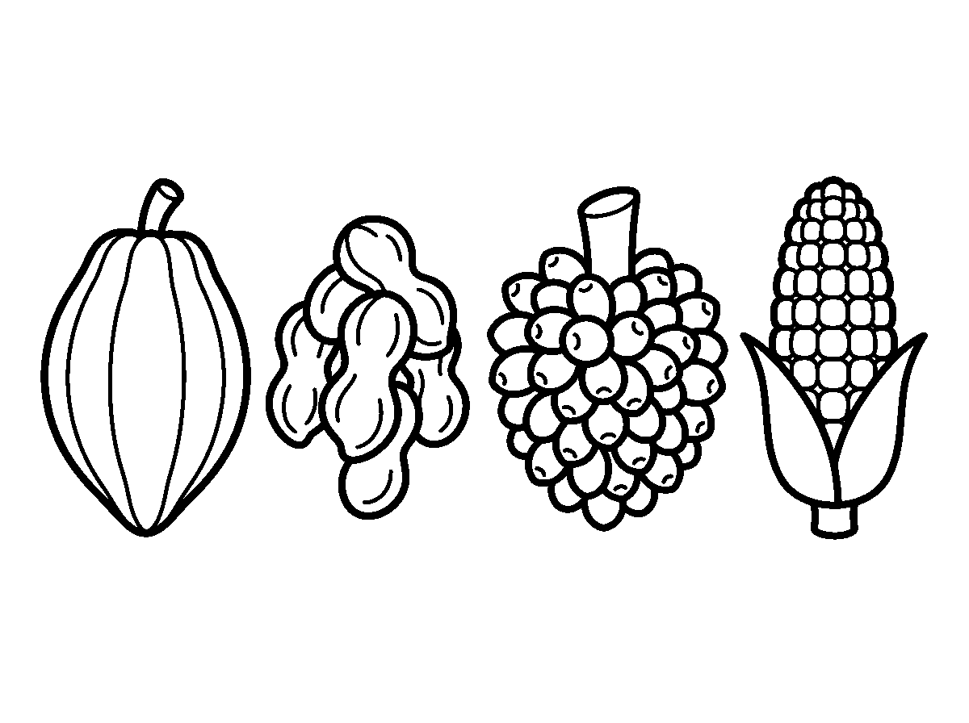
Worksheet
1. Cocoa and palm oil are products of A) the sea B) Nigeria C) the mine D) the desert
2. Farming that leaves the land good for the future is A) organic only B) wet farming C) lazy farming D) sustainable farming
3. Organic farming makes use of A) compost and manure B) plastic C) only water D) only chemicals
4. The best way to reduce waste at home is to A) burn everything B) finish our food and compost the peels C) throw waste in the gutter D) bury plastic in the yard
5. Fill in: We should not ____ the bush in the dry season.
6. Mention three crops grown in Nigeria and where they are grown.
7. Write two sentences on what you will do this week to protect your environment.
My own work
Plant one seed (orange seed, bean, or a fruit stone) in a tin, water it, and write its progress for five days.
Draw one food that came from a farm and colour it.

SOCIAL AND CITIZENSHIP STUDIES (SCS)
Weeks 1 to 6, 8 and 9. No note for Week 7 (Mid-Term), 10 (Revision), 11 (Examination). Depth: NERDC 2025 · Primary 1 · Social and Citizenship Studies · First Term W1–W10 and Second Term W1–W2, pp 655–658 — taught here two bands earlier, so every idea is carried by naming and role-play.

WEEK 1 — LEADERSHIP
Depth: NERDC Primary 1 · SCS · First Term W1 (pp 655–656).
You will learn to
• say what a leader is in one line
• name the leaders in my life
• tell the qualities of a good leader
• say why we need leaders
Things to know
• A leader is somebody who guides others and shows them what to do.
• My leaders are: father and mother at home, the teacher in class, the head teacher in the school, and the class captain among the children.
• Outside: the street leader (baale), the chairman of the local government, the governor of the state, and the President of the whole country.
• A good leader is kind, fair, honest and helpful.
• A good leader goes first in what is right, and does not do what he forbids others to do.
• We need leaders so that people will be guided, order will be kept, and work will be finished.
• A class without a monitor becomes noisy; a house without a head becomes untidy; a country without leaders has no direction.
• Leaders are given titles: chief, emir, oba, igwe, chairman, president, captain.
• We respect our leaders: we listen when they speak, we obey the rules they set, and we greet them.
Words for my notebook
A leader guides others. A good leader is kind, fair, honest and helpful. We listen to our leaders.
Let us talk
1. Who is a leader?
2. Name your four leaders at home and in school.
3. Mention three qualities of a good leader.
4. What happens in a class with no leader?
Worksheet
1. A leader is somebody who A) sleeps B) buys things C) runs away D) guides others
2. Which of these is a quality of a good leader? A) stealing B) rudeness C) fairness D) laziness
3. The leader of our class is the A) class captain B) driver C) head teacher D) trader
4. The leader of the whole country is the A) monitor B) baale C) president D) chairman
5. Fill in: A good leader is kind, fair, honest and ____.
6. Name four leaders you know.
7. Write two sentences on what a good leader does for people.
My own work
Write the names of the four leaders of your home and one thing each of them does.
Draw the person who leads in your class and colour the thing they hold.

WEEK 2 — LEADERSHIP AT HOME
Depth: NERDC Primary 1 · SCS · First Term W2 (pp 655–656).

You will learn to
• say who leads in my home
• state what parents do for the family
• name other leaders in the family
• say how I can help at home
Things to know
• Father and mother are the leaders of the home; one of them carries the final decision.
• A parent's duties are to give food, a place to live, clothes, education, love and protection.
• Grandparents are leaders too: their advice is heavy, and we do not answer them back rudely.
• An elder brother or sister leads the smaller children when father and mother are not at home.
• Children help by tidying their own things, sweeping, fetching light items, carrying messages, and looking after the babies.
• We obey our family leaders: their rule is our safety — the way we greet, the time we return, the food we eat.
• A home where children help is a home that finishes its work early and rests in peace.
• Respect at home begins with small things: answering "yes ma/sir", carrying a bag, not slamming doors.
Words for my notebook
Father and mother lead the home. They feed, clothe, teach and protect us. I help and I obey.
Let us talk
1. Who are the leaders of your home?
2. Mention two things parents do for the family.
3. What can you carry or tidy at home?
4. Why should we obey the rules of our home?
Worksheet
1. The leaders of the home are the A) father and mother B) traders C) neighbours D) friends
2. Which of these is a duty of parents? A) buying toys only B) playing all day C) sleeping D) feeding the children
3. When parents are away, the smaller children are led by A) the dog B) an elder sibling C) a baby D) the visitor
4. Grandparents' advice is A) forbidden B) to be respected C) useless D) not needed
5. Fill in: Children can tidy their own ____ and fetch light items.
6. Mention three duties of a parent.
7. Write two sentences on one way you help in your house.
My own work
Tidy your own sleeping place and your box of books today, and write what you did.
Draw your own house and colour the door of the room where the family talks.

WEEK 3 — COMMUNITY MOBILIZATION (PART 1)
Depth: NERDC Primary 1 · SCS · First Term W3 (pp 655–656).
You will learn to
• say what a community is
• name the kind of community I live in
• list the people who make up a community
• name the leaders of our community
Things to know
• A community is people living together in one area — a street, a village, a town.
• My community has neighbours, shopkeepers, drivers, teachers, nurses, farmers and worshippers.
• Community names differ: village is small, town is bigger, city is very big; a estate or layout is a planned community.

• Our community has a name; I can say it: "I live in ______."
• The leaders of the community are the chief (oba, emir, igwe), the baale of the street, the imam of the mosque, the pastor of the church, the mayor or chairman.
• These leaders meet to plan for the people: a new borehole, a blocked gutter, a school, a market.
• Mobilization means calling the people together to do a work they must do — clean-up, protecting children, keeping the peace.
• Everybody belongs to a community, and nobody lives in a community alone.
Words for my notebook
A community is people living in one area. Its leaders plan for everybody; mobilizing means calling the people together.
Let us talk
1. What is a community?
2. What is the name of your community?
3. Name three people who live in a community.
4. Who are the leaders of our community?
Worksheet
1. A community is A) people living together in one area B) a school bag C) one house D) a market day
2. A bigger town is called a A) city B) hut C) farm D) village
3. The head of a village or town in Yorubaland may be called the A) monitor B) oba C) pilot D) trader
4. Mobilizing the people means A) sending them away B) closing the market C) sleeping D) calling them together for a work
5. Fill in: Every community has a ____, and I can say mine.
6. Name three leaders of your community.
7. Write two sentences on one problem your community can solve together.
My own work
Write the name of your street or village, and the names of two neighbours.
Draw five neighbours doing one job together and colour the tools they share.

WEEK 4 — COMMUNITY MOBILIZATION (PART 2)
Depth: NERDC Primary 1 · SCS · First Term W4 (pp 655–656).
You will learn to
• say what cooperation means
• name community activities people do together
• state how communities help one another
• tell the children's part in the community
Things to know
• Cooperation means people working together to finish a job that one person cannot finish alone.
• Community activities: clean-up exercise on the last Saturday, festivals, town hall meetings, building a bridge or a classroom, watering the school garden.
• When somebody's house falls, the neighbours bring sand, blocks and hands — that is community support.
• At a naming ceremony, a wedding or a funeral, the whole street comes; joy and sorrow are shared.
• A strong community gives safety (watchmen, street light, neighbours who know one another), unity and progress.
• Our part as children: greet elders, do not litter, keep the gutters free, help the old cross the road, do not fight on the street.
• Work done together finishes quickly: "Many hands make the work light."
• A community that does not work together leaves its gutters blocked and its park in weeds.

Words for my notebook
Cooperation = working together. Clean-up, festivals and meetings are community work. Many hands make light work.
Let us talk
1. What is cooperation?
2. Mention three community activities.
3. How do neighbours help in times of need?
4. Name two things you can do for your community.
Worksheet
1. People working together is called A) fighting B) sleeping C) cooperation D) trading
2. A common clean-up day in a community is usually A) every morning B) on a fixed day C) at midnight D) never
3. A strong community gives its people A) dirt B) fear C) safety and unity D) quarrels
4. Which one is NOT a community activity? A) clean-up B) festival C) town meeting D) solitary quarrelling
5. Fill in: Many ____ make the work light.
6. Mention three ways communities help one another.
7. Write two sentences on one community work you have seen.
My own work
Pick one piece of litter in your street or compound today and put it in the bin; write what you saw afterwards.
Draw the place in your community where people meet and colour the roof.

WEEK 5 — CIVIC RESPONSIBILITIES (PARTS 1 AND 2)
Depth: NERDC Primary 1 · SCS · First Term W7 and W8 (pp 655–656) — both weeks in one.
You will learn to
• say what a responsibility is
• list my duties at home and at school
• keep my belongings in order
• treat other people with respect
Things to know
• A responsibility is a thing we must do, not a thing we may choose to do.
• At home: cleaning my own room, washing my plate, putting away my clothes, helping with small chores.
• At school: coming on time, doing my homework, keeping the classroom clean, bringing my books, respecting the bell.
• Being responsible with my belongings: my bag, my books, my uniform and my shoes are kept in order.
• If I am not responsible, there is a consequence: no homework means a poor class work; a lost book must be replaced.
• Respecting elders: greet them, give them a seat, do not answer back.
• Respecting people of my age: no fighting, no bullying, no giving nicknames that pain.
• Respecting younger ones: do not push them, help them when they fall.
• Use the polite words: "please", "thank you", "sorry", "excuse me".
• Take turns, share, and help those in need — a responsible child does not watch another suffer.
Words for my notebook
Responsibility is what I must do. I keep my things, do my work, respect elders and friends, and use polite words.
Let us talk
1. What is a responsibility?
2. Mention two duties of a pupil at school.
3. What is the consequence of not doing homework?
4. Say four polite words.

Worksheet
1. A responsibility is a thing we A) must do B) buy C) may ignore D) forget
2. Which of these is a duty at school? A) fighting B) doing homework C) coming late D) tearing books
3. Bullying other pupils is A) polite B) responsible C) wrong D) brave
4. What should we do with our books and bag? A) lose them B) keep them in order C) throw them D) hide them
5. Fill in: The four polite words are please, thank you, excuse me and ____.
6. Mention three responsibilities of a child at home.
7. Write two sentences on what happens when a child is not responsible.
My own work
Write your own morning list: three things you must do before coming to school, and tick them tomorrow.
Draw three things you do to keep your school clean and colour the one you do most.

WEEK 6 — NATIONAL IDENTITY AND SYMBOLS (PART 1)
Depth: NERDC Primary 1 · SCS · First Term W9 (pp 655–656).
You will learn to
• say that Nigeria is my country
• state where Nigeria is
• describe our national flag
• say how the flag is treated
Things to know
• Nigeria is my country; I am a Nigerian and Nigeria is my identity.
• Nigeria is in the west of the continent of Africa; our neighbours are Benin Republic, Niger, Chad and Cameroon.
• The capital of Nigeria is Abuja; the biggest city is Lagos.
• Our national flag has three vertical parts — green, white, green.
• Green stands for agriculture and our forests; white stands for peace and unity.
• The flag was made by Michael Akinkunmi in 1959, and it was first raised on the 1st of October 1960.
• The flag is saluted at school in the morning; it is flown at half a mast when a great person dies.
• We treat the flag with respect: it is not used as a towel, a napkin, a bag or a table cloth, and it is not allowed to touch the ground.
• Other documents of my identity (seen later at school): birth certificate, national identity card, passport.
Words for my notebook
Nigeria is my country in Africa. Our flag is green, white, green: land, peace and unity. We respect the flag.
Let us talk
1. What is your country?
2. Which continent is Nigeria in?
3. What is the colour in the middle of our flag, and what does it mean?
4. Mention two ways we show respect to the flag.
Worksheet
1. Nigeria is in the continent of A) America B) Africa C) Europe D) Asia
2. The capital of Nigeria is A) Abuja B) Ibadan C) Kano D) Lagos
3. The colours of the Nigerian flag are A) red, white, blue B) green, red C) black, yellow D) green, white, green
4. The white colour on our flag stands for A) wealth B) war C) peace and unity D) rain

5. Fill in: Our flag was designed by Michael ____ in 1959.
6. Name the countries that border Nigeria.
7. Write two sentences on how the flag is respected at school.
My own work
Draw the Nigerian flag with a ruler, colour it correctly, and write "green — white — green" under it.

WEEK 8 — NATIONAL IDENTITY AND SYMBOLS (PART 2)
Depth: NERDC Primary 1 · SCS · First Term W10 (pp 655–656).
You will learn to
• sing the first stanza of the national anthem
• describe the coat of arms
• name our money
• say when our independence is kept
Things to know
• The national anthem is sung standing at school and at national events. First stanza: "Arise, O compatriots, Nigeria calls you all; To serve her throne, her country, with heart and might…" (learned as the class is taught it).
• The national pledge is also said at school; we pledge to be faithful and to honour Nigeria.
• The coat of arms has: two horses on the sides, a shield in the middle with a black band in a Y-shape, a red eagle on top, and grass and a flower below.
• The Y stands for the rivers Niger and Benue; the black band is the fertile, rich soil of Nigeria.
• Our money is the Naira (₦), and its small part is the kobo: 100 kobo make one Naira; we use notes and coins.
• Our independence is on the 1st of October; it is kept as a public holiday with parades and the President's broadcast.
• Other things that identify us: the eagle, our membership of the United Nations and the African Union, and the languages of our peoples.
• Being proud to be Nigerian means: I do not say my country is the worst; I work to make it better.
Words for my notebook
Anthem, pledge, coat of arms, Naira and kobo, October 1st — these are the symbols of Nigeria.
Let us talk
1. What is on top of the coat of arms?
2. What does the Y-shape on the shield stand for?
3. How many kobo make one Naira?
4. Which day is our independence day?
Worksheet
1. The national anthem is sung while we are A) eating B) sitting C) standing D) running
2. The two animals on the sides of the coat of arms are A) cows B) horses C) lions D) goats
3. Our money is the A) franc B) Naira C) cedi D) dollar
4. Nigeria became independent on A) 1st June B) 1st October 1960 C) 29th May 1999 D) 1st January
5. Fill in: The black band on the shield stands for the ____ soil.
6. Mention four national symbols of Nigeria.
7. Write two sentences on what makes you proud to be a Nigerian.
My own work
Practise the anthem and the pledge at home, and write how many kobo make five Naira.
Draw the Nigerian flag with green at each side and white between them, then colour it.

WEEK 9 — PEOPLE, PLACES AND OBJECTS TO RESPECT (PARTS 1 AND 2)
Depth: NERDC Primary 1 · SCS · Second Term W1 and W2 (pp 657–658) — both weeks in one.
You will learn to
• name the people I must respect
• show respect in four ways
• behave well in a sacred place
• treat public places and objects with care
Things to know
• Elders are respected: father and mother, grandparents, teachers, community leaders, and every grown person older than me.
• Ways of showing respect: greeting them well, listening, obeying, and using their respectful title (ma, sir, papa, chief, alhaji, pastor, reverend).
• We also respect people of all ages and backgrounds — the small child, the person with a disability, a person of another tribe or religion.
• Kindness is respect: we speak softly, we help, we do not mock.
• Respect matters in society because without it people quarrel, and no work goes on.
• Sacred places: the church, the mosque, the shrine and the traditional site. In them we are quiet, we dress properly, and we do not litter or run about.
• Public places: school, hospital, market, bus park, library — we keep them clean, queue, and do not damage them.
• Objects to respect: the flag, religious books (Bible, Qur'an), the elders' belongings, and national monuments.
• Respecting national monuments means not writing on the wall, not breaking, and telling others to stop.
• A child who respects is respected; a child who honours is honoured.
Words for my notebook
I respect elders, all people, sacred places, public places, the flag, religious books and monuments.
Let us talk
1. Name four people you must respect.
2. Mention three ways of showing respect.
3. How should we behave in a church or a mosque?
4. Why must we respect the flag and religious books?
Worksheet
1. The first people we respect are our A) friends only B) dogs C) parents and elders D) strangers only
2. In a sacred place we should be A) eating B) running C) quiet and well dressed D) noisy
3. Writing on a national monument is A) allowed B) clever C) cheap D) wrong
4. Which one is an object to respect? A) the flag B) a broken cup C) a stone D) my old shoe
5. Fill in: A child who respects is ____.
6. Mention four public places and how we behave in them.
7. Write two sentences on why respect is important in a community.
My own work
Write five sentences beginning with "I respect…" naming five people or places.
Draw the thing in your house you must hold with care and colour it.

YORUBA
Weeks 1 to 6, 8, 9 and 11. No note for Week 7 (Mid-Term) or Week 10 (Revision).
Week 11 carries a note because the school's own table prints it as a teaching row ("Exam
Preparation"), not as an examination week. Depth: this subject is school-generated — there is no NERDC Yoruba scheme to floor it against. The extent of each week is the three strands the school itself prints (Ẹ̀dẹ̀ · Àṣà · Lítíréṣọ̀). The master corpus prints Yoruba without tone marks; tone marks are added in the body of the note so that the child reads the word correctly, and the topic line is left exactly as the school prints it.

WEEK 1 — Ede: Didaruko nnkan inu yara ikawe / Asa: Ikini ni ile Yoruba / Litireso: Orin keekeekee (imototo, ibawi)
Depth: school-generated — three strands as printed in the master corpus for N2 F1 W1.
You will learn to
• name things in the classroom in Yoruba
• greet an elder the Yoruba way
• say the words of a small song on cleanliness and respect
Things to know — Ẹ̀dẹ̀ (naming things in the room)
• yàrá ìkáwé — the classroom
• tébèèlì — table · ìgáòkó — chair · pátákó — the board
• ìwé — book · ìyàgà/penṣìlì — pencil · ẹlẹ́dọ̀tí — eraser
• bẹ́ẹ̀dì — bed (in the picture) · wọ̀nyí ni nǹkan tí mo rí nínú yàrá — "these are the things I see in the room"
• Pattern of speech: "Èyí ni ______." (This is a ______.)
• Naming game: I touch a thing and say its Yoruba name; my friend says it back.
Things to know — Àṣà (greeting in Yorubaland)
• In Yorubaland we greet; we do not walk past a person in silence.
• Ẹ́ káàárọ̀ — good morning · Ẹ́ káàṣánṣá — good afternoon · Ẹ́ káàlẹ̀ — good evening
• Ọ́ dábọ̀ — welcome (to one who has returned) · Ẹ ṣé — thank you
• A boy greets an elder by ìdòbì (prostration); a girl by ìkúnlẹ̀ (kneeling). To a king: "Ẹ̀ kóò" with the hands on the ground.
• When an elder greets me, I stop what I am doing and answer.
• Greeting is the first lesson of Yoruba manners: àgànmọ́ (good character).
Things to know — Lítíréṣọ̀ (the small song)
• Orin kékeré — a small song. We sing it twice, then we do the actions.
• "Ìmọ̀tọ̀́ tọ́, ìbàwọ̀n rẹ̀; — cleanliness is right, and respect goes with it;
• "ọmọ tí ó mọ́, ni a fiṣọ́ ọwọ́." — the child that is clean is the one people welcome.
• Words of the song to say aloud: ìmọ̀tọ̀́ (cleanliness), ìbàwọ̀n (respect), ọmọ (child), ọwọ́ (hand).
Words for my notebook
Ẹ̀ káàárọ̀ · Ẹ̀ káàṣánṣá · Ẹ̀ káàlẹ̀ · Ẹ́ ṣé. Èyí ni ìwé. — This is a book.
Let us talk
1. Point to the chair and say its Yoruba name.
2. How do you greet your teacher at eight in the morning?
3. What does a girl do when she greets an elder?
4. Sing the small song with the actions.
Worksheet
1. "Good morning" in Yoruba is A) ẹ̀ káàlẹ̀ B) ẹ̀ káàárọ̀ C) ọ́ dábọ̀ D) ẹ́ ṣé
2. Ìwé means A) chair B) book C) board D) bag
3. A girl greets an elder by A) kneeling B) shouting C) sitting down D) running

4. "Ẹ́ ṣé" is said when somebody A) gives you something B) calls you C) hurts you D) leaves
5. Fill in: The Yoruba name for the classroom is yàrá ____.
6. Say four things in the room in Yoruba.
7. Sing or say the small song of the week to your class.
My own work
Write the Yoruba name of five things in this room, and greet three people at home this evening in Yoruba.
Draw five things in your classroom and colour them; say each Yoruba name as you colour it.

WEEK 2 — Ede: Onka ede Yoruba 1-10 / Asa: Iwa rere / Litireso: Orin ikilo fun omode
Depth: school-generated — three strands as printed for N2 F1 W2.
You will learn to
• count from one to ten in Yoruba
• name the marks of good character
• say a small warning song for children
Things to know — Ẹ̀dẹ̀ (counting 1–10)
• ọ̀kan 1 · èjì 2 · ẹ̀ta 3 · ẹ̀rin 4 · àárún 5
• ẹ̀fà 6 · ẹ̀je 7 · ẹ̀jọ 8 · ẹ̀sán 9 · ẹ̀wá 10
• Clap once for ọ̀kan, twice for èjì… ten claps for ẹ̀wá.
• Counting backwards: ẹ̀wá, ẹ̀sán, ẹ̀jọ, ẹ̀je, ẹ̀fà, àárún, ẹ̀rin, ẹ̀ta, èjì, ọ̀kan.
• Ask and answer: "Meloo ni o ní?" (How many do you have?) — "Mẹ́ta ni mo ní." (I have three.)
• Numbers are used for days, for age and for the market.
Things to know — Àṣà (good character — ìwà rere)
• Ìwà rere means good character, and it is the greatest wealth of a child.
• A child of good character: tells the truth (òtítọ́), is kind (àànú), shares, obeys, does not steal, and does not lie.
• "Ìwà lẹ́wàá" — character is the true beauty; a fine face without good character is nothing.
• A good child greets, says "Ẹ́ ṣé", and returns what he borrowed.
• The Yoruba say: "Ọmọ dé, a wo bí a ṣe ń hùwà" — when a child arrives, people watch how he behaves.
Things to know — Lítíréṣọ̀ (warning song — orin ìkìlọ̀)
• An orin ìkìlọ̀ is a song that warns children away from bad things.
• "Má ṣe kòrò, kí owó má ṣè sọnù; — do not be idle, so that your money will not sleep;
• "má ṣe ja, kí ọ̀rẹ́ má ṣè bọ́." — do not quarrel, so that your friend will not fall away.
• The song has three rules: do not be lazy, do not quarrel, do not tell lies.
• We say it as a rhyme in the morning and sing it once before we sit down.
Words for my notebook
ọ̀kan · èjì · ẹ̀ta · ẹ̀rin · àárún · ẹ̀fà · ẹ̀je · ẹ̀jọ · ẹ̀sán · ẹ̀wá. Ìwà lẹ́wàá.
Let us talk
1. Count from ọ̀kan to ẹ̀wá.
2. What is the Yoruba word for five?
3. Mention three marks of good character.
4. What does "Ìwà lẹ́wàá" mean?
Worksheet
1. The Yoruba word for four is A) ẹ̀ta B) àárún C) ẹ̀rin D) ẹ̀fà
2. ẹ̀wá means A) eight B) six C) ten D) nine
3. "Ìwà lẹ́wàá" teaches that A) food is good B) character is beauty C) clothes are beauty D) money is beauty

4. Which one is NOT good character? A) sharing B) lying C) truth D) kindness
5. Fill in: The Yoruba for five is ____.
6. Count from 1 to 10 in Yoruba, then backwards.
7. Say two rules of the warning song in your own words.
My own work
Write the Yoruba names of numbers one to ten in order, and count ten beans into a cup aloud.
Draw ten oranges and colour them while you count them out loud in Yoruba.

WEEK 3 — Ede: Kika alifabeeti ede Yoruba / Asa: Awon ojo ninu ose / Litireso: Orin idaraya
Depth: school-generated — three strands as printed for N2 F1 W3.
You will learn to
• say the Yoruba alphabet in order
• name the seven days of the week in Yoruba
• join in a play song with the right actions
Things to know — Ẹ̀dẹ̀ (the Yoruba alphabet — alifábéẹ̀dẹ̀)
• The Yoruba alphabet has twenty-five letters: 18 consonants and 7 vowels.
• The vowels are: a, e, ẹ, i, o, ọ, u — the dots under ẹ and ọ change the sound.
• The consonants are: b, d, f, g, gb, h, j, k, l, m, n, ń, p, r, s, ṣ, t, w, y.
• Yoruba does not use c, q, v, x, z; those are only found in borrowed words.
• gb and ṣ are two letters each: gb as in "bag-bag", ṣ as in "she" but shorter.
• The ń (n with a dot) is a nasal sound: ìń ìń — as in "ọ̀nà".
• Three tones mark the voice: à (low), á (high), ā/à with the middle — and the combination marks, e.g. ǒ, ǐ, ẹ́.
Things to know — Àṣà (the days of the week — àwọn ọjọ́ inú ọ̀ṣẹ̀)
• Ọjọ́ Àìkú — Sunday · Ọjọ́ Ajé — Monday · Ọjọ́ Ìṣẹ́gun — Tuesday
• Ọjọ́-rúkú-ọ̀jọ́ — Wednesday · Ọjọ́ Bọ̀ṣẹ̀ — Thursday · Ọjọ́ Ẹtì — Friday · Ọjọ́ Àbámẹ́ta — Saturday
• Say them in order and clap seven times: the week is complete, then it begins again.
• Our markets have days: Ọjọ́ Àìkú is the day of church and rest; Ọjọ́ Ẹtì is the day of prayer for the Muslims.
• The names teach history: Ìṣẹ́gun (victory), Bọ̀ṣẹ̀ (the market day of the Ibadan people), Ẹtì (Friday).
Things to know — Lítíréṣọ̀ (play song — orin ìdáráya)
• Orin ìdáráya is a song sung while we play, with actions and a ring of children.
• "Yíyí po, a má yí po; — going round, we turn round;
• "ọmọ tí ó bá ṣàn, ni ó máa ṣojú." — the child that runs fast will be the one chosen.
• How to play: children hold hands in a ring, sing twice, and on the last word one child is chosen to stand in the middle.
• The play song teaches turn-taking and the rhythm of the language.
Words for my notebook
a b d e ẹ f g gb h i j k l m n ń o ọ p r s ṣ t w y — twenty-five letters; 7 vowels.
Let us talk
1. How many letters are in the Yoruba alphabet?
2. Say the seven vowels.
3. Which day is Ọjọ́ Bọ̀ṣẹ̀?
4. Sing the play song and show the action.
Worksheet
1. The Yoruba alphabet has A) 21 letters B) 25 letters C) 26 letters D) 30 letters
2. Which of these is a Yoruba vowel? A) q B) v C) ẹ D) c

3. Ọjọ́ Àìkú is A) Friday B) Sunday C) Wednesday D) Monday
4. The two Yoruba letters with special sounds are gb and A) sh B) ch C) kh D) ṣ
5. Fill in: The seven ____ of the week are called àwọn ọjọ́.
6. Say the days of the week in Yoruba in order.
7. Name the letters of the Yoruba alphabet from a to gb.
My own work
Copy the twenty-five Yoruba letters into your notebook, and write your own day of the week under each.

WEEK 4 — Ede: Isorongbesi laarin akekoo / Asa: Imototo ara eni / Litireso: Orin iwa rere
Depth: school-generated — three strands as printed for N2 F1 W4.
You will learn to
• speak politely to another pupil in Yoruba
• say the daily acts of keeping the body clean
• sing a song of good character
Things to know — Ẹ̀dẹ̀ (polite talk among pupils — ìsọ̀rọ̀ńbẹ̀sọ̀rọ̀)
• "ọ̀rọ̀ rẹ̀ dáadáa ni" — your word is good (a praise of what a friend said).
• Asking: "Ẹ̀ jọ̀ọ́, fún mi ní penṣìlì." — please give me a pencil.
• Answering: "Ẹ́ ṣé o." — thank you. · When you hurt somebody: "Ì jọ̀ọ́ ẹ̀, ẹ̀ má bà mi nù." — please, do not be angry with me.
• Greeting a friend: "ọ́ rè káàbọ̀" — welcome, my friend; and asking "Ṣé àlàáfíà?" — is it well? Answer: "Àlàáfíà ni."
• We do not use rude names; nicknames that pain are not "polite talk".
• Polite words end in the respectful "ẹ̀" when speaking to an elder — ẹ̀ jọ̀ọ́, ẹ́ ṣé, ẹ̀ máàdọ́rùn.
Things to know — Àṣà (cleanliness of the person — ìmọ̀tọ̀́tọ̀ ara ẹni)
• Ìmọ̀tọ̀́tọ̀ jẹ́ ìlera — cleanliness is health.
• Every day: bìrìkì (bath), fífó ẹnu (washing the mouth), fífọ́ ọwọ́ (washing the hands).
• Dídá nǹkan rẹ̀ mọ́ — keeping your own things clean: uniform, shoes, bag.
• Hair combed (ìdà), nails cut (àlàǹtẹ̀), clothes changed daily.
• Do not eat with dirty hands; wash after the toilet; do not share a toothbrush.
• A clean child is welcomed everywhere: "Ọmọ tí ó mọ́, a fiṣọ́ ọwọ́."
Things to know — Lítíréṣọ̀ (song of good character — orin ìwà rere)
• "Ìwà pẹ́, ẹ̀ ṣe é; — let character be long-lived, do it well;
• "àṣìwà kò dára, ọmọ mi o." — bad character is not good, my child.
• We sing it standing in a half-circle, one line each, and the class answers "ọmọ mi o".
• The song teaches three things: good character lasts, bad character spoils friendship, and a child should hear this daily.
Words for my notebook
Ẹ̀ jọ̀ọ́ · Ẹ́ ṣé · Ẹ̀ má bà mi nù · Àlàáfíà ni. Ìmọ̀tọ̀́tọ̀ jẹ́ ìlera.
Let us talk
1. How do you ask a friend for a rubber, politely?
2. What do you say when you hurt somebody?
3. Mention four daily acts of cleanliness.
4. What does "Ìmọ̀tọ̀́tọ̀ jẹ́ ìlera" mean?
Worksheet
1. "Ẹ́ ṣé" means A) please B) welcome C) thank you D) sorry
2. "Cleanliness is health" in Yoruba is A) ọmọ dé B) ìwà lẹ́wàá C) ìmọ̀tọ̀́tọ̀ jẹ́ ìlera D) àlàáfíà ni
3. We wash our hands before A) bathing B) playing C) eating D) sleeping only
4. To ask an elder politely we add A) "ẹ̀" B) "i" C) "o" D) "á"
5. Fill in: Fífó ẹnu means washing the ____.

6. Say four polite Yoruba words and what each is for.
7. Sing or say the song of good character.
My own work
Use three polite Yoruba words at home today, and write them down with what you said them for.

WEEK 5 — Ede: Sise nnkan (oro ase) / Asa: Ojuse ebi ninu idile / Litireso: Orin keekeekee ati ijo
Depth: school-generated — three strands as printed for N2 F1 W5.
You will learn to
• use action words in Yoruba to say what we do
• state the duties of each member of the family
• sing a small song and dance to it
Things to know — Ẹ̀dẹ̀ (action words — ọ̀rọ̀ àṣe)
• An action word (verb) tells us what somebody does.
• jẹ (eat) · mu (drink) · lọ (go) · wá (come) · sùn (sleep)
• kà (read) · kọ (write) · ṣe (do/make) · fọ (wash) · ge (cut)
• Sentence pattern: "Mo + action + thing" → Mo jẹ ẹ̀fún (I ate food); Mo kà á (I read it).
• With a name: Bọ́la ń sọ nǹkan di mímọ́ — Bola is making a thing clean.
• Question form: "Kí ni o ń ṣe?" — what are you doing? Answer: "Mo ń kà á."
• Do not mix the two: jẹ is for food, mu is for drink.
Things to know — Àṣà (family duties — ojúṣe ẹbí nínú ídílé)
• Bàba (father): works, provides money, protects the home.
• Ìyá (mother): cooks, buys food, cares for the children, teaches the small ones.
• Àgbà ará ilé (elder sibling): looks after the little ones, carries messages, leads the smaller ones.
• Ọmọdé (the small child): goes to school, obeys, keeps his things, learns to help.
• Everybody has a duty; when each person does his part, the house is peaceful.
• "Ilé kan ṣoṣo ni a ó gbé, iṣẹ́ pípín ni ọwọ́." — the house is one, the work is shared.
Things to know — Lítíréṣọ̀ (small song with a dance)
• "Wọ̀ o, wọ̀ o, ọmọdé wọ̀; — come in, children, come in;
• "iṣẹ́ ọwọ́ ni a fi ń jẹun." — it is the work of the hands that feeds us.
• Steps: four steps to the right, four to the left, clap twice, turn once — done with the song twice.
• Actions used in the dance come from work: fọ (wash), ge (cut), kọ́ (gather), gbé (carry).
• We dance on the quality, not on noise: quiet feet, straight back, smiling face.
Words for my notebook
jẹ · mu · lọ · wá · sùn · kà · kọ · ṣe · fọ · ge. Mo jẹ ẹ̀fún. — I ate food.
Let us talk
1. Say the Yoruba word for "eat" and for "drink".
2. "Kí ni o ń ṣe?" — answer it with an action you are doing.
3. Mention two duties of a mother and two of a child.
4. Show the four steps of the dance.
Worksheet
1. The Yoruba word "mu" means A) drink B) read C) sleep D) eat
2. "Mo ń kà á" means A) I am writing B) I am reading C) I am going D) I am eating
3. The one who provides money and protects the home is A) the neighbour B) the friend C) the father D) the baby

4. "Kí ni o ń ṣe?" is asked to find out A) what you are doing B) your name C) the day D) your age
5. Fill in: The Yoruba for "wash" is ____.
6. Mention the duty of each of these: father, mother, elder sibling.
7. Sing the small song and show two dance steps.
My own work
Write five Yoruba action words and use two of them in a sentence each.

WEEK 6 — Ede: Kika alifabeeti A-GB / Asa: Ikini fun orisirisi igba ati asiko / Litireso: Orin ibawi fun omode
Depth: school-generated — three strands as printed for N2 F1 W6.
You will learn to
• read the Yoruba letters from a to gb
• greet at different times and on different occasions
• say a song of respect for children
Things to know — Ẹ̀dẹ̀ (reading a–gb)
• The first eight letters of the Yoruba alphabet, in order: a, b, d, e, ẹ, f, g, gb.
• Sound them, do not name them: a as in àá (baba), b as in bé, d as in dé, e as in ẹnu, ẹ as in ẹ̀jẹ̀, f as in fẹ́, g as in gé, gb as in gbé.
• Put them with a vowel: ba, be, bẹ, da, de, dẹ, ga, ge, gba, gbe.
• Read the words: àbá (cotton) · ìbà (yam house) · ẹ̀dá (creature) · gẹ̀gẹ̀ (tall) · gbà (to accept).
• Trace the letters in the air with one finger, then on the board, then in your notebook.
• The dot on ẹ matters: bẹ̀ (to press) and be are not the same sound.
Things to know — Àṣà (greetings for times and occasions)
• Time greetings: Ẹ̀ káàárọ̀ (morning), Ẹ̀ káàṣánṣá (afternoon), Ẹ̀ káàlẹ̀ (evening), Ẹ̀ máàdọ́rùn (good night).
• On returning: Ọ́ dàbọ̀ — and the answer is "Ọ́ dábọ̀, ààbọ̀."
• At work: Ọ́ nàṣẹ́ — and the reply "A ṣe é, àṣẹ."
• After eating: Ẹ̀ jẹun ni? — reply Ìdílé ń jẹun.
• At a festival or naming ceremony: Odún rere / Ẹ̀ káàbọ̀ for the guest.
• For the sick: Àlàáfíà ni? and we bring water, not noise.
Things to know — Lítíréṣọ̀ (song of respect — orin ìbàwọ̀n)
• "Ẹ̀ káàbọ̀, ẹ̀ káàbọ̀; àgbà ń wọlé o." — welcome, welcome; the elder is entering.
• "Ojú rẹ̀ pẹ́, ẹnu rẹ̀ títún; — his eyes are old, his mouth is still good;
• "ọmọ tí ó bá ń bọ̀wọ́, ni a ń fún ní ọwọ́." — the child that respects is the one given honour.
• We stand when the elder stands, we sit when he sits, and we do not speak before him.
• The song is sung at the door of the class once, then we sit.
Words for my notebook
a b d e ẹ f g gb · Ẹ̀ káàárọ̀ · Ẹ̀ káàlẹ̀ · Ẹ̀ máàdọ́rùn · Ọ́ dàbọ̀.
Let us talk
1. Read the letters from a to gb.
2. What do you say to an elder when you are going to bed?
3. What is the reply to "Ọ̀ dábọ̀"?
4. Show me how you sit when an elder enters.
Worksheet
1. Which letter comes after e in the Yoruba alphabet? A) g B) d C) f D) ẹ
2. The Yoruba alphabet order begins A) b a d e B) a b d e C) a b c d D) a e i o u
3. "Ẹ̀ máàdọ́rùn" is said A) at noon B) at night C) in the morning D) before eating
4. The reply to "Ọ́ dàbọ̀" is A) bọ̀ B) àlàáfíà C) ẹ́ ṣé D) ààbọ̀

5. Fill in: "gb" is ____ letter, not two.
6. Say greetings for morning, afternoon and night in Yoruba.
7. Sing two lines of the song of respect.
My own work
Write the letters a to gb in your notebook and put the eight greetings of the week on the other side.

WEEK 8 — Ede: Kiko alifabeeti / Asa: Imototo ayika / Litireso: Ere osupa sise ni ale
Depth: school-generated — three strands as printed for N2 F1 W8.
You will learn to
• write the Yoruba letters correctly
• keep the environment clean and say how
• make and play a moonlight game at night
Things to know — Ẹ̀dẹ̀ (writing the letters — kíkọ́ alifábé)
• Write on the line: letters sit on it; b, d, f, g, gb, h, j, k, l go up, e, ẹ stay short.
• Start from the top and go down, not sideways; go from left to right.
• Copy each letter ten times: a a a … ẹ ẹ ẹ … gb gb gb.
• Then write the vowels in one row: a, e, ẹ, i, o, ọ, u.
• Then write words: àbà, ẹ̀dá, gẹ̀gẹ̀, gbà, ìbẹ̀.
• Use a pencil that is not too blunt; do not press so hard that the paper tears.
• What is written is read back the next day: writing that cannot be read is not finished work.
Things to know — Àṣà (cleanliness of the environment — ìmọ̀tọ̀́tọ̀ àyíká)
• Àyíká is everything around us: the house, the compound, the street, the classroom.
• We keep it clean by: sweeping, putting dirt in the bin, cutting long grass, and keeping the gutter open.
• Dirty water and blocked gutters bring mosquitoes and sickness.
• We do not throw papers, peels or tins on the ground; "ibi tí a tí jẹun, ibẹ̀ ni a ó fọ́" — the place where we ate is the place we clean.
• The toilet is flushed and left as we found it; water is not wasted.
• The school keeps a clean-up day; the class that cleans is the class that is praised.
Things to know — Lítíréṣọ̀ (moonlight play — ẹ̀rẹ̀ oòṣùpá ní àlẹ́)
• When the moon is bright, children play outside — that is ẹ̀rẹ̀ oòṣùpá.
• Game: Ìṣekúṣe (hide and seek) — one child counts, the others hide; "Wá o, wá o, a ó rí i!"
• Game: "Ẹ̀ ṣe é, ẹ̀ ṣe é, kí ni mo ṣe?" — a ring game where one child is asked to do an action and the others copy it.
• The rhyme at the start: "Oòṣùpá ń jẹ́ nǹkan dídùn; — the moon is eating something sweet; ọmọdé ń ṣe é, a ó rí wọ́n."
• Safety at moonlight play: stay inside the compound, no sharp sticks, no going near the road, and come in when called.
Words for my notebook
à b d e ẹ f g gb — I write on the line. Ìmọ̀tọ̀́tọ̀ àyíká: sweep, bin the dirt, open the gutter.
Let us talk
1. Write three Yoruba letters on the board.
2. What do we do with dirt in the compound?
3. Name one moonlight game and how it is played.
4. Why is a blocked gutter dangerous?
Worksheet
1. When writing, letters sit A) above the line B) below the line C) on the line D) anywhere
2. "Àyíká" means A) the environment B) the market C) the bed D) the family
3. Dirty water in the compound brings A) money B) rain C) visitors D) mosquitoes and sickness

4. A moonlight game is played A) outside when the moon shines B) in bed C) at dawn D) in class
5. Fill in: Long grass in the compound should be ____.
6. Write the vowels of the Yoruba alphabet in order.
7. Describe one game you play at moonlight and one rule that keeps it safe.
My own work
Sweep one corner of your compound, then write a full line each of a, ẹ, gb and one word using them.

WEEK 9 — Ede: Itesiwaju kika alifabeeti H-Q / Asa: Ikini fun ise (ise abinibi) / Litireso: Ewi keekeekee
Depth: school-generated — three strands as printed for N2 F1 W9.
You will learn to
• read the letters from h up to p
• greet people at work and name occupations in Yoruba
• say a small poem with the right feeling
Things to know — Ẹ̀dẹ̀ (reading on from h — ìtẹ̀síwájú kíkà)
• The next letters: h, i, j, k, l, m, n, ń, o, ọ, p. (The school's row says H–Q; in the Yoruba alphabet the letters run h to p, for there is no c, q, v, x or z.)
• Sound each with a vowel: ha, hi, ho · ja, ji, jo · ka, ki, ko · la, li, lo · ma, mi, mo · na, ni, no.
• Read the words: ìdí (reason) · ọ̀nà (road) · ilé (house) · omi (water) · ọkọ̀ (vehicle) · inú (inside).
• Blend trick: say the letter sound, then the vowel sound, then run them together — "k…o… kó".
• Read a full line from the chart without pointing, then read it again with pointing.
• Reading is done aloud, slowly, with the mouth open — not with the eyes only.
Things to know — Àṣà (greeting at work and occupations — ìkíni fún iṣẹ́)
• When you meet somebody working, say "Ọ́ nàṣẹ́"; the reply is "A ṣe é, àṣẹ."
• To a farmer at the farm: "Ìṣẹ́ gígba ni" — a harvesting work.
• Occupations in Yoruba: agbẹ̀ (farmer) · ọ̀dẹ̀ (hunter) · akọ́ (weaver) · oníṣẹ́ ogbó (blacksmith) · alakáwó (baker) · olùkọ́ (teacher) · oníṣègùn (doctor/traditional healer) · ọkọ̀ ojú irin (driver).
• The work of the hands is praised, never mocked: "Ọwọ́ ọmọ ènìyàn ló fi ń ṣe àṣẹ."
• Every work has its own tool: the farmer's hoe, the tailor's machine, the teacher's chalk.
• We greet a worker so that the work goes well and the person feels respected.
Things to know — Lítíréṣọ̀ (small poem — ẹ̀wì kékeré)
• A ẹ̀wì is spoken, not sung; it is said with the face and the hands.
• "Iṣẹ́, iṣẹ́ ni ọ̀rẹ́ ẹni; — Work, work is a person's friend;
• " tí a kò ṣiṣẹ́, òkùnkùn ń ṣe é." — if we do not work, darkness does us.
• Say it three times: slow, then with the hands, then with a loud voice on the last line.
• Meaning we can say: a child who works learns; one who is idle sits in the dark.
• The poem is our closing line every day this week, before we go home.
Words for my notebook
h i j k l m n ń o ọ p · Ọ́ nàṣẹ́ — A ṣe é, àṣẹ. Iṣẹ́ ni ọ̀rẹ́ ẹni.
Let us talk
1. Read from h to p.
2. What do you say to a man working on the road?
3. Name the Yoruba word for farmer, teacher and hunter.
4. Say the small poem with the hand actions.

Worksheet
1. Which of these is NOT a letter of the Yoruba alphabet? A) gb B) ń C) ṣ D) q
2. "Ọ́ nàṣẹ́" is said to somebody who is A) sleeping B) eating C) working D) running
3. The Yoruba word for teacher is A) ọ̀dẹ̀ B) alakáwó C) agbẹ̀ D) olùkọ́
4. "Aṣẹ" is the reply to A) ọ́ nàṣẹ́ B) ọ́ dàbọ̀ C) ẹ̀ ṣé D) ẹ̀ káàlẹ̀
5. Fill in: The Yoruba for farmer is ____.
6. Say the small poem and give its meaning in two sentences.
7. Read five words made from h to p.
My own work
Write the letters from h to p in one line, and write the names of five jobs you have seen this week.
Write the letters H to Q in large shapes and colour the ones you can read aloud.

WEEK 11 — Exam Preparation
Depth: school-generated revision row; it revises only Weeks 1–9 of this term.
You will learn to
• say everything you learnt this term without looking at the book
• write the words you must know
• answer in full Yoruba sentences, not one word
What to revise — Ẹ̀dẹ̀
• the twenty-five letters of the alifábé, and the seven vowels: a e ẹ i o ọ u
• reading a–gb and h–p; writing the letters on the line
• counting ọ̀kan to ẹ̀wá (1–10) and backwards
• action words: jẹ, mu, lọ, wá, sùn, kà, kọ, ṣe, fọ, ge
• the sentence pattern Mo + action + thing
What to revise — Àṣà
• greetings: ẹ̀ káàárọ̀, ẹ̀ káàṣánṣá, ẹ̀ káàlẹ̀, ẹ̀ máàdọ́rùn, ọ́ dàbọ̀, ọ́ nàṣẹ́
• how a boy and a girl greet an elder (ìdòbì, ìkúnlẹ̀)
• days of the week, from Ọjọ́ Àìkú to Ọjọ́ Àbámẹ́ta
• cleanliness of the body and of the environment
• ìwà rere and the family's duties
What to revise — Lítíréṣọ̀
• the small songs: ìkíni, ìbàwọ̀n, ìkìlọ̀, ìdárayá, and the ẹ̀wì "Iṣẹ́, iṣẹ́ ni ọ̀rẹ́ ẹni"
• how each song is answered by the class, and the actions that go with it
Words for my notebook
Mo mọ̀ ọ̀kan títí dé ẹ̀wá. Mo mọ̀ ẹ̀ káàárọ̀ àti ẹ̀ káàlẹ̀. Mo mọ̀ kíkà àti kíkọ́ alifábé Yorùbá.
Let us talk
1. Count to ten in Yoruba, without stopping.
2. Greet me as if I were an elder, in the right way.
3. Say the vowels of the Yoruba alphabet.
4. Sing one of this term's songs and say what it teaches.
Worksheet
1. How many letters are in the Yoruba alphabet? A) 25 B) 26 C) 24 D) 21
2. "Ẹ̀ káàlẹ̀" is the greeting of A) the evening B) the night C) the afternoon D) the morning
3. The Yoruba for nine is A) ẹ̀fà B) ẹ̀wá C) ẹ̀sán D) ẹ̀jọ
4. The two Yoruba letters that are pairs are gb and A) kh B) sh C) ṣ D) ch
5. Fill in: The day of rest for Christians in Yoruba is Ọjọ́ ____.
6. Write the seven vowels of the Yoruba alphabet in order.

7. Say the lines of one song you learnt this term and explain what it teaches.
My own work
Copy the four lists of this week into one page of your exercise book, and read it back to somebody tomorrow morning.

MATHEMATICS & ENGLISH
LITERACY — LANGUAGE DOMAIN

WEEK 1 — VOWELS AND CONSONANTS
Depth: NERDC Nursery 3 · Literacy (Language Domain) · First Term W1 (pp 465–469).
You will learn to
• name the five vowels: a, e, i, o, u
• say that all the other letters are consonants
• sort letters into vowels and consonants
• find the vowels inside a word
Things to know
• Of the 26 letters, five are vowels: a, e, i, o, u. Sometimes y works as a vowel too (my, fly, happy).
• The other twenty-one letters are consonants: b, c, d, f, g, h, j, k, l, m, n, p, q, r, s, t, v, w, x, y, z.
• Why they are special: when I say a vowel my mouth stays open and the air goes out freely; a consonant is made by closing or narrowing the mouth with lips, teeth or tongue.
• Every word in English has at least one vowel. "I" and "a" are words made of one vowel only.
• A word without a vowel is not readable — that is why we write "skul" as school.
• Two vowels together often make one long sound: see, boat, rain, read.
• Sorting game: two hoops on the floor, vowel letters in one hoop, consonant letters in the other.
• Counting vowels in a word: banana has 3 a's and 2 a's — five vowels in all; book has 2.
• Clap the vowels: I clap once for each vowel sound I hear in a spoken word.
• This work is the foundation for reading and writing; every word I read will need a vowel.
Words for my notebook
The vowels are a, e, i, o, u. The other 21 letters are consonants. Every word has at least one vowel.
Let us talk
1. Say the five vowels.
2. How many consonants are there?
3. Circle the vowels in your name.
4. Is "m" a vowel or a consonant, and how do you know?
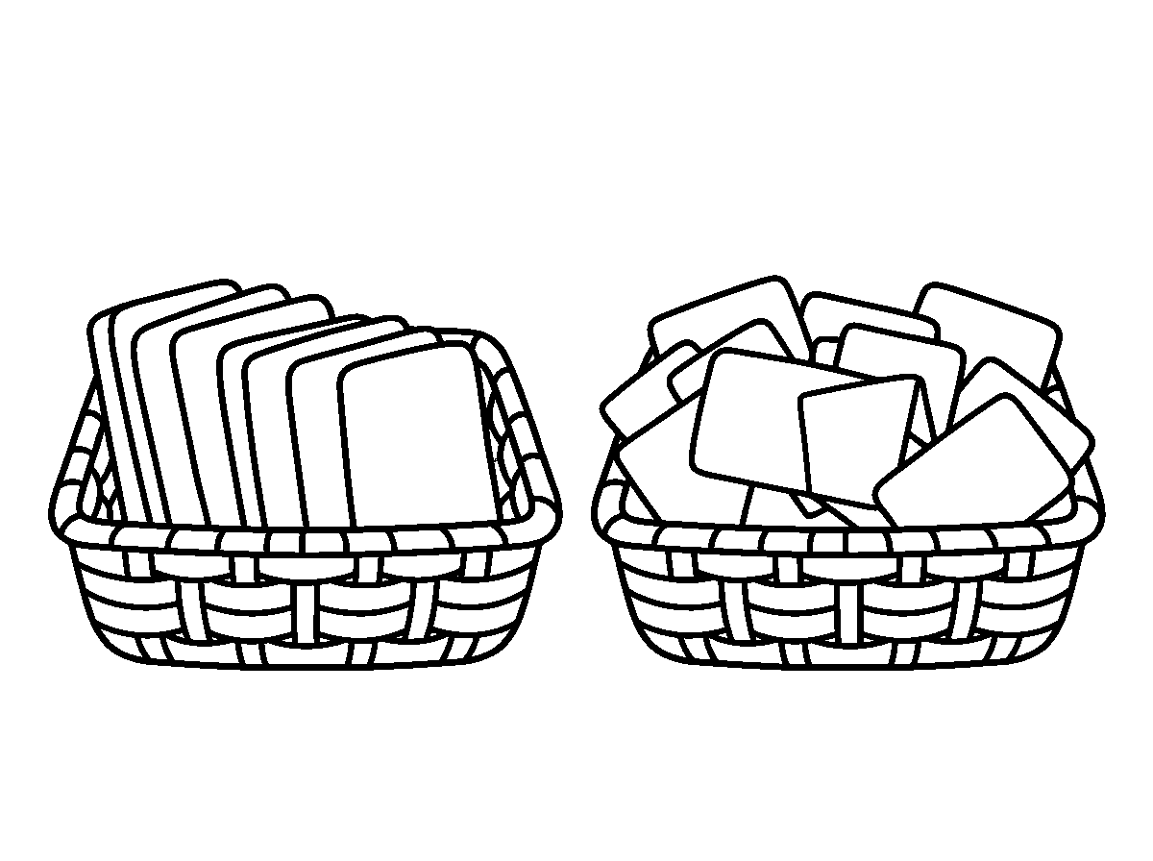

Worksheet
1. The five vowels are A) a, e, i, o, u B) a, b, c, d, e C) x, y, z, w, q D) b, c, d, f, g
2. Letters that are not vowels are called A) names B) sounds C) consonants D) words
3. The vowel(s) in "cat" is/are A) t B) c C) a D) none
4. Which word has TWO vowels? A) cat B) dog C) book D) pen
5. Fill in: The letter that is sometimes a vowel is ____.
6. Write the five vowels in small letters, then the first five consonants.
7. Say whether each of these is a vowel or a consonant: m, o, p, e, s.
My own work
Write your name and circle every vowel in it.
Draw five little houses for a, e, i, o and u, write one letter on each roof, then colour the roofs.

WEEK 2 — SINGLE SOUNDS: d, a, i, m
Depth: NERDC Nursery 3 · Literacy (Language Domain) · First Term W2 (pp 465–469).
You will learn to
• say the sounds /d/, /a/, /i/, /m/
• write the letters d, a, i, m
• blend these four sounds into real words
• hear where a sound sits in a word
Things to know
• Four sounds this week: /d/ as in dog, doll, dad, dig; /a/ as in apple, ant, cat, mat; /i/ as in ink, insect, sit, pin; /m/ as in mum, man, mat, milk.
• With only four sounds I can already make real words: dad, mad, dim, aim, amid, man (with /n/ from before).
• Blending is saying the sounds fast together: d – a – d = dad; m – a – d = mad; d – i – m = dim.
• Segmenting is the opposite: I hear "dim" and say /d/ /i/ /m/, three sounds, three letters.
• Sound positions: in "dog", /d/ is at the beginning; in "mad", /a/ is in the middle; in "bid", /d/ is at the end.
• Writing: d is a circle with a tall stem up; a is a circle with a short line; i is a short line with a dot; m is three little humps.
• Say the sound, not the letter name: /m/, not "em", when we are building words.
• Finger spelling: one finger per sound, then write the letters in order.
• Tricky pair: /d/ and /b/ feel the same in the mouth — the difference is that /d/ uses the tongue tip and stays short.
• Practice game: I raise a card when I hear /m/ in a word you say.
Words for my notebook
d a i m — /d/ dog, /a/ apple, /i/ ink, /m/ mum. d-a-d = dad. m-a-d = mad. d-i-m = dim.
Let us talk
1. Make the sound /m/ for me.
2. Blend: m – a – n.
3. What is the first sound in "dog"?
4. Which of our four letters needs a dot?
5. Say a word that ends with /d/.

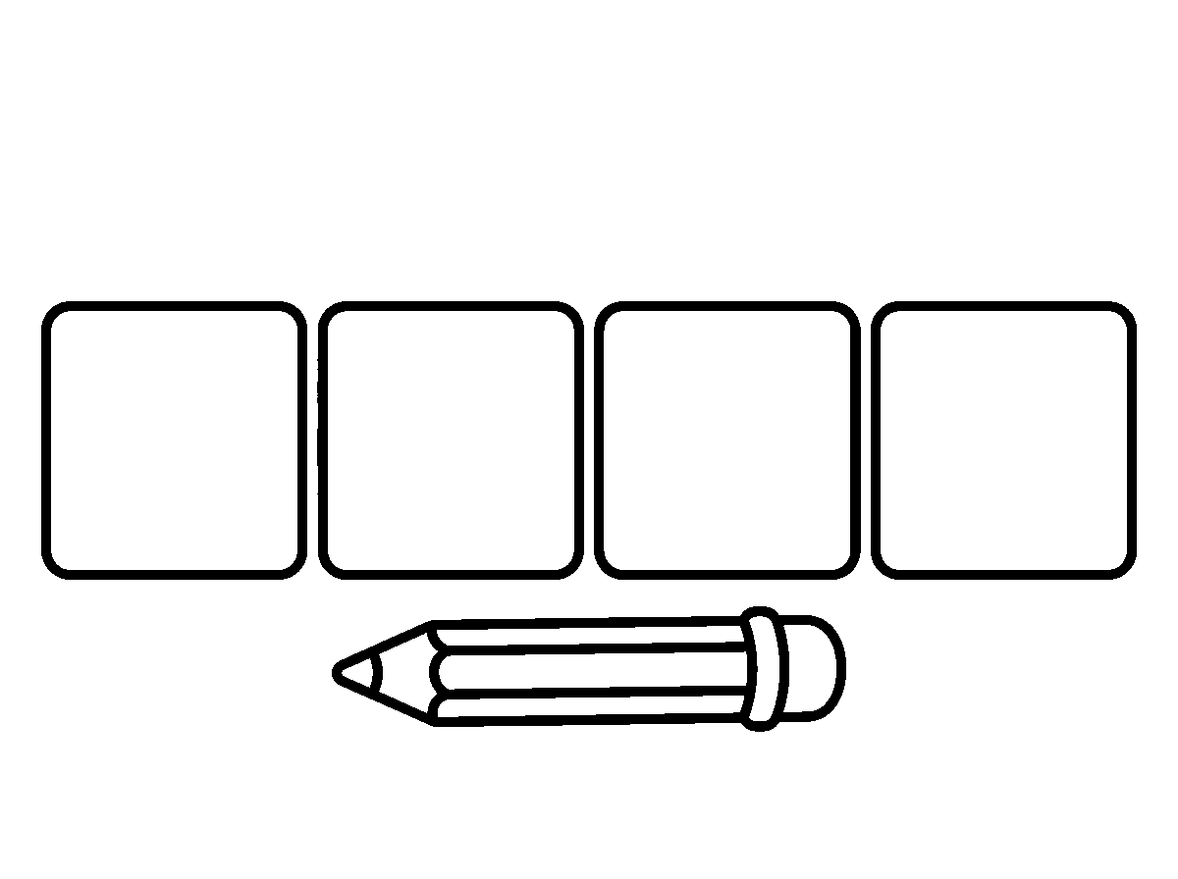
Worksheet
1. The first sound in "mum" is A) /m/ B) /u/ C) /d/ D) /n/
2. d – i – m spells A) dam B) dim C) mad D) mid
3. The sound /a/ is heard at the beginning of A) dog B) mum C) apple D) ink
4. Which letter is written with a dot on top? A) a B) m C) d D) i
5. Fill in: The word "dad" is made of ____ sounds.
6. Write each of d, a, i, m four times in small letters.
7. Say three words that begin with /m/.
My own work
Write the words dad, mad, dim, man and use each in a spoken sentence in class.
Draw a dog, an ant, an insect and a map; write the first sound under each one and colour the ant.

WEEK 3 — SIGHT WORDS: You, Me, Her, We
Depth: NERDC Nursery 3 · Literacy (Language Domain) · First Term W3 (pp 465–469).
You will learn to
• read four sight words at once
• write them correctly
• say what each one means
• use them in sentences
Things to know
• A sight word is a word I know on sight — I do not sound it out, I read it in one look.
• This week's four: you, me, her, we.
• me points at myself; you points at the person I am talking to; her points at a girl or woman; we means me and other people together.
• "You" and "we" start with the same letter w? No — you and we: look carefully, these two are often swapped.
• These words break the sound rules a little, so they must be memorised by the eye: "you" has a y but no /y/ sound in it.
• Flash-card drill: the card shows for two seconds; I say the word before it is hidden.
• Sentences I can now read: "You and me." "We see her." "Her bag is red."
• Writing: these words go on the line with no capitals unless they begin a sentence; "I" is the only small word that is always a capital.
• Memory games: word-to-picture matching, and "what is missing?" when one card is hidden under a book.
• My sight-word bank is growing: this week four, next week three more.

Words for my notebook
you · me · her · we — I read them without spelling. "We see her."
Let us talk
1. Which word points at yourself?
2. Read this card: "you".
3. Make a sentence with "we".
4. Which of these four words is about a girl?
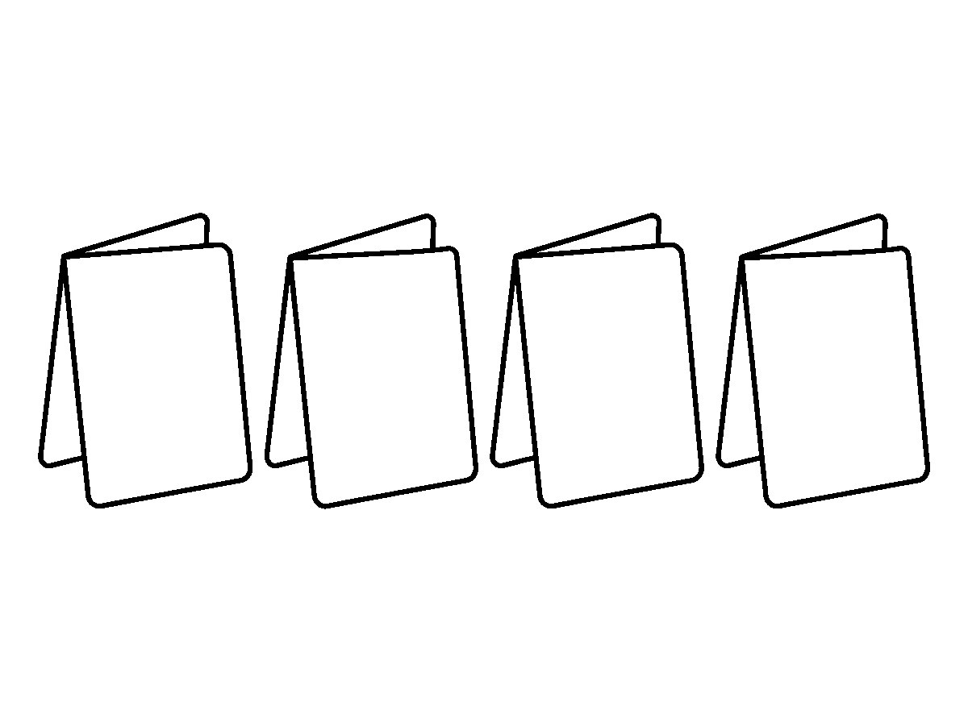
Worksheet
1. The word that points at the person being spoken to is A) her B) me C) you D) we
2. "We" means A) one girl B) me and others C) only me D) many things
3. Choose the correct word: "____ see the fan." A) We B) Me C) Her D) You and me only
4. A sight word is a word that A) must be sounded out B) has six letters C) is always a name D) is read at once
5. Fill in: The four sight words this week are you, me, ____ and we.
6. Write one sentence using "her".
7. Read these cards aloud in class: you — me — her — we.
My own work
Write each of the four words five times and read them to your classmate tomorrow.
Draw the people in your family, point at yourself, write 'me' under that one and colour the picture.

WEEK 4 — SIGHT WORDS: I, Go, Car
Depth: NERDC Nursery 3 · Literacy (Language Domain) · First Term W4 (pp 465–469).
You will learn to
• read and write three sight words you have not used yet
• always write "I" as a capital
• join new words with the old ones
• read short sentences
Things to know
• Three new words: I, go, car.
• I is a single letter but it is always a capital, wherever it stands: "I go." "She and I run."
• go is a verb — it is a doing word; car is a noun — it is a thing.
• My sight words are now seven: you, me, her, we, I, go, car.
• Short sentences I can read and write: "I go." "We go." "I see a car." "You and I go." "I go in her car."
• Word order matters in English: "I go car in" is wrong; "I go in the car" is right.

• Read the whole sentence, then look back at the words you did not know.
• Building sentences: add one word at a time to a short sentence and read it again each time.
• Copying practice: read the word, cover it, write it, then check — never copy letter by letter.
• Dictation: I hear the sentence twice, then write it, then read my own writing back.
Words for my notebook
I · go · car. "I" is always big. Sentences: I go. We go. I see a car.
Let us talk
1. Why is "I" written big?
2. Read this sentence: "I go in her car."
3. Which of this week's words is a doing word?
4. Make a sentence that has "car" and "we".
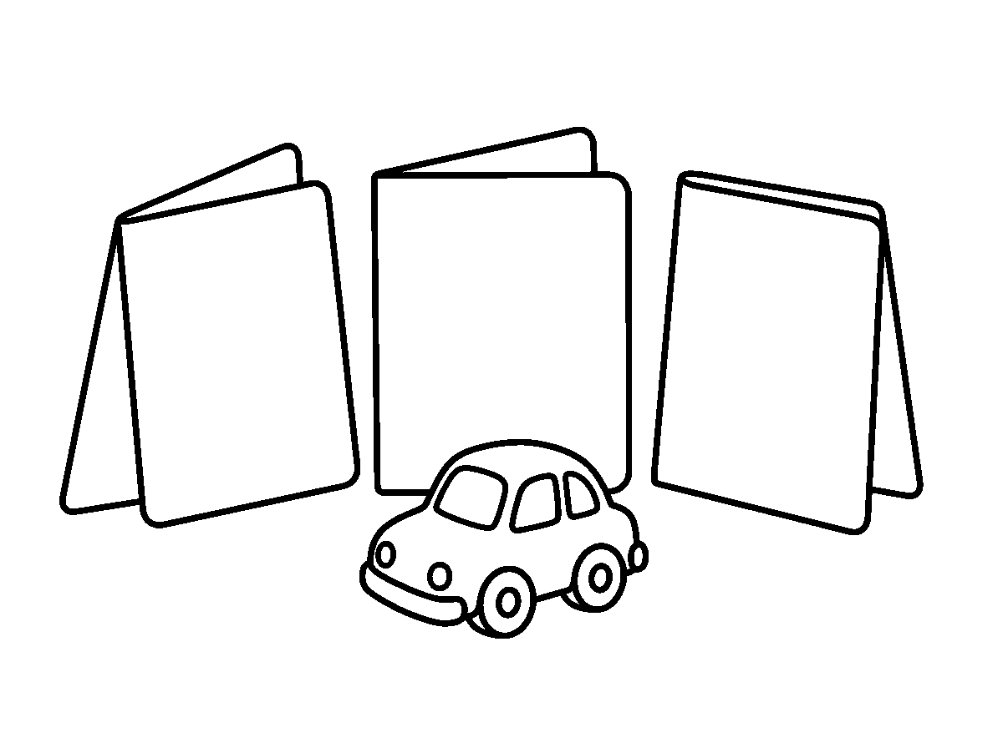
Worksheet
1. The word "I" is written A) always a capital B) always small C) only at the start D) with a dot
2. "car" is a A) thing B) doing word C) letter D) sound
3. Which sentence is correct? A) I go in the car. B) I go car. C) Car I go. D) Go I car.
4. Which sight words do I now know? A) six B) seven C) four D) ten
5. Fill in: "We ____ in her car." (go / car / I)
6. Write two sentences, each using "I" and "car".
7. Read aloud: "You and I go. I see her car."
My own work
Write five sentences using any of the seven sight words, and underline every "I".

WEEK 5 — DIGRAPH: th, ck, wh
Depth: NERDC Nursery 3 · Literacy (Language Domain) · First Term W7 (pp 465–469).
You will learn to
• say what a digraph is
• read and write words with th, ck and wh
• hear /th/ at the beginning and at the end of words
• sort words by their digraph
Things to know
• A digraph is two letters that make one sound: sh, ch, th, ph, wh, ck.
• th makes two different sounds: a soft/buzzy one at the start of the, this, that, with, they, and a hissy one at the end of bath, math, three, think, thumb.

• For the buzzy /th/ my tongue tip touches the teeth and my voice works; for the hissy /th/ the voice is off. Feel your throat to tell them apart.
• ck says /k/ and is nearly always at the end of a small word: back, clock, duck, pick, stick, black, kick.
• wh says /w/ at the start of questions: what, when, where, which, white, wheel.
• Words where two letters do one job are not spelled the way they sound — that is why they need practice.
• Sorting game: three columns on the board — th, ck, wh — and I put each word card in its column.
• Reading practice: "Who took the clock from the bench?" — three digraphs in one sentence.
• Writing: underline the two letters that work together, so I do not forget them.
• Sound hunt: how many words with th can our class say in one minute?
Words for my notebook
A digraph is two letters, one sound. th: this, bath. ck: duck, clock. wh: what, when, where.
Let us talk
1. What is a digraph?
2. Say "this" and "bath" — where is your tongue?
3. Name two words ending in ck.
4. Which two letters are in "what"?
5. Is "sh" a digraph? Why?
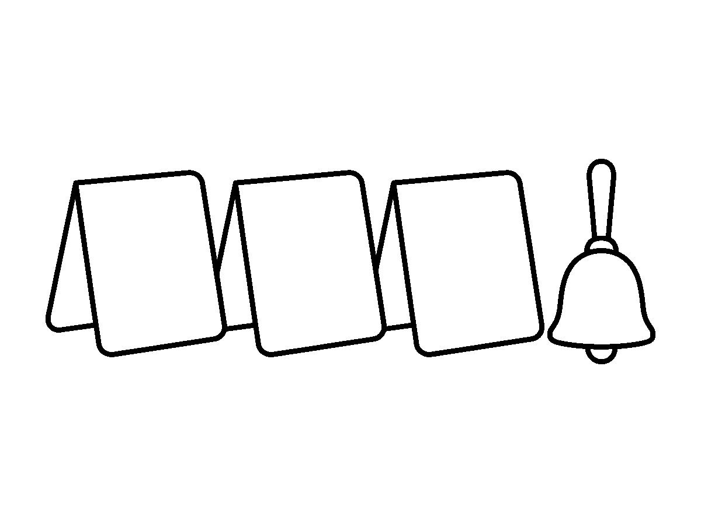
Worksheet
1. A digraph is A) a capital letter B) a word with six letters C) two letters making one sound D) two sounds in one letter
2. The digraph at the end of "duck" is A) ck B) wh C) sh D) th
3. "think" begins with the sound A) /t/ B) /th/ (voice off) C) /f/ D) /s/
4. Which word has "wh"? A) rich B) chin C) back D) which
5. Fill in: The two letters that make the /k/ sound at the end of "clock" are ____.
6. Write two th-words, two ck-words and two wh-words.
7. Underline every digraph in this sentence: "They took the black clock home."
My own work
Find five things at home whose names have a digraph in them and write the digraph under each.

WEEK 6 — SIGHT WORDS: The, This, They
Depth: NERDC Nursery 3 · Literacy (Language Domain) · First Term W8 (pp 465–469).
You will learn to
• read and write three new sight words
• notice the "th" digraph inside them
• use them in sentences
• read longer sentences
Things to know
• Three more sight words: the, this, they.
• All three begin with the th digraph I learnt last week — so my eye already knows two letters of each word.
• "the" is the most common word in English; it points at the one thing you mean: the car, the fan.
• this is for one thing near me; these would be for many (that comes later).
• they means more than one person or thing already spoken about: "Where are the boys? They are outside."
• My sight words are now ten: you, me, her, we, I, go, car, the, this, they.
• Sentences I can read: "This is the car." "They see me." "The cat sat on the mat." "I go with them."
• Do not write "teh" — the letters in "the" are t-h-e and the h is not a mistake.
• Flash-card speed: ten cards, ten seconds each, no sounding out.
• Writing practice: one sentence with "this", one with "they", then read them back to check.
Words for my notebook
the · this · they — all start with the th digraph. "This is the car." "They see me."
Let us talk
1. Which of our new words is the commonest word in English?
2. Read: "They see this."
3. Point at one thing and say a sentence with "this".
4. What do "the", "this" and "they" have in common at the start?
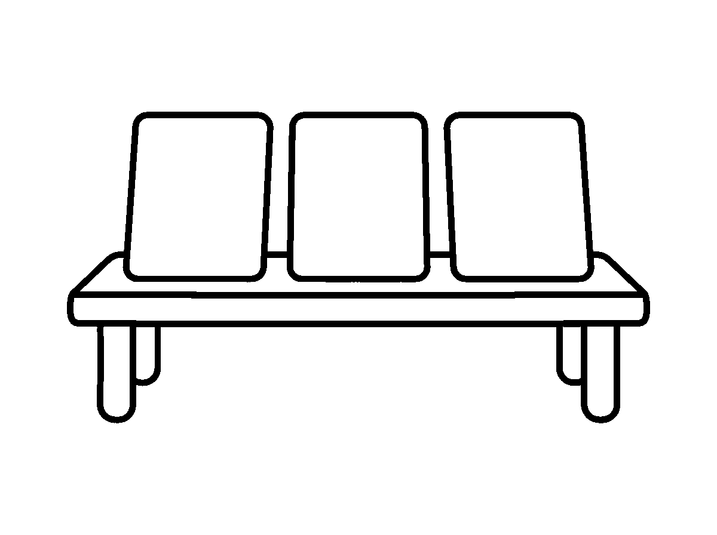
Worksheet
1. "the", "this" and "they" all begin with A) wh B) th C) sh D) ch
2. The word that points at one thing near me is A) the B) me C) this D) they
3. "They" means A) more than one person or thing B) a place C) a doing word D) one thing
4. How many sight words do I know now? A) ten B) seven C) twelve D) six

5. Fill in: "____ is the fan." (This / They / Me)
6. Write two sentences, one with "the" and one with "they".
7. Read all ten of your sight words from a card in class.
My own work
Make a card for each of the ten sight words and keep them in your pencil case for reading practice.
Draw three things in this room you could say 'this' about, and colour two of them.

WEEK 8 — DIGRAPH: ph, sh, ch
Depth: NERDC Nursery 3 · Literacy (Language Domain) · First Term W9 (pp 465–469).
You will learn to
• read and write words with ph, sh and ch
• know that ph sounds like f
• tell the three sounds apart by ear
• sort words into digraph families
Things to know
• ph says /f/: phone, photo, elephant, graph, dolphin. Strange, but true in most English words.
• sh says /ʃ/ — the quiet sound a mother makes: ship, shop, fish, wash, she, shell, brush, shoe.
• ch says /tʃ/ — a quick soft hitting sound: chair, church, chat, chip, much, bench, lunch, chin.
• "sh" and "ch" are easy to confuse by ear: ship / chip, wash / watch. Say them slowly, then check.
• sh can sit at the start or the end of a word (shop, fish); ch is common at both ends too (chair, much); ph is usually at the start or end (phone, graph).
• Digraph families I now have: th, ck, wh, ph, sh, ch.
• Sorting game: put word cards under the right digraph on the wall chart.
• Sentence reading: "The children wish for a new phone." — ch, sh and ph all in one line.
• Writing: write the two letters together, never one alone; "fone" is a spelling mistake even though it sounds right.
Words for my notebook
ph = /f/ (phone, photo). sh (ship, fish). ch (chair, much). Six digraphs now: th, ck, wh, ph, sh, ch.
Let us talk
1. What sound does ph make?
2. Name three things with "sh" in their names.
3. Say "ship" then "chip" — how are they different?
4. In "elephant", which letters say /f/?
5. Which digraph is in "lunch"?

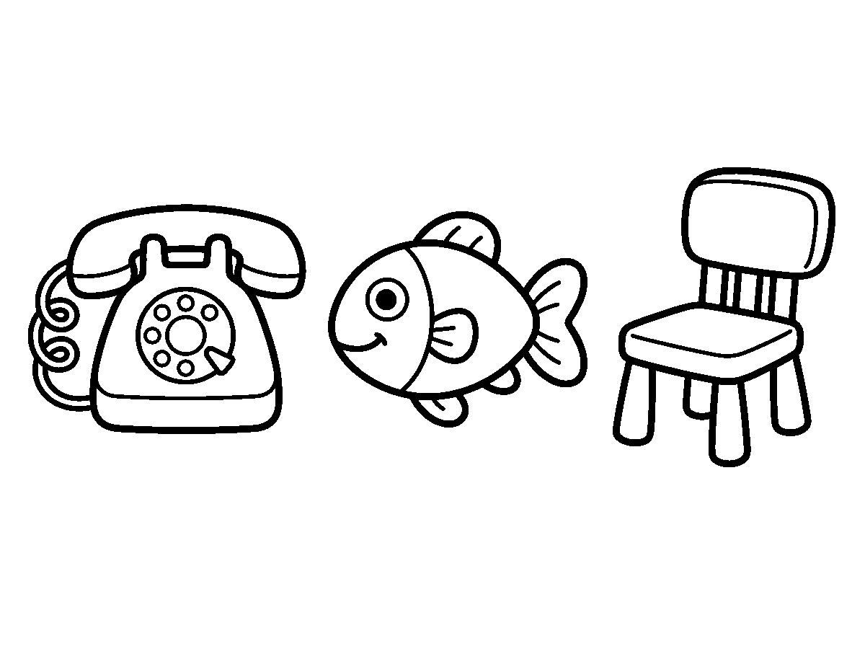
Worksheet
1. "ph" is pronounced like A) f B) v C) p D) ph
2. Which word has the "sh" digraph? A) step B) soap C) shop D) ship and shop — choose the odd one
3. The digraph in "much" is A) th B) ck C) sh D) ch
4. Which spelling is correct? A) phoe B) phone C) phon D) fone
5. Fill in: In "photo", the two letters that make one sound are ____.
6. Write two words each with ph, sh and ch.
7. Read this sentence twice: "The children wash the chess board on the bench."
My own work
Look for five digraph words in any of your story books and write them with their digraph underlined.
Draw a phone, a fish and a child; write the two-letter sound under each and colour the fish.

WEEK 9 — SIGHT WORDS: Photo, She, Chart · CONSONANT BLENDS: Play, Fly, Greet
Depth: NERDC Nursery 3 · Literacy (Language Domain) · First Term W10 (pp 465–469).
You will learn to
• read and write three sight words that carry digraphs
• say what a consonant blend is
• read words with pl, fl and gr
• tell a blend from a digraph
• read and write sentences using everything I know
Things to know
• Three sight words: photo (has ph), she (has sh), chart (has ch) — my digraph words are now sight words.
• A consonant blend is two consonants together where I still hear both sounds: play, fly, greet, blue, clap, frog.
• That is the difference: in a digraph two letters make one sound (sh, ch, ph); in a blend two letters keep both sounds (pl = /p/ + /l/).
• pl: play, please, plant, plus, plum.
• fl: fly, flag, flip, flat, flower.
• gr: greet, green, grab, grass, grape.
• My sight words are now thirteen: you, me, her, we, I, go, car, the, this, they, photo, she, chart.
• Reading: "She can play with the children." "I greet the girl in the green dress." "We go to the chart."
• Blending practice with three sounds: s-p-l-a-t has five letters but the blend /spl/ plus at — that is how longer words begin to open for me.

• Last week of teaching: I read my thirteen words and my six digraphs from the wall chart without help.
Words for my notebook
photo · she · chart. Blends: pl (play), fl (fly), gr (greet). A blend keeps both sounds; a digraph makes one.
Let us talk
1. Which digraph is in "photo"?
2. What sounds are in the blend "fl"?
3. Say a word beginning with "gr".
4. Is "sh" a blend or a digraph, and how do you know?
5. Read this sentence: "They play in the green grass."

Worksheet
1. "photo", "she" and "chart" each contain A) six letters B) two vowels C) a blend D) a digraph
2. In the blend "pl", how many sounds do I hear? A) two B) one C) none D) three
3. Which word begins with a blend? A) shop B) thin C) fly D) chat
4. "greet" begins with the blend A) gr B) ee C) g D) r
5. Fill in: A digraph is two letters with ____ sound; a blend is two consonants with both sounds.
6. Write three words each with pl, fl and gr.
7. Read and copy this sentence: "She can play with the children in the green field."
My own work
Write five sentences using your sight words, and underline every digraph and blend you use.
LITERACY — LETTER WORK

WEEK 1 — REVIEW OF ALPHABET: Aa – Ff
Depth: NERDC Nursery 3 · Literacy (Letter Work) · First Term W1 (pp 454–457).
You will learn to
• know the letters A to F in big and small form
• match a capital letter to its small letter
• say the sound of each letter
• trace and write Aa to Ff
Things to know
• The alphabet has 26 letters; I am reviewing the first six: A a, B b, C c, D d, E e, F f.
• A letter has two shapes: capital (big) and small (lower case). Capitals begin names and sentences.
• A a says /a/ — apple, ant; B b says /b/ — ball, bat; C c says /k/ — cat, cup.

• D d says /d/ — dog, doll; E e says /e/ — egg, hen; F f says /f/ — fan, fish.
• The sound a letter makes is not the same as its name: the letter is "bee", the sound is /b/.
• Matching game: capital card to small card — A with a, B with b, and so on.
• Initial sound: the first sound I hear in a word. "Fan" starts with /f/, so it belongs to F.
• Writing: a sits on the line, b has a tall stem up, no tail; f goes up and has a cross-bar.
• Alphabet song slowly: A B C D E F, then stop and clap the six sounds.
Words for my notebook
Aa Bb Cc Dd Ee Ff — apple, ball, cat, dog, egg, fan.
Let us talk
1. Sing the first six letters.
2. What sound does C make?
3. Name a word that starts with /d/.
4. Which small letter goes with E?
5. Trace b and d: which one has its tall stem up?
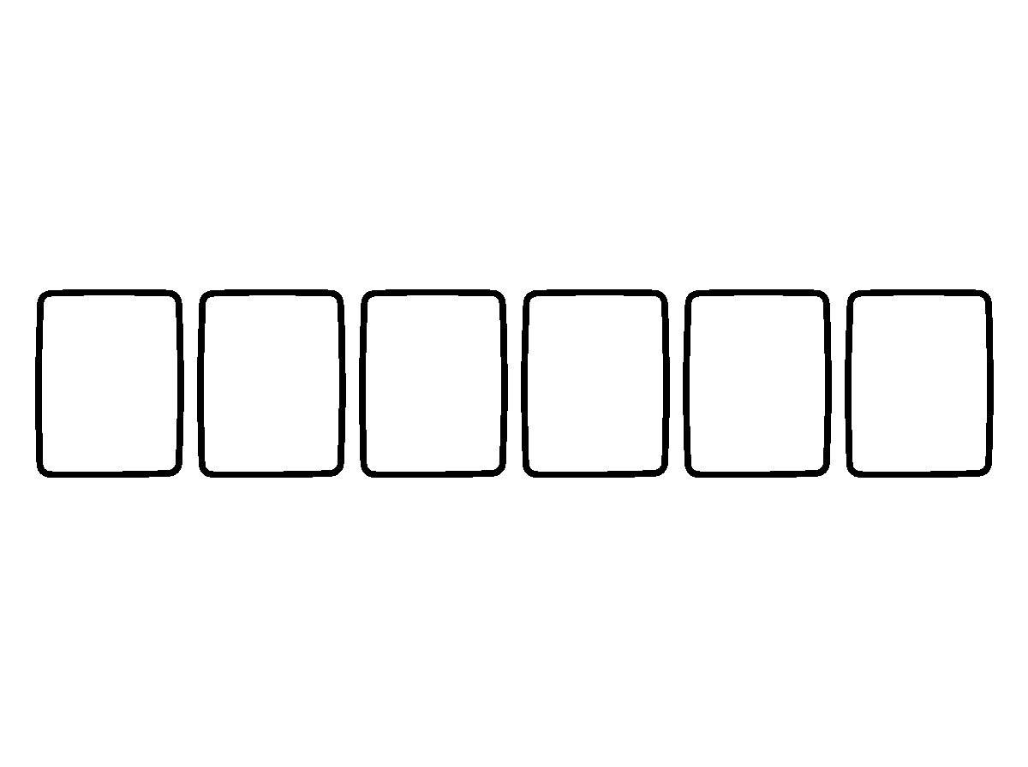
Worksheet
1. The small letter of "B" is A) p B) b C) d D) q
2. Which word begins with /f/? A) fan B) cat C) man D) van
3. The sound of the letter A in "apple" is A) /a/ B) /e/ C) /o/ D) /i/
4. Which pair matches? A) Ee B) Cc C) Dd D) Ff — find the odd one out in the pairs Aa, Bb, Cc, De
5. Fill in: The letter that begins "egg" is ____.
6. Write Aa to Ff, one line of capitals and one line of small letters.
7. Draw one thing for B and one thing for F, and write the letter beside each.
My own work
Find six things at home that begin with A, B, C, D, E, F and write their letters.

WEEK 2 — REVIEW OF ALPHABET: Gg – Ll
Depth: NERDC Nursery 3 · Literacy (Letter Work) · First Term W2 (pp 454–457).
You will learn to
• know the letters G to L
• say the sound of each of them
• match capitals to small letters
• write Gg to Ll on the line

Things to know
• G g, H h, I i, J j, K k, L l — the next six letters.
• Sounds: G /g/ — goat, gun; H /h/ — hat, hen; I /i/ — ink, insect; J /dʒ/ — jug, jam; K /k/ — kite, key; L /l/ — lion, lamp.
• G and K make the same sound in most small words (goat, kite) — that is not a mistake, English is like that.
• The letter I is also the word for me: "I" is always a capital, even in the middle of a sentence.
• Matching: capital to small, letter to picture, letter to the first sound in my name.
• Writing: g goes down below the line; h is tall; i has a dot; j has a dot and a tail; k is tall with two arms; l is a tall straight line.
• Sound hunt: point to things in the room that begin with /h/, /l/, /g/.
• My letters so far: Aa Bb Cc Dd Ee Ff Gg Hh Ii Jj Kk Ll — twelve.
Words for my notebook
Gg Hh Ii Jj Kk Ll — goat, hat, ink, jug, kite, lion.
Let us talk
1. What sound does H make?
2. Which letter always looks like a capital, even in the middle of a sentence?
3. Name a word that starts with /k/.
4. Say your letters from A to L.
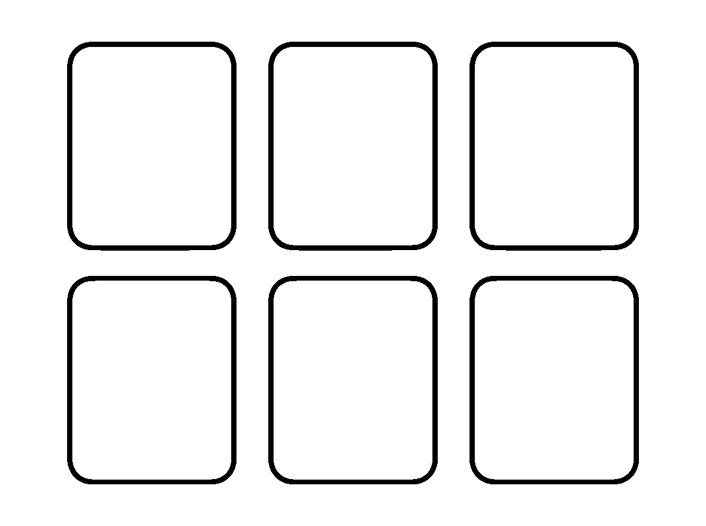
Worksheet
1. The letter that begins "lion" is A) i B) n C) r D) l
2. Which pair does NOT match? A) Jj B) Kk, kite — choose: G–goat, H–hat, J–kite C) Gg D) Hh
3. /g/ is the sound of A) l B) g C) j D) k
4. Which letters both say /k/? A) G and L B) H and J C) C and K D) I and K
5. Fill in: The small letter of "H" is ____.
6. Circle the words that start with I: ink — insect — igloo — apple.
7. Write Gg to Ll, capitals and small letters.
My own work
Write the first letter of your name and your friend's name in capital and small form.

WEEK 3 — REVIEW OF ALPHABET: Mm – Rr
Depth: NERDC Nursery 3 · Literacy (Letter Work) · First Term W3 (pp 454–457).
You will learn to
• know the letters M to R

• say their sounds
• hear the first sound in a spoken word
• write Mm to Rr neatly
Things to know
• M m, N n, O o, P p, Q q, R r.
• Sounds: M /m/ — mat, man, milk; N /n/ — net, nut; O /ɒ/ — orange, ox; P /p/ — pen, pan; Q /kw/ — queen; R /r/ — rat, run.
• Q is nearly always followed by u: queen, quick, quiet — that is why its sound is /kw/.
• M and N are nasal sounds: I feel them in my nose, and my mouth closes for /m/ but not for /n/.
• Initial sound practice: hear "pan" → /p/; "net" → /n/; "run" → /r/.
• Writing: m has three strokes, n two, p goes down below the line, q below too; o is a full circle.
• Sorting game: which letters sit on the line and which have tails below it (g, j, p, q).
• My alphabet so far: eighteen letters, from Aa to Rr.
Words for my notebook
Mm Nn Oo Pp Qq Rr — mat, net, orange, pen, queen, rat.
Let us talk
1. What sound does N make?
2. Which letter always wants a "u" after it?
3. Say the first sound in "orange".
4. Which of your letters has a tail below the line?
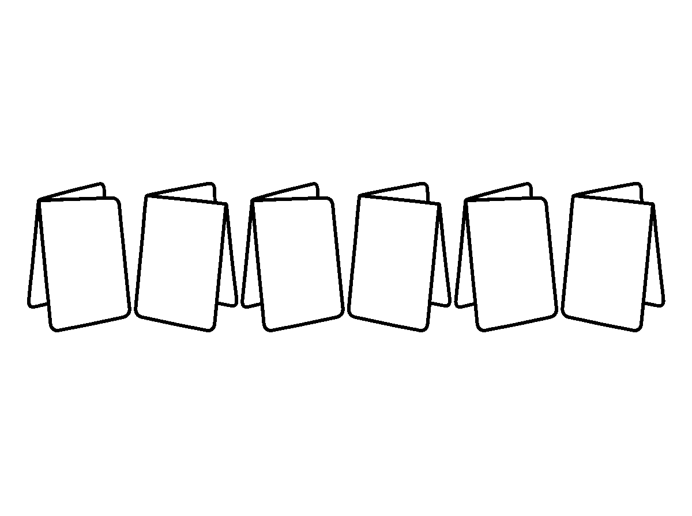
Worksheet
1. "Queen" begins with the sound A) /k/ B) /n/ C) /q/ D) /kw/
2. The letter that begins "net" is A) r B) n C) m D) o
3. Which letter goes below the line when we write it? A) p B) m C) n D) o
4. The sound /m/ is heard first in A) net B) rat C) mat D) pen
5. Fill in: Q is nearly always followed by the letter ____.
6. Write Mm to Rr, capitals and small letters.
7. Say three words that start with /p/.
My own work
Look round the class and write down the first letter of six things you can see.
Write the letters M to R in large shapes on one page and colour each letter a different colour.

WEEK 4 — REVIEW OF ALPHABET: Ss – Zz
Depth: NERDC Nursery 3 · Literacy (Letter Work) · First Term W4 (pp 454–457).

You will learn to
• know the last letters S to Z
• say the sound of each
• write the whole alphabet in order
• finish the alphabet review
Things to know
• S s, T t, U u, V v, W w, X x, Y y, Z z — the last eight letters.
• Sounds: S /s/ — sun, sock; T /t/ — tap, tin; U /ʌ/ — umbrella, up; V /v/ — van, vat. W /w/ — water, wet; X /ks/ — box, fox; Y /j/ — yam, yes; Z /z/ — zebra, zone.
• X usually comes at the end of small English words: fox, box, six. Its sound is /ks/.
• V and W are not the same: for /v/ my teeth touch my lip; for /w/ my lips make a round hole.
• "X-mas" is not a word to start with x — say the sound at the end of "fox".
• Now the whole alphabet: Aa Bb Cc Dd Ee Ff Gg Hh Ii Jj Kk Ll Mm Nn Oo Pp Qq Rr Ss Tt Uu Vv Ww Xx Yy Zz — 26 letters.
• Singing it all: the alphabet song from A to Z with the sounds after each letter.
Words for my notebook
Ss Tt Uu Vv Ww Xx Yy Zz — sun, tap, umbrella, van, water, box, yam, zebra. The alphabet has 26 letters.
Let us talk
1. Say the alphabet from A to Z without looking.
2. What sound does Z make?
3. Where does the letter X usually appear in a small word?
4. Show me the difference between /v/ and /w/.
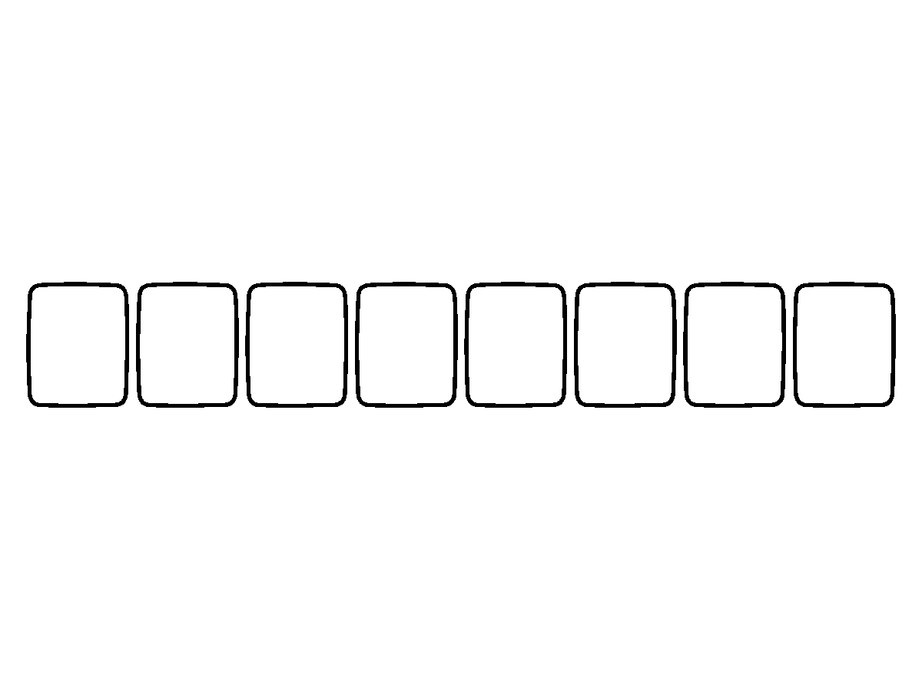
Worksheet
1. The number of letters in the English alphabet is A) 24 B) 27 C) 26 D) 25
2. "Zebra" begins with the sound A) /s/ B) /dʒ/ C) /v/ D) /z/
3. Which letter is NOT in the last eight? A) Q B) V C) W D) Y
4. The sound of X in "fox" is A) /s/ B) /ex/ C) /ks/ D) /z/
5. Fill in: The letter between T and V is ____.
6. Write the whole alphabet in small letters in your book.
7. Circle the letters that begin your name, your mother's name and your father's name.
My own work
Write your full name and underline each letter you have learnt this term.
Write the letters S to Z in large shapes and colour only the ones made with straight lines.

WEEK 5 — THREE-LETTER WORDS: CVC PATTERN (Part 1)
Depth: NERDC Nursery 3 · Literacy (Letter Work) · First Term W7 (pp 454–457).
You will learn to
• say what a CVC word is
• blend three sounds into one word
• read the -at and -an word families
• write three-letter words
Things to know
• A three-letter word has three sounds: a consonant, a vowel, a consonant — we call it CVC.
• To blend means to run the sounds together: c – a – t … cat. Say it slowly, then fast.
• The middle letter of these words is the short vowel a, so the family rhymes.
• The -at family: cat, bat, rat, mat, hat, sat, fat.
• The -an family: can, man, pan, ran, fan, van, tan.
• Changing the first sound makes a new word: cat → hat → bat → mat — only the first sound moves.
• Reading a CVC sentence: "The cat sat on the mat." — six words, all easy once I blend.
• Writing: say each sound, write its letter, then read my word back from left to right.
• Never write the sounds in the wrong order — read what you wrote to be sure.
Words for my notebook
c-a-t = cat. The -at family: cat, bat, rat, mat, hat, sat. The -an family: can, man, pan, ran, fan, van.
Let us talk
1. Blend this for me: m – a – t.
2. What is the middle sound in "pan"?
3. Change one sound in "cat" to make a new word.
4. Read: "The man ran."
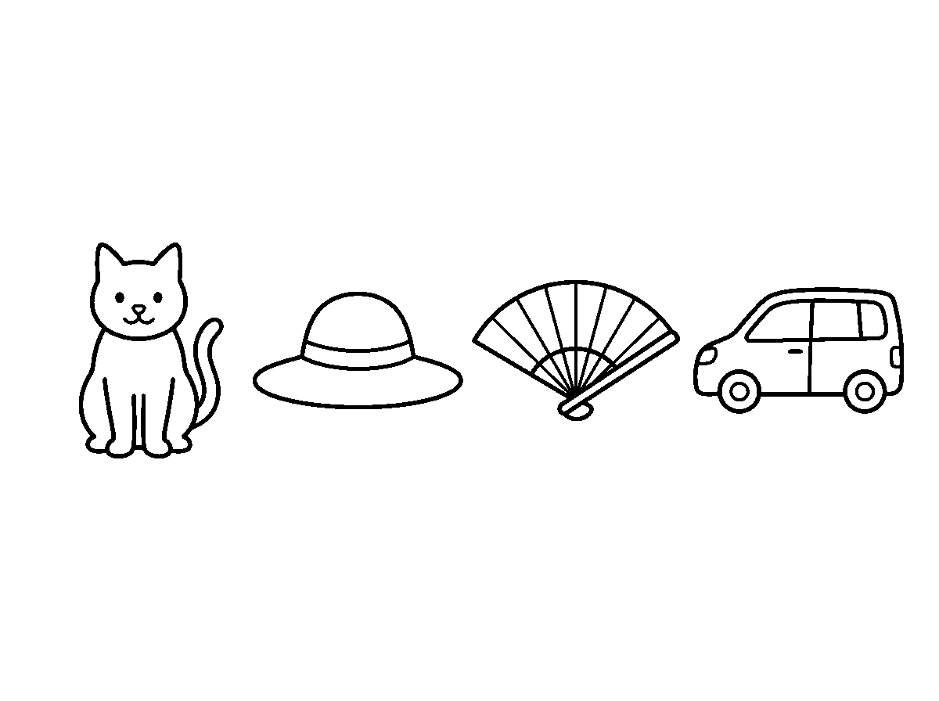
Worksheet
1. A CVC word has the pattern A) three consonants B) three vowels C) vowel-consonant-vowel D) consonant-vowel-consonant
2. The word made by b-a-t is A) bat B) but C) tab D) bet
3. Which word belongs to the -an family? A) pen B) pin C) mat D) pan
4. In "cat", the vowel is A) none B) t C) a D) c
5. Fill in: m – a – ____ = man.
6. Write four words from the -at family.
7. Read this sentence twice: "The rat sat on the mat."

My own work
Write five CVC words and draw a small picture for two of them.

WEEK 6 — THREE-LETTER WORDS: CVC PATTERN (Part 2)
Depth: NERDC Nursery 3 · Literacy (Letter Work) · First Term W8 (pp 454–457).
You will learn to
• read the -en, -in and -og families
• blend words with the short e and short i sounds
• hear the difference between e and i
• take dictation of three-letter words
Things to know
• The -en family: pen, hen, ten, men, den, wren.
• The -in family: pin, tin, bin, win, fin, sin.
• The -og family: dog, log, fog, hog, jog.
• Short e — my mouth is open a little and flat: pen, ten, hen. Short i — my mouth is smaller and higher: pin, tin, hit.
• The pair that tricks people: pen / pin, ten / tin, beg / big. Listen for the vowel.
• Blending practice: p – e – n = pen; d – o – g = dog.
• Dictation: hear the word, say its sounds one by one with a finger for each, then write the letters.
• Word-picture matching: the picture of ten fingers goes with "ten", not "tin".
• Make a new word from an old one by changing the middle sound: pen → pin → pan.
Words for my notebook
pen, hen, ten · pin, tin, win · dog, log, fog. Short e and short i are different sounds.
Let us talk
1. Blend: h – e – n.
2. Say "ten" and "tin" — how are they different?
3. What word is d-o-g?
4. Change the middle sound in "pin" to make "pan".
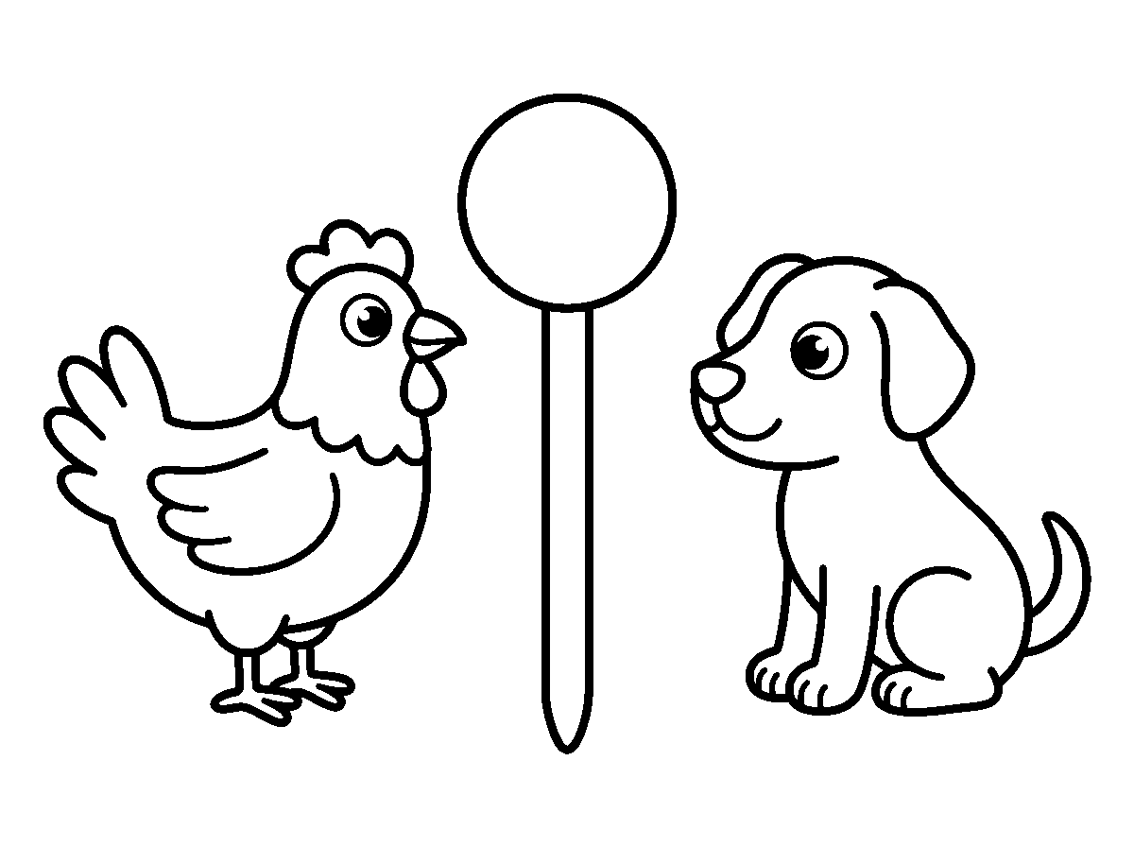
Worksheet
1. The word made by t-e-n is A) ten B) tin C) ton D) tan
2. Which word has the short i sound? A) hen B) pen C) ten D) bin
3. "dog" belongs to the family A) -in B) -en C) -at D) -og
4. The first sound in "hen" is A) /hen/ B) /h/ C) /n/ D) /e/
5. Fill in: p – i – n spells ____.
6. Write two words from -en and two from -in.
7. Take dictation of four words and read your answers back.

My own work
Write the -en, -in and -og words on three cards each and shuffle them into their families at home.
Draw a cat, a pen and a pot; write the word under each picture and colour the pot.

WEEK 8 — THREE-LETTER WORDS: CVC PATTERN (Part 3)
Depth: NERDC Nursery 3 · Literacy (Letter Work) · First Term W9 (pp 454–457).
You will learn to
• read the -un, -op and -ug families
• build words from letter cards
• read all six word families together
• write CVC words without help
Things to know
• The -un family: sun, bun, run, fun, gun, spun.
• The -op family: top, hop, mop, pop, cop, drop.
• The -ug family: bug, hug, mug, rug, jug, tug.
• Word building with cards: give me s, u, n — I put them in order and read "sun".
• Sentence practice: "The big bug sat on the rug." — five words, and I can read all of them.
• The families so far: -at, -an, -en, -in, -og, -un, -op, -ug — that is the whole of my CVC collection.
• Reading games: sound a word, write it, and match it to a picture; read the fastest list in the class.
• Independent writing: no looking, say the sounds slowly, and write one letter per sound.
• Words that look similar: bun / fun / run, top / hop / mop — the first sound changes the word.
Words for my notebook
sun, bun, run · top, hop, mop · bug, hug, mug. I can read eight word families now.
Let us talk
1. Read: "The pup ran home."
2. What is the family of "mop"?
3. Change one sound in "sun" to make "fun".
4. Name the middle sound in "rug".
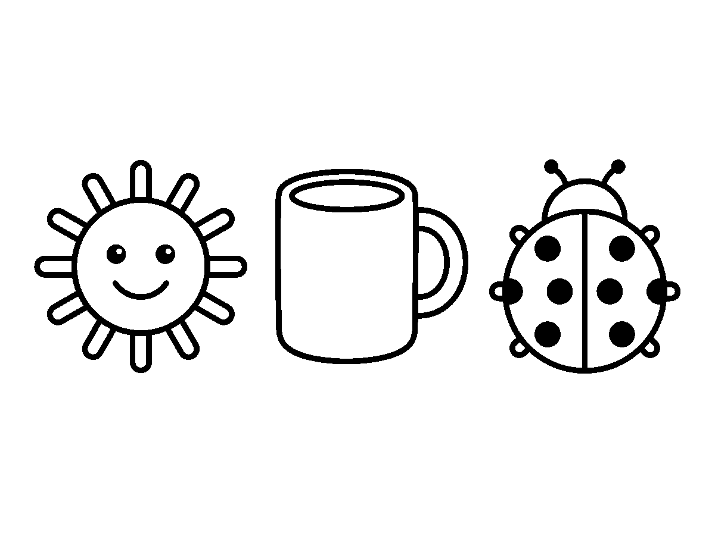
Worksheet
1. The word s-u-n is A) sun B) son C) sin D) san
2. "mug" belongs to the family A) -en B) -op C) -un D) -ug
3. Which word is made from the sounds b-u-g? A) bog B) bag C) bug D) big

4. The first sound in "top" is A) /p/ B) /t/ C) /to/ D) /o/
5. Fill in: The word that rhymes with "hop" and means the highest place is ____.
6. Build and write four words from the -un family.
7. Read this sentence: "The fun bug ran on the rug."
My own work
Write one sentence that uses three words from the families you have learnt.

WEEK 9 — STORY TELLING AND LETTER WORK INTEGRATION
Depth: NERDC Nursery 3 · Literacy (Letter Work) · First Term W10 (pp 454–457).
You will learn to
• listen to a simple story and answer questions on it
• pick out letters and sounds from story words
• retell a story in my own words
• find CVC words inside a story
Things to know
• Listening rules: eyes on the teller, mouth quiet, hands still, and think about what is happening.
• Our story for the week: "The Rat and the Sun" — a rat, a mat, a pot and a hot sun.
• Comprehension questions are asked in this order: who, what, where, when, why.
• The words in the story that I can already read: rat, sat, mat, sun, bun, pin — all CVC words.
• Sound hunt: in the story, how many words begin with /s/? with /r/?
• Retelling: say it in three parts — the beginning, the middle, the end.
• The moral is the lesson the story teaches: for our story, small and clever can beat big and hot.
• Drawing story elements: I draw the rat, the mat, the sun, and label each with its first letter.
• Vocabulary from the story: scorching, clever, shade — new words go in my notebook.
• Telling my own story: every child says one sentence in turn, and we build a story together.
Words for my notebook
Who? What? Where? When? Why? — the five questions for any story.
Let us talk
1. Who was in our story?
2. What did the rat sit on?
3. Where was the shade?
4. Tell the beginning of the story in one sentence.
5. Draw one part of the story and write the letter it begins with.

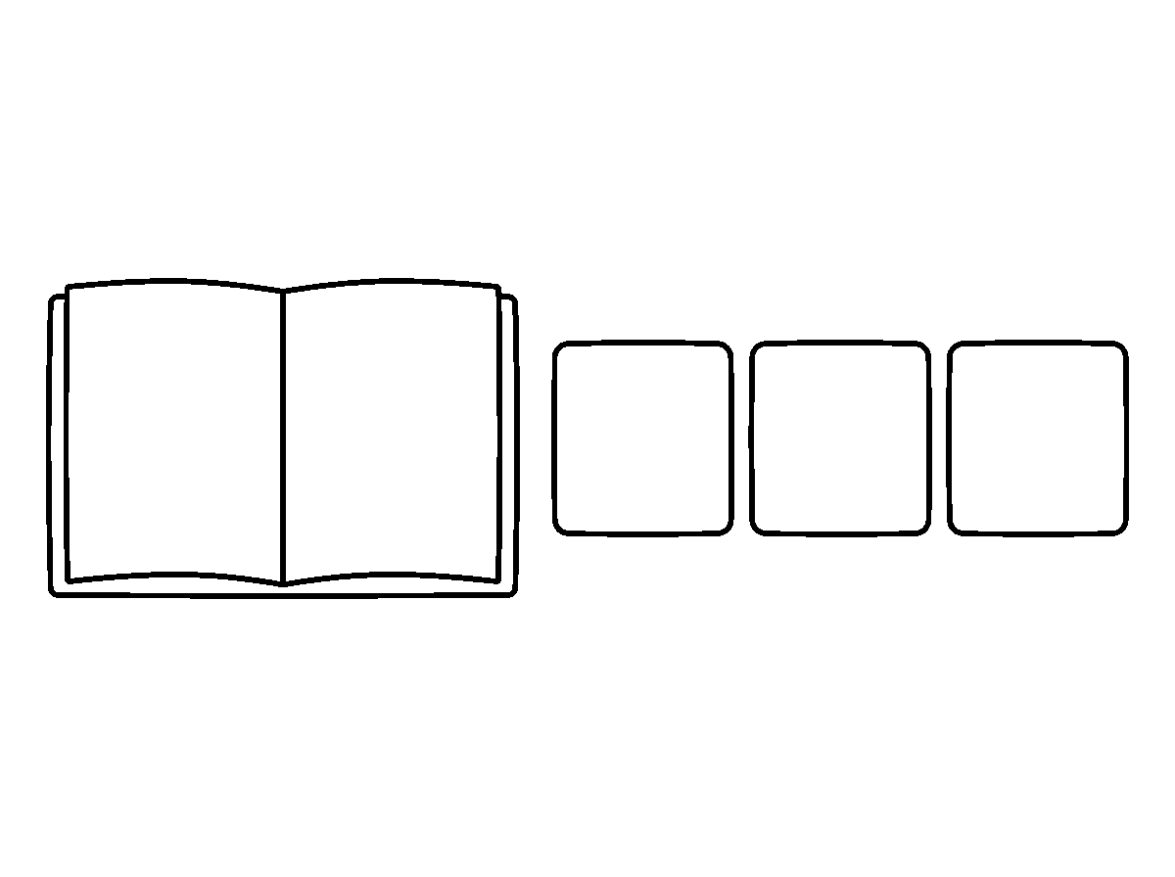
Worksheet
1. The question that asks about a person is A) what B) where C) why D) who
2. Which of these is a CVC word from our story? A) rat B) shade C) scorching D) clever
3. The lesson a story teaches is called the A) ending B) rhyme C) title D) moral
4. The first part of a story is the A) beginning B) cover C) middle D) end
5. Fill in: In the story, the rat sat on the ____.
6. Write the letters of the three characters you liked in our story.
7. Retell our story in three sentences: beginning, middle, end.
My own work
Tell a story of your own to your classmate and ask them two questions about it.
NUMERACY

WEEK 1 — WHOLE NUMBERS 1–200
Depth: NERDC Primary 2 · Mathematics · First Term W1 and W2 (pp 675–676); Nursery 3 · Numeracy · Second Term W7.
You will learn to
• count from 1 to 200 without losing my place
• read and write numbers 1–200 in figures and in words
• say how many hundreds, tens and units are in a number
• compare two numbers with >, < and =
• count in 2s, 3s, 5s and 10s
Things to know
• Counting 1–100 is what I already know; this week we go on to 101, 102 … 200.
• 100 is one hundred. 200 is two hundred — it is two hundreds, or twenty tens.
• Every number has a place: hundreds, tens, units (ones). In 147 the 1 is one hundred, the 4 is four tens, the 7 is seven units.
• Expanded form: 147 = 100 + 40 + 7. The word "expanded" means opened out.
• Reading a number written in words: "one hundred and forty-seven" → 147; "one hundred and ninety-one" → 191; "two hundred" → 200.
• Comparing: > is greater than, < is less than, = is equal to. The open mouth faces the bigger number: 147 > 74.
• Ordering 147, 102, 200, 96 from smallest to largest: 96, 102, 147, 200.

• Skip counting: by 2s — 2, 4, 6 … 20; by 5s — 5, 10, 15, 20; by 10s — 10, 20, 30 … 200.
• Even numbers end in 0, 2, 4, 6, 8; odd numbers end in 1, 3, 5, 7, 9.
• Counting is easier when I touch one object for one number: twenty caps, twenty sticks, twenty beads.
• We celebrate it: "I can count to two hundred!"
Words for my notebook
147 = 100 + 40 + 7. The places are hundreds, tens and units. 147 > 74. Counting by 10s: 10, 20, 30 … 200.
Let us talk
1. Count from 95 to 105.
2. In the number 152, which digit is the tens?
3. Say 100 + 60 + 3 as one number.
4. Which is bigger, 189 or 198?
5. Count by fives from 5 to 50.
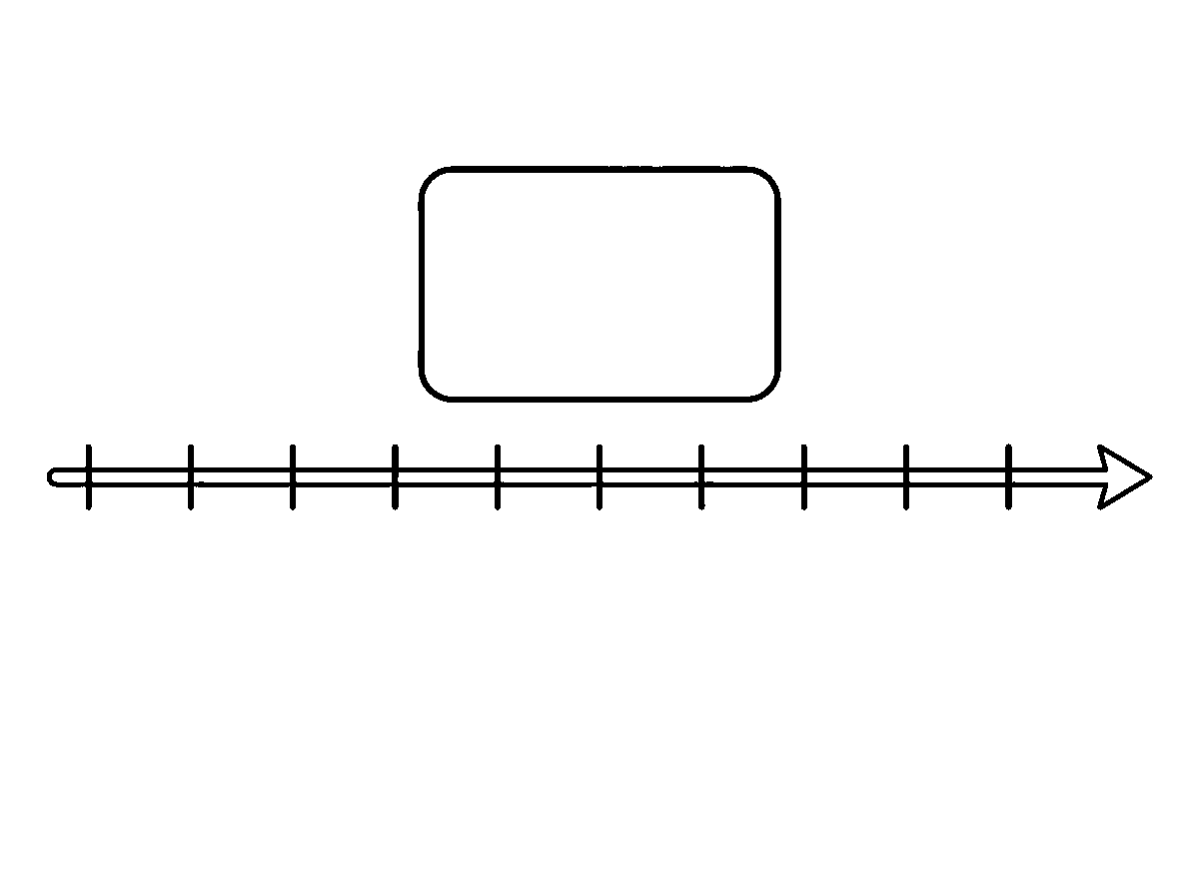
Worksheet
1. Two hundred is the same as A) twenty tens B) two units C) two hundred units only D) two tens
2. In 163, the 6 stands for A) six units B) sixteen C) six hundreds D) six tens
3. The expanded form of 128 is A) 12 + 8 B) 1 + 2 + 8 C) 100 + 20 + 8 D) 100 + 28
4. Which sign is correct: 96 ___ 102? A) < B) > C) none D) =
5. Fill in: Counting in 10s, after 170 comes ____.
6. Write "one hundred and ninety-one" in figures.
7. Arrange 105, 99, 200, 150 from smallest to greatest.
My own work
Count the spoons in your house up to one hundred, and write the number you reached in figures and in words.
Draw twenty dots in two rows of ten and colour one whole row.

WEEK 2 — PLACE VALUE
Depth: NERDC Nursery 1 · Numeracy · Second Term W2 and Third Term W2 (tens and ones), reinforced by Primary 2 · First Term W1–W2.
You will learn to
• group objects into tens and ones
• say the tens and ones in a two-digit number
• use a tens-and-ones chart
• build a number from its tens and ones
Things to know
• Ten ones make one ten. That one sentence is the whole lesson.

• Tie sticks in bundles of ten: three bundles and four loose sticks = 34.
• A place-value chart has two columns: Tens | Ones. Put 3 beads under Tens and 4 under Ones → 34.
• In 47: the 4 is in the tens place and means 40; the 7 is in the ones place and means 7.
• The same digit means different things in different places: in 77 the first 7 is 70, the second 7 is 7.
• Ten frames help me see it: two full frames and six more = 26.
• Build it backwards: 5 tens and 2 ones = 52; 9 tens and 0 ones = 90.
• Compare with place value first: 61 and 16 use the same digits, but 61 is bigger because it has more tens.
• Round numbers: 30, 40, 50 are 3 tens, 4 tens, 5 tens — the ones column is empty (zero).
Words for my notebook
Ten ones make one ten. In 47, the 4 is tens (40) and the 7 is ones. Same digits, different places, different numbers.
Let us talk
1. How many ones make one ten?
2. Show me 27 with bundles and loose sticks.
3. In 63, which digit is in the ones place?
4. Which is bigger, 52 or 25, and why?
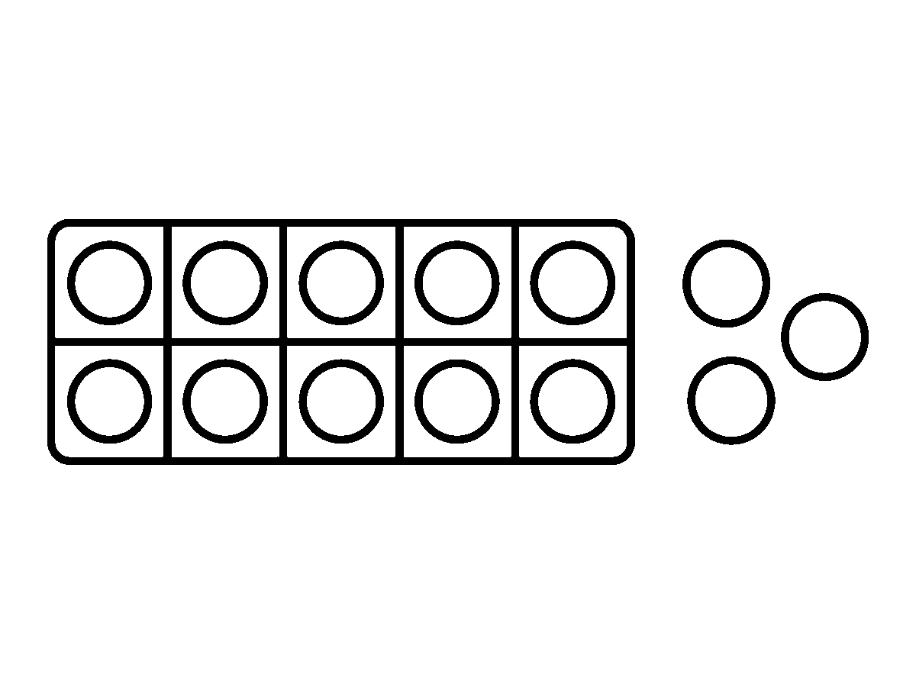
Worksheet
1. Seven tens and five ones make A) 57 B) 12 C) 705 D) 75
2. In 84, the 8 stands for A) 4 B) 800 C) 80 D) 8
3. 3 tens and 0 ones is A) 33 B) 3 C) 30 D) 13
4. The number in which the 6 shows six tens is A) 26 B) 61 C) 6 D) 16
5. Fill in: Ten ones make one ____.
6. Draw a tens-and-ones chart for the number 58.
7. Explain why 41 is greater than 14.
My own work
Take 40 beans or caps and group them into tens; write how many tens and how many ones you got.

WEEK 3 — WRITING NUMBERS IN WORDS
Depth: NERDC Primary 2 · Mathematics · First Term W1 (pp 675–676); Nursery 3 · Numeracy · Second Term W1.
You will learn to
• write the names of numbers from 1 to 100 in words
• spell the tricky number names
• read a number name and write the figure
• match figures to words

Things to know
• 1 one, 2 two, 3 three, 4 four, 5 five, 6 six, 7 seven, 8 eight, 9 nine, 10 ten.
• The teens are the hard ones: 11 eleven, 12 twelve, 13 thirteen, 15 fifteen, 18 eighteen, 20 twenty.
• Note the spelling: thirteen (not threeteen), fifteen (not fiveteen), eighty (not eighty).
• From 21 upward we write with a space or a line: twenty-one, thirty-four, ninety-nine.
• 40 is forty — there is no "u" in it. 100 is one hundred; 200 is two hundred.
• Big ones: 147 is one hundred and forty-seven.
• Reading test: "sixty-five" → I write 65; "one hundred and three" → 103.
• Write it small and keep it on the line; a figure written upside down (6 for 9) is a mistake in sums, not in handwriting.
• Even and odd still work in words: "forty" ends in an even figure, "thirty-seven" in an odd one.
Words for my notebook
twenty-one · thirty-four · forty · fifty · one hundred and forty-seven. Spell "forty" without a "u".
Let us talk
1. Say the number names from eleven to twenty.
2. How do you spell 40 in words?
3. What figure is "sixty-five"?
4. Say the difference between "thirteen" and "thirty".
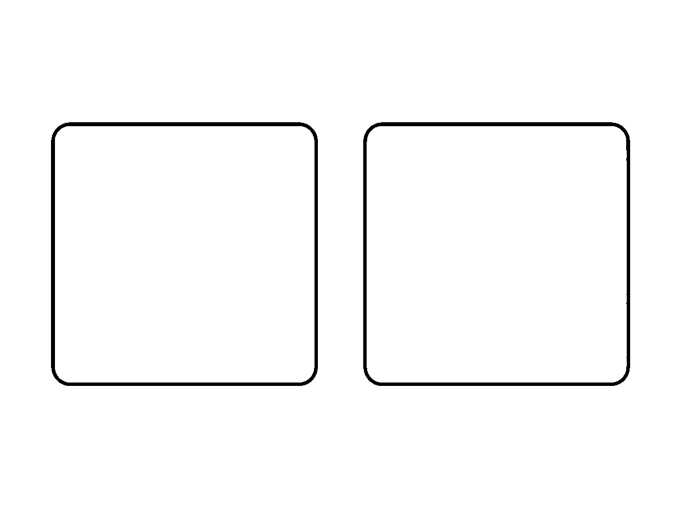
Worksheet
1. The correct spelling of 13 in words is A) thirden B) thirteen C) three-teen D) threeteen
2. "Forty" is the word for A) 40 B) 14 C) 4 D) 400
3. "One hundred and three" is written A) 130 B) 300 C) 113 D) 103
4. The words "twenty-one" mean A) 2 B) 12 C) 20 D) 21
5. Fill in: 100 is written in words as ____.
6. Write in words: 58, 91 and 147.
7. Read these names and write the figures: forty-four, sixty, one hundred and ten.
My own work
Write the number names of your age, your class number and your house number, then check them with the chart.

WEEK 4 — WRITING WORDS IN FIGURES
Depth: NERDC Primary 2 · Mathematics · First Term W1 (pp 675–676).
You will learn to
• turn a number name into figures quickly

• hear a number and write it
• not mix up -teen and -ty
• check what I wrote
Things to know
• "Writing words in figures" is the opposite of last week: thirty-six → 36.
• Say the word in parts: sixty-three = sixty (60) + three (3) → 63.
• The "-teen / -ty" trap: thirteen is 13, thirty is 30; fifteen is 15, fifty is 50. Listen for the long "ee" sound in -teen.
• Zero keeps a place: "two hundred and five" → 205, not 250 and not 25.
• Write in figures only — no words, no commas — and put one number per line so it can be checked.
• Dictation: I hear the number twice; the first time I listen, the second time I write.
• Checking: read my figure back aloud as a word; if it does not sound like what I heard, try again.
• Matching game in class: the word card and the figure card go together on the wall.
Words for my notebook
sixty-three → 63. Two hundred and five → 205. Read your answer back to check it.
Let us talk
1. Write "seventy-two" in figures.
2. What is the difference between 13 and 30 in words?
3. Write "one hundred and eight" in figures.
4. How do you check your answer after writing it?
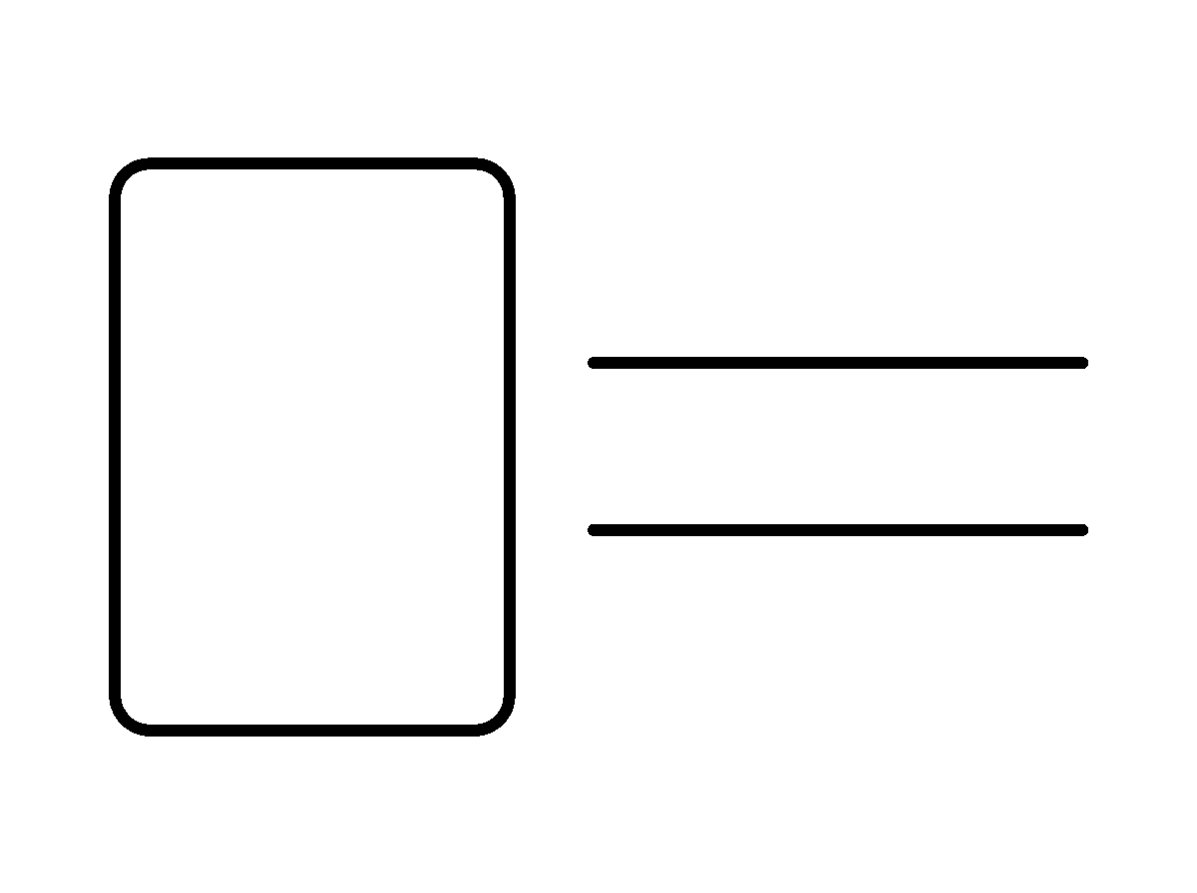
Worksheet
1. "Eighty-four" in figures is A) 14 B) 84 C) 48 D) 80
2. "Two hundred and seven" is A) 270 B) 27 C) 702 D) 207
3. Which word matches 60? A) sixty-one B) sixty C) sixteen D) seventy
4. "One hundred and ten" is A) 1001 B) 101 C) 110 D) 11
5. Fill in: The figure for "forty-nine" is ____.
6. Write in figures: fifty-five, one hundred and twenty, two hundred.
7. Read back your five answers and tick each one that is right.
My own work
Write your telephone number and your house number in words, then turn them back into figures and compare.
Write one, two and three in words on three cards, cut the cards out and paste them in your book.

WEEK 5 — ADDITION (INTRODUCTION)
Depth: NERDC Primary 1 · Mathematics · First Term W7 (pp 618–619).
You will learn to
• say that addition means putting together
• use the signs + and =
• add within 5 in two formats
• tell an addition story with objects
Things to know
• Addition means putting together or adding more; the answer is called the sum or total.
• The plus sign (+) means "and" or "more"; the equals sign (=) means "is the same as".
• With counters: 2 stones and 1 stone → count them all → 2 + 1 = 3.
• Horizontal form: 3 + 2 = 5. Vertical form: write 3, put +2 under it, draw a line, write 5.
• Number bonds of 5: 0 and 5, 1 and 4, 2 and 3 — pairs that make five.
• Adding zero changes nothing: 4 + 0 = 4.
• Counting on is faster than counting all: for 4 + 2, start at 4 and count on two — 5, 6.
• A story problem: "Ada has 2 oranges, and her friend gives her 1 more. How many has she now?" → 2 + 1 = 3.
• Our fingers are the first calculator; the number line is the second.
Words for my notebook
Addition is putting together. The sign is +, and the answer after = is the total. 3 + 2 = 5.
Let us talk
1. What does the + sign mean?
2. Show me 2 + 3 with your fingers.
3. What is the sum of 4 and 1?
4. Tell a story that ends in 5 + 2.
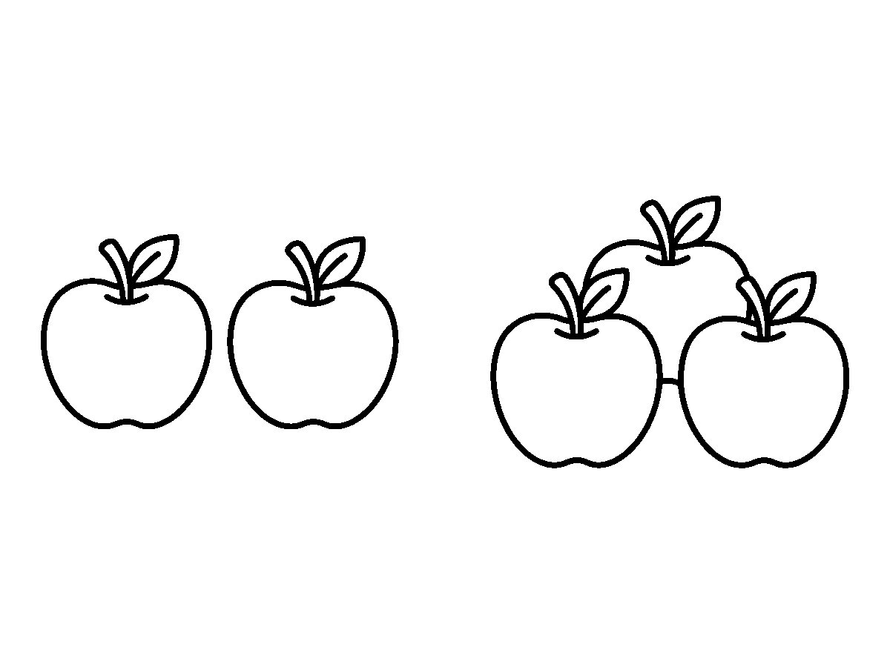
Worksheet
1. Addition means A) comparing B) sharing C) putting together D) taking away
2. The sign used in addition is A) + B) × C) – D) =
3. 3 + 0 = A) 3 B) 0 C) 1 D) 30
4. In 2 + 3 = 5, the 5 is called the A) difference B) tens C) place D) sum
5. Fill in: 1 and ____ make five.
6. Write 4 + 3 in the vertical format and solve it.
7. Make up a story that can be solved by 2 + 2.

My own work
Write two addition sums within 5 from things in your house (cups, spoons, plates) and solve them.

WEEK 6 — ADDITION
Depth: NERDC Primary 1 · Mathematics · First Term W8 (pp 618–619); Primary 2 · First Term W7 and W8.
You will learn to
• add within 10 with objects and pictures
• add two single digits in my head
• add 2-digit numbers without carrying
• use a number line to add
• check an addition with subtraction
Things to know
• Addition facts to 10 are the things I must know without counting: 6 + 4 = 10, 7 + 3 = 10, 8 + 2 = 10, 9 + 1 = 10.
• Adding zero: 9 + 0 = 9; adding one: 9 + 1 = 10.
• On a number line: to do 6 + 3, put the finger on 6 and jump three steps right → 9.
• Two-digit without carrying: 23 + 14 → add the ones (3 + 4 = 7), add the tens (20 + 10 = 30) → 37.
• With carrying (a challenge for later in the week): 28 + 7 → 8 + 7 = 15, so 20 + 15 = 35.
• Adding three or more numbers: 2 + 3 + 4 — take two first (2 + 3 = 5), then 5 + 4 = 9.
• Mental addition: "What is 5 and 5? 10. Then 10 and 2? 12." No fingers needed.
• Real life: how many in all — 6 pencils and 5 crayons = 11 items; ₦5 and ₦10 = ₦15.
• Check with subtraction: 23 + 14 = 37, and 37 − 14 = 23. If the check does not come back, do the addition again.
• The order does not matter: 4 + 6 is the same as 6 + 4.
Words for my notebook
Know the facts to 10. For 23 + 14: ones first (3+4=7), then tens (20+10=30) → 37. Check with subtraction.
Let us talk
1. What is 7 + 3? 8 + 2? 6 + 4?
2. Show me 5 + 4 on the number line.
3. How do you add 20 + 30 quickly?
4. How do you check that 25 + 12 = 37?
5. Give me two pairs that make 10.
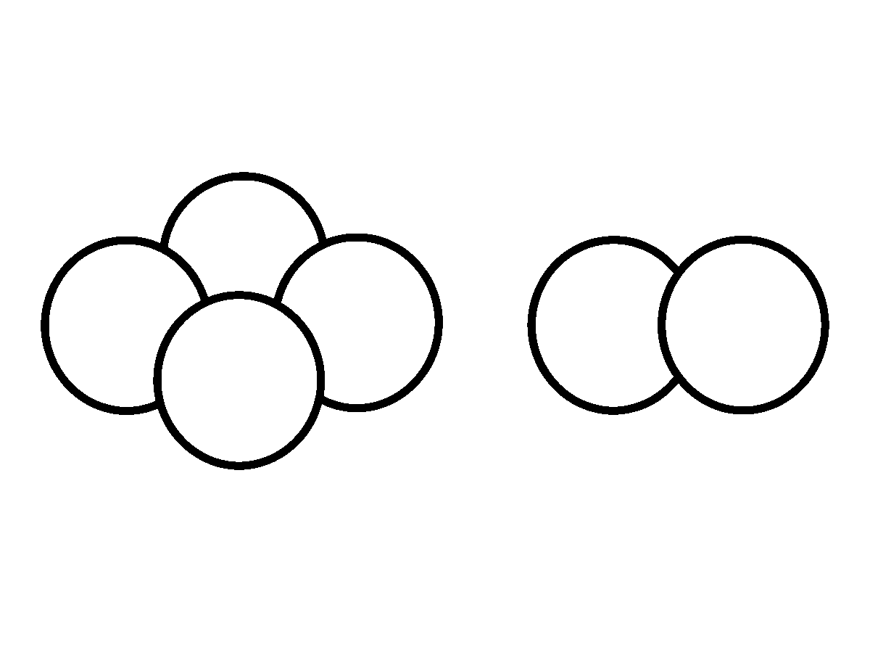
Worksheet
1. 6 + 4 = A) 12 B) 11 C) 10 D) 9

2. 32 + 15 = A) 47 B) 17 C) 46 D) 57
3. On a number line, adding means jumping to the A) up B) left C) right D) down
4. 5 + 0 = A) 10 B) 0 C) 50 D) 5
5. Fill in: 28 + 7 = ____ (carry the ten).
6. Add 3 + 5 + 2 and show your working.
7. Check 24 + 13 by subtraction and write both lines.
My own work
Write five addition sums within 10 and five two-digit sums without carrying; solve them all in your book.
Draw four stones in one circle and three in another, join the circles with a plus sign, then colour both circles.

WEEK 8 — SUBTRACTION (INTRODUCTION)
Depth: NERDC Nursery 2 · Numeracy · Third Term W1 (pp 344–347); Primary 1 · Mathematics · First Term W9 (pp 618–619).
You will learn to
• say that subtraction means taking away
• use the minus sign (−)
• subtract within 5 with objects and pictures
• tell what zero does in subtraction
Things to know
• Subtraction means taking away, removing, or finding the difference between two numbers.
• The minus sign (−) means "take away"; the answer is called the difference or the remainder.
• With counters: 5 stones, take away 2, count what is left → 5 − 2 = 3.
• Words for the same thing: "5 minus 2", "5 less 2", "take 2 away from 5".
• Horizontal form: 5 − 1 = 4. Vertical form: 5 on top, −1 below, line, then 4.
• With pictures: cross out the ones that go; count the ones not crossed.
• Zero in subtraction: 5 − 0 = 5 (nothing taken, nothing lost); 5 − 5 = 0 (all taken, none left).
• Counting back is the trick: for 6 − 2, start at 6 and count back two — 5, 4.
• A subtraction story: "I have 5 sweets and I eat 2. How many are left?" → 5 − 2 = 3.
• Subtraction is the opposite of addition: if 2 + 3 = 5, then 5 − 3 = 2.
Words for my notebook
Subtraction is taking away. The sign is −, and the answer is the difference. 5 − 2 = 3.
Let us talk
1. What does the − sign mean?
2. Show me 4 − 1 with your fingers.
3. What is 3 − 3? What is 3 − 0?
4. Tell a story that ends in 5 − 2.

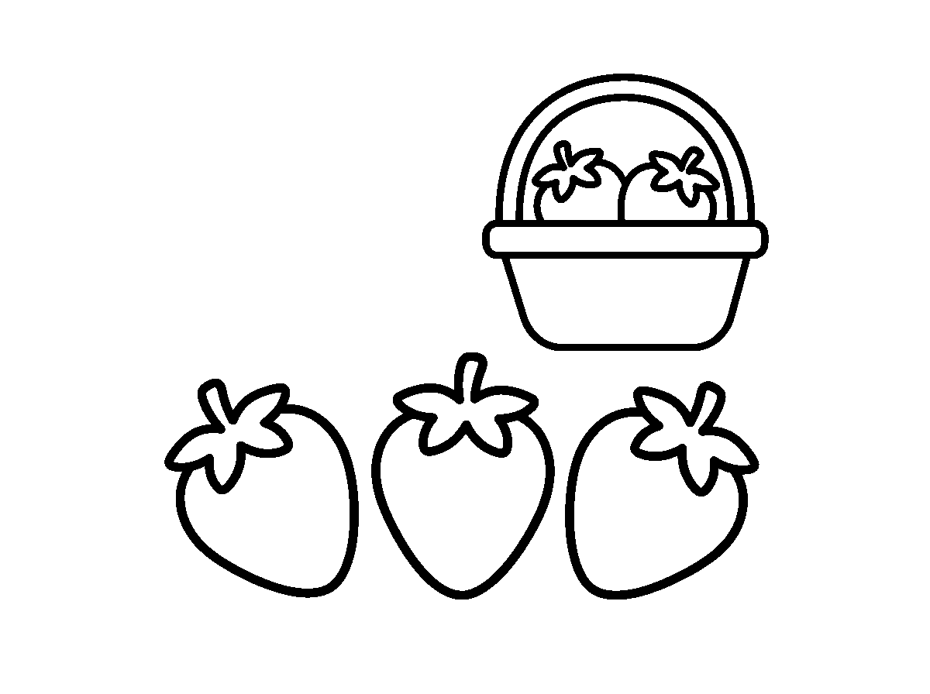
Worksheet
1. Subtraction means A) sharing fairly B) taking away C) putting together D) multiplying
2. 4 − 1 = A) 3 B) 0 C) 5 D) 4
3. The answer in subtraction is called the A) difference B) place C) sum D) total
4. 6 − 6 = A) 6 B) 1 C) 12 D) 0
5. Fill in: If 2 + 3 = 5, then 5 − 3 = ____.
6. Write 5 − 2 in the vertical form and solve it.
7. Make up a story that can be solved by 4 − 1.
My own work
Line up six caps, take two away, and write the whole thing as one number sentence.
Draw seven oranges, cross out two, and colour the five that are left.

WEEK 9 — SUBTRACTION
Depth: NERDC Primary 1 · Mathematics · First Term W10 (pp 618–619); Primary 2 · First Term W9 and W10 (pp 675–676).
You will learn to
• subtract within 10 fluently
• subtract 2-digit numbers without borrowing
• borrow when the ones are not enough
• check a subtraction with addition
• use subtraction with money and with objects
Things to know
• Subtraction facts within 10: 10 − 4 = 6, 10 − 7 = 3, 9 − 5 = 4 — these must be quick.
• Subtracting zero changes nothing: 8 − 0 = 8.
• "Difference between" means: how far apart two numbers are — the difference between 7 and 3 is 4.
• Without borrowing: 48 − 25 → ones (8 − 5 = 3), tens (40 − 20 = 20) → 23.
• With borrowing: 42 − 15 → the 2 cannot take the 5, so borrow one ten: 12 − 5 = 7, and 30 − 10 = 20 → 27.
• On the number line, subtracting means jumping to the left.
• Checking with addition: 48 − 25 = 23, and 23 + 25 = 48. If it does not add back, work again.
• Real life: ₦10 − ₦4 = ₦6 change; 20 pupils, 3 absent → 17 present; a 60 km journey, 25 km covered → 35 km left.
• Never swap the numbers without thinking: 3 − 8 is not 8 − 3; in subtraction, order matters.
Words for my notebook
For 48 − 25: ones first, then tens → 23. Check by adding back. If the ones are too small, borrow a ten.

Let us talk
1. What is 10 − 6? 9 − 4?
2. Find 57 − 23 in your book.
3. When do you need to borrow?
4. Your mother has ₦50 and buys ₦30 of bread — what is left?
5. How would you check 41 − 16?
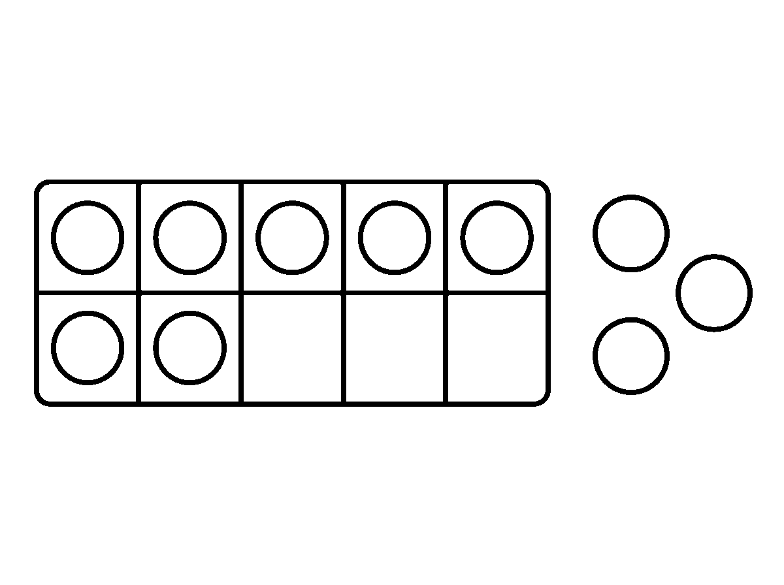
Worksheet
1. 10 − 3 = A) 8 B) 7 C) 6 D) 13
2. 56 − 23 = A) 32 B) 79 C) 43 D) 33
3. In 42 − 15 we must A) add one B) borrow a ten C) multiply D) swap the numbers
4. Subtraction is checked with A) addition B) subtraction C) division D) counting
5. Fill in: The difference between 9 and 4 is ____.
6. Work out 63 − 28 and show the borrowing.
7. Write a money story that is solved by ₦100 − ₦45.
My own work
Write three subtraction stories from your own home (sweets, caps, money) and solve each one.
Draw ten shells, take away four, and colour the ones that stay.

GENERAL KNOWLEDGE
Weeks 1 to 6, 8 and 9. No note for Week 7 (Mid-Term), 10 (Revision), 11 (Examination). Term theme: Myself, My Family & My School. This subject is school-generated — there is no NERDC scheme for it — so each week's extent is the school's own `Breakdown (Subtopics)` list, reproduced line for line as bullets below.

WEEK 1 — MYSELF: MY NAME, MY AGE AND MY BODY
Depth: school breakdown for N2 F1 W1.
You will learn to
• say my full name and my nickname clearly
• say my age and whether I am a boy or a girl
• name the parts of my body
• say which sense I use for each thing
Things to know
• My full name has two parts: my first name and my family name — "Adaeze Okafor".
• My nickname is the short name people at home call me — "Ada".
• I say it clearly, standing up, and I do not shout it.
• My age: "I am four years old." I know whether I am a boy or a girl.
• "I am special, I am me" — there is no other child with my face and my name.
• Parts of my body I can name: head, eyes, ears, nose, mouth, hands, legs.
• Senses: I see with my eyes, hear with my ears, smell with my nose, taste with my tongue, feel with my skin.
• Song we sing with the actions: "Head, shoulders, knees and toes" — twice, then fast.
• Rhyme of the week: "I am special, I am me; I have two hands, one, two, three…" (clap on each number).
Words for my notebook
My name is ______. I am ____ years old. I am a boy / a girl. I am special, I am me.
Let us talk
1. Stand up and say your full name.
2. What do people at home call you?
3. How old are you, and are you a boy or a girl?
4. Touch something you can smell, and tell us what you use.
Worksheet
1. The two parts of my full name are my first name and my A) age B) nickname C) class D) family name
2. We see with our A) eyes B) nose C) hands D) ears
3. "I am special, I am ___." A) we B) me C) they D) you
4. The name people at home call you is your A) full name B) nickname C) tribe D) school name
5. Fill in: I am ____ years old.
6. Name seven parts of your body.
7. Say which sense you use for: a bell, a flower, a mango.
My own work
Write your first name five times and draw your face under it.

WEEK 2 — MY FAMILY: MEMBERS AND THEIR ROLES
Depth: school breakdown for N2 F1 W2.
You will learn to
• name the members of my family and of the extended family
• say what each member does at home
• show love and respect to my family
• use the polite words at home

Things to know
• The members of my family at home: father, mother, brothers, sisters — and me.
• The extended family is bigger: grandpa, grandma, uncles, aunts, cousins.
• What each one does: father works and brings things home; mother cooks and buys food; brothers and sisters play, learn and help.
• Love and respect at home: we greet in the morning, we do not shout at a small child, we help grandpa to sit.
• At home we say "please" when we ask, "thank you" when we receive, and "sorry" when we do wrong.
• We share what we have: the biscuit, the crayons, the chair by the fan.
• Family song: "This is my family — this is my family, we love one another."
• Drawing of the week: my family, with five names written under the five people.
Words for my notebook
My family: father, mother, brothers, sisters. Big family: grandpa, grandma, uncles, aunts, cousins.
Let us talk
1. Name the people who live with you.
2. Who is your father's mother to you?
3. Say one thing your mother or father does every day.
4. What do you say when your sister gives you a cup?
Worksheet
1. Your mother's mother is your A) aunt B) cousin C) sister D) grandma
2. When somebody gives you something you say A) please B) sorry C) goodbye D) thank you
3. A girl who is your father's daughter is your A) aunt B) cousin C) grandma D) sister
4. Who cooks food at home? A) anybody who can help B) only the mother C) only the children D) nobody
5. Fill in: My uncle's children are my ____.
6. Name four people in your family and one thing each does.
7. Say the three polite words we use at home.
My own work
Draw your family and write one word under each person: father, mother, brother, sister, me.

WEEK 3 — MY SCHOOL: PLACES, PEOPLE AND THINGS
Depth: school breakdown for N2 F1 W3.
You will learn to
• say the name of my school and my class
• name places in the school and what each is for
• name the people who work in the school
• pack and care for my school bag
Things to know
• The name of my school: ______. My class: Nursery 2. I say both out loud.
• Places in the school: classroom (we learn), playground (we play), library (we read), toilet (we freshen up), office (the head teacher works).
• People in the school: the head teacher (head of the school), teachers (they teach), the caretaker (he keeps the compound clean), the school nurse (she treats anyone who is hurt or sick).
• What is in my school bag: exercise books, reader, pencils, crayons, sharpener, handkerchief, water bottle.
• Taking care of school things: no torn pages, no writing on the desk, the bag shut, the books in the bag — not in a heap.
• School tour: we walked to the five places and said each name at the door.

• Matching game: the picture to the word — library, office, toilet.
Words for my notebook
My school is ______. My class is Nursery 2. Places: classroom, playground, library, toilet, office.
Let us talk
1. What is the name of this school?
2. Where do we read story books?
3. Who treats a pupil that has fallen?
4. Name four things inside your bag today.
Worksheet
1. We play during break in the A) library B) office C) toilet D) playground
2. The head of the school is the A) nurse B) head teacher C) pupil D) caretaker
3. Where do we freshen up? A) the toilet B) the store C) the library D) the office
4. Which of these should NOT be in the school bag? A) book B) cooking pot C) crayon D) pencil
5. Fill in: My class is Nursery ____.
6. Name four people who work in your school.
7. Write two sentences on how you take care of your books.
My own work
Colour the school bag and ring the five things that belong inside it.

WEEK 4 — MY CLASSROOM: RULES AND MATERIALS
Depth: school breakdown for N2 F1 W4.
You will learn to
• name objects in the classroom
• state the rules we keep in class
• keep the classroom clean
• name the colours of things in the room
Things to know
• Objects in the classroom: table, chair, board, books, pencils, crayons, plus the duster, the clock and the shelf.
• Classroom rule one: raise your hand before you speak or before you leave your seat.
• Rule two: listen when the teacher or another pupil is talking.
• Rule three: share the crayons, the books and the toys.
• Rule four: keep quiet while somebody else is answering.
• Keeping the room clean: paper goes in the dustbin, desks are tidied, the board is wiped after use.
• Colours of the things we see: red, blue, yellow, green, black, white.
• Game of the week: "Find something that is red… that is round… that is soft" — three runs, one for each clue.
Words for my notebook
Our rules: raise the hand, listen, share, keep quiet. The dustbin is for paper. Colours: red, blue, yellow, green, black, white.
Let us talk
1. Name four things in this classroom.
2. What must you do before you speak?
3. Where does a piece of wrapper go?
4. Find something yellow and bring it near the board.
Worksheet
1. We write on the A) bag B) chair C) board D) dustbin
2. Before speaking in class we A) raise our hand B) stand on the chair C) clap D) shout
3. Paper and wrappers go into the A) cupboard B) shoe C) dustbin D) bag
4. Which of these is a colour of a crayon? A) fast B) soft C) loud D) yellow

5. Fill in: When a friend is answering, we keep ____.
6. Mention four rules of the classroom.
7. Name three objects in the room and the colour of each.
My own work
Colour the classroom picture: the book red, the bag blue, the board green, the chair brown.

WEEK 5 — MY HOME AND MY NEIGHBOURHOOD
Depth: school breakdown for N2 F1 W5.
You will learn to
• name the rooms of my house and what each is for
• say who lives with me and where I sleep and eat
• describe my street, village or town
• use near and far, up and down
Things to know
• Rooms in my house: sitting room (visitors sit), kitchen (food is cooked), bedroom (we sleep), bathroom (we bathe).
• Some houses have a dining room, a veranda, a store and a compound.
• The people who live with me are my family; I sleep in the bedroom and I eat in the sitting room or the dining area.
• My street / village / town is called ______; my house number or landmark is ______.
• On my way to school I see: the shop, the bus stop, the church, the mosque, the gutter, the mango tree, my neighbour's gate.
• Near means not far — the gate is near. Far means a long walk — the market is far.
• Up is the hill or the shelf; down is the gutter or the floor.
• "My home is my first school" — at home I learned to walk, to speak, to greet and to hold a spoon.
Words for my notebook
Rooms: sitting room, kitchen, bedroom, bathroom. My street is ______. Home is my first school.
Let us talk
1. Where is food cooked in your house?
2. Which room do you sleep in?
3. Name two things you see on your way to school.
4. Point to something near you and something far from you.
Worksheet
1. We bathe in the A) kitchen B) bedroom C) store D) bathroom
2. The room where visitors sit is the A) fence B) shed C) toilet D) sitting room
3. A place a long walk away is said to be A) far B) small C) up D) near
4. We call our home our first A) church B) market C) school D) shop
5. Fill in: Food is cooked in the ____.
6. Name the four rooms of your house and what each is for.
7. Write two sentences on what you see on your way to school.
My own work
Draw your house with four rooms and write the name of each room inside it.

WEEK 6 — COLOURS, SHAPES AND SIZES AROUND ME
Depth: school breakdown for N2 F1 W6.
You will learn to
• name the colours I can see
• find circles, squares, triangles and stars in the room
• compare two things by size
• name the colours of the Nigerian flag

Things to know
• Primary colours (the colours that other colours are mixed from): red, blue, yellow.
• Other colours I know: black, white, green, brown, orange, purple.
• Shapes: circle (plate, ball, clock, wheel), square (tile, handkerchief, box face), triangle (roof, sandwich cut in two, ruler end), star (on the flag, in the sky at night).
• Sizes: big and small (a bag and a pencil), long and short (a chalk and a stick), tall and short (two pupils, back to back).
• Words for comparison: "This is bigger than that", "Mine is shorter than yours".
• The Nigerian flag is green and white: two green strips and one white strip in the middle.
• Games: shape hunt (find five round things), colour sorting (beads into six cups), size stacking (biggest box at the bottom).
• Mixing two colours makes a new one: red and yellow make orange; blue and white make light blue.
Words for my notebook
Red, blue, yellow are primary colours. Circle, square, triangle, star. Our flag is green and white.
Let us talk
1. Say the three primary colours.
2. Bring something round to the front.
3. Which of you is taller, you or your partner?
4. What are the colours of the Nigerian flag?
Worksheet
1. Which of these is a primary colour? A) pink B) purple C) brown D) yellow
2. The shape of a ball is a A) circle B) square C) star D) triangle
3. A roof is the shape of a A) triangle B) square C) line D) circle
4. The Nigerian flag is A) red and blue B) green and white C) black and yellow D) purple and pink
5. Fill in: Red and yellow mixed together make ____.
6. Name four shapes and one thing of each shape in this room.
7. Write two sentences comparing two things by size.
My own work
Colour three circles red, two squares blue and one triangle yellow.

WEEK 8 — ANIMALS AND BIRDS AROUND ME
Depth: school breakdown for N2 F1 W8.
You will learn to
• name domestic animals and the sound each one makes
• name wild animals I have seen in pictures
• name birds and say where animals live
• tell a domestic animal from a wild animal
Things to know
• Domestic animals live with people and are looked after: dog, cat, goat, chicken, cow, and in some homes, sheep and rabbit.
• Their sounds: dog — woof; cat — miaow; goat — meh; hen — koko; cow — moo.
• Wild animals live in the bush and are not kept in the house: lion, elephant, monkey, snake, leopard, buffalo.
• Birds have feathers, two legs and a beak, and most of them fly: parrot, pigeon, hen, duck, eagle.
• The eagle appears on our national coat of arms — it is the first look at "our national bird".
• Where animals live: home (dog), farm (cow, goat, hen), bush (lion, monkey), water (fish, duck, frog), sky (bird, kite).
• What animals give us: the cow gives milk, the hen gives eggs, the dog guards the house.

• Song with actions: "Old MacDonald had a farm, E-I-E-I-O" — each child makes the sound of one animal.
• We do not go near a strange dog, and we never touch a snake.
Words for my notebook
Domestic: dog, cat, goat, chicken, cow. Wild: lion, elephant, monkey, snake. Birds have feathers and beaks.
Let us talk
1. Which animal says "meh"?
2. Name two wild animals.
3. What does a hen give us?
4. Say two things that show an animal is a bird.
5. Where does a fish live?
Worksheet
1. Which animal gives us milk? A) dog B) hen C) goat D) cow
2. Which one is a wild animal? A) goat B) chicken C) cat D) lion
3. A bird has A) fur B) feathers C) four legs D) scales only
4. The sound of the dog is A) miaow B) woof C) koko D) moo
5. Fill in: The ____ is on our national coat of arms.
6. Name four animals that live on a farm.
7. Write two sentences on one animal you like and what it gives us.
My own work
Draw four animals, two that live with people and two that live in the bush.

WEEK 9 — GOOD HABITS: GREETINGS, POLITENESS AND CLEANLINESS
Depth: school breakdown for N2 F1 W9.
You will learn to
• greet correctly at morning, afternoon and evening
• greet an elder before myself
• use the four magic words
• keep my body and my uniform clean
Things to know
• Morning (before noon): "Good morning." Afternoon: "Good afternoon." Evening: "Good evening." Bedtime: "Good night."
• We greet elders first — the grown person is greeted before a child of my age; it is a duty, not a favour.
• In Yoruba: Ẹ̀ káàárọ̀ (morning), Ẹ̀ káàṣánṣá (afternoon), Ẹ̀ káàlẹ̀ (evening). In Hausa: Ina wuni?, Ina rana?, Ina fada? — the reply to all is "Lafiya."
• The four magic words: "please" (asking), "thank you" (receiving), "sorry" (when I do wrong), "excuse me" (passing, or after sneezing).
• Hands are washed before eating and after using the toilet — with soap, rubbing the fingers and the nails.
• Teeth are brushed morning and night; the body is bathed daily; the nails are cut short.
• The uniform is kept neat: shirt in, buttons done, shoes brushed, hair combed.
• Role-play of the week: a visitor comes to the class — we stand, greet, offer a seat, and speak when spoken to.
• The Good-Habit chart on our wall: each day a tick for the habit we kept; Friday is the day we count the ticks.
Words for my notebook
Good morning, good afternoon, good evening, good night. Please, thank you, sorry, excuse me. We greet elders first.
Let us talk
1. What do you say at seven in the morning?
2. Whom do you greet first — your headmaster or your friend?
3. When do we say "excuse me"?
4. Show me how you wash your hands.
5. How many times a day do we brush our teeth?

Worksheet
1. At half past six in the evening we say A) hello sir B) good night C) good evening D) good morning
2. The word we use when we ask for something is A) please B) welcome C) sorry D) goodbye
3. We wash our hands A) only on Friday B) once a week C) before eating and after the toilet D) never
4. Who is greeted first? A) a dog B) a baby C) an elder D) a friend
5. Fill in: We brush our teeth ____ and night.
6. Mention the four magic words and when each is used.
7. Write two sentences on the good habit you will keep next term.
My own work
Write the four magic words and use each one in a sentence of your own.

EXAMINATION PRACTICE — BASIC SCIENCE (NURSERY 2 · FIRST TERM)
Time: 1 hour · Total: 50 marks
SECTION A — OBJECTIVE (30 MARKS)
Choose the correct option and ring the letter.
1. Our body has a head, a neck, a trunk, and the ___
A) arms and legs B) ears and nose C) tail and wings D) knees and sandals
2. The part that joins the head to the body is the ___
A) ankle B) chest C) neck D) waist
3. We use our ___ to hear sounds
A) nose B) elbows C) toes D) ears
4. How many fingers do we have on both hands?
A) ten B) five C) eight D) twelve
5. The part of the trunk at the back of us is the ___
A) waist B) chin C) back D) chest
6. Which of these is found on the arm?
A) knee B) wrist C) hip D) ankle
7. We brush our teeth ___ a day
A) five times B) once C) three times D) twice
8. Before eating we must ___
A) wash our hands B) sleep on the mat C) run about the room
D) watch the television
9. Our nails should be kept ___
A) painted with chalk B) short and clean C) wet with water
D) long and full of dirt
10. Which one do we use on our hair?
A) a spoon B) a plaster C) a comb D) a cup
11. Every day we should wear ___ clothes
A) torn B) wet C) someone else's D) clean
12. For the body to be strong we must ___
A) never play outside at all B) eat good food and sleep well
C) eat only sweets every day D) drink only cold soft drinks
13. First aid is the ___ help given to a hurt person
A) first B) slowest C) secret D) last
14. Which of these is kept in the first aid box?
A) cutlass B) broom C) plaster D) chalk
15. Which one is NOT a first aid box item?
A) a roll of cotton wool B) a clean bandage C) a small thermometer
D) chewing stick
16. A thermometer is used to ___
A) tell if the body is hot B) count the pupils in class C) wash the school chairs
D) cut the bandage in two
17. A bandage is used to ___
A) carry books to the office B) brush the school gate C) wrap up a wound
D) cook the family food
18. Who should use the things in the first aid box?
A) a baby B) a grown-up C) the class goat D) any pupil
19. A wound is an injury that ___
A) breaks the skin B) paints the skin C) cleans the skin D) warms the skin
20. A blue-black mark from bumping, with the skin not open, is a ___
A) cut B) burn C) plaster D) bruise
21. Which kind of wound comes from a thorn or a nail going deep into the skin?
A) A soft round bump B) Puncture wound C) A clean dry graze D) A small blue bruise
22. Which one can cause a burn?
A) a cold fan B) a soft pillow C) a hot pot D) a school bag
23. What is the first thing to do before caring for a wound?

A) run and shout B) put mud on it C) blow the dust in D) wash the hands
24. We clean a small wound with ___
A) clean water B) chalk dust from the board C) some kerosene
D) a cup of dirty water
25. On a healing wound there is a scab. We must ___
A) pick it every day B) leave it alone C) rub sand on it D) cut it with a blade
26. Sickness means the body ___
A) is growing too fast B) is working quite well C) is not working properly
D) is always clean and neat
27. Which one is a sign of sickness?
A) high temperature B) a brand new school shoe C) very clean nails
D) a loud happy laugh
28. Malaria is brought to us by the bite of a ___
A) bird B) goat C) rat D) mosquito
29. A sick person should drink plenty of ___
A) kerosene B) soda C) water D) palm oil
30. The top layer of the earth where plants grow is called ___
A) rock B) soil C) sand only D) water
SECTION B — SUB-OBJECTIVE (10 MARKS)
Answer briefly.
31. Name the five big parts of the body.
32. Mention four parts found on the head.
33. State three daily practices that keep the body clean.
34. Name four things inside a first aid box.
35. Give the use of each: (a) plaster (b) thermometer (c) bandage.
36. Mention three things that can cause wounds at home.
37. Write the steps for caring for a small wound in order.
38. Name four signs (symptoms) of sickness.
39. State three ways of preventing sickness.
40. Name the types of soil and mark the one best for plants.
SECTION C — THEORY (10 MARKS)
Answer in full sentences.
41. Name four parts of your body and say what each one does. (2 marks)
42. Why must we keep our body clean? Give three reasons. (2 marks)
43. Your friend falls in the compound and his knee is bleeding. What should you do? (2 marks)
44. What is sickness? Name four causes and three ways of preventing it. (2 marks)
45. What are rocks? Mention three uses of rocks and three types of soil. (2 marks)
Teacher's key — Section A (letter and answer text)
1. A — arms and legs
2. C — neck
3. D — ears
4. A — ten
5. C — back
6. B — wrist
7. D — twice
8. A — wash our hands
9. B — short and clean
10. C — a comb
11. D — clean
12. B — eat good food and sleep well
13. A — first
14. C — plaster
15. D — chewing stick
16. A — tell if the body is hot
17. C — wrap up a wound

18. B — a grown-up
19. A — breaks the skin
20. D — bruise
21. B — Puncture wound
22. C — a hot pot
23. D — wash the hands
24. A — clean water
25. B — leave it alone
26. C — is not working properly
27. A — high temperature
28. D — mosquito
29. C — water
30. B — soil
Marking points — Sections B & C
& C (marking guide)**
31. head; neck; trunk; arms; legs
32. eyes; nose; ears; mouth
33. bathing; brushing teeth twice; washing hands
34. plasters; bandages; cotton wool; antiseptic
35. covers a small cut; checks for fever; wraps a wound / supports a sprain
36. sharp objects; hot pots or fire; falls and scrapes
37. wash hands; clean with water; apply antiseptic; cover with plaster
38. fever; pain; coughing; vomit
39. wash hands; eat healthy food and drink clean water; sleep under a mosquito net
40. sandy; clay; loamy — best for plants
41.
42.
43.
44.
45.

EXAMINATION PRACTICE — CULTURAL AND CREATIVE ARTS (NURSERY 2 · 1ST TERM)
Time: 1 hour · Total: 50 marks
SECTION A — OBJECTIVE (30 MARKS)
Choose the correct option and ring the letter.
1. The drawing of a car has these four parts ___
A) petals, roots, a stem and seeds B) pages, a cover, a spine and words
C) body, windows, two wheels and a headlight D) wings, feathers, a beak and a tail
2. What do wheels do?
A) They help the car to move B) They keep the car warm C) They light the car inside
D) They help the car to sing
3. We use crayons to ___
A) cook rice in the pot B) cut our hair into shapes C) wash the grease off our hands
D) colour inside the lines of a drawing
4. Paint is kept in a ___
A) school shoe B) soft pillow C) small tin or can D) big cooking pot
5. Before we paint, the surface must be ___
A) wet and muddy B) clean and dry C) hot from the sun D) covered in dust and sand
6. Thumb-printing is done with the ___
A) thumb of the hand B) point of the elbow C) tip of the ear D) knee of the leg
7. The pattern made by pressing a thumb on paper is called a ___
A) hand shake drawing B) footprint rubbing C) wall shadow D) thumb print
8. A Barney is a character we ___
A) wear on the head B) eat C) draw and colour D) keep in water
9. The lines that show where a drawing ends are called ___
A) outlines B) story verses C) rhyming lines D) deep shadows
10. In "Barney's environment" we colour the things ___
A) only the inside of Barney's big mouth B) around Barney — his home and his friends
C) only what is hidden under Barney's bed D) the moon and all the far away stars
11. A pig has a short tail that is ___
A) long like a rope B) feathered like a bird C) flat and square
D) curly like a spring
12. The foot of a pig is called a ___
A) paw with claws B) fin C) trotter D) hoof of a horse
13. The pig, goat and cow are drawn in our lesson because they are ___
A) animals kept at home B) wild animals of the bush C) toys made of plastic
D) animals of the deep sea
14. Strands of dried grass or wheat used for making jewellery are ___
A) leaves B) straw C) bones D) stones
15. A craft pattern that goes red, blue, red, blue is called a ___
A) straight line B) song pattern C) repeating pattern D) one-off pattern
16. Which of these can be made out of straw?
A) A bracelet, a ring and a small cap B) A bed made of iron
C) A cup filled with cold water D) A pencil carved from hard wax
17. An umbrella protects us from ___
A) the noise of the market B) our own homework C) the snake in the bush
D) falling rain and hot sunshine
18. The strong cloth stretched over an umbrella is called the ___
A) carrying handle B) canopy C) rubber tip D) box it came in
19. The frame of wire that holds the canopy is called the ___
A) skeleton B) market basket C) soft pillow D) car wheel
20. Vegetable printing uses ___

A) a wooden eating spoon B) a long sewing needle C) the cut surface of an okra
D) only a painting brush
21. Before printing with a vegetable, we spread paint on a ___
A) bucket of water B) flat tray or plate C) wall mirror D) school shoe
22. The print left by an okra looks like ___
A) a tall storey building B) a plain round ball C) a long straight road
D) a little star or a flower
23. Plasticine, which we mould with our hands, is a soft ___
A) coloured clay B) sweet red fruit C) clean cotton cloth D) running tap water
24. A small ball and a rolled snake-like piece are the first ___
A) dances for jumping B) sums for adding C) shapes for modelling
D) songs for singing
25. To join two pieces of plasticine we ___
A) drop them twice B) press them hard together C) sew them with thread
D) blow air on them
26. Keeping paint off your uniform while you work is part of ___
A) breaking the tools in anger B) hiding the materials from friends
C) wasting the paint and materials D) taking good care of materials and tools
27. A drawing that shows a thing as it really looks is made with ___
A) patience and careful shading B) only a long ruler C) a clean soft rubber
D) two eyes kept closed
28. The noise dance we do with simple instruments keeps the body ___
A) making no sound at all B) sitting completely still on the chair
C) moving the feet and hands in time with the beat D) quietly asleep on the mat
29. Which of these is NOT a way of making a pattern?
A) Repeating the same colours B) Alternating shapes and lines
C) Printing with a leaf D) Shouting loudly in class
30. A good artist at the end of an art lesson ___
A) hides the crayons under a bench B) washes the brush and lays the work out to dry
C) tears the finished drawing in two D) leaves the wet paint pot on the floor
SECTION B — SUB-OBJECTIVE (10 MARKS)
Answer briefly.
31. Name the four parts of a car we draw.
32. Mention three things we colour a car drawing with.
33. Give two rules of thumb-printing.
34. Name two places we print a thumb pattern.
35. Draw or name two things we colour in Barney's environment.
36. Name two things about a pig's body.
37. Mention two things we make from straw.
38. State two rules for caring for an umbrella.
39. Name two vegetables we can print with.
40. Give two things you can model with plasticine.
SECTION C — THEORY (10 MARKS)
Answer in full sentences.
41. Draw a car and colour it (2 marks)
42. Write about your own thumb print: how you made it and what you turned it into (2 marks)
43. Draw Barney and colour his environment (2 marks)
44. Describe how you made an umbrella in class, naming its three parts (2 marks)
45. Write two sentences on what you moulded with plasticine and how you joined the pieces (2 marks)
Teacher's key — Section A (letter and answer text)
1. C — body, windows, two wheels and a headlight
2. A — They help the car to move

3. D — colour inside the lines of a drawing
4. C — small tin or can
5. B — clean and dry
6. A — thumb of the hand
7. D — thumb print
8. C — draw and colour
9. A — outlines
10. B — around Barney — his home and his friends
11. D — curly like a spring
12. C — trotter
13. A — animals kept at home
14. B — straw
15. C — repeating pattern
16. A — A bracelet, a ring and a small cap
17. D — falling rain and hot sunshine
18. B — canopy
19. A — skeleton
20. C — the cut surface of an okra
21. B — flat tray or plate
22. D — a little star or a flower
23. A — coloured clay
24. C — shapes for modelling
25. B — press them hard together
26. D — taking good care of materials and tools
27. A — patience and careful shading
28. C — moving the feet and hands in time with the beat
29. D — Shouting loudly in class
30. B — washes the brush and lays the work out to dry
Marking points — Sections B & C
& C (marking guide)**
31. body; windows; two wheels; headlight
32. crayons; water colours; poster colours
33. press firmly; do not slide the hand; use enough paint
34. a card; a wall chart; a wrapper
35. his home; his friends; trees and animals
36. curly tail; trotters; fat body; short legs
37. bracelets; rings; caps; mats
38. open it gently; shake off rain and let it dry; keep it away from sharp things
39. okra; leaves; spring onion; potato
40. a ball; a plate; an animal; a fruit
41.
42.
43.
44.
45.

EXAMINATION PRACTICE — CHRISTIAN RELIGIOUS STUDIES (NURSERY 2 · 1ST TERM)
Time: 1 hour · Total: 50 marks
SECTION A — OBJECTIVE (30 MARKS)
Choose the correct option and ring the letter.
1. God made everything — the heavens and the ___
A) markets B) buses C) earth D) schools only
2. How many days did God take to make the world in our lesson?
A) forty B) ten C) two D) six
3. On Day 1 God made ___
A) light B) cattle C) man D) fish
4. On Day 3 God made the dry land and ___
A) the moon B) plants and trees C) the sun D) the fish
5. On Day 4 God made lights in the sky — the sun, the moon and ___
A) the whales B) the birds C) the goats D) the stars
6. On Day 6 God made ___
A) the sky B) the light C) man and woman D) only the animals
7. Which day did God rest on?
A) The seventh day B) The second day C) The first day D) The fifth day
8. The first man was ___
A) Moses B) David C) Noah D) Adam
9. The first woman was ___
A) Hannah B) Eve C) Mary D) Ruth
10. Adam and Eve lived in the Garden of ___
A) Jericho B) Jordan C) Eden D) Gethsemane
11. God gave Adam and Eve the duty to ___
A) sail upon the sea B) write a long book C) build a city of stone
D) take care of the garden
12. Who or what tempted Eve?
A) The fish B) The serpent C) The crow D) The lion
13. The command they broke was not to eat from the tree of the ___
A) oil of the olive tree B) leaves of the fig tree C) knowledge of good and evil
D) fruit of the palm tree
14. The special name for God as the maker of all things is ___
A) Creator B) Captain C) Carpenter D) Cousin
15. The psalm we say with thanksgiving is Psalm ___
A) 23 B) 136 C) 91 D) 1
16. "Give thanks to the Lord, for he is ____"
A) great only B) far C) sleeping D) good
17. Every good and perfect gift comes down from ___
A) God B) the neighbour C) the river D) the market
18. Food, water and shelter are gifts that ___
A) make us poor B) belong to one tribe only C) keep us alive D) end at evening
19. Which of these is NOT a gift from God in our lesson?
A) Rain B) Stealing C) Our parents D) Sunshine
20. God gave His only Son because He ___
A) likes songs only B) was told to C) was sleeping D) loves the world
21. The gift of God's Son is our ___
A) Saviour B) king of one town only C) neighbour only D) classmate
22. Jesus was born in the town of ___
A) Nazareth only B) Jericho C) Bethlehem D) Cairo
23. The virgin mother of Jesus was ___
A) Deborah B) Mary C) Ruth D) Rachel
24. The baby Jesus was laid in a ___
A) manger B) basket of yam C) palace bed D) chariot
25. The angels told the ___
A) soldiers B) fishermen C) shepherds D) merchants first
26. The gift that was NOT brought by the wise men is ___

A) gold B) myrrh C) frankincense D) sand
27. Which of these do we learn from Jesus as a child?
A) To hide from people B) To grow in wisdom and favour C) To speak very little
D) To fear the dark
28. Jesus died on the ___
A) tree in the garden B) boat C) cross D) throne
29. On the third day Jesus ___
A) went to Egypt B) fell asleep C) stayed buried D) rose again
30. Because Jesus lives, we are ___
A) saved B) too young to pray C) lost D) afraid of daylight
SECTION B — SUB-OBJECTIVE (10 MARKS)
Answer briefly.
31. Name the six days of creation in order.
32. Say what God made on Day 3 and Day 4.
33. Give three reasons why God rested on the seventh day.
34. Mention four gifts of God listed in our lesson.
35. State three ways we thank God for His gifts.
36. Name three things we must NOT do to God's gifts.
37. Who are the four people in the story of the birth of Jesus?
38. Mention the three gifts of the wise men.
39. Give two reasons why we celebrate Christmas.
40. State two things that happened after Jesus died.
SECTION C — THEORY (10 MARKS)
Answer in full sentences.
41. Write on the work of creation in six days (2 marks)
42. Why do we call God the Creator? Give three reasons (2 marks)
43. Explain how we show thankfulness for the gifts of God (2 marks)
44. Tell the story of the birth of Jesus in four sentences (2 marks)
45. Why is Jesus called the greatest gift of God? Write two reasons (2 marks)
Teacher's key — Section A (letter and answer text)
1. C — earth
2. D — six
3. A — light
4. B — plants and trees
5. D — the stars
6. C — man and woman
7. A — The seventh day
8. D — Adam
9. B — Eve
10. C — Eden
11. D — take care of the garden
12. B — The serpent
13. C — knowledge of good and evil
14. A — Creator
15. B — 136
16. D — good
17. A — God
18. C — keep us alive
19. B — Stealing
20. D — loves the world
21. A — Saviour
22. C — Bethlehem
23. B — Mary
24. A — manger
25. C — shepherds
26. D — sand

27. B — To grow in wisdom and favour
28. C — cross
29. D — rose again
30. A — saved
Marking points — Sections B & C
& C (marking guide)**
31. light; sky; land and plants; sun, moon, stars; fish and birds; man and animals
32. plants and dry land; lights in the sky
33. to make it holy; to set an example; to enjoy what He made
34. food; water; clothes; shelter; schools and teachers; our body
35. before meals; in songs; by prayer; by sharing
36. waste them; damage them; boast over them
37. Mary; Joseph; the shepherds; the wise men
38. gold; frankincense; myrrh
39. God's love; the birth of Jesus; thanksgiving and joy
40. He rose again; He appeared to His friends; He lives forever
41.
42.
43.
44.
45.

EXAMINATION PRACTICE — BASIC DIGITAL LITERACY (NURSERY 2 · 1ST TERM)
Time: 1 hour · Total: 50 marks
SECTION A — OBJECTIVE (30 MARKS)
Choose the correct option and ring the letter.
1. Technology means the smart things people make and use to ___
A) sleep more soundly B) spend money more quickly C) do work more easily
D) walk more slowly
2. A digital device is a machine that works with ___
A) fire and shows things on a wall B) electricity and shows things on a screen
C) rope and pulls things up a hill D) water and keeps things in a pot
3. This one is NOT a digital device ___
A) a wooden broom B) a smart watch C) a camera D) a tablet
4. The device used for taking pictures is a ___
A) broom B) kettle C) camera D) fan
5. A tablet is different from a desktop because it is ___
A) made of wood and of cloth B) big, heavy and fixed on a table
C) sold only inside a bank D) flat, light and touched with the finger
6. Which computer stays on a table and does not move about?
A) A smart watch B) A desktop C) A radio D) A tablet
7. A machine that opens and shuts like a book, with a battery, is a ___
A) laptop B) desktop C) typewriter D) television
8. The smallest and lightest computer to carry is the ___
A) desktop B) CPU box C) printer D) tablet
9. The part that shows pictures, letters and numbers is the ___
A) keyboard B) speaker C) monitor D) mouse
10. We press keys to put information into the computer with the ___
A) printer B) keyboard C) CPU D) monitor
11. The right order of work on a computer is ___
A) keyboard or mouse, then CPU, then monitor B) CPU, then mouse, then keyboard
C) mouse, then monitor, then keyboard D) monitor, then keyboard, then CPU
12. The machine that puts the picture or letter out on paper is a ___
A) scanner B) mouse C) printer D) monitor
13. A computer in the bank is used to ___
A) cook food for the workers B) water the plants outside
C) sweep the floor of the hall D) count money and print a receipt
14. The price of goods in a shop is read by a ___
A) radio B) machine that reads the price C) pencil and paper only D) fan
15. Time on a device should be shared between learning and ___
A) play, with a limit on play B) fighting, with a limit C) sleeping, with no limit
D) cooking, with no limit
16. A screen is wiped with ___
A) a rough washing rag B) sand and water C) a soft, dry cloth D) a wet mop
17. A laptop should be carried ___
A) by its long wire, dragged along B) with the screen facing downward
C) open in only one small hand D) closed in two hands inside a padded bag
18. The cable is taken out of the socket by holding ___
A) the wire, pulled hard B) the plug itself C) the screen D) the chair
19. Before we switch off, we save the work and ___
A) shut the programme, then kill the power B) shake the monitor once or twice
C) take the keyboard right away D) pull the cable out in a hurry
20. The room in the school where many computers are kept is the ___
A) computer chapel B) computer kitchen C) computer store D) computer lab
21. Food and drink in the computer lab are ___
A) kept under the chair B) not allowed on the desk C) allowed on every desk

D) given to the CPU
22. If a machine gives smoke or a bad smell, we ___
A) hide it under the desk B) press every key on the keyboard
C) leave it and tell the teacher at once D) pour cold water on the machine
23. Long ago, people counted with stones and with a frame of sliding beads called a(n) ___
A) abacus B) laptop C) monitor D) printer
24. The first machines used parts that glowed and grew hot called ___
A) tablets B) microchips C) printers D) vacuum tubes
25. The tiny part that replaced the hot vacuum tube was the ___
A) keyboard B) candle C) transistor D) abacus bead
26. The Englishman who designed the Analytical Engine was ___
A) Ada Babbage B) Charles Babbage C) Michael Akinkunmi D) Chukwuemeka Odumegwu
27. The machine built by Babbage to work out tables of numbers without mistakes was the ___
A) Printing press B) Spinning jenny C) Steam engine D) Difference Engine
28. Babbage's plans could not be built fully because the ___
A) the money he had for the metal parts B) the numbers he wrote in his log book
C) workshop of his day could not make such parts
D) the plans he drew on his paper only
29. A set of written instructions for a machine is called a ___
A) programme B) pillow C) parcel D) poster
30. A computer language was named after ___
A) the monitor B) Ada Lovelace C) Babbage's town D) the abacus
SECTION B — SUB-OBJECTIVE (10 MARKS)
Answer briefly.
31. Mention five digital devices you know.
32. State three things a smartphone does.
33. Name the four basic parts of a computer.
34. Say what each of these is used for: monitor and CPU.
35. Mention three places where a computer is used.
36. Give four rules for caring for a device.
37. State three safety rules of the computer lab.
38. Name the three kinds of computer we learnt.
39. Mention three uses of the abacus or old counting things.
40. Say two things about Babbage and Ada Lovelace.
SECTION C — THEORY (10 MARKS)
Answer in full sentences.
41. Explain what technology means and give four devices at home that are digital (2 marks)
42. Describe how you care for a tablet or a laptop, in four points (2 marks)
43. Write on the rules of the computer lab (2 marks)
44. Tell what happens from the keyboard to the monitor when you type (2 marks)
45. Write on what you learnt about the change of computers from the abacus to today (2 marks)
Teacher's key — Section A (letter and answer text)
1. C — do work more easily
2. B — electricity and shows things on a screen
3. A — a wooden broom
4. C — camera
5. D — flat, light and touched with the finger
6. B — A desktop
7. A — laptop
8. D — tablet
9. C — monitor

10. B — keyboard
11. A — keyboard or mouse, then CPU, then monitor
12. C — printer
13. D — count money and print a receipt
14. B — machine that reads the price
15. A — play, with a limit on play
16. C — a soft, dry cloth
17. D — closed in two hands inside a padded bag
18. B — the plug itself
19. A — shut the programme, then kill the power
20. D — computer lab
21. B — not allowed on the desk
22. C — leave it and tell the teacher at once
23. A — abacus
24. D — vacuum tubes
25. C — transistor
26. B — Charles Babbage
27. D — Difference Engine
28. C — workshop of his day could not make such parts
29. A — programme
30. B — Ada Lovelace
Marking points — Sections B & C
& C (marking guide)**
31. computer; tablet; smartphone; smart watch; camera
32. calls; photographs; plays music
33. monitor; keyboard; mouse; CPU
34. the monitor shows work; the CPU does the thinking
35. bank; hospital; school; shop; home
36. keep food and drink away; wipe with a soft dry cloth; carry with two hands; do not drop or hit it
37. walk, do not run; no food or drink on the desk; do not touch cables or sockets
38. desktop; laptop; tablet
39. counting in markets; adding beads up; taking away beads down; school counting
40. Babbage designed the Analytical Engine and the Difference Engine; Ada wrote the first programme
41.
42.
43.
44.
45.

EXAMINATION PRACTICE — NIGERIAN HISTORY ( · )
Time: 1 hour · Total: 50 marks
SECTION A — OBJECTIVE (30 MARKS)
Choose the correct option and ring the letter.
1. History is the story of ___
A) what will happen tomorrow B) what we eat today C) how to count money
D) what happened in the past
2. Which of these is a thing of the past?
A) what you will do at noon B) what you are doing now C) what you did yesterday
D) the lunch in the pot
3. The best people to tell you about the past are ___
A) the toys under my bed at home B) grandparents and old people of the town
C) the new clock on the staff room wall D) the puppies playing in our street
4. A photograph of your baby days helps you know about ___
A) tomorrow's weather B) the price of bread C) next session D) your past
5. At the top of a family tree we write ___
A) the grandparents B) the cousins of a friend C) the class teacher D) the babies
6. Knowing your family name tells people your ___
A) bus number B) weight C) identity D) shoe size
7. The story of what happened before can help us to ___
A) count to one hundred B) make good decisions C) run faster D) sleep late always
8. A community is made up of ___
A) the people and places around us B) only the children of our class
C) nothing except the market stalls D) only the big houses on our road
9. The person who sells us tomatoes and fish is the ___
A) the pupil in Nursery 1 B) the nurse at the clinic C) the pilot in the aeroplane
D) trader
10. The man who keeps our street safe is the ___
A) the baker with hot bread B) the tailor with a sewing machine C) policeman
D) the driver of the bus
11. A sick person in the community is taken to the ___
A) the barber at the shop B) nurse or hospital C) the driver of the keke
D) the musician with a drum
12. The three major ethnic groups of Nigeria are ___
A) Red, Blue and Green B) Tuesday, Friday and Sunday C) Lagos, Kano and Ibadan
D) Hausa, Igbo and Yoruba
13. The greeting 'Sannu' belongs to the ___
A) Hausa people B) Igbo people C) Yoruba people D) Tiv people
14. Amala and ewédú are food of the ___
A) Kanuri only B) Ijaw only C) Yoruba D) Hausa only
15. 'Ndewo' is the greeting of the ___
A) Fulani people B) Hausa people C) Nupe people D) Igbo people
16. Besides the big three, another people in Nigeria are the ___
A) Tiv B) Toyota C) Ankara D) Naira
17. We buy food and things for the house at the ___
A) mosque B) market C) classroom D) playground
18. A house that has caught fire needs the ___
A) the tailor near the school gate B) the library of the school C) fire station
D) the barber shop at the junction
19. A thief in the street should be reported to the ___
A) the school gate keeper B) the church choir on Sunday
C) the market woman with her basket D) police station

20. People gather to pray in the ___
A) the market stall of the trader B) church or the mosque
C) the playground in the evening D) the bus park in the morning
21. In the playground, when only one ball is available, we should ___
A) take turns B) fight for it C) hide it D) take it home
22. The home of a traditional ruler is called the ___
A) clinic B) garage C) palace D) bakery
23. The meeting of the whole town is held in the ___
A) the kitchen of my house B) community hall C) the animal shed behind the fence
D) the water side at the stream
24. In the north of Nigeria the traditional ruler is the ___
A) Oba B) Igwe C) Deji D) Emir
25. An old monument in our town tells us about ___
A) the next election B) the new cinema C) the history of the place
D) the price of new school shoes
26. Tolerance means we ___
A) respect people who are different from us B) laugh at the names of other people
C) refuse to sit with anybody at lunch D) fight over food in the market square
27. What we want for ourselves, we should also ___
A) hide from our friends B) take by force C) laugh at D) want for other people
28. A bundle of sticks is hard to break because we are ___
A) weak alone B) too many children C) stronger together D) not allowed to try
29. How many groups of people are there in Nigeria?
A) more than two hundred and fifty B) only three groups in the whole country
C) about ten groups D) exactly one group
30. The green colour on the Nigerian flag stands for ___
A) the river Niger in our country B) the land of Nigeria C) the sky above us at noon
D) our school uniform on Monday
SECTION B — SUB-OBJECTIVE (10 MARKS)
Answer briefly.
31. Mention three things or people that tell us about the past.
32. Write the order of a family tree from the top.
33. Name four people who help us in the community.
34. Mention the three major ethnic groups and one thing each is known for.
35. Match the place to its use: market, hospital, school, police station.
36. Name three traditional places of a town.
37. State four rules of living together in peace.
38. Mention three festivals in Nigeria and where they are held.
39. Describe the Nigerian flag and what its colours mean.
40. Say two ways Nigerians are different and two things that make us one.
SECTION C — THEORY (10 MARKS)
Answer in full sentences.
41. What is history? Give two reasons why we learn it. (2 marks)
42. Mention four people who help us in our community and what each does. (2 marks)
43. Name the three major ethnic groups in Nigeria and one food or cloth of each. (2 marks)
44. What happens in the palace, and what happens in the community hall? (2 marks)
45. 'Different people, one Nigeria.' Explain this in two sentences. (2 marks)

Teacher's key — Section A (letter and answer text)
1. D — what happened in the past
2. C — what you did yesterday
3. B — grandparents and old people of the town
4. D — your past
5. A — the grandparents
6. C — identity
7. B — make good decisions
8. A — the people and places around us
9. D — trader
10. C — policeman
11. B — nurse or hospital
12. D — Hausa, Igbo and Yoruba
13. A — Hausa people
14. C — Yoruba
15. D — Igbo people
16. A — Tiv
17. B — market
18. C — fire station
19. D — police station
20. B — church or the mosque
21. A — take turns
22. C — palace
23. B — community hall
24. D — Emir
25. C — the history of the place
26. A — respect people who are different from us
27. D — want for other people
28. C — stronger together
29. A — more than two hundred and fifty
30. B — the land of Nigeria
Marking points — Sections B & C
& C (marking guide)**
31. grandparents and old people; photographs; old objects, books and monuments
32. grandparents; parents; children
33. nurse; policeman; trader; teacher; driver; caretaker
34. Hausa — Sannu, tuwo, babban riga; Igbo — Ndewo, fufu and soup; Yoruba — Ẹ̀káàrọ̀, amala, àdìrè
35. market — buying; hospital — treating the sick; school — learning; police station — reporting crime
36. the palace; the community hall; monuments or old buildings
37. do not mock a name; do not say your god is wrong; sit with everybody; learn to greet in another language
38. Durbar — the north; Eyo — Lagos; New Yam — the south-east
39. two green strips and one white in the middle; green for the land, white for peace
40. language, food, dress, festivals; one country, one flag, English as a link language, anthem
41.
42.
43.
44.
45.

EXAMINATION PRACTICE — PHYSICAL AND HEALTH EDUCATION (NURSERY 2 · 1ST TERM)
Time: 1 hour · Total: 50 marks
SECTION A — OBJECTIVE (30 MARKS)
Choose the correct option and ring the letter.
1. Exercise means the physical activities that ___
A) make us sleep in the day B) keep the body on the chair C) keep the hands still
D) make the body move and work
2. A game is an organised activity with ___
A) books, played for class B) rules, played for fun C) money, played for food
D) no rule, played for fear
3. Exercise makes the heart and the ___
A) lungs work well B) ears hear better C) hair become thicker D) teeth grow longer
4. A child who plays and exercises ___
A) sleeps all day B) cannot sleep at all C) stays awake at night
D) sleeps better at night
5. Games teach discipline because I ___
A) keep my eyes shut while I run B) wait for my turn and listen for the whistle
C) shout at my partner and push in front D) leave the ground before the game ends
6. Egg and spoon race trains the ___
A) ear and the power of hearing B) back and the power of bending
C) hand and the sense of balance D) nose and the smell of things
7. In the egg and spoon game, if the ball falls we ___
A) cry and go home B) leave the ground C) throw the spoon away
D) pick it up and continue
8. In a sack race the player ___
A) carries the sack on the head for a friend
B) stands inside a sack and jumps to the line C) runs beside a sack full of sand
D) hides inside a big sack at the line
9. In the three-legged race, the pair must ___
A) run in opposite directions, fast B) carry one another to the finishing line
C) walk as one, with the inside legs tied D) jump over each other's legs twice
10. Musical chairs and freeze dance are both games of ___
A) movement and stopping on a signal B) eating and drinking quickly
C) reading and writing neatly D) counting money on a chair
11. Stretching the body means ___
A) holding the breath for a long time B) reaching for the sky and touching the toes
C) running to the far gate D) jumping over a deep ditch
12. Skipping is done with a ___
A) sack, jumped inside to the line B) ball, thrown up to a partner
C) stick, carried slowly across the ground
D) rope, jumping forwards and then backwards
13. Leaping is a big jump ___
A) from both feet onto one mat B) backwards over a rope
C) from one foot to the other foot D) sideways on the ground only
14. The safe way to land from a jump is with ___
A) soft, bent knees B) straight, locked knees C) closed eyes D) the head first
15. Body conditioning means exercises that make the body ___
A) heavy and slow B) tall and thin C) warm and sleepy D) fit and in good control
16. Arms are stretched sideways while balancing because they ___

A) help us to hear better B) keep the body very warm C) act like the beam of a scale
D) stop the wind from blowing
17. While balancing on one leg, a good trick is to ___
A) close both ears B) count slowly to ten C) shout at a friend
D) hop three times fast
18. Walking heel to toe on a line drawn on the floor trains the ___
A) balance of the body B) grip of the hand C) sight of the eye
D) hearing of the ear
19. Kicking, hitting, bouncing and rolling are ___
A) breathing games B) balancing exercises C) resting positions
D) manipulative movements
20. An underhand throw is made with the arm ___
A) behind the back B) swinging from behind and low C) above the head and high
D) straight down at the ground
21. The safest object to throw and catch in class is a ___
A) bean bag B) piece of wood C) stone D) bottle
22. Catching is done with ___
A) one hand only, with the eyes on the ground
B) the head and the two shoulders together
C) two hands out, eyes on the object all the way to them
D) the knees and the feet of the player
23. The brain and its wires working with the muscles is called ___
A) skin and hair B) bone and joint C) heart and lung D) neuro-muscular
24. A dance routine is ___
A) a single jump done only once in the day
B) the same order of steps done again and again C) a slow song with no movement at all
D) a game played with a ball and a bat
25. A forward roll is started from a ___
A) standing jump, with the legs kicked high B) full run, with the arms swinging fast
C) squat, with the two hands placed on the mat
D) lying down, with the back flat on the floor
26. A roll must be done on a mat or soft ground because ___
A) a hard floor can hurt the neck and the back B) soft ground is faster for running
C) the floor of the class is dusty D) the mat is colourful and clean to look at
27. Sport develops flexibility, which is the ability to ___
A) hear a small sound B) bend and stretch easily C) run a long distance
D) count to two hundred
28. Agility is the ability to ___
A) lift a heavy bucket B) hold a pose for a long time C) read a long sentence
D) move quickly and change direction
29. Reaction is shown when ___
A) the ear hears the clap and the leg starts to run
B) the mouth tastes the food we eat at home
C) the eye closes slowly at the time for sleep
D) the hand holds a pencil on the exercise book
30. Strength is built by ___
A) long sleeping B) eating sweets only C) exercise and play
D) sitting and watching
SECTION B — SUB-OBJECTIVE (10 MARKS)
Answer briefly.
31. Mention four things exercise and games do for the body.
32. State four basic games we played in class.
33. Name four body exercises in the stretching lesson.

34. Give three rules for fair play in a game.
35. Mention three ways of walking we learnt.
36. State four safety rules for throwing and catching.
37. Name the two parts that work together in a neuro-muscular skill.
38. Give three things needed for a good balance.
39. Mention four qualities sport develops in a child.
40. State three rules we keep in the rolling area.
SECTION C — THEORY (10 MARKS)
Answer in full sentences.
41. Write on the importance of exercise and games to a child of my age (2 marks)
42. Describe three games we do in class and what each one trains (2 marks)
43. Explain the difference between leaping and hopping, and say how to land safely (2 marks)
44. Write on throwing: name the two throws and give two safety rules (2 marks)
45. Describe how a forward roll is done and state two rules for doing it safely (2 marks)
Teacher's key — Section A (letter and answer text)
1. D — make the body move and work
2. B — rules, played for fun
3. A — lungs work well
4. D — sleeps better at night
5. B — wait for my turn and listen for the whistle
6. C — hand and the sense of balance
7. D — pick it up and continue
8. B — stands inside a sack and jumps to the line
9. C — walk as one, with the inside legs tied
10. A — movement and stopping on a signal
11. B — reaching for the sky and touching the toes
12. D — rope, jumping forwards and then backwards
13. C — from one foot to the other foot
14. A — soft, bent knees
15. D — fit and in good control
16. C — act like the beam of a scale
17. B — count slowly to ten
18. A — balance of the body
19. D — manipulative movements
20. B — swinging from behind and low
21. A — bean bag
22. C — two hands out, eyes on the object all the way to them
23. D — neuro-muscular
24. B — the same order of steps done again and again
25. C — squat, with the two hands placed on the mat
26. A — a hard floor can hurt the neck and the back
27. B — bend and stretch easily
28. D — move quickly and change direction
29. A — the ear hears the clap and the leg starts to run
30. C — exercise and play
Marking points — Sections B & C
& C (marking guide)**
31. strong and healthy body; growth; muscles and bones; heart and lungs; energy
32. egg and spoon; sack race; blindfold and fill a basket; three-legged race; musical chairs; freeze dance
33. stretching; bending; raising arms and legs; skipping; leaping; hopping
34. no pushing; no cheating; no taking another's place; say "well played" to a loser

35. normal and fast walk; slow walk; on tiptoe or on the heels; walking backwards
36. soft objects only; never at a face; look before throwing; wait for your partner
37. the nerves (brain and its wires); the muscles
38. steady head; arms stretched sideways; eyes open; practice on a line
39. flexibility; agility; balance; coordination; reaction; speed; strength
40. mat or soft ground only; chin tucked; a grown-up watching; never on a friend
41.
42.
43.
44.
45.

EXAMINATION PRACTICE — PREVOCATIONAL STUDIES (NURSERY 2 · 1ST TERM)
Time: 1 hour · Total: 50 marks
SECTION A — OBJECTIVE (30 MARKS)
Choose the correct option and ring the letter.
1. Agriculture is the work of growing crops and ___
A) selling goods in the market B) driving buses in the town
C) building houses on the land D) rearing animals for man to use
2. A person who grows crops and rears animals is a ___
A) trader only B) driver C) farmer D) watchman
3. Yam, rice, beans and maize are things agriculture gives us as ___
A) food B) books for the school C) cloth D) medicine for the eyes
4. Cotton grown on a farm is used for making ___
A) paper B) cooking oil C) water D) cloth
5. Wood from the farm and the forest is used for making ___
A) cups of glass B) shoes of rubber C) furniture and planks D) plates of iron
6. Farmers sell their surplus at the ___
A) river bank B) market C) school gate D) bus stop only
7. Garri and yam flour are made from ___
A) cassava and yam B) corn and pepper C) cocoa and milk D) rice and beans
8. The broom we use to sweep is made from the ___
A) skin of a goat B) wheel of a car C) bone of a fish D) midrib of a palm leaf
9. The first farming activity is ___
A) selling the produce at the market B) clearing the bush and sticks from the land
C) washing the hands after work D) cooking the food at home
10. Rotten leaves and animal droppings added to make the soil rich are ___
A) sand and gravel B) manure and chemical only C) manure D) salt and pepper
11. Keeping birds, grasshoppers and goats away from the farm is ___
A) protecting the crop B) tilling the soil C) harvesting the yam
D) watering the ridge
12. Gathering yam, maize and rice when they are ripe is ___
A) clearing B) harvesting C) planting D) weeding
13. Crops grown to feed the family are called ___
A) medicinal crops B) cash crops C) food crops D) timber crops
14. Cocoa, groundnut, cotton and rubber are grown to be ___
A) fed to the animals B) burnt after harvest C) eaten at every meal
D) sold and to bring money
15. Rice, maize, guinea corn and wheat are ___
A) grain crops that we call cereals B) soft crops that we call tubers
C) yellow crops that we call fruits D) wild crops that we call weeds
16. The branch of agriculture that keeps farm animals is ___
A) the keeping of trees, that is, forestry
B) the growing of crops, that is, crop production
C) animal rearing, that is, animal husbandry D) the catching of fish, that is, fishery
17. The young of the goat is called the ___
A) lamb B) calf C) chick D) kid
18. The young of the sheep is the ___
A) foal B) lamb C) piglet D) kid
19. Sick animals are ___
A) left in the sun all day B) given more salt C) kept apart from the rest
D) put in the fish pond
20. The branch of agriculture that deals with trees and the forest is ___
A) crop production B) fishery C) husbandry D) forestry

21. Iroko, mahogany, teak and pine are trees grown for ___
A) honey B) timber C) eggs D) milk
22. Where all the trees are cut down, the land becomes ___
A) dry and washed away B) cooler and deeper C) fuller of fish D) richer and wetter
23. The branch of agriculture that deals with catching and rearing fish is ___
A) crop production B) forestry C) fishery D) husbandry
24. Keeping fish in a pond or in a cage is called ___
A) fish smoking, that is, drying B) fish farming, that is, aquaculture
C) fish counting, that is, numbering D) fish selling, that is, trading
25. The tools of the fisherman are ___
A) ruler, pencil and eraser B) kettle, cup and saucer
C) cutlass, hoe and watering can D) net, hook and line, basket and canoe
26. Small fish caught in the net are ___
A) thrown back into the water B) dried and kept for a year C) given to the goats
D) sold at a higher price
27. Most food in Nigeria comes from ___
A) the market alone B) the office in town C) small family farms
D) big foreign ships
28. Cocoa, palm oil, rubber and cashew are crops that bring ___
A) rust to the tools B) money into Nigeria C) sand to the farm
D) cold to the house
29. Farming in a way that keeps the land good for our children is ___
A) market agriculture B) dry agriculture C) quick agriculture
D) sustainable agriculture
30. Organic farming uses ___
A) compost, not chemical fertiliser B) only chemical fertiliser
C) salt and clean sand D) nothing on the land
SECTION B — SUB-OBJECTIVE (10 MARKS)
Answer briefly.
31. Define agriculture and name the person that does it.
32. Mention four things agriculture gives us.
33. List five basic farming activities in their order.
34. Name four tools used on a small farm.
35. Give four kinds of crops we classified.
36. State four things farm animals give us.
37. Mention three branches of agriculture other than crop production.
38. Give three reasons why we must protect trees.
39. State four tools or items used in fishery.
40. Mention two ways we keep fish fresh for the market.
SECTION C — THEORY (10 MARKS)
Answer in full sentences.
41. Write on the importance of agriculture to people in Nigeria (2 marks)
42. Explain four farming activities from clearing to harvest (2 marks)
43. Describe the branches of agriculture and give one example of each (2 marks)
44. Write on how farm animals are cared for (2 marks)
45. What is your own part in protecting the environment and not wasting food? (2 marks)
Teacher's key — Section A (letter and answer text)
1. D — rearing animals for man to use
2. C — farmer
3. A — food
4. D — cloth
5. C — furniture and planks
6. B — market

7. A — cassava and yam
8. D — midrib of a palm leaf
9. B — clearing the bush and sticks from the land
10. C — manure
11. A — protecting the crop
12. B — harvesting
13. C — food crops
14. D — sold and to bring money
15. A — grain crops that we call cereals
16. C — animal rearing, that is, animal husbandry
17. D — kid
18. B — lamb
19. C — kept apart from the rest
20. D — forestry
21. B — timber
22. A — dry and washed away
23. C — fishery
24. B — fish farming, that is, aquaculture
25. D — net, hook and line, basket and canoe
26. A — thrown back into the water
27. C — small family farms
28. B — money into Nigeria
29. D — sustainable agriculture
30. A — compost, not chemical fertiliser
Marking points — Sections B & C
& C (marking guide)**
31. growing crops and rearing animals for man to use; farmer
32. food; eggs, milk and meat; cotton for cloth; wood; medicine; income
33. clearing; tilling; planting; weeding and watering; manuring; protecting; harvesting; storage and selling
34. cutlass; hoe; rake; watering can; knapsack sprayer; basket
35. food crops; cash crops; fruit and vegetable crops; cereals; legumes; oil and drink crops
36. meat; milk; eggs; hide or skin; manure; strength for ploughing
37. animal husbandry; forestry; fishery
38. they hold the soil; they clean the air and bring rain; they give timber, fruit and medicine
39. net; hook and line; fishing rod; basket or trap; canoe or boat; pond
40. salting; smoking; drying; ice
41.
42.
43.
44.
45.

EXAMINATION PRACTICE — SOCIAL AND CITIZENSHIP STUDIES (NURSERY 2 · 1ST TERM)
Time: 1 hour · Total: 50 marks
SECTION A — OBJECTIVE (30 MARKS)
Choose the correct option and ring the letter.
1. A leader is somebody who ___
A) cooks the food of the family at home B) sells other things to other people
C) guides other people and shows them what to do
D) drives a car to the market by himself
2. The leader of my class in school is the ___
A) teacher, with the class captain B) the watchman at the gate
C) the cleaner of the corridor D) a visitor from town
3. The leader of a street or community is called the ___
A) monitor B) baale C) pupil D) prefect
4. A quality of a good leader is being ___
A) silent, far and forgetful B) rude, lazy and greedy
C) kind, fair, honest and helpful D) noisy, proud and quick to anger
5. We need leaders so that people will be ___
A) sent away to another town B) left alone, with nothing at all to say
C) paid money on every market day D) guided, with order kept and work finished
6. The leaders of my home are ___
A) father and mother B) the neighbours only C) the pupils of the class
D) the traders at the gate
7. The advice of the grandparents is heavy because they ___
A) are older than everybody else in the street
B) have seen more of life, and we answer them with respect
C) stay in another state with our relations
D) give us money at the end of every single month
8. When father and mother are away, the smaller children are led by ___
A) the neighbour's child B) no one at all C) an elder brother or sister
D) the family dog
9. Respect at home begins with small things: answering "yes ma/sir", carrying a bag and ___
A) not slamming doors B) dropping plates loudly C) leaving shoes in the passage
D) running upstairs
10. A small settlement is a village; a bigger one is a ___
A) state B) country C) ocean D) town
11. The name of the place I live is said like this: ___
A) "I run to ______" B) "I eat at ______" C) "I live in ______"
D) "I sleep in ______"
12. An example of community mobilization is ___
A) the heavy rain that falls in the month of June
B) the clean-up exercise on the last Saturday of the month
C) the closing of the market at high noon D) the long sleep taken in the afternoon sun
13. Cooperation means people ___
A) fighting one another to finish a job quickly
B) paying another person to do the whole job
C) waiting at home for the government to do everything
D) working together to finish a job one person cannot finish alone
14. When a neighbour's house falls down, the community brings ___
A) sand, blocks and hands B) a full pot of soup C) music and dancing shoes
D) a new television set
15. A strong community gives its people ___
A) hunger and thirst B) noise, dust and fear C) safety, unity and progress
D) homework and tests
16. The proverb of cooperation says ___

A) money finishes the good work B) one head carries all the load
C) slow and slow wins the race D) many hands make the work light
17. A responsibility is a thing we ___
A) must do, and not a thing we may choose to do B) can buy for ourselves at the market
C) give to another child in the class D) may forget when we are very busy
18. If I lose or spoil a borrowed book, the consequence is that ___
A) the book returns itself B) it must be replaced or paid for
C) nothing at all happens D) the owner buys two
19. People of all ages and backgrounds must be respected, including ___
A) only the rich ones B) only my own class mate C) only the old ones
D) a person with a disability
20. Polite words we use are please, thank you, sorry and ___
A) over to you B) good night C) excuse me D) mind the gap
21. Nigeria's neighbours include Benin Republic, Niger, Chad and ___
A) Egypt B) Cameroon C) Kenya D) Ghana
22. Our national flag has three vertical parts: ___
A) green, white and green B) white, blue and white C) red, gold and green
D) green, yellow and red
23. The white on the Nigerian flag stands for ___
A) water B) milk C) peace and unity D) morning
24. Nigeria became independent on the ___
A) 1st of January 1960 B) 1st of October 1960 C) 27th of October 1958
D) 29th of May 1999
25. The first stanza of our anthem begins "Arise, O ___
A) compatriots" B) countrymen of Kano C) leaders of the town"
D) children at school
26. The national pledge is said at school to ___
A) open the market for the traders B) sing before the match on Friday
C) greet the visitors that come to the school
D) be faithful to the country and to honour Nigeria
27. The Y on the shield stands for ___
A) the two horses B) the rivers Niger and Benue C) the shape of the flag
D) the capital city
28. Independence day is kept with ___
A) a long holiday with no programme B) farming competition
C) parades and the President's broadcast D) school examinations only
29. A sacred place like the church or the mosque must be met with ___
A) quiet behaviour and proper dress B) shoes on the altar table
C) loud talking and running D) food and drink in the hall
30. Objects we respect include the flag, religious books, the elders' belongings and ___
A) the broken chair B) other people's slippers C) the refuse gutter
D) national monuments
SECTION B — SUB-OBJECTIVE (10 MARKS)
Answer briefly.
31. Mention four leaders of the community and where each leads.
32. State four qualities of a good leader.
33. Give four duties of a parent in the home.
34. Name the four things that make up the community around me.
35. Mention four community activities that need mobilization.
36. State four responsibilities of a pupil at school.
37. Give three ways we respect elders and three ways we respect younger ones.
38. Name the colours of the flag and the meaning of each.
39. Mention four things that identify Nigeria as my country.
40. State four objects or places that must be respected.

SECTION C — THEORY (10 MARKS)
Answer in full sentences.
41. Who is a leader? Give four reasons why we need leaders (2 marks)
42. Describe the work of a good leader at home and in the class (2 marks)
43. What is community mobilization? Give two examples and the children's part (2 marks)
44. Describe the Nigerian flag and the coat of arms, saying what the colours and the Y stand for (2 marks)
45. Write on respect: name three people, three places and three objects we must respect, and say how (2 marks)
Teacher's key — Section A (letter and answer text)
1. C — guides other people and shows them what to do
2. A — teacher, with the class captain
3. B — baale
4. C — kind, fair, honest and helpful
5. D — guided, with order kept and work finished
6. A — father and mother
7. B — have seen more of life, and we answer them with respect
8. C — an elder brother or sister
9. A — not slamming doors
10. D — town
11. C — "I live in ______"
12. B — the clean-up exercise on the last Saturday of the month
13. D — working together to finish a job one person cannot finish alone
14. A — sand, blocks and hands
15. C — safety, unity and progress
16. D — many hands make the work light
17. A — must do, and not a thing we may choose to do
18. B — it must be replaced or paid for
19. D — a person with a disability
20. C — excuse me
21. B — Cameroon
22. A — green, white and green
23. C — peace and unity
24. B — 1st of October 1960
25. A — compatriots"
26. D — be faithful to the country and to honour Nigeria
27. B — the rivers Niger and Benue
28. C — parades and the President's broadcast
29. A — quiet behaviour and proper dress
30. D — national monuments
Marking points — Sections B & C
& C (marking guide)**
31. father/mother (home); teacher (class); baale (street); oba or emir (town); chairman (local government)
32. kind; fair; honest; helpful; goes first in what is right
33. food; shelter; clothes; education; love and protection
34. neighbours; shopkeepers; drivers; teachers; nurses; farmers; worshippers
35. clean-up exercise; festivals; town hall meeting; building a bridge or a borehole; protecting children
36. come on time; do homework; keep the classroom clean; bring books; respect the bell
37. greet, listen, obey, use titles; do not push them, help them when they fall, no bullying
38. green for agriculture and forests; white for peace and unity
39. flag; anthem; coat of arms; Naira; independence day; English as a link language

40. the flag; Bible and Qur'an; church and mosque; school, hospital, market; monuments
41.
42.
43.
44.
45.

EXAMINATION PRACTICE — YORUBA (NURSERY 2 · 1ST TERM)
Time: 1 hour · Total: 50 marks
SECTION A — OBJECTIVE (30 MARKS)
Choose the correct option and ring the letter.
1. "Yàrá ìkáwé" in English is the ___
A) sleeping room B) dining room C) reading room D) classroom
2. The Yoruba name for the table is ___
A) tébèèlì B) ẹlẹ́dọ̀tí C) ìgáòkó D) pátákó
3. The board in the class is called ___
A) tébèèlì B) ìwé C) pátákó D) bẹ́ẹ̀dì
4. When I point at a thing and name it, I say ___
A) "Ẹ́ ṣé o" B) "Kí ni orúkọ rẹ?" C) "Báwo ni?" D) "Èyí ni ______"
5. "Good morning" in Yoruba is ___
A) Ẹ̀ káàárọ̀ B) Ẹ̀ káàlẹ̀ C) Ẹ̀ máàdọ́rùn D) Ẹ̀ káàṣánṣá
6. "Good afternoon" is said as ___
A) Ọ́ dàbọ̀ B) Ẹ̀ káàṣánṣá C) Ẹ ṣé D) Ẹ̀ káàárọ̀
7. A boy greets an elder by ___
A) ìkúnlẹ̀ (kneeling) B) clapping the hands twice C) standing and waving
D) ìdòbì (prostration)
8. A girl greets an elder by ___
A) ìdòbì (prostration) B) running to the door C) ìkúnlẹ̀ (kneeling)
D) jumping once
9. When a friend comes back home we say ___
A) Ọ́ dàbọ̀ B) Ẹ̀ káàlẹ̀ C) Ẹ̀ jẹun ni D) Ọ́ nàṣẹ́
10. "Thank you" in Yoruba is ___
A) Kí ni o ń ṣe B) Ẹ ṣé C) Ì jọ̀ọ́ ẹ̀ D) Ẹ̀ jọ̀ọ́
11. Numbers: the Yoruba word for 5 is ___
A) ẹ̀fà B) ẹ̀jọ C) ẹ̀sán D) àárún
12. "Ẹ̀wá" is the number ___
A) nine B) eight C) ten D) four
13. "Meloo ni o ní?" is a question that means
A) where do you live B) how many do you have C) when did you come
D) what is your name
14. "Mẹ́ta ni mo ní" means ___
A) I have three B) I am three years old C) I want three D) I saw three
15. "Ìwà lẹ́wàá" teaches that ___
A) money is the greatest wealth B) a fine face is everything C) speed wins the race
D) good character is the true beauty
16. One rule in the warning song is ___
A) do not sleep early, so that you will work B) do not run, so that you will not fall
C) do not be idle, so that your money will not sleep
D) do not sing, so that you will learn
17. The Yoruba alphabet has letters ___
A) twenty-five in all: 18 consonants and 7 vowels
B) twenty-four in all: 17 consonants and 7 vowels C) thirty letters in all
D) twenty-six in all: 20 consonants and 6 vowels
18. The seven vowels of Yoruba are ___
A) a, e, i, o, u, w, y B) a, e, ẹ, i, o, ọ, u C) a, b, c, d, e, f, g
D) e, ẹ, i, o, ọ, u, n
19. The two letters that are written as pairs are ___
A) sh and th B) kp and q C) ch and ph D) gb and ṣ
20. The dot under ẹ and ọ ___
A) changes the sound of the letter B) shows a long pause C) makes the letter silent
D) doubles the letter
21. "Ọjọ́ Àìkú" is the day we call ___
A) Wednesday B) Sunday C) Saturday D) Friday

22. The seven days of the week end with ___
A) Ọjọ́-rúkú-ọ̀jọ́ B) Ọjọ́ Ìṣẹ́gun C) Ọjọ́ Àbámẹ́ta D) Ọjọ́ Àìkú
23. The first eight letters of the Yoruba alphabet, in order, are ___
A) a, b, d, e, ẹ, f, g, gb B) a, b, c, d, e, f, g, h C) b, d, f, g, gb, h, j, k
D) a, e, ẹ, i, o, ọ, u, b
24. The three tones that mark the voice are ___
A) high only, with no other tone B) dài, gún and kúkú C) è, é and ẹ
D) à (low), á (high) and ā (middle)
25. Do not mix them up: "mu" is used for ___
A) book B) drink C) water only D) food
26. "Kí ni o ń ṣe?" is asked when we want to know
A) who somebody greeted B) where somebody lives C) what somebody is doing
D) how old somebody is
27. The sentence pattern we learnt is ___
A) Mo + action + thing B) Action + Mo + thing C) Thing + action + Mo
D) Mo + thing + action
28. "Ọ́ nàṣẹ́" is a greeting for a person who is ___
A) just born B) at school C) at rest D) at work
29. The Yoruba word for a farmer is ___
A) ọ̀dẹ̀ B) akọ́ C) agbẹ̀ D) alagbe
30. A ẹ̀wì is different from orin because it is ___
A) danced, not spoken B) spoken, not sung C) written, not read
D) sung twice, never once
SECTION B — SUB-OBJECTIVE (10 MARKS)
Answer briefly.
31. Name five things in the classroom in Yoruba.
32. Say the three greetings for morning, afternoon and evening.
33. Mention four ways we greet at the right time or place.
34. Count from ọ̀kan to ẹ̀wá.
35. State three marks of a child of good character.
36. Name the seven vowels of the Yoruba alphabet.
37. Mention the seven days of the week in Yoruba.
38. Give four action words and their meanings.
39. State the duties of the father and the elder sibling.
40. Name two moonlight games and one rule of safety.
SECTION C — THEORY (10 MARKS)
Answer in full sentences.
41. Write the names of six things in your classroom in Yoruba and say what each is used for (2 marks)
42. Describe how you greet an elder, a friend and a person at work, and give the reply to each (2 marks)
43. Write on "Ìwà lẹ́wàá": say what it teaches and give three things a child of good character does (2 marks)
44. Name the parts of the body or of the house you keep clean and say how you clean them (2 marks)
45. Write two sentences with action words and explain the meaning of the ẹ̀wì "Iṣẹ́, iṣẹ́ ni ọ̀rẹ́ ẹni" (2 marks)
Teacher's key — Section A (letter and answer text)
1. D — classroom
2. A — tébèèlì
3. C — pátákó
4. D — "Èyí ni ______"
5. A — Ẹ̀ káàárọ̀
6. B — Ẹ̀ káàṣánṣá
7. D — ìdòbì (prostration)
8. C — ìkúnlẹ̀ (kneeling)
9. A — Ọ́ dàbọ̀
10. B — Ẹ ṣé

11. D — àárún
12. C — ten
13. B — how many do you have
14. A — I have three
15. D — good character is the true beauty
16. C — do not be idle, so that your money will not sleep
17. A — twenty-five in all: 18 consonants and 7 vowels
18. B — a, e, ẹ, i, o, ọ, u
19. D — gb and ṣ
20. A — changes the sound of the letter
21. B — Sunday
22. C — Ọjọ́ Àbámẹ́ta
23. A — a, b, d, e, ẹ, f, g, gb
24. D — à (low), á (high) and ā (middle)
25. B — drink
26. C — what somebody is doing
27. A — Mo + action + thing
28. D — at work
29. C — agbẹ̀
30. B — spoken, not sung
Marking points — Sections B & C
& C (marking guide)**
31. tébèèlì; ìgáòkó; pátákó; ìwé; ìyàgà; ẹlẹ́dọ̀tí
32. Ẹ̀ káàárọ̀; Ẹ̀ káàṣánṣá; Ẹ̀ káàlẹ̀
33. Ọ́ dàbọ̀ on return; Ọ́ nàṣẹ́ at work; Ẹ̀ máàdọ́rùn at night; Odún rere at a festival
34. ọ̀kan èjì ẹ̀ta ẹ̀rin àárún ẹ̀fà ẹ̀je ẹ̀jọ ẹ̀sán ẹ̀wá
35. tells the truth; is kind and shares; obeys, does not steal, returns what he borrowed
36. a e ẹ i o ọ u
37. Àìkú Ajé Ìṣẹ́gun Ọjọ́-rúkú-ọ̀jọ́ Bọ̀ṣẹ̀ Ẹtì Àbámẹ́ta
38. jẹ eat; mu drink; lọ go; wá come; sùn sleep; kà read
39. father works, provides money, protects the home; elder looks after the little ones and carries messages
40. Ìṣekúṣe (hide and seek); ring game "Ẹ̀ ṣe é"; stay inside the compound, no sharp sticks
41.
42.
43.
44.
45.

EXAMINATION PRACTICE — MATHEMATICS & ENGLISH · LITERACY (LANGUAGE DOMAIN) (NURSERY 2 · 1ST TERM)
Time: 1 hour · Total: 50 marks
SECTION A — OBJECTIVE (30 MARKS)
Choose the correct option and ring the letter.
1. The five vowels are ___
A) b, c, d, f, g B) x, y, z, w, q C) a, e, i, o, u D) a, b, c, d, e
2. Letters that are not vowels are called ___
A) names B) sounds C) numbers D) consonants
3. The vowel in the word "cat" is ___
A) a B) t C) none D) c
4. Which of these words has two vowels?
A) cat B) book C) pen D) dog
5. A letter that sometimes works as a vowel is ___
A) k B) b C) y D) t
6. The sound /d/ is the first sound in ___
A) owl B) fan C) sun D) dog
7. The letters d, a, i, m are four ___
A) signs in sums B) sounds we learnt to blend C) words we learnt to read
D) names of colours
8. d-i-m spells ___
A) dim B) mid C) dam D) mad
9. "mum" begins with the sound ___
A) /u/ B) /n/ C) /a/ D) /m/
10. A sight word is a word that ___
A) is always the name of a person B) has no fewer than six letters
C) I read at once, without sounding it out D) must be sounded out every single time
11. The word that points at the person being spoken to is ___
A) you B) it C) her D) me
12. "We" means ___
A) one girl or one woman B) me and other people together C) a thing that I put on
D) only myself, and nobody else
13. A sight word that is about a girl or a woman is ___
A) you B) we C) her D) go
14. The word that is always written big, even in the middle of a sentence, is ___
A) go B) car C) a D) I
15. "car" is a ___
A) thing (noun) B) letter C) sound D) doing word (verb)
16. A sentence I can build from my sight words is ___
A) Car this is the B) This is the car C) Is car the this D) This car is the the
17. The most common word in English is ___
A) go B) her C) the D) car
18. "They" is a word that points to ___
A) myself and my own name only B) one single thing that is near me
C) the place where I sleep at night D) more people or things already spoken of
19. A digraph is ___
A) two letters that make one sound B) a word of six letters C) a capital letter
D) two sounds in one letter
20. The digraph at the end of "duck" is ___
A) wh B) ck C) th D) sh
21. In the word "think", the first sound is ___
A) /f/ made with the lips B) /t/ with a hard kick of air C) /s/ drawn out at the end
D) /th/ with the voice switched off

22. The two letters in "what" are ___
A) ck B) ch C) wh D) sh
23. "ph" is pronounced like ___
A) /f/ B) /p/ C) /v/ D) /ph/
24. The digraph in "much" is ___
A) ck B) ch C) th D) sh
25. The correct spelling of the picture-taking machine is ___
A) fone B) phoan C) pone D) phone
26. Photo, she and chart each contain ___
A) a blend B) six letters C) a digraph D) two vowels
27. In the blend "pl" I hear ___
A) the sound /p/ only, with /l/ silent B) both sounds: /p/ and then /l/
C) the sound /l/ only, with /p/ silent D) no sound at all
28. A blend is different from a digraph because in a blend ___
A) a vowel replaces them B) only one letter is written C) the letters are silent
D) each consonant is still heard
29. "greet" begins with the blend ___
A) gr B) ee C) g D) r
30. "fly" begins with the blend ___
A) f B) ly C) fl D) y
SECTION B — SUB-OBJECTIVE (10 MARKS)
Answer briefly.
31. Write the five vowels and say how many consonants there are.
32. Count the vowels in the word "banana" and say which they are.
33. Blend these and write the words: d-a-d, m-a-n, s-u-n.
34. Read and copy: "I see her car." and "They go with them."
35. Name the four sight words learnt in Week 3 and the three learnt in Week 6.
36. Underline every digraph in this line: "They took the black clock home."
37. Write two words each with th, ck, wh, ph, sh and ch.
38. Name the three blends of Week 9 and one word for each.
39. Say a sentence using "this" and a sentence using "they".
40. Mention two rules for reading a sentence well.
SECTION C — THEORY (10 MARKS)
Answer in full sentences.
41. Write the difference between a vowel and a consonant and give five examples of each (2 marks)
42. Write five sight words and use three of them in sentences (2 marks)
43. Explain what a digraph is and write six words that carry one (2 marks)
44. Explain the difference between a digraph and a blend, with two examples of each (2 marks)
45. Write two sentences about your family using only words you can read from memory (2 marks)
Teacher's key — Section A (letter and answer text)
1. C — a, e, i, o, u
2. D — consonants
3. A — a
4. B — book
5. C — y
6. D — dog
7. B — sounds we learnt to blend
8. A — dim
9. D — /m/
10. C — I read at once, without sounding it out
11. A — you

12. B — me and other people together
13. C — her
14. D — I
15. A — thing (noun)
16. B — This is the car
17. C — the
18. D — more people or things already spoken of
19. A — two letters that make one sound
20. B — ck
21. D — /th/ with the voice switched off
22. C — wh
23. A — /f/
24. B — ch
25. D — phone
26. C — a digraph
27. B — both sounds: /p/ and then /l/
28. D — each consonant is still heard
29. A — gr
30. C — fl
Marking points — Sections B & C
& C (marking guide)**
31. a e i o u; 21 consonants
32. three of them; a, a, a
33. dad; man; sun
34. correct copying of both sentences
35. you, me, her, we; the, this, they
36. th (they, the); ck (black, clock)
37. any correct pairs: this/think, back/duck, what/when, phone/photo, ship/fish, chair/much
38. pl — play; fl — fly; gr — greet
39. This is the fan.; They see me. (any correct use)
40. read aloud, slowly; mouth open, left to right; go back to the word you did not know
41.
42.
43.
44.
45.

EXAMINATION PRACTICE — MATHEMATICS & ENGLISH · LITERACY (LETTER WORK) (NURSERY 2 · 1ST TERM)
Time: 1 hour · Total: 50 marks
SECTION A — OBJECTIVE (30 MARKS)
Choose the correct option and ring the letter.
1. The English alphabet has letters ___
A) 26 B) 24 C) 25 D) 28
2. The small letter of "B" is ___
A) q B) d C) b D) p
3. The letters A, B, C, D, E, F are called the ___
A) six numbers B) six vowels C) last six letters of the alphabet
D) first six letters of the alphabet
4. The sound made by the letter C in "cat" is ___
A) /c/ B) /k/ C) /s/ D) /t/
5. Which word begins with the sound /f/?
A) fan B) van C) san D) man
6. The letter that begins "egg" is ___
A) A B) I C) E D) F
7. The pair that matches correctly is ___
A) Jj B) Ha C) Hb D) Hh
8. The letter that begins "lion" is ___
A) N B) L C) R D) I
9. Both G and K can be heard in ___
A) yam and water B) hat and jam C) goat and kite D) sun and tap
10. Mm, Nn, Oo, Pp, Qq, Rr are letters we reviewed in ___
A) Week 3 B) Week 1 C) Week 6 D) Week 9
11. The letter that always needs a "u" after it is ___
A) p B) m C) l D) q
12. Which of our letters has a tail that goes below the line?
A) n B) p C) m D) o
13. The last eight letters of the alphabet are ___
A) m, n, o, p, q, r, s, t B) a, b, c, d, e, f, g, h C) s, t, u, v, w, x, y, z
D) s, r, q, p, o, n, m, l
14. The letter X in "fox" says ___
A) /ks/ B) /ex/ C) /z/ D) /s/
15. A CVC word is a word made of ___
A) three vowels together B) consonant, vowel, consonant C) only two letters
D) three consonants together
16. The word made by c-a-t is ___
A) cut B) kit C) cot D) cat
17. Which of these belongs to the -at family?
A) hat B) hug C) hop D) hen
18. The word that rhymes with "pen" is ___
A) ton B) tin C) ten D) tan
19. The middle sound in "pan" is ___
A) /i/ B) /a/ C) /e/ D) /o/
20. p-e-n spells ___
A) pen B) pin C) pun D) pan
21. "dog" belongs to the word family ___
A) -un B) -en C) -og D) -in
22. The sounds b-u-g make the word ___
A) bag B) bog C) big D) bug
23. sun, bun, run and fun all belong to the family ___
A) -op B) -un C) -ug D) -at
24. The word that means the highest place and rhymes with "hop" is ___
A) top B) tap C) cup D) mop
25. bug, hug, mug and rug belong to the family ___
A) -og B) -un C) -ug D) -an

26. The question that asks about a person is ___
A) what B) where C) why D) who
27. A story is told in this order ___
A) middle only B) beginning, middle and end C) title and page
D) end, middle and beginning
28. The lesson a story teaches is called the ___
A) title B) rhyme C) moral D) cover
29. In class we listen to a story with ___
A) eyes on the teller and the mouth kept quiet B) hands up and the feet running about
C) eyes shut and the body walking away D) the mouth singing a different song
30. Changing the first sound of "cat" to "h" gives ___
A) hot B) hut C) hit D) hat
SECTION B — SUB-OBJECTIVE (10 MARKS)
Answer briefly.
31. Write the first six letters of the alphabet in small letters.
32. Match four letters with their pictures: A, B, C, D.
33. Name the six letters reviewed in Week 3 and one word for each.
34. Write the -at family — any four words.
35. Write the -en and the -in families, two words each.
36. Name three letters that go below the line when we write them.
37. Read this sentence and say the CVC words in it: "The big bug sat on the log."
38. Answer the four questions on our story: who, what, where, how it ended.
39. Write the last eight letters of the alphabet.
40. Say the sound of each of these: sh, ch, th, ph, wh, ck.
SECTION C — THEORY (10 MARKS)
Answer in full sentences.
41. Write the whole alphabet in small letters (2 marks)
42. Make six words from the -at and the -un families and use two of them in sentences (2 marks)
43. Retell our class story in three sentences: beginning, middle and end (2 marks)
44. Match and write: for each of five letters, one word that begins with it (2 marks)
45. Draw one thing from the story and write the letter its name begins with, with two words that begin alike (2 marks)
Teacher's key — Section A (letter and answer text)
1. A — 26
2. C — b
3. D — first six letters of the alphabet
4. B — /k/
5. A — fan
6. C — E
7. D — Hh
8. B — L
9. C — goat and kite
10. A — Week 3
11. D — q
12. B — p
13. C — s, t, u, v, w, x, y, z
14. A — /ks/
15. B — consonant, vowel, consonant
16. D — cat
17. A — hat
18. C — ten
19. B — /a/
20. A — pen

21. C — -og
22. D — bug
23. B — -un
24. A — top
25. C — -ug
26. D — who
27. B — beginning, middle and end
28. C — moral
29. A — eyes on the teller and the mouth kept quiet
30. D — hat
Marking points — Sections B & C
& C (marking guide)**
31. a b c d e f
32. apple; ball or bat; cat or cup; dog or doll
33. m mat; n net; o orange; p pen; q queen; r rat
34. cat bat rat mat hat sat fat
35. pen hen ten men; pin tin bin win fin
36. g j p q y
37. big bug sat log
38. the rat; the mat and the sun; outside in the yard; the rat found shade
39. s t u v w x y z
40. /ʃ/; /tʃ/; /θ/ or /ð/; /f/; /w/; /k/
41.
42.
43.
44.
45.

EXAMINATION PRACTICE — MATHEMATICS & ENGLISH · NUMERACY (NURSERY 2 · 1ST TERM)
Time: 1 hour · Total: 50 marks
SECTION A — OBJECTIVE (30 MARKS)
Choose the correct option and ring the letter.
1. Two hundred is the same as ___
A) twenty ones B) two hundred ones and two tens C) twenty tens D) two tens
2. In the number 163, the digit 6 stands for ___
A) six tens B) sixteen units C) six units D) six hundreds
3. The expanded form of 128 is ___
A) 1 + 2 + 8 B) 100 + 20 + 8 C) 12 + 8 D) 100 + 28
4. Counting in tens from 170, the next number is ___
A) 160 B) 187 C) 180 D) 171
5. The number that is 100 + 40 + 7 is ___
A) 147 B) 417 C) 174 D) 107
6. An even number among these is ___
A) 157 B) 131 C) 189 D) 146
7. In 47, the digit in the ones place is ___
A) 4 B) 0 C) 7 D) 47
8. Seven tens and five ones make ___
A) 705 B) 75 C) 57 D) 12
9. Ten ones make ___
A) ten hundreds B) one thousand C) one hundred D) one ten
10. The number that has 4 tens and 0 ones is ___
A) 40 B) 14 C) 44 D) 4
11. In 77, the first 7 stands for ___
A) seven hundred B) seventy-seven C) seventy D) seven
12. Sixty-five written in words is ___
A) "fifty-six" B) "sixty-five" C) "sixty and five" D) "six ten five"
13. The correct spelling of the number 13 is ___
A) thirden B) three-teen C) threeteen D) thirteen
14. "One hundred and three" in figures is ___
A) 103 B) 113 C) 130 D) 300
15. The figure for forty-nine is ___
A) 94 B) 40 C) 49 D) 4
16. Forty is written in words as ___
A) fourty-one B) forty C) fourty D) four-tee
17. In 25, the digit 2 stands for ___
A) two hundred B) five C) two D) twenty
18. One more than 199 is ___
A) 200 B) 198 C) 201 D) 190
19. Skip counting by twos from 2 gives ___
A) 2, 3, 5, 8 B) 2, 12, 22, 32 C) 2, 4, 6, 8 D) 4, 6, 8, 11
20. Addition means ___
A) taking things away B) putting things together C) comparing two numbers
D) sharing a cake
21. In 2 + 3 = 5, the answer 5 is called the ___
A) tens B) difference C) place D) sum
22. 3 + 0 gives ___
A) 3 B) 30 C) 1 D) 0
23. The sum of 6 and 4 is ___
A) 2 B) 10 C) 9 D) 12
24. On a number line, adding means jumping to the ___
A) left B) up C) right D) down
25. 23 + 14 gives ___
A) 46 B) 47 C) 36 D) 37
26. "Five less two" written as a number sentence is ___
A) 5 − 2 = 3 B) 5 ÷ 2 = 3 C) 5 × 2 = 10 D) 5 + 2 = 7

27. The answer in subtraction is called the ___
A) sum B) place C) difference D) total
28. 5 − 5 gives ___
A) 10 B) 0 C) 5 D) 1
29. 10 − 3 is ___
A) 7 B) 6 C) 8 D) 13
30. Subtraction is checked by using ___
A) counting on fingers only B) multiplication C) the ruler D) addition
SECTION B — SUB-OBJECTIVE (10 MARKS)
Answer briefly.
31. Write the tens and ones in the number 58.
32. Write 147 in expanded form and say what each digit stands for.
33. Write these in words: 20, 40 and 100.
34. Add: 20 + 30 and 28 + 7.
35. Subtract: 57 − 23 and 42 − 15.
36. Mention two ways to check an addition sum.
37. Say which is greater in each pair: 96 and 102; 189 and 198.
38. Name three things you used for grouping into tens in class.
39. Count from 95 to 105 and say which numbers are odd.
40. Say what the answer of an addition is called and what the answer of a subtraction is called.
SECTION C — THEORY (10 MARKS)
Answer in full sentences.
41. Write the numbers 101 to 120 in figures and any five in words (2 marks)
42. Show 34 with bundles of tens and ones, then write it in expanded form (2 marks)
43. Write two addition and two subtraction stories from things at home and solve them (2 marks)
44. Work out 38 + 27 and 63 − 28; show the carrying and the borrowing (2 marks)
45. Explain how you check that 48 − 25 = 23, and why 61 is greater than 14 (2 marks)
Teacher's key — Section A (letter and answer text)
1. C — twenty tens
2. A — six tens
3. B — 100 + 20 + 8
4. C — 180
5. A — 147
6. D — 146
7. C — 7
8. B — 75
9. D — one ten
10. A — 40
11. C — seventy
12. B — "sixty-five"
13. D — thirteen
14. A — 103
15. C — 49
16. B — forty
17. D — twenty
18. A — 200
19. C — 2, 4, 6, 8
20. B — putting things together
21. D — sum
22. A — 3
23. B — 10
24. C — right
25. D — 37

26. A — 5 − 2 = 3
27. C — difference
28. B — 0
29. A — 7
30. D — addition
Marking points — Sections B & C
& C (marking guide)**
31. 5 tens and 8 ones
32. 100 + 40 + 7; 1 hundred, 4 tens, 7 ones
33. twenty, forty, one hundred
34. 50; 35
35. 34; 27
36. count back with subtraction; add again the other way round; use the number line
37. 102; 198
38. sticks in bundles; caps; beans; beads
39. 95 to 105; odd: 95, 97, 99, 101, 103, 105
40. sum; difference
41.
42.
43.
44.
45.

EXAMINATION PRACTICE — GENERAL KNOWLEDGE ( · )
Time: 1 hour · Total: 50 marks
SECTION A — OBJECTIVE (30 MARKS)
Choose the correct option and ring the letter.
1. When somebody asks who you are, the first thing you say is your ___
A) shoe size B) class only C) name D) father's work
2. We see the pictures on the board with our ___
A) eyes B) ears C) elbows D) toenails
3. We hear the bell of the school with our ___
A) nose B) hair C) fingers D) ears
4. If you are four years old you say: I am ___
A) one year old B) ten years old C) four years old D) forty years old
5. Your father's father is your ___
A) cousin B) grandpa C) nephew D) brother
6. When a teacher gives you a book you say ___
A) thank you B) sorry only C) go away D) excuse me
7. In my family, the work of the house is done by ___
A) a visitor who comes from the town B) the father alone in the house
C) only the smallest child in the house D) everybody helping one another
8. Where can we borrow and read story books in school?
A) the toilet B) the playground C) the library D) the kitchen
9. The head of the school is the ___
A) school nurse B) head teacher C) caretaker D) pupil in Jss 1
10. Which one of these should NOT be inside your school bag?
A) a cooking pot B) a pencil C) a book D) a crayon
11. Before you answer in class you should ___
A) run to the board B) shout the answer C) stand on the chair D) raise your hand
12. Waste paper in the classroom goes into the ___
A) bag of a friend B) cupboard shelf C) dustbin D) school bag
13. The room in which food is cooked at home is the ___
A) kitchen B) bedroom C) sitting room D) veranda
14. The room where you sleep at night is the ___
A) kitchen B) bedroom C) toilet D) store
15. A shop at the end of a long street is ____ from your house
A) near B) tall C) short D) far
16. Which three colours are the primary colours?
A) red, blue and yellow B) green, purple and pink C) black, brown and grey
D) gold, silver and bronze
17. The shape of a plate or a ball is a ___
A) square B) triangle C) circle D) star
18. The shape of a roof is a ___
A) circle B) triangle C) square D) line
19. The colours of the Nigerian flag are ___
A) green and white B) red and yellow C) blue and white D) black and red
20. Which one of these animals gives us milk?
A) goat B) cat C) dog D) cow
21. The sound a goat makes is ___
A) moo B) meh C) woof D) quack
22. Which of these animals lives in the bush?
A) goat B) hen C) lion D) dog
23. A bird has feathers, a beak and ___
A) four legs B) scales only C) a long tail like a fish D) two legs
24. Fish live in ___
A) water B) the bush C) the kitchen D) the sky
25. At seven o'clock in the morning we greet with ___
A) see you later B) good morning C) goodbye friend D) good night
26. When you must pass in front of an elder you say ___

A) go away B) move out C) excuse me D) sorry sir
27. How many times a day should we brush our teeth?
A) never at all B) once a week C) four times in a night
D) twice — morning and night
28. In our culture, the person we greet first is ___
A) a dog B) an elder C) our own friend of the same age D) a small baby
29. People say that the first school of a child is ___
A) the market B) the church C) the home D) the barber shop
30. We wash our hands ___
A) before eating and after the toilet B) only before sleeping at night
C) only after we bathe in the morning D) only once in the whole week
SECTION B — SUB-OBJECTIVE (10 MARKS)
Answer briefly.
31. Name seven parts of the body you can point to.
32. Mention four people in your family and two people of the extended family.
33. Name five places in your school.
34. Mention four people who work in your school.
35. State four rules of the classroom.
36. Name the four rooms of a house and what each is for.
37. Give the colours of the Nigerian flag and the meaning of white.
38. Mention five domestic animals and the sound of one.
39. Write the four magic words of good manners.
40. When do we wash our hands, and how do we keep our uniform neat?
SECTION C — THEORY (10 MARKS)
Answer in full sentences.
41. Say your name, your age and your class in two sentences. (2 marks)
42. Who lives with you at home? Say one thing each person does. (2 marks)
43. Name four places in your school and what each is used for. (2 marks)
44. Write four rules you keep in the classroom. (2 marks)
45. Mention two wild animals and two animals that live at home; say how we treat animals. (2 marks)
Teacher's key — Section A (letter and answer text)
1. C — name
2. A — eyes
3. D — ears
4. C — four years old
5. B — grandpa
6. A — thank you
7. D — everybody helping one another
8. C — the library
9. B — head teacher
10. A — a cooking pot
11. D — raise your hand
12. C — dustbin
13. A — kitchen
14. B — bedroom
15. D — far
16. A — red, blue and yellow
17. C — circle
18. B — triangle
19. A — green and white
20. D — cow
21. B — meh
22. C — lion
23. D — two legs
24. A — water

25. B — good morning
26. C — excuse me
27. D — twice — morning and night
28. B — an elder
29. C — the home
30. A — before eating and after the toilet
Marking points — Sections B & C
& C (marking guide)**
31. head; eyes; ears; nose; mouth; hands; legs
32. father, mother, brothers, sisters; grandpa/grandma, uncles/aunts/cousins
33. classroom; playground; library; toilet; office
34. head teacher; teachers; caretaker; school nurse
35. raise your hand; listen; share; keep quiet
36. sitting room — visitors; kitchen — cooking; bedroom — sleeping; bathroom — bathing
37. green and white; white stands for peace
38. dog, cat, goat, chicken, cow; any correct sound
39. please; thank you; sorry; excuse me
40. before eating and after the toilet; clean, pressed, not torn
41.
42.
43.
44.
45.

